Secondary Students’ Accounts of Carbon-transforming Processes Before and After Instruction
NARST Paper

Written by: Kennedy M. Onyancha and Charles W. Anderson (Michigan State University) Yongsang Lee, Jinnie Choi, Karen Draney (University of California, Berkeley)
Culturally relevant ecology, learning progressions and environmental literacy
Long Term Ecological Research Math Science Partnership
April 2009
Disclaimer: This research is supported by a grant from the National Science Foundation: Targeted Partnership: Culturally relevant ecology, learning progressions and environmental literacy (NSF-0832173). Any opinions, findings, and conclusions or recommendations expressed in this material are those of the author(s) and do not necessarily reflect the views of the National Science Foundation.


Secondary Students’ Accounts of Carbon-transforming Processes Before and After Instruction

Kennedy M. Onyancha and Charles W. Anderson
Michigan State University

Yongsang Lee, Jinnie Choi, Karen Draney
University of California, Berkeley

Abstract
The purpose of this study is to examine the extent to which more targeted instruction using designed instructional materials is helpful in eliciting student scientific explanations of 6 selected carbon-transforming processes of combustion, cross processes, decomposition, growth, photosynthesis, and respiration. Additionally, we examined these students’ accounts regarding the corresponding principles of energy and matter. Students’ accounts came from 4 secondary school teachers, two of whom used designed instructional materials and two did not. We first used grounded theory to analyze students’ responses to pre-posttests regarding the 6 processes and then matched-pair t-test to analyze these responses. We found overall significant pre-post gains in students’ accounts in processes and principles among teachers who used more targeted instruction than those teachers who did not. This was true even among teachers whose students’ pretests were roughly similar. We also found no significant pre-post gains in high school students’ accounts in the process of growth irrespective of form of instruction.

The National Research Council (NRC, 1996; see also, Pophram, 2007; Smith, Wiser, Anderson, & Krajcik, 2006) describe learning progressions as sequenced and successively more complex ways of thinking about a topic that learners master and investigate a topic over a broad span of time. This proposed model suggests that student reasoning about specific concepts is naive at school entry level, but progressively shifts to more complex reasoning through higher levels. As Mohan, Chen, and Anderson (in press) inform us, learning progressions are influenced by such societal expectations as science learning standards that span entry level, what we refer to as lower anchor, to higher level, what we call higher anchor.
This study is part of a larger multi-year study. It focuses on helping students understand not only macroscopic events, but also microscopic events of processes such as carbon-transforming processes, and in effect, move them toward participating in environmental decision-making (Mohan, Chen, and Anderson, in press). This is reflected in reform-based science advocated for in the National Science Education Standards (NSES, 1996). While it is important that students are supported to move toward reasoning anchored on scientific accounts of events, visible or otherwise, it is equally important that teachers rethink and use instructional materials that help them to achieve this goal. Certainly, this calls for more targeted instruction through, for instance, use of well designed instructional materials to help bridge complex systems in ways that make student learning possible.
The significance of more targeted instruction using designed instructional materials has attracted interest in this area in recent studies. To illustrate, Taylor, Van Scotter & Coulson (2007), have argued that curriculum development “has resulted in extensive portfolio of research-based instructional materials that span the sciences disciplines” (p. 44). Moreover, these studies have shown that instructional materials are useful in student science learning. For instance, a study by McNeill, Lizotte, Krajcik, & Marx (2006) revealed that instructional materials (fading written scaffolds) helped students to write stronger scientific explanations on the basis of claim, evidence, and reasoning.
Although this may be true, other studies have reported that students’ atomic-molecular level scientific reasoning is still problematic. This is particularly true in explanations relating to carbon-transforming processes, especially at stages involving chemical changes (Cokelez, Dumon, & Taber, 2008; Hesse, & Anderson, 1992; Liu, 2006). In particular, students find it hard to trace matter and/or energy separately in systems containing organic carbon at the atomic-molecular level, often confusing matter transformation with conversion of energy (Mohan, Chen, and Anderson, in press). We hope that by having teachers engage in more targeted instruction using designed instructional materials in supporting students in science learning activities, they (students) will begin and/or continue to use scientific accounts necessary for participating in informed environmental decision-making.
Purpose of the study
The purpose of this study is to examine the extent to which more targeted instruction using instructional materials is suited for helping learners develop scientific explanations of carbon-generating processes such as photosynthesis; carbon-transforming processes through biosynthesis, digestion, and food chains; and carbon-oxidizing processes through cellular respiration and combustion (Mohan, Chen, and Anderson, in press). Specifically, this study investigates the extent to which more targeted instruction using instructional materials we designed are helpful in eliciting student scientific explanations of carbon-generating, carbon-transforming, and carbon-oxidizing processes. We explore this through the analysis of middle and high (secondary) school students’ responses to items relating to these processes. Prior to using the designed instructional materials, students were first asked to respond to identified structured items about these processes. Then two teacher participants used designed instructional materials, during their regular class schedule, to purposely help students move toward constructing scientific explanations of the same processes.
Research questions
This study is guided by these questions:
- How do students’ accounts of carbon-transforming processes in socio-ecological systems change as a result of instruction?
- How are changes in students’ accounts of carbon-transforming principles related to differences in instruction?
These questions were studied during a learning progression investigation about student learning in regularly scheduled classes during the spring semester of 2008.
Method
Participants and Context
In this study, we followed 227 middle school students and 151 high school (9 to 12 grade) students in one- to two-month long learning progression intervention from secondary schools near a large Midwestern city as they were taught using the aforementioned instructional materials. Whereas there were five secondary school teacher participants in the study, we selected four based on the fact that these were the teachers who had most of their students complete pre-posttests. Three of these teachers and their students attended public schools, and one and her students attended a math and science center for gifted high school students. Her students however returned to their public schools for other courses. The selected teachers and students mainly came from school districts with a largely higher Caucasian student population (approximately 88%). An average 37% of the students received either free or reduced lunch.
Student participants completed a short pre-test on a number of structured items relating to carbon-generation, transformation, and oxidation processes. Depending on class schedules, the start of the intervention varied from school to school. Using these items, we sought students’ reasoning about these processes. For example, we asked students to explain: what happens to matter when a person loses weight; using substances and chemical processes, why people use gasoline instead of water to run their cars; and what happens to matter (“stuff”) of gasoline when the car burns it to make it run. Of the four secondary school teachers, two used the designed instructional materials to help their students work toward constructing scientific explanations of what happens to carbon during the aforementioned complex processes. After an average of one- to two-month long intervention, teacher participants had student participants complete a short post-test on the same pre-test questions.
Data analysis
The pre-posttests were analyzed using exemplar workbooks we developed based on the quality of sampled student item responses and level of achievement. We provide examples of student responses and a description of levels in table 1 below. The development of this workbook was gradual. During the first round of blind coding of transcribed student responses, four research team coders agreed over 80% of the time with disagreements settled on consensus. Next, we identified emerging patterns which we then used to develop levels of achievement. For student accounts characterized by materials as enablers we designated them as level 1, and those characterized by chemical processes with conservation of atoms and molecule, we designated them as level 4. For the second and third round coding, we followed round one procedure but with subsequent larger samples of student responses. The final coder agreement was over 90%.
We used matched pair t-test to examine the overall effect of more targeted instruction of students’ accounts of carbon-transforming processes. In particular, and based on pre-post item responses, we examined changes in students’ accounts of carbon-transforming processes as a result of instruction and how changes in these accounts added up to changes in principles of energy and matter: That is, how observed changes related to differences in instruction and grade level. In total, we examined students’ responses to items relating to 6 carbon-transforming processes of combustion, cross processes, decomposition, growth, photosynthesis, and respiration.
Table 1: level of achievement and sample student item (BODYTEMP) responses
Level | BODYTEMP
Level | Characteristics of Responses | Exemplar Responses
4  Agency at atomic/molecular scale - atom rearrangement associated with energy transformation and degradation  Successfully use energy transformation and degradation as constraints on processes | Identify the major source of body heat as food/organic molecules and understand heat as unavailable energy form. OR  Identify chemical changes  Using energy degradation to constrain chemical changes. | I think that this is right because when we take in food only 10% is used as energy and the rest gets used up as heat.
3  Agency at cellular level - Unsuccessful constraints  Unsuccessfully use matter/energy as constraints of processes | Recognize food or organic substances in food as the major source of energy for body temperature and attempt to trace energy, but does not recognize heat as the energy form different from usable form of energy and/or cannot trace energy separately from matter. OR  Identify changes of matter/energy happened to foods when eaten by people  Unsuccessful constrain chemical changes | c. heat mainly comes from the food we eat.  Explanation:  We actually break down the nutrients to get energy. For example, we break down carbohydrates and protein to get energy.
2  Agency at organ level - Hidden mechanism:  Energy as enabler: 1) Associate foods, fuels, sunlight, warmth with energy; and/or 2) view energy as enabler of processes | 1) May recognize that food provide heat for human body, but do not trace energy in processes. 2) Do not identify food as the major energy source for body temperature: May identify heat transfer from sun; May hold the idea that heat/energy is created when doing exercises: Heat/Energy/Foods as enabler of body temperature | c. heat mainly comes from the food we eat.  Explanation: When you eat, the food creates energy and when you burn the energy through activeness and exercise, your bodies thermal energy and heat go higher.  d. When people exercise their bodies create heat because they are moving around.
1  Agency at organism scale - Force-dynamics causation  Multiple Macroscopic enablers of events | Attribute body temperature to external factors such as wearing clothes: External factors as enablers of body temperature | b. If your clothes that you are wearing are sweats, they will keep you really warm. The clothes creates heat while your body is in them.

Findings
Our analysis of sampled student item responses showed, overall, that whereas traditional instruction produces marginal changes in students’ levels of achievement in selected carbon-transforming processes, some more targeted forms of instruction show more promise. This pattern was found in our analysis of carbon-transforming a) processes by instruction and b) principles by instruction.
Changes in students’ accounts of carbon-transforming processes as a result of differences in instruction
In using our exemplar workbooks to analyze the students’ responses to items in the preceding six processes, we found more significant gains in pre-post accounts of these processes in relation to the quality of responses among students whose teachers used more targeted instruction than among those who did not. We began our analysis by first examining overall pre-post comparisons between students whose teachers used more targeted instruction and those who did not in terms of processes by grade level and principles by grade level. Then, we examined specific processes by instruction.
Our data analysis roughly fell into two recognizable patterns. First was the pattern of significant pre-post gains in processes and principles among students whose teachers used more targeted instruction than did students whose teachers used traditional instruction. Second was the pattern of no significant pre-post gains in the process of growth irrespective of the instructional approach among high school students. These patterns were evident in both comparisons by grade level and comparisons by instruction in relation to the 6 processes we examined and the corresponding principles.
Overall comparisons of processes by grade level
Overall pre-post gains and the process of growth. In looking at overall processes by grade level, we found higher pre-post gains in high school than middle school (Table 2 & also figure 1). In high school, notable positive gains were in 5 out of 6 processes. We highlight these processes in green in table 2 below. That is, we found that of the 6 processes we examined, only growth showed no pre-post gain t(149) = -0.021, p > 0.05. By comparison, only 2 out of 6 processes in the middle school showed positive pre-post gains in students’ accounts of carbon-transforming processes. We highlight these in green with those processes that did not show significant gains highlighted in red in table 2 below. These were combustion and growth.
In addition to overall more targeted instruction looking more promising than traditional instruction, these results suggest that high school students struggle to understand carbon-transformation in the process of growth. As we will show in this paper, this pattern was observed among all high school teachers irrespective of form of instruction.
Grade Level |  | t-test for Equality of Means
 |  | t | df | Sig. (2-tailed) | Mean Difference | Std. Error Difference | 95% Confidence Interval of the Difference
 |  |  |  |  |  |  | Lower | Upper
Middle | Comb | -2.267 | 225 | 0.024 | -0.321 | 0.142 | -0.600 | -0.042
Middle | Cross | 0.249 | 225 | 0.804 | 0.033 | 0.134 | -0.231 | 0.298
Middle | Decom | -0.438 | 225 | 0.662 | -0.071 | 0.163 | -0.393 | 0.250
Middle | Growth | -2.423 | 225 | 0.016 | -0.335 | 0.138 | -0.607 | -0.062
Middle | Photo | 1.078 | 225 | 0.282 | 0.111 | 0.103 | -0.092 | 0.315
Middle | Resp | -1.763 | 225 | 0.079 | -0.094 | 0.053 | -0.200 | 0.011
High | Comb | -5.657 | 149 | 0.000 | -1.415 | 0.250 | -1.909 | -0.920
High | Cross | -3.862 | 149 | 0.000 | -0.805 | 0.208 | -1.217 | -0.393
High | Decom | -2.452 | 149 | 0.015 | -0.814 | 0.332 | -1.470 | -0.158
High | Growth | -0.021 | 149 | 0.983 | -0.004 | 0.209 | -0.417 | 0.408
High | Photo | -3.596 | 149 | 0.000 | -0.985 | 0.274 | -1.526 | -0.444
High | Resp | -5.303 | 149 | 0.000 | -0.639 | 0.120 | -0.876 | -0.401
Table 2: Pre-Post comparison of Processes by grade level
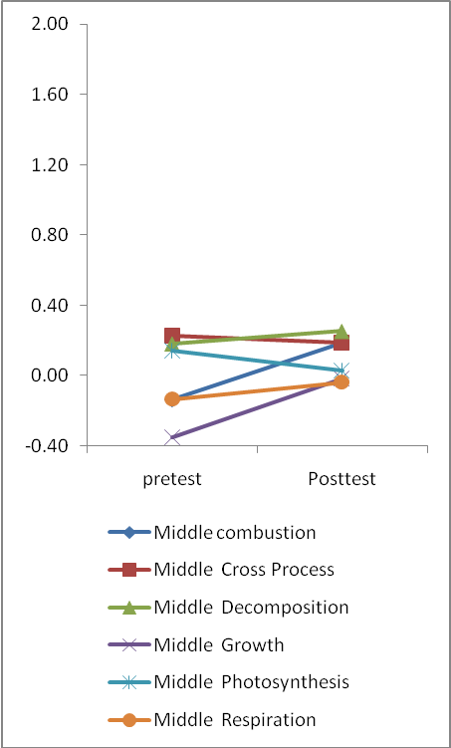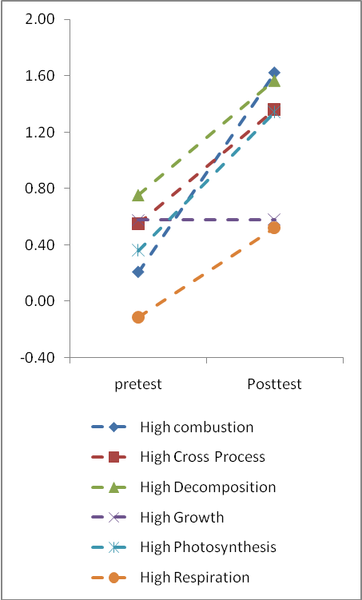
Figure 1: Graphical Pre-Post comparison of Processes by grade level

Overall comparisons of principles by grade level
Our analysis of principles by grade level showed similar patterns of performance as did process by grade level. That is, unlike middle school, we found pre-post gains for high school in the two principles of energy and matter. We highlight these in green in table 3 below (See also figure 2 below). Contrary to high school pre-post gains, middle school students’ accounts showed no overall significant gain in either of the two principles of energy and matter (See red highlight in table 2 below).
What do these findings suggest? Generally, on the one hand, our findings suggest that high school students perform better in their accounts of carbon-transforming processes than middle school students. This inference follows from the clear pattern of higher level overall performance by high school students in processes where pre-post gains were in 5 out of 6 unlike middle school students’ performance in processes where pre-post gains were 2 out of 6. Additionally, improved pre-post performance in principles of energy and matter in high school, unlike middle school students who showed no significant pre-post gains in either of the two principles, suggests that high school students perform better than do middle school students in carbon-transforming processes.
On the other hand, we hypothesized that pre-post gains in some processes and not in others suggested that some items were more difficult (e.g. growth) than others (e.g. photosynthesis) for high school students. Similarly, some items (e.g. photosynthesis and respiration) may be more challenging for middle school students than others (e.g. combustion and growth). We reasoned that if these hypotheses were true, then it was probable that some of the items we used may not have been useful in adequately predicting students’ ability levels in these processes. Our hypotheses following our findings pointed to, for instance, checking for item quality and therefore validity regarding levels of achievement in especially the process of growth. But first, we analyzed specific processes by instruction and principles by instruction to determine if indeed some processes stood out.

Table 3: Pre-Post comparison of Principles by grade level
Grade Level |  | t-test for Equality of Means
 |  | t | df | Sig. (2-tailed) | Mean Difference | Std. Error Difference | 95% Confidence Interval of the Difference
 |  |  |  |  |  |  | Lower | Upper
Middle | Energy | -1.889 | 225 | 0.060 | -0.149 | 0.079 | -0.304 | 0.006
Middle | Matter | -1.077 | 225 | 0.283 | -0.104 | 0.097 | -0.294 | 0.086
High | Energy | -5.627 | 149 | 0.000 | -0.842 | 0.150 | -1.138 | -0.547
High | Matter | -3.814 | 149 | 0.000 | -0.723 | 0.190 | -1.098 | -0.348

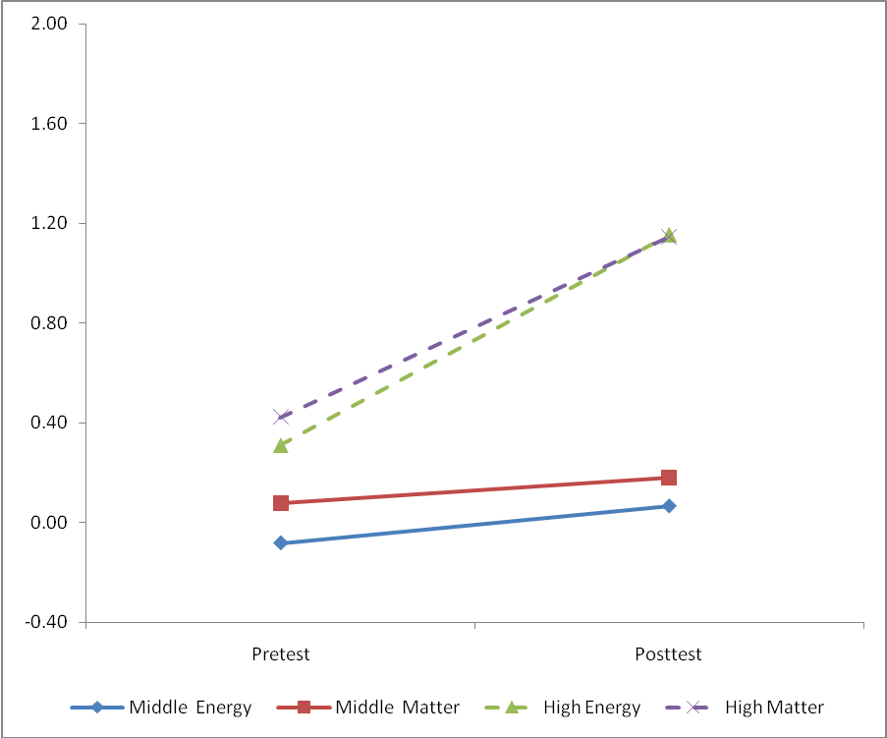
Figure 2: Graphical Pre-Post comparison of Principles by grade level

Comparisons of specific processes by instruction
Specific pre-post gains and the process of growth. In terms of specific processes by instruction, we found, on the one hand, that there were higher pre-post gains among students whose teachers [H (TH) & R (TR)] used designed instructional materials (Table 4 & figure 3 below). Specifically, although TH’s students’ accounts showed marginal gains in photosynthesis, she had her students’ accounts show significant gains in 4 out of the 6 carbon-transforming processes we examined. That is, significant gains were in combustion, cross processes, decomposition, and respiration. However, although TH’s students’ accounts showed marginal gains in photosynthesis (yellow highlight in table 4), the same students’ accounts did not show gains in the process of growth. We highlight significant pre-post gains in green and those with no pre-post significant gains in red (see table 4 below).
Similarly, TR’s students’ accounts showed significant gains in 4 out of the 6 carbon-transforming processes. That is, there were significant gains in combustion, cross processes, photosynthesis, and in respiration. TR’s students’ accounts, however, did not show significant gains in decomposition and, like TH, in the process of growth.
Table 4: Pre-Post comparison of Processes by instruction
Teacher ID |  | t | df | Sig. (2-tailed) | Mean Difference | Std. Error Difference | 95% Confidence Interval of the Difference
 |  |  |  |  |  |  | Lower | Upper
MA | Comb | -2.267 | 225 | 0.024 | -0.321 | 0.142 | -0.600 | -0.042
 | Cross | 0.249 | 225 | 0.804 | 0.033 | 0.134 | -0.231 | 0.298
 | Decomp | -0.438 | 225 | 0.662 | -0.071 | 0.163 | -0.393 | 0.250
 | Growth | -2.423 | 225 | 0.016 | -0.335 | 0.138 | -0.607 | -0.062
 | Photo | 1.078 | 225 | 0.282 | 0.111 | 0.103 | -0.092 | 0.315
 | Resp | -1.763 | 225 | 0.079 | -0.094 | 0.053 | -0.200 | 0.011
A | Comb | -0.834 | 35 | 0.410 | -0.239 | 0.287 | -0.823 | 0.344
 | Cross | -0.622 | 35 | 0.538 | -0.170 | 0.273 | -0.723 | 0.384
 | Decomp | -2.638 | 35 | 0.012 | -0.914 | 0.347 | -1.618 | -0.211
 | Growth | 0.957 | 35 | 0.345 | 0.421 | 0.440 | -0.472 | 1.315
 | Photo | -2.527 | 35 | 0.016 | -0.913 | 0.361 | -1.647 | -0.180
 | Resp | -3.049 | 35 | 0.004 | -0.414 | 0.136 | -0.690 | -0.138
H | Comb | -6.410 | 68 | 0.000 | -2.095 | 0.327 | -2.747 | -1.443
 | Cross | -3.538 | 68 | 0.001 | -1.029 | 0.291 | -1.609 | -0.448
 | Decomp | -1.994 | 68 | 0.050 | -0.855 | 0.429 | -1.711 | 0.001
 | Growth | -0.546 | 68 | 0.587 | -0.143 | 0.261 | -0.664 | 0.378
 | Photo | -1.934 | 68 | 0.057 | -0.715 | 0.370 | -1.452 | 0.023
 | Resp | -4.738 | 68 | 0.000 | -0.831 | 0.175 | -1.181 | -0.481
R | Comb | -3.327 | 42 | 0.002 | -1.118 | 0.336 | -1.796 | -0.440
 | Cross | -2.810 | 42 | 0.007 | -0.858 | 0.305 | -1.475 | -0.242
 | Decomp | -0.841 | 42 | 0.405 | -0.410 | 0.487 | -1.394 | 0.574
 | Growth | -0.139 | 42 | 0.890 | -0.048 | 0.346 | -0.747 | 0.650
 | Photo | -3.247 | 42 | 0.002 | -1.289 | 0.397 | -2.090 | -0.488
 | Resp | -2.113 | 42 | 0.041 | -0.440 | 0.208 | -0.859 | -0.020

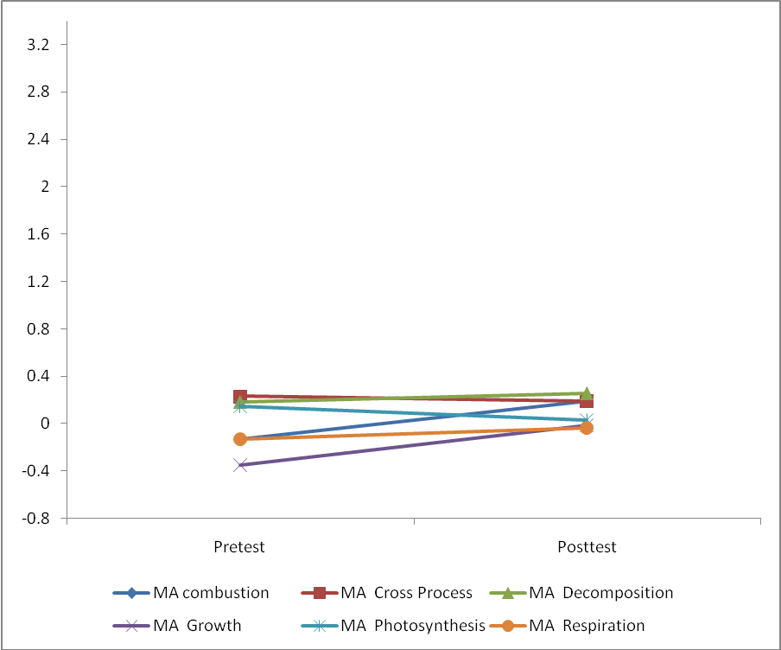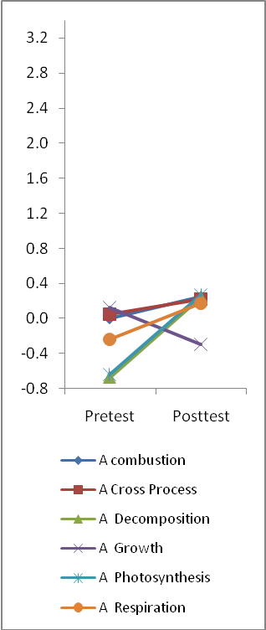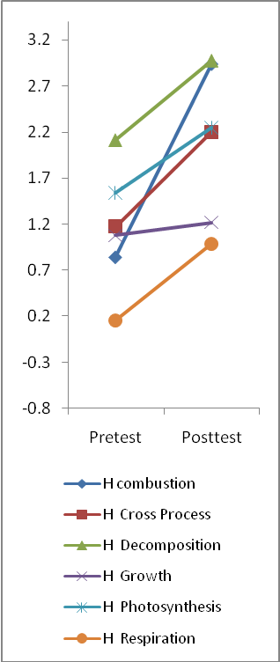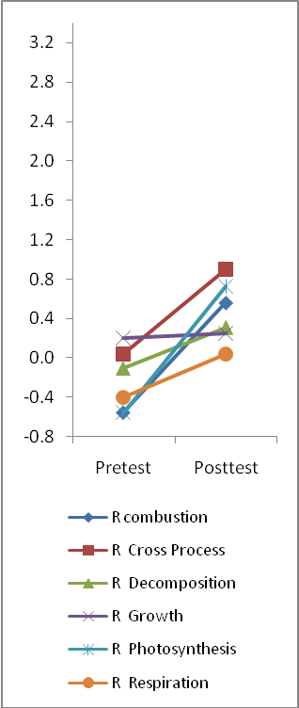
Figure 3: Graphical Pre-Post comparison of Processes by instruction
We found, on the other hand, little significant pre-post gains in students’ accounts of carbon-transforming processes among teachers [A (TA) & MA (TMA)] who did not use designed instructional materials (Table 4 & figure 3 above). Specifically, TA’s students’ accounts showed mixed results with pre-post gains in 3 processes; decomposition, respiration, and Photosynthesis. At the same time, TA’s students’ accounts showed no significant pre-post gains in 3 other carbon-transforming processes: Combustion, cross processes, and growth (see red highlight in table 4. Similarly, TMA’s students’ accounts did not make significant pre-post gains in 4 of the six processes. These were the processes of photosynthesis, cross processes, respiration, and decomposition. Again, for significant gains from students’ carbon-transforming accounts, we highlight them in green and accounts that did not show significant gains, we highlight them in red (see table 4 above).
Comparisons among teachers with similar pretests and the process of growth. We further analyzed data relating to teachers whose students’ pretest accounts were roughly similar (see figure 3). When we looked at high school only, we found similar results as we did in, “specific pre-post gains and the process of growth” above. Whereas TA, who had not used instructional materials, had pre-post gains in 3 processes, teachers H and R, who had used instructional materials, showed positive gains in 4 processes each. Again, growth was among processes in which students’ pre-post accounts showed no significant gains.
Moreover, we compared students’ pre-post accounts from TA and TR. These were high school teachers whose students’ pretests were nearly similar. That is, these two teachers’ students started nearly at the same pretest level (see figure 3 above). Our findings yet again showed that students’ accounts from TR who had used more targeted instruction showed more pre-post gains (4 out of 6) than did students’ accounts from TA who used more traditional instruction (3 out of 6). Again, growth showed no significant pre-post gains from either of the two teachers’ students’ accounts.
When we looked at middle school, we found comparable results. TMA, like TA from high school, had not used instructional materials in her class. Although TMA’s students’ pretest scores were roughly similar to those of TA’s and TR’s students (see figure 3), yet, from our analysis, her students’ accounts showed positive gains in only 2 (combustion and growth) out of the 6 processes. This indicates, among other interpretations, that middle school students generally perform better in these two processes than other processes.
Furthermore, given that only middle school students’ accounts in the process of growth showed significant pre-post gains, we hypothesized that this process was taught in middle school and not in high school. This raised the possibility of another hypothesis: That if indeed the process of growth was taught in middle school, then it was not well aligned to other processes that are taught in high school. We also thought that a possible reason why accounts regarding growth among high school students did not significantly improve could be related to high school growth item validity. We therefore checked for the validity of high school items regarding the process of growth.
Item validity and the process of growth. After confirming that high school students’ pre-post carbon-transforming accounts showed no significant gains irrespective of form of instruction, we qualitatively checked for items relating to this process at the high school level. To do this, we began with the assumption that if the items we used were valid, then they could elicit responses at all levels of achievement. To find out if this was the case, we first checked our earlier validity estimates of growth items (see yellow highlight in appendix A). Then we checked our exemplar worksheets (see example appendix B).
Our validity estimates (appendix A) showed that all but two items were valid at levels 1 through 4. The two invalid items were; ENERPEOP (energy people) invalid at level 4, and STOREEN (store energy) invalid at level 1. Whereas this may be true, other items seemed to be invalid at level 4 because they too did not generate students’ accounts of carbon-transforming process of growth at that level (see appendix B). These items included INFANT (Infant growth) and EATAPPLE. We also noted that the item ‘LIGHTEN’ was structured differently for middle school than it was for high school. Additionally, STOREEN was designed for high school only. From these observations, we hypothesize that most growth items in the process of growth for high school were not adequate enough for examining students’ pre-post accounts of this process. We think that further future work relating to these and similar items may help us improve our approaches to assessment of carbon-transforming processes among high school students.
Comparisons of principles by instruction
Overall, on the one hand, there were pre-post gains in students’ accounts regarding principles among teachers who used targeted instruction (Table 5 & figure 4 below). We highlight significant gains in green in table 5. Specifically, TH’s pre-post students’ accounts of carbon-transforming processes relating to both the principles of energy and matter showed significant positive change. Similarly, TR’s students’ accounts showed significant gains in the pre-posttests the accounts regarding both the principles of energy and matter.
On the other hand, overall, we found little significant pre-post gains in students’ accounts regarding principles among teachers who used traditional instruction (Table 5 & figure 4). That is, whereas TA’s students’ accounts showed pre-post gains in the principle of matter, these students’ accounts did not show significant pre-post gains in the principle of energy. We highlight principles with pre-post gains in green and those with no pre-post gains in red in table 5 below.
Contrary to TH’s and TR’s students’ pre-post significant gains in both the principles of energy and matter, TMA’s students’ pre-posttests showed no significant change in either of the two principles (see table 5). Given that both TH and TR, unlike TA and TMA, were the only teachers who used our designed instructional materials, we, although cautiously, attributed their students’ significant pre-post gains in the two principles to more targeted instruction. These are preliminary results however and more work needs to be done for more conclusive inferences.
Table 5: Pre-Post comparison of Principles by instruction
Teacher ID |  | t | df | Sig. (2-tailed) | Mean Difference | Std. Error Difference | 95% Confidence Interval of the Difference
 |  |  |  |  |  |  | Lower | Upper
MA | Energy | -1.889 | 225 | 0.060 | -0.149 | 0.079 | -0.304 | 0.006
 | Matter | -1.077 | 225 | 0.283 | -0.104 | 0.097 | -0.294 | 0.086
A | Energy | -1.413 | 35 | 0.166 | -0.319 | 0.226 | -0.777 | 0.139
 | Matter | -2.761 | 35 | 0.009 | -0.568 | 0.206 | -0.986 | -0.151
H | Energy | -6.811 | 68 | 0.000 | -1.094 | 0.161 | -1.414 | -0.773
 | Matter | -3.940 | 68 | 0.000 | -0.741 | 0.188 | -1.117 | -0.366
R | Energy | -4.254 | 42 | 0.000 | -0.770 | 0.181 | -1.135 | -0.405
 | Matter | -2.940 | 42 | 0.005 | -0.631 | 0.215 | -1.064 | -0.198

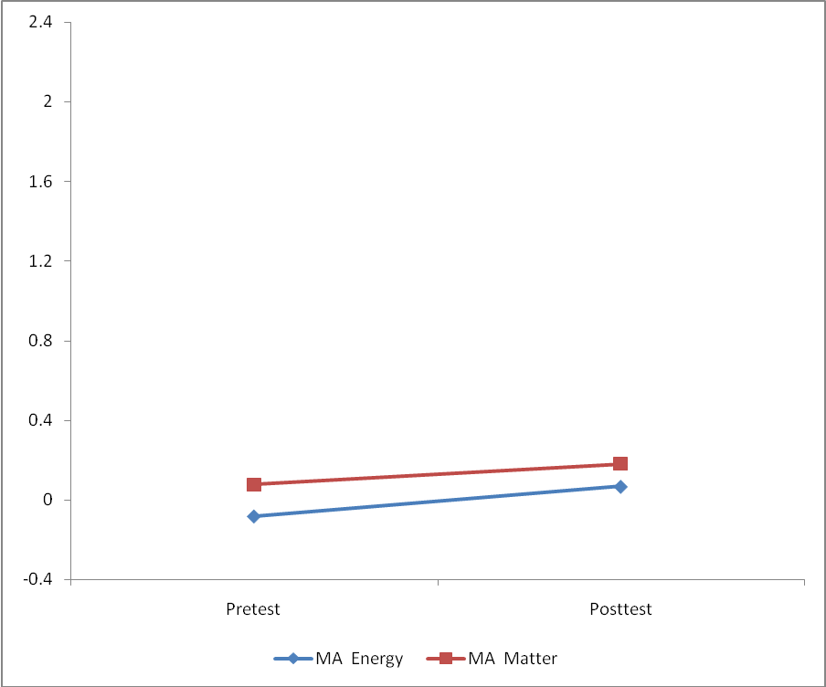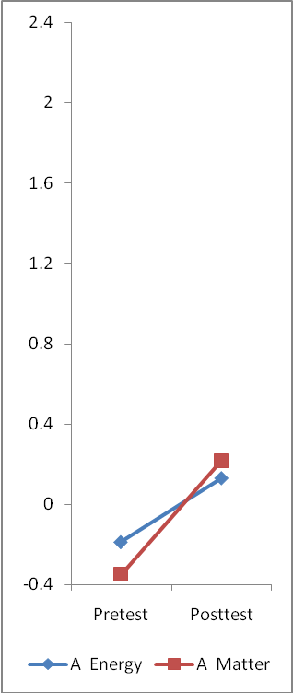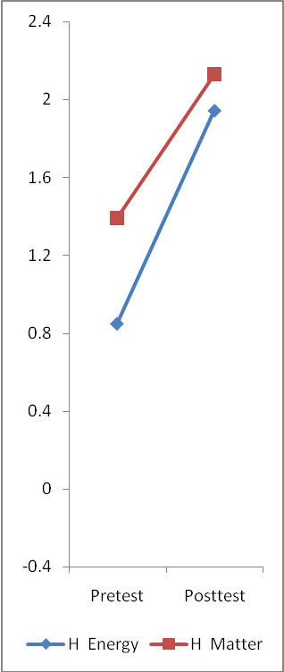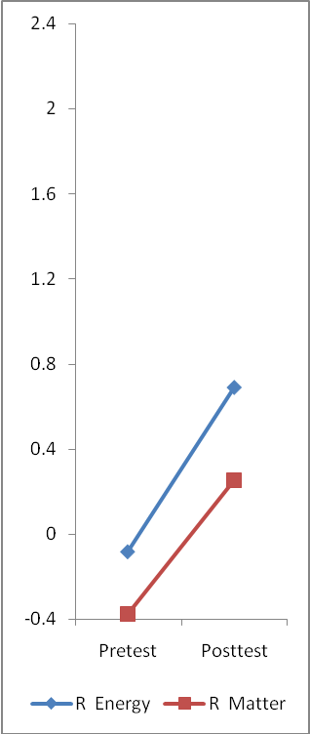
Figure 4: Graphical Pre-Post comparison of Principles by instruction
Certainly, we wish to note that one of the study limitations relates to its design: That we did not collect and include data about how specifically, with or without instructional materials, each of the four teachers included here engaged their students in learning about carbon-transforming processes. We therefore feel that there is need for further future work to examine how each teacher specifically engaged their students in learning about the carbon-transforming processes we examined and what impact this might have on students’ accounts about these processes.
Contribution of the study to student science learning
Learners constantly encounter a multiplicity of challenges regarding connected, in this case, carbon-transforming processes. Work on helping learners to learn science in ways that confer them with tools for meaningfully engaging in environmental decision making as informed citizens has been the basis for the constant call for reform-based science teaching (e.g. AAAS, 1993; NRC, 2007; NSS, 1996). Our preliminary findings from this study suggest that use of instructional materials for more targeted instruction holds promise for supporting learners move from force-dynamic reasoning to more model-based reasoning.

References:
Cokelez, A., Dumon, A. & Taber, K. S. (2008). Upper secondary French students, chemical transformations and the “Register of Models”: A cross-Section study. International Journal of Science Education, 30(6), 807-836
Hesse, J.J., & Anderson, C.W. (1992). Students’ conceptions of chemical change. Journal of Research in Science Teaching, 29(3), 277-299.
McNeill, K., Lizotte, D., Krajcik, J., & Marx, R. W. (2006). Supporting students’ construction of scientific explanations by fading scaffolds in instructional materials. Journal of the Learning Sciences, 5(2) p 153-191
Mohan, L., Chen, J., & Anderson, W. A. (in press). Developing a multi-year learning progression for carbon cycling in socio-ecological systems.
National Research Council (1996). The national science education standards. Washington, DC: National Academies Press.
Pophram, W. J. (2007). The lowdown on Learning Progressions. Educational Leadership, 64(7), 83-84
Smith, C. L, Wiser, M., Anderson, C. W., & Krajcik, J. (2006). Focus article: Implications of Research on Children’s Learning for Standards and Assessment: A proposed Learning Progression for Matter and the Atomic-Molecular Theory. Measurement: Interdisciplinary Research and Perspectives, 4 (1&2), 1-98
Taylor, J. A, Van Scotter, P., & Coulson, D. (2007). Bridging Research on Learning and Student Achievement: The role of instructional materials. Science Educator, 16 (2), 44-50

Appendix A: Item validity estimates
Item | Grade  Level | validity estimates
 | Grade  Level | level 1 | leve 2 | level 3 | level 4
AIRDIFF | EMH
ANIMWNTR | E |  |  |  |  | M | X
APPLEROT | EMH
BODYTEMP | EMH |  |  |  |  | M&E | X
BRNMATCH | E
CUTTREE | E
DEERWOLV | H
DIFEVENTS | EMH |  |  |  |  | M&E | X
EATAPPLE | EMH
ECOSPHERE | MH
ENERPEOP | MH |  |  |  |  | M&E | X
ENERPLNT | MH
ENPYRAMID | H
FDFINGER | E |  |  |  |  | M&E | X
GAS_MT | MH
GASWATER | EMH
GLUGRAPE | MH |  |  |  |  | M&E | X
GRANJOHN | MH |  |  |  |  | M | X
HOTTHINGS | MH |  |  |  |  | E | X
INFANT | EMH
JARED | E |  |  |  |  | M&E | X
LBULB | MH |  |  |  |  | E | X
LIGHTENelm | E |  |  |  |  | E | X
LIGHTENmid | M
LIGHTENhi | H
SEEDGAIN | H
STOREEN | MH |  |  |  |  | E | X
THINGTREE | EMH
TREEDECAY | EMH
TROPRAIN | MH |  |  |  |  | M&E | X
WAXBURN | EMH
WOODMIX | EMH
WTLOSS | EMH

Appendix B: Example growth exemplar worksheet
Level |  | INFANTmh |  | EATAPPLE |  | MUSCMIX
Level | Characteristics of Transformation Items | Characteristics of Responses | Exemplar Responses | Characteristics of Responses | Exemplar Responses | Notes | Characteristics of Responses | Exemplar Responses
4  Chemical processes with conservations of atoms and mass. | Explain digestion and biosynthesis at the atomic-molecular and cellular levels, focusing on key reactants and products. Recognize that growth of organisms occur when organisms synthesize simple carbohydrates and amino acids into more complex molecules (lipids, proteins, etc). | NA | No example | NA | No example |  | Identify muscle cell in terms of atomic-molecular scale and identify chemical substances in the cell. | I believe that the muscle cell is made up of many different things, like lactic acid for when you are lifting things or using the muscle, glucose is stored in the cell in order for the cell to have enough energy, its is made up of tissues that come together to form the muscle.
3  Materials as transformed by processes with matter-energy conversion, no conservation of atoms. | Identifies important chemical substances that are obtained from eating food and trace these to cellular level with a cellular mechanism for matter transformation during digestion | Identifies some of important reactants and products (amino acids, proteins, oxygen) in biosynthesis, but does not explain cellular mechanisms  Connects cellular respiration to biosynthesis by referring to a mediating molecule (ATP) | (Sunlight) Yes (Water) Yes (Air) Yes (Food) Yes (Exercise) Yes  Yes for sunlight because plants get their energy from sunlight and the girl has to eat vegetables to be healthy.  Yes for water because water is an essential for all living organisms (Your body is 80%! You need to drink enough of it to sustain this!)  Yes for air because air has oxygen and oxygen is needed to make ATP which is needed to make muscle and such, which is needed to grow.  Yes for food because the amino acids that are proteins are in the food. Your body doesn't make some of these, but still needs them to grow. These proteins eventually make DNA which is what really ""tells"" your body to grow.  Yes for exercise because exercise keeps you healthy and builds muscle. Without exercise, this girl would not have the strength to get through a normal day. | Identifies "mineral" and "nutrients" that are the product of digestion and things that help feet grow. The explanation moves beyond organ level. | The substances all become small particles. Substances help your feet grow because they give your feet minerals and nutrients. | Note: For level 3, students mention substances that are main components of cell, for level 2, student mention something not substance, (e.g. energy) or some minor substances in the cell. | Recognize components of muscle(carbon based minerals) at cellular level. | Muscle cells contain different elements and minerals that are carbon-based, but the source of those compounds is varied and composed of many substances that used the matter previously.  Muscle cells have different parts in them, like cytoplasm, mitochondria, cell wall, cell membrane, nucleus etc. They are animal cells and are made up of different parts.
2  Materials as enablers with solid-solid & gas-gas cycle. | Recognize that food or other materials are incorporated into the body and transformed by organs for the body to use. Do not consistently distinguish matter from other conditions such as sunlight and exercise. Air is not consistently recognized as matter that can contribute to mass increase | Describe growth as a general process of incorporating food and water into the body and focuses on materials the baby takes in, but does not provide cellular-level explanations.  Does not distinguish between energy-rich materials (e.g. food) and low-energy materials (e.g. water).  Does not recognize "air" as something that can contribute to weight gain because it helps her "stay thin" | (Sunlight) No (Water) Yes (Air) No (Food) Yes (Exercise) No  The matter she is made of did not come from sunlight or air or excurses because they help keep her thin and alive but not giving her matter like food and water. Food and water go inside her, giving her nutrients to grow matter. | First example focuses on the path and organs in the digestive system in explaining digestion, but does not provide cellular-level explanations.  The second response thinks that energy converted from the food plays a role in growing feet by giving "strength" | It goes down the esophagus and into the large and small intestines then to the stomach? Probably [helps the feet grow], I don't know how.  Then convert into energy. The food can give him strength [to help feet grow]. |  | Identify muscle as mixture, but don't name any components of muscle. | There of course would be several elements in the mucel cell, but I think there would have to be several different structures made form different things to complete the cells job.
1  Materials as enablers | Focus on natural tendency of food and other materials to help gain weight. Explain in terms of human intentions or experiences. Does not recognize that food contains energy-rich materials or is transformed in the body (does not mention organs involved in digestion). | Explain that water and food "naturally" make people gain weight and uses a personal experience to explain exercise. | (Sunlight) No (Water) Yes (Air) No (Food) Yes (Exercise) Yes  Water & food naturally make someone weight more. And, everytime I exercise, I gain a pound. | Does not recognize organ level explanation of digestion of connect eating with growth. | I don't know [what happens to the apple]. NO the apple dosn't make his feet grow!!! | (Note: if choice is no and explanation is e.g. “muscle cell is muscle cell”, it should be classified as level 1) | Explain muscle based on human intentions, and don't identify mixture. | Muscle cells make people strong to lift things up.

