Carbon Student Assessment Annotated Key
Key to 2012’s student assessment with descriptive text and likely student answers

Written by: carbon strand researchers
Culturally relevant ecology, learning progressions and environmental literacy
Long Term Ecological Research Math Science Partnership
October 2011
Disclaimer: This research is supported by a grant from the National Science Foundation: Targeted Partnership: Culturally relevant ecology, learning progressions and environmental literacy (NSF-0832173). Any opinions, findings, and conclusions or recommendations expressed in this material are those of the author(s) and do not necessarily reflect the views of the National Science Foundation.


MSP Carbon Assessment [Form B]

Please answer these questions as carefully and completely as you can. If you are not sure of the answer, write about any ideas that you have. If you can help us to understand how you think about these questions, then we can do a better job of explaining science in ways that make sense to you.

Please put your initials (not your full name) in the boxes
First | Middle | Last

Date __________________________

Class __________________________ Teacher __________________________

- A mature maple tree can have a mass of 1 ton or more (dry biomass, after removing the water), yet it starts from a seed that weighs less than 1 gram. Which of the following processes contributes the most to this huge increase in biomass that is not water? Choose the correct answer.

    - absorption of mineral substances from the soil via the roots
    - absorption of organic substances from the soil via the roots
    - incorporation of carbon dioxide gas from the atmosphere into molecules by green leaves
    - incorporation of water from the soil into molecules by green leaves
    - absorption of solar radiation (sunlight) into the leaf

Explain why your choice is best (If you think some of the other processesses above also contribute to the dry mass increase, explain how).
Level 4 students will choose c and explain that CO2 (and/or water) are transformed into substances the tree is made of.
Level 3 students are likely to say that carbon dioxide, water, and materials from soil all contribute to the weight gain. They trace matter but do not recognize that most weight gain is from gas (CO2)
Level 2 students describe how materials and sunlight trigger the process of growth.
Level 1 students often describe plant needs or weight gain is from the natural growth of the tree (the tree generates matter by itself).

- Which of the following is (are) the energy source(s) for plants? Choose either YES or NO for each of the following.

- Water  - Sunlight  - Air  - Nutrients in soil  - Plants make their own energy. | ◻ YES ◻ NO  ◻ YES ◻ NO  ◻ YES ◻ NO  ◻ YES ◻ NO  ◻ YES ◻ NO

Explain ALL your answers, including why the things you have chosen NO for are NOT sources of energy for plants.
Level 4 students identify sunlight as the only energy source for plants and the explanation is about energy transformation.
Level 3 students identify sunlight as one of many energy sources and explanation is about matter-energy conversion or identify some reactants and products of photosynthesis.
Level 2 students describe the process of “making food” and food is energy for plants to grow.
Level 1 students do not explain in terms of either matter or energy. Instead, they explain that plant have “needs” such as water, sunlight, air, soil, etc.

- When light energy comes into a plant and goes through photosynthesis, what will happen to it? Choose what you think is the best answer in the following.

    - The energy will not exist because it is used up in photosynthesis.
    - The energy will leave the plant’s body as energy.
    - The energy will change into a material or materials during photosynthesis and be stored in the plant’s body.
    - The energy will change into another form of energy during photosynthesis and be stored in the plant’s body.
    - None of the above. My answer is ______________________________________________________________________________________________________________________________________

Explain why your choice is best. In your explanation, you could include additional information such as the name of material or the form of energy.
Level 4 students choose d (or d and b) and explain energy transformation in photosynthesis (i.e., light energy becomes chemical energy of organic materials).
Level 3 students may describe photosynthesis in ways that confuse between matter transformation and energy transformation (e.g., matter-energy conversion) such as light energy becomes glucose.
Level 2 are likely to explain that energy is used up to power photosynthesis or energy powers growth.
Level 1 students are likely to talk about sunlight as a plant need. So, when plants have sunlight, it just grows bigger and bigger.
- The following is an experiment regarding animal growth.

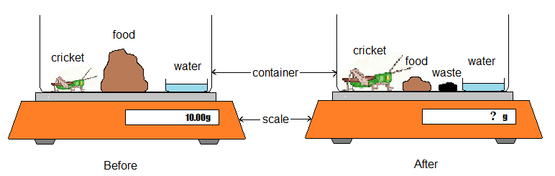

What is your prediction of the outcome of this experiment? Suppose we put a cricket in a container with plenty of food and make sure that it always has the same amount of water. Nothing can get in or out of the container except gases and water. At the beginning of the experiment, the container with cricket, water, and food weighs exactly 10 g.

At the end of the experiment, the cricket has eaten some of the food and gotten bigger. Some of the cricket’s waste (feces or poop) is also in the container. How much would you expect the container (with cricket, food, water, and waste) to weigh?

    - More than 10 g.
    - Still exactly 10 g.
    - Less than 10 g.

Explain the reason for your prediction.
Level 4 students choose c. The explanation should describe cellular respiration as the process that cause the total weight being less than 10g.
Level 3 students understand the container as an open system and attempt to conserve mass but cannot do that successfully. Some of them are likely to explain that not all food becomes the cricket’s body mass and waste, because some food becomes energy or is consumed up through metabolism. Some may explain that the total mass decreases due to water evaporation.
Level 2 students treat the container as a closed system without recognize gas input/output. They focus on the mass of solids and liquids without recognize gases. They may say that the total mass is conserved.
Level 1 students focuses on observable features and do not explain in terms of mass. They are likely to explain in terms of size change such as: criket grows bigger and food becomes smaller, etc.

- The following is an experiment regarding plant growth.

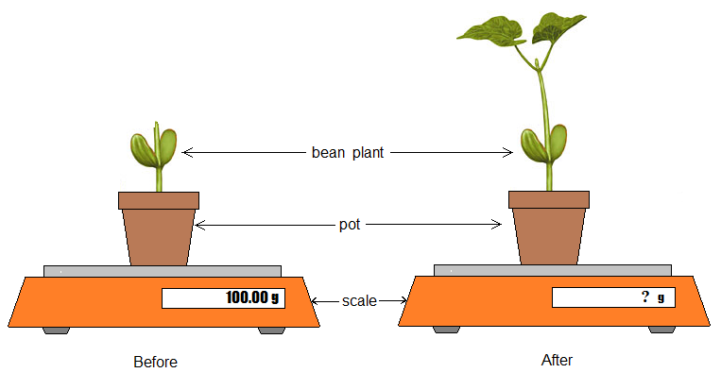

What is your prediction of the outcome of this experiment? Suppose we have a growing bean plant in a small pot with plenty of soil and make sure that it always has the same amount of water in the soil. Nothing can get in or out of the cup except gases and water. At the beginning of the experiment, the pot, plant, and soil weighed exactly 100 g.

At the end of the experiment, the plant has grown bigger. How much would you expect the pot, plant, and soil to weigh?

    - More than 100 g.
    - Still exactly 100 g.
    - Less than 100 g.

Explain the reason for your prediction.
Level 4 students choose a and explain how mass gain of the plant is from carbon dioxide in the air.
Level 3 students attempt to conserv mass but cannot do that successfully. They recognize air’s or carbon dioxide’s contribution to mass gain of the plant, but do not recognize it as the major contributor.
Level 2 students describe mass gain in terms of hidden process such as nutrients becom the plant’s tissue, plants making food from resources, etc.
Level 1 students does not address any hidden processes. They focus on observable changes. They often explain that plants grow bigger (size change), so it put on more weight.

- Use the table below to explain where you think that carbon is found inside a tree and how it gets there.
Location | Choose either YES or NO | If you chose YES, explain how the carbon gets to that location. Include molecules in your explanation if you can.
Does a tree have carbon in its leaves? | ◻ YES ◻ NO | Level 4 students choose yes for leaves, wood, and roots. They explain that carbon gets to leaves because carbon dioxide reacts with water to produce glucose (and also oxygen) in photosynthesis; and photosynthesis happens in the leaves. They also explain that the organic materials such as glucose are carried to wood and roots from the leaves.  Level 3 students identify carbon in leaves. Their explanation mentions that organic materials are produced and organic materials contain carbon.  Level 2 students do not identify any chemical change. They may explain that plants take in carbon dioxide and that is why plants have carbon. Or state that plant parts contain carbon because of some hidden processes.  Level 1 students may not identify carbon. They may use the word carbon for explanation in ways that do not make sense. They may focus on plant needs.
Does a tree have carbon in its wood? | ◻ YES ◻ NO
Does a tree have carbon in its roots? | ◻ YES ◻ NO

- Your body produces heat to maintain its normal temperature. Where does the heat mainly come from? Please choose ONE answer that you think is best.

    - The heat mainly comes from sunlight.
    - The heat mainly comes from the clothes you are wearing.
    - The heat mainly comes from the foods you eat.
    - The heat mainly comes from your body when you are exercising.

Explain why you think that the answer you chose is better than the others. (If you think some of the other answers are also partially right, explain that, too.)
Level 4 students choose c and explain that heat is transformed from the chemical energy stored in organic matter (body tissue) in cellular respiration. They should also explain that food becomes body tissue in digestion and biosynthesis.
Level 3 students choose c and explain that heat is released from metabolism (or any general description of processes) but do not identify cellular respiration as the process that release heat, or do not identify that heat is transformed from (chemical) energy stored in organic materials that transformed from food.
Level 2 students may choose a, c, or d and explain that food provide energy, but does not describe any hidden process.
Level 1 students may choose any choice and explain in terms of macroscopic observation or experiences such as: when you wear more clothes, you feel warmer.

- Look at the six items below and answer the questions.
Item | A. Does it contain carbon? | If you chose YES, answer the questions below.
Item | A. Does it contain carbon? | B. Where is the carbon found inside this item? | C. Where was the carbon before it got inside this item?
 | ◻ YES  ◻ NO
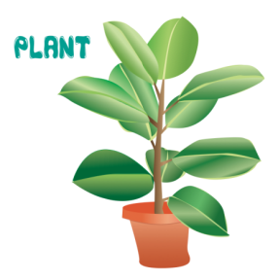 | ◻ YES  ◻ NO
 | ◻ YES  ◻ NO
 | ◻ YES  ◻ NO
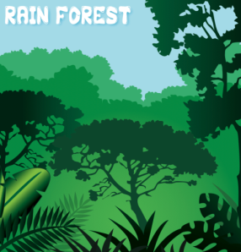 | ◻ YES  ◻ NO
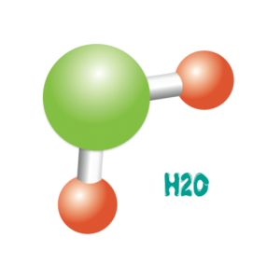 | ◻ YES  ◻ NO

Level 4 students choose no for water and yes for all other choices. They are able to explain the following: 1) carbon is found in organic molecules (e.g., glucose, cellulose, or any carbohydrates, lipids, etc.) in plants, egg, and forest; DNA molecules contain carbon atoms; carbon goes into organisms’ body in photosynthesis, in which carbon dioxide and water react and becomes organic moleucles (and oxygen); sea contain carbon due to CO2 resolving in water.
Level 3 students should state that water does not contain carbon. They may identify organisms contain carbon and identify organic moleucles of organisms, but they cannot successuflly explain how carbon gets into organisms’ body.
Level 2 students explain carbon in ways that do not identify carbon as an atom. They often explain some hidden processes such as plants take into carbon dioxide and change it into oxygen.
Level 1 students do not understand what carbon means and provde answers based on macroscopic observations or percetions.

- Look at the picture of a simple carbon cycle below, and answer the following questions. This diagram outlines the carbon cycle. Note: “Gt C” = gigatons of carbon, y⁻¹ = ‘per year’, ‘physiochemical diffusion’ refers to CO₂ dissolving in and out of water.
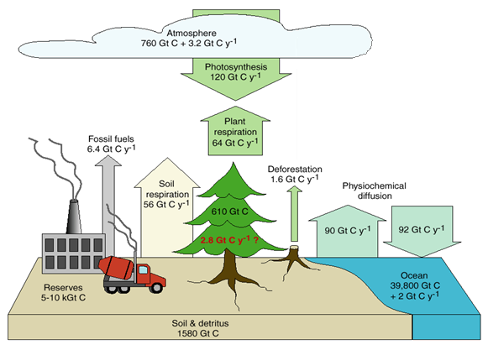
  - Can you tell from this diagram where the carbon on Earth is located, and where it can be found in the largest amounts? ◻ YES ◻ NO
If you answered YES, explain how you can tell.

  - Can you tell where carbon is moving from one area to another? ◻ YES ◻ NO
If you answered YES, explain how you know where carbon is moving, and explain two of the movements that seem most important to you in order to understand the diagram.

Level 4 students are able to trace carbon with the recognition that carbon change between organic and inorganic forms in photosynthesis and cellular respiration. They should be able to explain the following: when fossil fuels burn, the organic materials react with oxygen and become carbon dioxide and water, so carbon is released. When plants carry out cellular respiraiton, organic matter reacts with oxygen and become carbon dioxide and water. Carbon dioxide is also released from sea water (not required). Organic materials in soil may decompose (cellular respiraton), in which organic matter also react with oxygen and release carbon dioxide and water.
Level 3 students may identify some chemical processe but not all.
Level 2 students do not identify any chemical process and describe in terms of hidden processes that related to carbon. For example, they may explain that plants need to breath, so they take in carbon dioxide.
Level 1 students do not understand the question and may provide responses that about macroscpic observations.
A small plant is put in a huge glass chamber with plenty of air. Three days later, what change will have happened to the mass of the air and the mass of the plant?
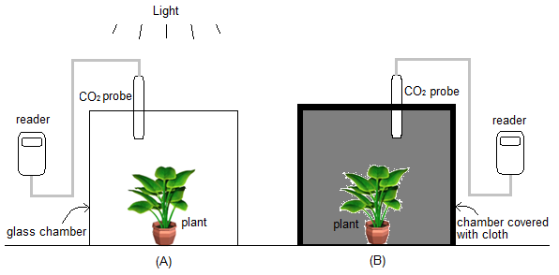
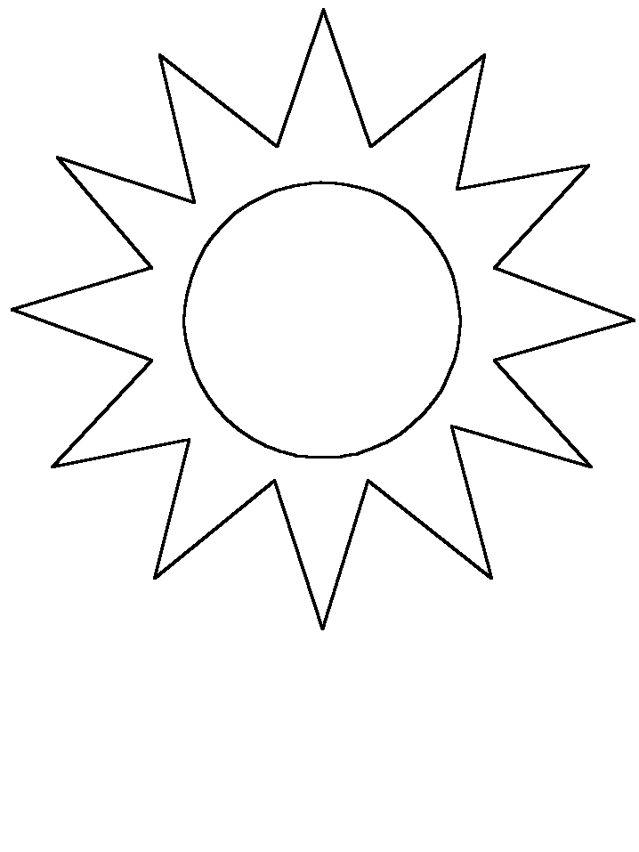
Glass Chamber

1) The mass of the AIR inside the chamber will _____________________________.
a. increase b. decrease c. stay the same
Please explain the reason for your choice.

2) The mass of the plant inside the chamber will ___________________________.
a. increase b. decrease c. stay the same
Please explain the reason for your choice.
Level 4 students explain that the plant gains weight due to photosynthesis, in which carbon dioxide in the closed chamber reacts with water and becomes part of the plant’s body tissue. They also explain that carbon dioxide in the air decreases due to photosynthesis. They may describe cellular respiration, but that is not required.
Level 3 students explain plant growth in terms of photosynthesis or identify organic molecules, but they do not correct trace matter (carbon dioxide in the air participates in photosynthesis and becomes part of the plant’s body tissue).
Level 2 students explain plant growth in terms of hidden processes such as carbon dioxide becoming oxygen or nutrients of soil becoming plant body.
Level 1 students do not identify any processes. They describe observations. For example, the plant will grow and becomes bigger, so it has more weight; the plant will die because it does not have enough air.
10. Which of the following personal actions impact atmospheric carbon dioxide (CO₂) levels and climate change?
Personal action | Does it have an effect on climate change? Choose YES or NO. | If you chose YES, explain how the action would impact climate change. If you chose NO, explain why the action would not impact climate change.
Using cloth bags instead of plastic or paper bags at the grocery store | ◻ YES ◻ NO | Level 4 response: plastic is an oil product; paper bags are made from trees. Therefore, producing plastic and paper bags consumes energy. Given that about 50% electricity used in the U.S. is from burning coals, producing the bags will cause a large amount of carbon emission. Using paper bags will lead to cutting trees, causing less carbon being removed from the atmosphere. Plastic decompose very slowly, but because it is made from raw oil, they do release carbon dioxide and methane.
Walking or riding your bike instead of taking car or bus | ◻ YES ◻ NO | Level 4 response: car uses gasoline, which release carbon dioxide when gasoline is burned.
Planting Trees | ◻ YES ◻ NO | Level 4: Trees remove carbon dioxide.
Conserving energy | ◻ YES ◻ NO | Level 4: About half electricity used in the U.S. is from burning coal. So, using less electrical energy will reduce carbon emission. Use less other energy sources such as gasoline or any other fossil fuels also reduce carbon emission.
Buying organic and local foods | ◻ YES ◻ NO | Level 4. Buying organic and local foods will leads to less energy consumption for transportation and production of fertilizers. As elaborated above, using less energy cause less carbon emission.

<The End. Thank You.>

