Sample Workshop Evaluation
Supplemental material for designing Professional Development Workshops
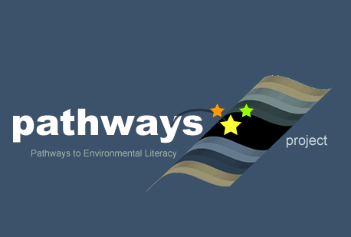
Written by Sara Syswerda and Sarah Bodbyl-Roels (Michigan State University) and Rose Shaw (independent evaluator)
Culturally relevant ecology, learning progressions and environmental literacy
Long Term Ecological Research Math Science Partnership
2013
Disclaimer: This research is supported by a grant from the National Science Foundation: Targeted Partnership: Culturally relevant ecology, learning progressions and environmental literacy (NSF-0832173). Any opinions, findings, and conclusions or recommendations expressed in this material are those of the author(s) and do not necessarily reflect the views of the National Science Foundation.

NSF MSP: Pathways to Environmental Literacy (March 21, 2013)
K-12 Partnership KBS Workshop

Please rate (from 1 to 5) the usefulness to you of these workshop sessions with 1 = Low and 5 = High. Space is also provided for comments. If you did not participate in an event, do not record a rating.

Plenary Talk 1- Please rate (1 to 5, 5 high) the usefulness of Dave Warners’ talk to you: _________

Comments about this session:

Concurrent Session 1- Please record your rating (1 to 5, 5 high) of the session you attended.

_____Human Energy Systems (Hannah Miller, Jenny Dauer, and Andy Anderson)
_____ Project GREEEN Session (Jake Nalley, Michael Kuczynki, Tyler Bassett, Dustin Kincaid)
_____BEST plots Session (Cara Krieg, Sara Garnett, Alycia Reynolds-Lackey)
_____BoxCar2D Session (Anne Royer, Liz Schultheis, Sara Garnett)

Comments about the Concurrent Session 1 you attended:

Plenary Talk 2 - Please rate (1 to 5, 5 high) the usefulness of Joe Krajcik’s Next Generation Science Standards Update to you: _________

Comments about this session:

Concurrent Session 2- Please record your rating (1 to 5, 5 high) of the session you attended.

_____ Food Safety, Microbes, and Biosensors (Lisa Wininger and Sara Syswerda)
_____ Project GREEEN Session (Jake Nalley, Michael Kuczynki, Tyler Bassett, Dustin Kincaid)
_____BEST plots Session (Cara Krieg, Sara Garnett, Alycia Reynolds-Lackey)
_____BoxCar2D Session (Anne Royer, Liz Schultheis, Sara Garnett)

Comments about the Concurrent Session 3 you attended:

(Please turn over for the rest of the survey)

To what degree do you feel this workshop supported each of these workshop objectives?

 | Low |  |  |  | High
Participants will increase their understanding of the importance of native species | 1 | 2 | 3 | 4 | 5
Participants will gain a greater perspective for how the Next Generation Science Standards will affect their classrooms | 1 | 2 | 3 | 4 | 5
Exploration activities will increase participants’ understanding of using real data with your students | 1 | 2 | 3 | 4 | 5

- Please rate the overall quality of this workshop (1 to 5, 5 high)

- How likely is it that you would recommend this workshop to colleagues who teach the same subjects and grades you teach?

Very unlikely Unlikely Likely Very likely

- Do you feel more prepared to teach about native species and restoration?

- We will be doing a session on the Next Generation Science Standards during the Summer Institute. Is there anything in particular you would like us to do or cover about the NGSS?

- Are there other subjects/topics you would like to see covered during the Summer Institute?

SS/RS(3/18/2013)

