Examples of Student Data
Data presented to teachers during a professional development

Written by: , Alan Berkowitz¹, Brad Blank², Aubrey Cano³, Bess Caplan¹, Beth Covitt⁴, Katherine Emery³, Kristin Gunckel⁵, LaTisha Hammond⁶, Bill Hoyt⁷, Nicole LaDue⁸, John Moore², Tamara Newcomer¹, Tom Noel², Lisa Pitot², Jen Schuttlefield⁹, Sara Syswerda⁸, Dave Swartz², Ray Tschillard¹⁰, Andrew Warnock and Ali Whitmer⁶. (Cary Institute¹, Colorado State Univ. ², U.C. Santa Barbara³, Univ. Montana⁴, Univ. of Arizona⁵, Georgetown Univ.⁶, Univ. Northern Colorado ⁷, Michigan State Univ.⁸, Univ. Wisconsin⁹, Poudre Learning Center¹⁰ )
Culturally relevant ecology, learning progressions and environmental literacy Long Term Ecological Research Math Science Partnership
2012
Disclaimer: This research is supported by a grant from the National Science Foundation: Targeted Partnership: Culturally relevant ecology, learning progressions and environmental literacy (NSF-0832173). Any opinions, findings, and conclusions or recommendations expressed in this material are those of the author(s) and do not necessarily reflect the views of the National Science Foundation.


Examples of Student Data
- Order these responses from least (1) to most sophisticated (4).
- Discuss with your group why you ordered the responses this way.
- What do these responses suggest about how these students see the world (not what did they get right or wrong)?

How does water get into a river?
Order | Student Response | Comments
 | Because it flowes from the Lakes into our rivers that's how the water gets in the river
 | By digging a hole and the rain, snow, or ice melts and the water will drain in the river.
 | Runoff from when it rains goes into the river, and also water gets through the earth and becomes groundwater. That flows to the river as well.
 | Water Cycle, because water gets used over and over again

If you had to make ocean water drinkable, how would you do it?
Order | Student Response | Comments
 | I would use a filter to let the water go through to clean it
 | To make ocean water drinkable you would have to distill the water because when you distill it the salt is what is left behind
 | I would have a purifying machine.
 | I would not be very happy because I would have to drink uncleaned water

How does water get into well #1?

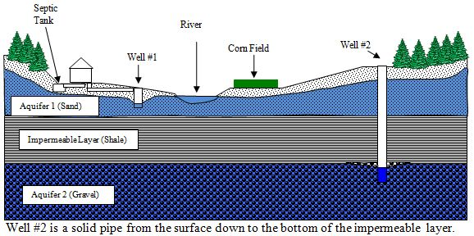

Order | Student Response | Comments
 | from the aquifer that it goes down into.
 | From the septic tank and when it rains. From the sinks. From the Bath Tubs. From the towilets
 | Water could get into well #1 will be rain or pipes that let clean water in your well.
 | The Rain pathway goes into Well 1 by Raining in the river and going into the aquifer to Well 1. The river pathway goes from the river into the aquifer and into Well #1. The Aquifer 1 path goes from the aquifer to the well.

What happens to salt when it dissolves in water?
Order | Student Response | Comments
 | The water overpowers the salt by making it disappear.
 | The molecules combine/react with each other and sticking to each other
 | The H₂O is negatively charged so Na⁺ is attracted like a hydrogen bond and the NaCl will break apart.
 | When salt dissolves in water it turns the water a different color like a darker color

