DRK12 Watershed Model Activity --- From Beth and Kristin’s Summer Workshop with DRK12 Water Tools Teachers in July 2011
Professional Development Workshop for MS/HS teachers
Written by: Beth Covitt⁴, Kristin Gunckel⁵, (Univ. Montana⁴, Univ. of Arizona⁵ )
Culturally relevant ecology, learning progressions and environmental literacy Long Term Ecological Research Math Science Partnership
2011
Disclaimer: This research is supported by a grant from the National Science Foundation: Targeted Partnership: Culturally relevant ecology, learning progressions and environmental literacy (NSF-0832173). Any opinions, findings, and conclusions or recommendations expressed in this material are those of the author(s) and do not necessarily reflect the views of the National Science Foundation.

DRK12 Watershed Model Activity --- From Beth and Kristin’s Summer Workshop with DRK12 Water Tools Teachers in July 2011

Activity 2: Watershed Model
(Adapted from Watershed Model Activity developed by Global Rivers Environmental Education Network available at http://www.in.gov/dnr/nrec/files/Tarp_Activity.pdf)

Description: Students create a model watershed using two tarps and various other objects. They put the model into action using spray bottles of water and observe how water moves through the model. With help from the teacher, the students identify various components of a watershed system and discuss driving forces and constraining factors at work as water moves through a watershed. Students use the Pathways Tool to consider where water in a watershed comes from and goes to. They use the Drivers and Constraints Tool to consider what moves water and constrains the movement of water in a watershed.

Note: IF POSSIBLE, CONDUCT THIS ACTIVITY OUTSIDE.

Variation: This activity can also be modified so that students model a specific watershed (e.g., the one where they live).

Activity Functions (I-AIM Stage):
Explore & Investigate: Explore phenomena and look for patterns – Students explore the phenomenon of water movement through a watershed through creating a working model. They observe driving forces and constraining factors at work.

Explain: Introduce scientific ideas – Students learn the definition of a watershed and definitions for watershed-related terms including watershed boundary, slope, topography, tributary, river, river valley, source, and mouth. Students will be able to use the watershed model as a context for explaining how watersheds are structured and how they function (i.e., as governed by driving force of gravity and constraining factors including topography and permeability).

Time: 1 hour

Materials:
- 2 plastic tarps
- 5 spray bottles filled with water (Set three bottles on stream and two on spray)
- Assorted items to create landscape: plastic bags, newspapers, plastic flower pots
- Blue string to mark rivers and lakes
- Green string to mark watershed boundaries
- Masking tape for marking river sources, mouths, lakes, etc.
- Several permanent markers
- Paper towels for cleaning up spills
- A compass for finding cardinal directions
- Enough Pathways Tools and Drivers and Constraints Tools for students to complete in groups of 3 to 4 (see templates at end of lesson)
- Paper and pencils for drawing maps

Teacher Background Information about Scientific Models and Model-Based Reasoning:
In this activity, students think about and discuss various questions related to the structure and function of watersheds. As they talk and provide responses, consider what levels of the learning progression their different ideas represent. Rather than just providing the students with higher level answers, think about how engaging the students with the model, with the tools, and with each other in discussion and scientific argumentation, can help them to develop model-based understanding of watersheds that is more sophisticated. The paragraphs below provide a very brief introduction to scientific models, modeling practices, and model-based reasoning. As students engage in this watershed model activity, think about how you can support them in engaging in scientific modeling and model-based reasoning to develop deeper understanding of the structure and function of watersheds.

A scientific model is an abstract, simplified representation of a system or phenomenon that makes the central features of the system or phenomenon explicit and visible, and that can be used to generate explanations and predictions (Harrison and Treagust, 2000). Examples of types of scientific models include conceptual models (e.g., Mendel’s simple dominance of heredity model), diagrams (e.g., water cycle diagram), mathematical models (e.g., Malthusian population growth model), and physical models (e.g., stream water table).

Working with scientific models involves constructing and using models, as well as evaluating and revising them. Schwarz et al. (2009) operationalize modeling practices to include:
- Students can construct models consistent with prior evidence and theories to illustrate, explain or predict phenomena
- Students can use models to illustrate, explain, and predict phenomena
- Students can compare and evaluate the ability of different models to accurately represent and account for patterns in phenomena, and to predict new phenomena
- Students can revise models to increase their explanatory and predictive power, taking into account additional evidence or aspects of a phenomenon.

Model-based reasoning involves all of these practices. Environmental science literate citizens, in particular, should be able to engage in these modeling practices in order to understand the science of environmental issues, predict likely outcomes of different courses of action, and inform their decisions about what personal actions to take.

It is important to clarify that not all representations are models. Models are specialized representations that embody aspects of mechanism, causality and function to illustrate, explain and predict phenomena. In other words, models must embody information about how and why a system or phenomenon works the way it does.

Interestingly though, it is possible for some representations to serve as models for some people, but not for others. Consider the water cycle diagram. Young students memorize the water cycle diagram, dutifully indicating that water evaporates into the sky, condenses in clouds, precipitates to the ground, and then returns to the sky in a never-ending cycle. For young students, however, this diagram is often just a representation --- a story of water going from one place to the next through named processes. The water cycle only becomes a model when one considers the causality and mechanisms involved with water moving. What causes water to move from place to place? In other words, what’s the driving force for water moving? Sometimes it is gravity, sometimes, heat energy, sometimes pressure. The word gravity generally doesn’t appear in most diagrams of the water cycle. Yet it is there as an implicit understanding for individuals who use the water cycle diagram as a model for predicting and explaining what happens to water in the environment. Further, while young students view the water cycle as having a definite order – rain to ground to evaporation and back again, more sophisticated model-based reasoners understand that at any point in the cycle, water could go to different places next – depending on constraining factors such as topography, permeability, or relative humidity. Being able to reason about multiple diverse possibilities using a model is another characteristic that distinguishes model-based reasoning from merely reading a representation. In short, what makes something a model instead of a representation is sometimes about what a person brings to the model from their own understanding about implicit, rather than explicit, elements of causality, mechanism and function of the system or phenomenon that is being represented.

Ideas about modeling practices described above are from:
Schwarz, C. V., Reiser, B. J., Davis, E. A., Kenyon, L., Achér, A., Fortus, D., et al. (2009). Developing a learning progression for scientific modeling: Making scientific modeling accessible and meaningful for learners. Journal of Research in Science Teaching, 46, 632-654.

Procedure:
- Lay one tarp flat on ground and have students stand around edge of tarp with toes on edge of tarp.

- Hand plastic bags, newspapers and flower pots to different people. Have students fluff up the plastic bags and make loosely crumpled newspaper wads. Students should then spread items out, concentrating items (especially tall items) in the middle of the tarp. The edges of the tarp should be relatively clear of items.

- Ask three volunteers to open the second tarp and cover the items in the middle of the first tarp. Arrange the second tarp so that it is directly over the bottom tarp. Push down on the top tarp where there are gaps between the materials, creating “topography.”

- Ask students to imagine that the tarp represents a place, possibly their community. Ask students which way is North. Use a few pieces of tape placed to form an arrow to mark North on the model. Ask the students to identify land features that they notice. They may notice elements such as hills, peaks, ridges, ravines, valleys, etc.

- Ask students if they know what the word topography means. As needed after they share their ideas, clarify that topography is the surface shape and features of an area of land. It can also mean a description of the surface shape (especially when depicted on a map). (The term topography comes from the Greek words topos meaning “place” and grapho meaning “write.”)

- Hand out the spray bottles to students around the tarp. The students can “rain” on the watershed by spraying towards the middle of the tarp. After water begins to run down the hills and collect in depressions in the landscape, stop the rain and ask the students to report on what they are observing.

- Here are some questions to ask the students. Note that use of Tools is integrated with some of the questions:
  - What bodies of water do you see in our model? The teacher can write names that students come up with on masking tape and have students put the names where they should go, labeling the bodies of water in the model.

  - Are there any other landforms in our model that we recognize and can mark? MARK THE LANDFORMS THAT STUDENTS INDICATE WITH LABELED TAPE.

  - If a drop of water fall here [one side of a watershed boundary] where does it go? If it falls here [other side of boundary] where does it go? AT THIS POINT, HANDOUT AN UNCOMPLETED PATHWAYS TOOL (SEE BOTTOM OF THIS LESSON PLAN) TO EACH GROUP OF 3 TO 4 STUDENTS. HAVE THE GROUPS DISCUSS AND COMPLETE THE PATHWAYS TOOL, INDICATING BOTH WHERE WATER GOES AFTER IT ENTERS THE WATERSHED, AND WHERE IT CAME FROM BEFORE IT ENTERED THE WATERSHED. AS APPROPRIATE, YOU MAY CHOOSE TO HAVE STUDENTS JUST INDICATE ONE PLACE IN EACH BOX, OR CONSIDER MULTIPLE PATHWAYS (E.G., THE FURTHER THEY GO FROM THE MIDDLE BOX, THE MORE POSSIBLE PLACES THEY INDICATE). AFTER STUDENTS COMPLETE THE PATHWAYS TOOL, HAND OUT THE DRIVERS AND CONSTRAINTS TOOL (SEE BOTTOM OF THIS LESSON PLAN). AS A WHOLE GROUP, PROBE STUDENTS ABOUT THE POSSIBILITIES OF WHERE A DROP OF WATER COULD GO IF IT FALLS AS RAIN IN THE WATERSHED. ONCE THE STUDENTS HAVE RAISED THE THREE POSSIBILITIES OF “DOWN OVER THE GROUND AS RUNOFF,” “BACK INTO THE ATMOSPHERE,” OR “INTO THE GROUND,” HAVE THE GROUPS WORK ON THE DRIVERS AND CONSTRAINTS TOOL FOCUSING ON THESE THREE PLACES.

  - Can you mark the water bodies (streams, rivers, lakes, etc.) in our model with blue string? What evidence did you use to decide where to put the blue string? Students can name and label rivers and lakes in the model with names from water bodies where they live or with made-up names.

  - Can you mark the surface boundaries that separate which way water flows in our model with the green string? What evidence did you use to decide where to put the green string? AFTER STUDENTS PROVIDE THEIR EVIDENCE, TELL THEM THAT THE GREEN STRINGS REPRESENT WATERSHED BOUNDARIES. ask students to mark one of the watershed boundaries with a labeled piece of tape.

  - What is a watershed? AFTER STUDENTS SHARE THEIR IDEAS AND DISCUSS, PROVIDE THE FOLLOWING DEFINITION, “A WATERSHED IS AN area of land where all of the surface water that drains off goes to the same place. The place the water drains to is usually a body of water such as a river, lake, or ocean.”

  - how many different watersheds are represented in our model? What’s your evidence for the number of watersheds?

  - Where is the highest elevation in our model? How do you know? Ask students to mark with a piece of tape labeled “highest elevation.”

  - Where is the lowest elevation in our model? How do you know? Ask students to mark with a piece of tape labeled “lowest elevation.”

  - Does all of the water that falls on our model end up at the lowest elevation? What’s your evidence?

  - If students have not already done so, ask them to find and label examples of the following elements on the model: river source, river mouth, and tributary. At what relative elevation is a river source located? At what relative elevation is a river mouth located? Are tributaries located at higher or lower elevation than a main river? How do you know? Which way do tributaries flow? What evidence can you use to help you determine which way a tributary will flow?

- Next, ask students (in pairs) to draw a top-down-view map of the model. Students can name rivers and lakes in their models with names from water bodies where they live or with made-up names. The maps should include the following elements clearly labeled:
  - Compass rose
  - Watershed boundaries
  - Water bodies including tributaries, rivers and lakes.
  - A river source and a river mouth
  - Places with highest and lowest elevation
  - Direction of flow of rivers and tributaries marked with arrows

- Have the students work in their groups of 3 to 4 to revise and refine their Pathways Tools and Drivers and Constraints Tools based on having engaged in the modeling activity. Groups can share, compare, and discuss their completed Tools.

- Ask students application questions that they can use their models to help them think about and answer. Groups can answer the following questions and turn them in with their completed Tools. In addition, lead a full class discussion of the completed tools and the students’ ideas about the questions. If you have one, a document camera can be a useful classroom support for allowing students to show their work and solicit feedback, comments, and scientific arguments from their fellow students.
  - Does all the water that falls on the land in a watershed runoff to the lowest place in the watershed? How do you know?
  - Can lakes flow into rivers?
  - If you hadn’t built a model and just had a map of a place to look at, would you be able to tell anything about the shape of the land that is represented by looking at the map? What clues could you use?
  - What are the strengths and weakness of the Tarp Watershed model when compared with a real world watershed?

- Ask students to help clean up the watershed model. If you are inside, ask eight volunteers (one on each corner and one in the middle of each side) to pick up the top tarp so the water remains in the middle and dispose of the water in a sink.

Names:
Watershed Model Map
Working with your partner, draw a top-down-view map of the watershed model. The map should include the following elements clearly labeled:
  - Compass rose
  - Watershed boundaries
  - Water bodies including tributaries, rivers and lakes.
  - At least one river source and one river mouth
  - Places with highest and lowest elevation
  - Direction of flow of rivers and tributaries marked with arrows

Pathways Tools:

Not completed:

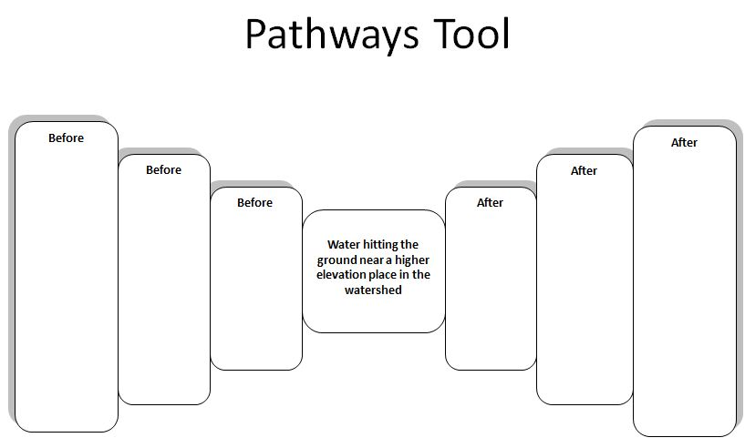
Simpler One Pathway Example:
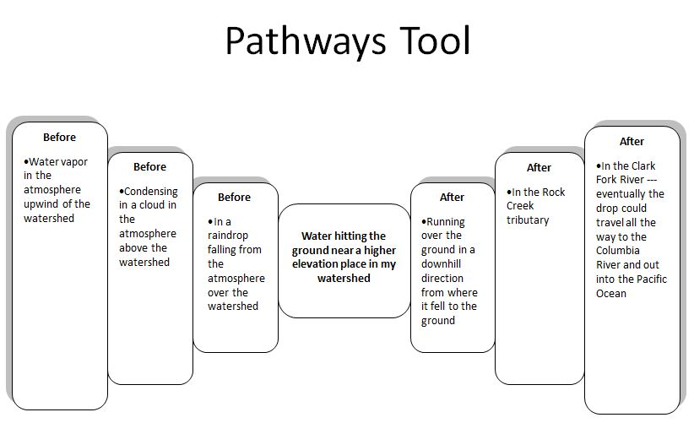

More Complex Multiple Pathways Example:
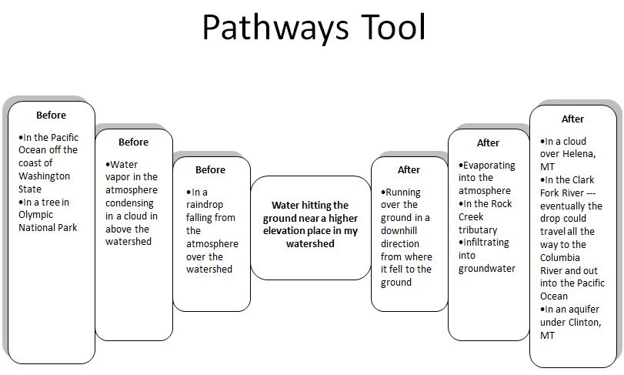
Drivers and Constraints Tools:
Not completed:
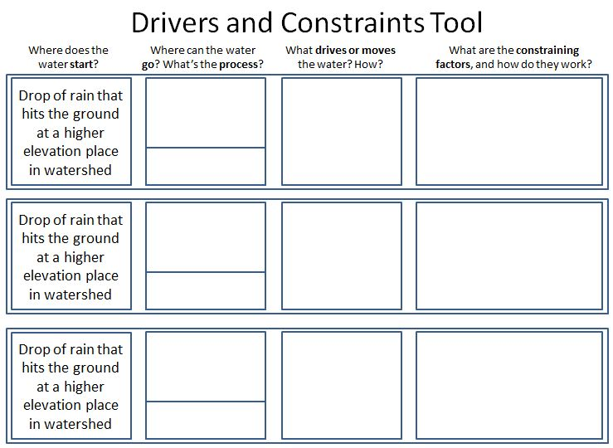

Example:
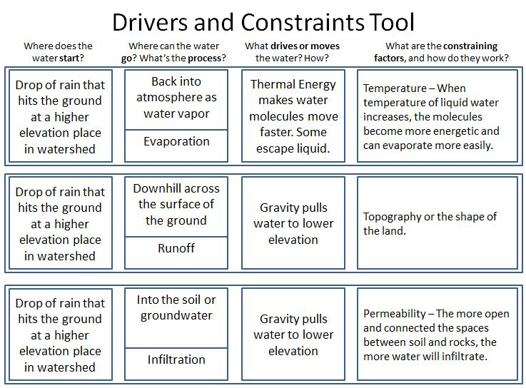

Using the Tools
Pathways Tool
Use the Pathways Tool to support students in considering the different pathways water can take into, through and out of a watershed.
Level 1: The Pathways Tool will help Level 1 students connect the immediate macroscopic world (e.g., a piece of river that you can stand next to and see) with the larger landscape of the surface water system. Help students work on a single possible pathway for water entering, traveling through, and exiting a watershed.
Level 2: The Pathways Tool can help Level 2 students consider that there are diverse pathways water can take from any one point. These students may focus on the most visible pathway of liquid water running over the surface in a watershed. Using the Pathways Tool, push Level 2 students to think about other pathways – such as evaporating into the atmosphere or infiltrating into the soil and groundwater system.
Level 3: Level 3 students consider different pathways, but may leave out less prominent paths, or add in improbable paths. Use the Pathways Tool to encourage Level 3 students to argue with each other about whether or not certain diverse pathways (e.g., from a lake into a river) are possible or not and why.
Drivers and Constraints Tool
Use the Drivers and Constraints Tool to support students in thinking about the driving forces and constraining factors at play as water moves into, through and out of a watershed.
Level 1: Level 1 students often focus on humans as the source of all actions. They may not consider that the natural world provides driving forces that do not require human intervention. Use the drivers and constraints tool, perhaps with just one row, to help Level 1 students focus on the central idea that liquid water runs down in a watershed because of gravity, and that the shape of the land influences what path the water will take, as gravity pulls water down slopes to lower places.
Level 2: Use the Drivers and Constraints Tool in conjunction with first hand experiences with the model to help Level 2 students think about important questions such as, “Can water move from a main river into a tributary? Why or why not? What is the driving force? What is the constraining factor?” or “Is running off the only place water can go in a watershed? What about into the ground? What would be the driving force that would move water into the ground? What would happen if the tarp were made out of a different material, such as a cotton tablecloth? Would the water all still run off? What would be different?”
Level 3: Level 3 students should be able to complete the Drivers and Constraints Tool with moderate amounts of support. After they fill it out, have them use the completed Tool to help them reason about some challenge questions related to the model. For example, you could ask, “Could water move from Point A to Point B (higher elevation) in the watershed? Why or why not?” Ask students to support their claims with evidence and reasoning related to the Drivers and Constraints Tool. What would be the driving force for water moving from A to B? What could constrain the movement of the water? Level 3 students can also benefit from being pushed to consider the relative likelihood of different pathways. Sometimes Level 3 students believe that all different pathways for water are equally as likely. These students can use ideas and reasoning about drivers and constraints to discuss and argue about the relative likelihood of different pathways.
Student Thinking – Watershed Model & Tracing a Watershed (Next activity)
How will students at each level respond to these activities?
 | What ideas and challenges in reasoning will they have? | What should instruction focus on?
Level 4 – Model-Based Accounts | - Students identify multiple pathways and driving forces and constraining variables for pathways.  - Students can successfully translate between a 3-D model and a 2-D map in both directions and can use this inference when identifying and drawing watershed boundaries. | - Supports similar to those for Level 3 students may also be beneficial for students performing at Level 4.
Level 3 – School Science Accounts | - Students recognize direction of water flow in a watershed, and may be able to create a map with arrows showing correct water flow direction. However, they may not consider driving forces and constraining variables without direction from the teacher.  - Students may be more successful in converting 3-D models to maps, but encounter challenges in creating 3-D models from maps.  - Students may successfully draw watershed boundaries without realizing the information about topography and elevation that is implied by these boundaries.  - Students may recognize multiple pathways, but may not consider which are more likely (students consider all to be equally likely). | - The Pathways Tool can be used to support students in considering the diverse pathways water may take.  - Use Drivers and Constraints Tool to help students to focus on the driving forces and constraining factors that govern movement of water in a watershed – applying these to the diverse pathways water may take. This Tool can also be used to help students consider the likelihood of water following different pathways.  - Ask students to describe the topography in various places on maps.  - As time allows, provide new examples of watershed maps to students and have them model the shape of the watershed in clay.
Level 2 – Force-Dynamic Accounts with Mechanisms | - Students recognize that water can flow to connected places, but may not distinguish between upstream and downstream movement when looking at a map of the watershed.  - Students may use rules such as “water moves from big water to little water.”  - Students may focus on just the most obvious pathway for water (over the surface).  - Students will see that water flows across the tarp and may find it challenging to consider that water in an actual watershed can also evaporate and/or infiltrate into the ground. | - Support students as they create their maps, helping them to think about why the arrows on the map showing water flow direction point the way they do. Help students think about how water flows down not just at the macroscopic scale, but also at the landscape scale, which can be inferred from a map.  - Use Pathways Tool and Drivers and Constraints Tool to help students consider multiple pathways water may take in a watershed and constraints such as topography on direction of flow. For example, use Driver and Constraints Tool to help students think about the question, “Can water move up tributaries to stream sources?”  - Help students recognize that in a real world watershed some water will evaporate and some will infiltrate into the ground. Show students that the tarp is waterproof and ask what would happen if we used a cotton tablecloth instead of a tarp?
Level 1 – Force Dynamic Accounts | - Students focus on the immediate and visible world and may find it challenging to connect the model to the idea of a large landscape. Consequently, students may have trouble representing their watershed model in a map. | - Help students consider how big a watershed is in comparison to a part of a river that you stand next to.  - Provide students with flat maps and relief maps of the same area for them to look at and compare. Help students see where water resides in the relief map and how that connects to the 2-D map representation.  - Instead of asking Level 1 students to make a map, provide a map for them and work with them to compare the map and the model to see the similarities.  - Consider creating both a 2-D and 3-D map (e.g., in clay or other modeling material) of the school campus or other nearby area with visible topography with Level 1 students to help them understand the connection between maps and models at an intermediate scale – not as large as an entire watershed.

