Water Formative Assessments & Tools for Reasoning Workshop –
Using the Learning Progression to Support Student Understanding of Maps and Surface Water
Professional Development Workshop presented to teachers

Written by: , Alan Berkowitz¹, Brad Blank², Aubrey Cano³, Bess Caplan¹, Beth Covitt⁴, Katherine Emery³, Kristin Gunckel⁵, LaTisha Hammond⁶, Bill Hoyt⁷, Nicole LaDue⁸, John Moore², Tamara Newcomer¹, Tom Noel², Lisa Pitot², Jen Schuttlefield⁹, Sara Syswerda⁸, Dave Swartz², Ray Tschillard¹⁰, Andrew Warnock and Ali Whitmer⁶. (Cary Institute¹, Colorado State Univ. ², U.C. Santa Barbara³, Univ. Montana⁴, Univ. of Arizona⁵, Georgetown Univ.⁶, Univ. Northern Colorado ⁷, Michigan State Univ.⁸, Univ. Wisconsin⁹, Poudre Learning Center¹⁰ )
Culturally relevant ecology, learning progressions and environmental literacy Long Term Ecological Research Math Science Partnership
December 2012
Disclaimer: This research is supported by a grant from the National Science Foundation: Targeted Partnership: Culturally relevant ecology, learning progressions and environmental literacy (NSF-0832173). Any opinions, findings, and conclusions or recommendations expressed in this material are those of the author(s) and do not necessarily reflect the views of the National Science Foundation.


Water Formative Assessments & Tools for Reasoning Workshop –
Using the Learning Progression to Support Student Understanding of Maps and Surface Water
Table of Contents
Workshop Goals 1
Notes for Facilitators 2
Agenda 3
Supporting Materials 4
Activity 1 5
School Map Formative Assessment 5
Activity 2 6
The Upper Anchor for Surface Water 6
One Page Learning Progression Framework Table 7
Activity 3 8
Example Student Responses to Schoolyard Map FA (Initial Handout Version) 8
Example Student Responses to Schoolyard Map FA (Example Answer Key) 10
Activity 4 15
Pathways Tool 15
Drivers and Constraints Tool 16
Activity 5 17
TE Exploration #1.1 (Mapping Proportions of Surface Areas) and Exploration #1.2 (Runoff) 17
Student Thinking Table 31
Activity Description Table 32

Workshop Goals
Explore how learning progression-based formative assessments and tools for reasoning can help teachers:
- Elicit and interpret students’ ideas
- Consider how students at different learning progression levels are likely to understand and respond to lessons and activities
- Refine lessons and activities to be sensitive to the particular informal ideas that students may hold (as shown by formative assessments)
- Refine lessons and activities to help students reach higher levels of achievement on the learning progression (including through integration of tools for reasoning)

Notes for Facilitators
Here are a few suggestions and things to keep in mind for PD facilitators:
- Consider modeling the workshop goals (practices) described above with teachers throughout your summer PD with the teachers. For example, let the teachers know that you have reviewed their spring tests and used their responses to refine the professional development activities.
- The Student Thinking Table and Activity Description Table are both included at the end of the Water Teacher Experiment Teacher Guide. Please encourage your teachers that, while they are teaching the unit with their students, they can use these tables to help them plan for enacting the activities in ways that best meet the needs of their own students based on where the students are with respect to the learning progression.
- You can also let the teachers know that the formative assessments) including student sheets and teacher materials for evaluating students’ responses) have been integrated into the Teaching Experiment Teacher Guide. Please encourage the teachers to use these formative assessments to help elicit and respond to their students’ ideas in their water-related instruction.
- Similarly, please let the teachers know that two Tools for Reasoning including the Pathways Tool and the Drivers and Constraints Tool have also been integrated into the teaching experiment. These tools, which teachers will be introduced to in this PD activity, are designed to be used in social contexts (e.g., small groups and whole group discussions and scientific arguments) to support students in developing deeper conceptual understanding of water systems. The tools address particular challenges in water systems reasoning that we have discovered in our research with students. For example, the Pathways Tool helps students consider multiple pathways for water moving through systems, and to think about whether different pathways are reasonable/likely. The Drivers and Constraints Tool helps students think and learn about what forces move water through connected systems, and what factors may constrain where/how/how fast water will move.
- Consider conducting Activity 5 in the agenda below after teachers engage in the TE experiments.
- If possible, sites could take a little more time to do this than two hours to do this activity, perhaps through interweaving with engaging the teachers in aspects of the Water Teaching Experiment.
- It will be important for facilitators to make connections back to this activity throughout the workshop --- so that it’s not a stand alone activity that teachers do not see as connected to their teaching of the Water TE.

Agenda
Act. | Title | Time | Description | Materials
1 | FA’s | 10 min | Teachers answer the school map formative assessment. | - School map FA
2 | WS Big Ideas | 15 min | Handout the sheet describing surface water upper anchor and have teachers read and discuss. Also handout one page table of water learning progression framework and make sure discussion considers how the big ideas reflect level four reasoning. | - Surface Water Upper Anchor Handout  - One-page Water LP Table
3 | Student Thinking about WS’s | 40 min | Begin by asking teachers how they think their students would answer the school map formative assessment. Teachers can then look at the one page learning progression table to provide initial estimates of what levels of reasoning the different ideas they have identified represent.  Handout example student and teacher responses to the school map formative assessment and learning progression rubrics for evaluating responses. Teachers should work in small groups to estimate levels of achievement for the different responses.  Then, in small groups, teachers can discuss what strengths and challenges students who give different responses are likely to have. Teachers can use the one page learning progression table and the watershed big ideas handout to help them think about this. Groups can share out examples of how they rated some of the responses including observations about strengths and challenges students who gave those responses would have. | - White Board & Markers  - Example Student Responses to School Map FA  - Rubric for Evaluating School Map FA Responses
4 | Intro to Tools | 15 min | Show and discuss the Pathways Tool and Drivers and Constraints Tool. We have a PowerPoint that introduces these, provides examples of filled in tools for different activities/contexts, and discusses some of the affordances they can provide in supporting students in moving to higher levels of achievement. | - Handouts of Pathways Tool  - Handouts of Drivers and Constraints Tool  - PowerPoint Introducing the Tools
5 | School Map Refinement  Activity | 30 min | Split the teachers into 4 groups (could have more than one group for each of these):  - Schoolyard Map Activity and Runoff Exploration Level 2  - Schoolyard Map Activity and Runoff Exploration Level 3  - Testing Fundamental Processes: Runoff Level 2  - Testing Fundamental Processes: Runoff Level 3  Each group should take their assigned TE activity and refine it for students who may have responded to the formative assessment at either Level 2 or 3. Working on the activities will include:  - Read through the activities as written.  - Fill in a tool (Pathways for Map Activity or Drivers and Constraints for Runoff Activity) twice. One tool should show how a student at Level 2 or 3 might fill in the tool before engaging in the activity. The second completed tool should show what a goal completion of the tool for the students would be at the end of the activity.  - Consider how Level 2 or 3 students would respond to the activity as written and use the Student Reasoning Table to identify what strengths those students would bring and what challenges they might encounter while engaging in the activity.  - Discuss and record how the activity could be refined to help students at either Level 2 or 3 develop more sophisticated understanding. Fill in the Blank Activity Description Table to outline what the refined activity will look like and how it will support student learning. | - Schoolyard Map Activity Description from TE  - Runoff Activity Description from TE  - Materials for each of the activities for teachers to interact with (optional)  - Student Reasoning Table  - Blank Activity Description Table
6 | Sharing Out | 10 min | Each group takes five minutes to share out their activities, describing how students at their group’s level of reasoning would respond to the activities, how they will refine the activities to be sensitive to students’ ideas and to scaffold more sophisticated understanding, and how they will integrate the Pathways Tool and Drivers and Constraints Tool into the lesson to support student learning.

Supporting Materials
Note: Some materials are introduced in one activity and then also used in subsequent activities.

Activity 1

School Map Formative Assessment
Below is a map of a school campus.
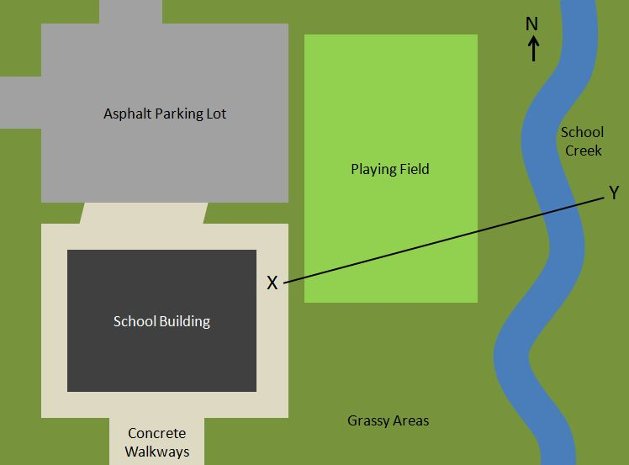

1. If you were looking from the side instead of from above, what would the shape (height) of the land be like across the distance from Point X to Point Y? (Circle the answer you think is the best.)
A | 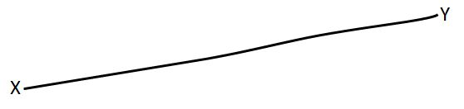 | D | 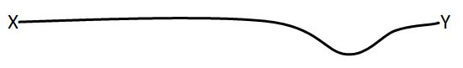
B | 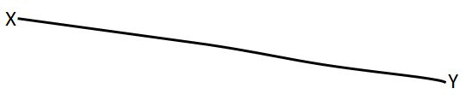 | E
C | 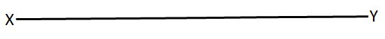 | F | There’s no way to know.

Explain your reasons for your answer.
____________________________________________________________________________________________________________________________________________________________________________________

2. Circle which direction you think School Creek is flowing: North South You can’t tell from the map

Explain how you know.
____________________________________________________________________________________________________________________________________________________________________________________

Activity 2

The Upper Anchor for Surface Water
Structure of Surface Water Systems: Surface water systems are connected to the atmospheric water system and the groundwater system. Water can exist on the surface in liquid and frozen states.
- Macroscopic Scale: Water that falls on the land either runs off over the surface watershed, infiltrates into the groundwater system, or evaporates into the atmosphere. Water running off across land, as well as water in lakes, ponds, river, streams, creeks and oceans are all part of the surface water system.
- Large (Landscape) Scale: A watershed is an area of land where all of the surface water that drains off goes to the same place, often a body of water such as a river, lake, or ocean. The high point between two watersheds is the watershed boundary or a water divide. The watershed boundary does not necessarily have to be a noticeable ridgeline. In relatively flat landscapes, a watershed boundary could be a very slight rise in the land not noticeable to the eye. Watersheds can be nested within one another. For example, tributary watersheds are nested within larger river watersheds. Tributary parts of watersheds are higher in elevation than the downstream sections of the larger river watershed systems they belong to.

Processes: Water moves in and out of as well as through the surface water system. Water in the surface water system can also change state. These processes can be described at different scales.
- Macroscopic Scale: Water enters the surface water system from the atmosphere through condensation and precipitation. Water also enters the surface water system through discharge from the groundwater into springs, marshes, streams, rivers, lakes, ponds, etc. Water moves downhill within the surface water system due to the driving force of gravity.
- Large Scale: The force of gravity pulls water down from the highest elevations to the lowest elevations within a watershed. The rate and volume of runoff (discharge) in a watershed is affected by constraining factors such as climate and precipitation volumes and rates, snowmelt volumes and rates, amount and type of vegetation, slope and permeability of the surface (soil, rock, asphalt, etc.). Topography (shape of the land) is a constraining factor related to the direction of flow of water in the surface water system.

Energy in Watersheds: Water within a watershed moves from the areas of higher potential energy to lower potential energy. Energy is required to move water uphill.

Change Over Time: Watersheds and surface features of the Earth change naturally over time. Water erodes Earth materials from one location and transports and deposits them in other locations. Natural changes in weather and climate can also affect the rate and volume of runoff and infiltration as well as the water quality within a watershed. Human activities (e.g., building or removing dams, paving surfaces, changing the composition of the atmosphere) can also change the rate and volume of runoff, volume of infiltration in into the groundwater system, and quality of water within a watershed.

One Page Learning Progression Framework Table
Characteristics of accounts at each level of achievement
 | Progress Variable
Level of Achievement | Structures & systems | Scale | Scientific principles | Representations | Dependency & human agency
Level 4  Qualitative model-based accounts | Provide multiple, detailed, accurate pathways through environmental systems  Account for chemical nature of substances during mixing and moving | Atomic-molecular through large landscape | Include driving forces (e.g., gravity, pressure)  Include constraining factors (e.g., permeability, topography) | Interpret constraining factors inferred from representations | Identify limitations to human agency or dependence on environmental systems
Level 3  Incomplete school science accounts | Provide multiple pathways through hidden and invisible connections, including human-engineered systems in moderate detail  Identify different types of substances in water | Microscopic to landscape scale  May refer to smaller particles such as atoms or molecules | Put events in order  No driving forces or constraining factors included | Connect representations to three-dimensional physical world  Do not infer driving forces or constraining variables | Include human systems as part of environmental systems  Do not recognize limitations of either human agency or environmental systems
Level 2  Force-dynamic accounts with mechanisms | Identify familiar and visible connections, including general connections to human systems  Water quality is referred to as a function of “good” and “bad” stuff | Broader macroscopic to large-scale focus across familiar and visible dimensions | Identify mechanism  Rely on actors or agents  Fit particular circumstances | Include limited (e.g., 2 dimensional) connections from representations to the physical world | Portray human systems as operating separately from natural systems but human systems can be impacted by natural systems
Level 1  Force-dynamic accounts | Water is represented only in isolated, visible locations  Water quality is referred to as a function of types of water | Limited to macroscopic and immediately visible structures or phenomena | Focus on human structures, actions or needs  No mechanisms for phenomena included | No connections from representations to the physical world | Portray humans as sources and movers of water  Portray water as serving human needs

Activity 3

Example Student Responses to Schoolyard Map FA (Initial Handout Version)
 | If you were looking from side instead of above, what would shape of land be like? | Which direction is School Creek flowing? | Code | Notes
1 | F. We don’t know what the ground is like with this diagram. | You can’t tell. The map doesn’t show the way the current is flowing.
2 | D. The school creek would be contained at a lower elevation than the surrounding areas. As far as the rest of the cross-section, there is no further evidence of elevation change. | You can’t tell. The map gives no contour lines or elevation markers that would show an elevation slope. Water runs downhill and I do not see any evidence of direction or slope.
3 | D. Well, I think that it stays the same, and then it gets to the creek so it dips then goes back to normal. | You can’t tell. Well, I can’t see any way that the water is moving North or South.
4 | A. I looked at the pitcher above and it gave you a line and I looked at the answers and overlayed it. | N. North because it showed an arrow with an N on it so I think that meant North.
5 | D. I think D because it has a dip where the creek would be. | You can’t tell from the map because it is an over hed view.
6 | A. Because if you look at it sideways it is straight but it curves up a little. | S. Because North is up and South is down.
7 | D. The “dry” land would have to be at an elevation greater than the creek in order for the water not to spread out uniformly. | You can’t tell. Depends on North to South elevation change and no information about this is given.
8 | F. From above it looks flat. | You can’t tell. On the map it can’t tell.
9 | D. Because the river needs to be lower than the school or the H2O would flow into school. Middle flat due to playing field. | You can’t tell. There is no elevation or other visuals to give you a hint of “down hill.” Gravity flow is down hill.
10 | C. If seen on the same level it would just look like it’s directly across. | S. From my basic understanding of how water flows.
11 | D. So when you walk from the school across this field its flat but when you get to the creek it sinks into the ground. | You can’t tell. The picture doesn’t show if it is running of a mountain or hill in the north or south.
12 | F. I think the stream could be flowing either way. So there is no way to tell where it is flowing so you don’t know if it is on a hill or not. | You can’t tell. It could be flowing either way.

Example Student Responses to Schoolyard Map FA (Example Answer Key)
 | If you were looking from side instead of above, what would shape of land be like? | Which direction is School Creek flowing? | Code | Notes
1 | F. We don’t know what the ground is like with this diagram. | You can’t tell. The map doesn’t show the way the current is flowing. | 2 | Understands that the map represents the land, but doesn’t know how.
2 | D. The school creek would be contained at a lower elevation than the surrounding areas. As far as the rest of the cross-section, there is no further evidence of elevation change. | You can’t tell. The map gives no contour lines or elevation markers that would show an elevation slope. Water runs downhill and I do not see any evidence of direction or slope. | 4 | Includes constraining factors (elevation inferred from position of creek/surrounding areas) to interpret shape of land. Recognizes lack of relevant (e.g., topo lines, elevation markers) for direction of flow.
3 | D. Well, I think that it stays the same, and then it gets to the creek so it dips then goes back to normal. | You can’t tell. Well, I can’t see any way that the water is moving North or South. | 3 | Connects 3-D representation to real world, but doesn’t provide explanation of how/why (e.g., no description of elevation or gravity).
4 | A. I looked at the pitcher above and it gave you a line and I looked at the answers and overlayed it. | N. North because it showed an arrow with an N on it so I think that meant North. | 1 or 2 | First response looks like student may not be viewing map as a representation of a place at all (just looking at the lines). Second response suggests improper application of compass rose to suggest flow.
5 | D. I think D because it has a dip where the creek would be. | You can’t tell from the map because it is an over hed view. | 3 | Responses suggest student is interpreting map but the response does not provide any explanation of how or why (e.g., driving force of gravity or constraining factor of elevation or topography).
6 | A. Because if you look at it sideways it is straight but it curves up a little. | S. Because North is up and South is down. | 1 | Looking at map as literal rather than representation of a landscape. Just focuses on line. Indicates all rivers run South (somewhat common level one idea).
7 | D. The “dry” land would have to be at an elevation greater than the creek in order for the water not to spread out uniformly. | You can’t tell. Depends on North to South elevation change and no information about this is given. | 4 | Uses constraining factor (elevation) to interpret the map.
8 | F. From above it looks flat. | You can’t tell. On the map it can’t tell. | 1 or 2 | Response appears to interpret map as literal rather than as representation (just looking at the line). Student may realize map is a representation, but does not have any sense of how to interpret a landscape from map.
9 | D. Because the river needs to be lower than the school or the H2O would flow into school. Middle flat due to playing field. | You can’t tell. There is no elevation or other visuals to give you a hint of “down hill.” Gravity flow is down hill. | 4 | Uses both driving force of gravity and constraining factor of elevation to interpret the map and direction of water flow.
10 | C. If seen on the same level it would just look like it’s directly across. | S. From my basic understanding of how water flows. | 2 | Naive understanding of how map represents landscape. Believes rivers just flow south.
11 | D. So when you walk from the school across this field its flat but when you get to the creek it sinks into the ground. | You can’t tell. The picture doesn’t show if it is running of a mountain or hill in the north or south. | 3 | Doesn’t explicitly mention elevation but does describe topography. Thinks you need a hill or mountain for water to run down (rather than possible shallow slope). Might be a 3.5 or almost a 4.
12 | F. I think the stream could be flowing either way. So there is no way to tell where it is flowing so you don’t know if it is on a hill or not. | You can’t tell. It could be flowing either way. | 2 | May realize map is a representation, but does not have a sense of how to interpret a landscape from map showing a river.

Teacher Information and Rubric for Schoolyard Map FA
Purpose
To understand depictions of watersheds on maps, students need to be able to translate back and forth between 3-dimensional landscapes and 2-dimensional maps. To do so, students should understand how maps (even maps that do not show topo lines) can include information about topography. Because surface water flows down due to the force of gravity, locations marked as water on a map will be at a lower elevation compared with areas of land next to the water. Some maps showing moving water also provide clues about direction of water flow, but that is not the case for the map in this assessment. Through using this formative assessment, you will be able to probe your students’ levels of spatial reasoning in translating between 2-dimensional maps and 3-dimensional landscapes. Once you identify challenges students are having with map reading and spatial reasoning skills, you will be able to provide focused guidance aimed at helping students to 1) create maps that provide accurate information about 3-dimensional landscapes in 2-dimensions, 2) make inferences about landscape topography from 2-dimensional maps, and 3) use their understanding of the driving force of gravity and the constraining factor of topography to make inferences about direction of water flow using maps.

Target Understanding (Upper Anchor)
Students who provide level 4 answers are making inferences connecting 2-dimensional maps to 3-dimensional landscapes. Maps that do not include topographic lines can still provide information about topography. In order to understand maps in this sophisticated way, students need to use understanding of runoff processes. Because the driving force of gravity moves surface water to places of lower elevation, a river will be lower in elevation than the land to either side of the river.

Also on many maps, it is possible to make inferences about which direction water is flowing in a river based on clues such as the angle at which a tributary meets a river, and the relative location of an ocean or a lake that a river flows into. (Note that there are some circumstances in which a lake can flow into a river – such as a reservoir behind a dam and/or a mountain tarn formed by a glacier). On the school campus map in this assessment, there are no clues provided that would enable someone to figure out the direction of flow of School Creek.

Students providing upper anchor (level 4) responses to the probe show some understanding of driving forces (gravity) and constraining factors (e.g., topography). Example responses could look like:
1. D
Playing fields are usually pretty level and in option D, the profile of the land starts out pretty level from point X. Then, I know that a creek has to be lower than the land around the creek because water flows down due to gravity. In option D, the profile of the land dips down then goes back up as you move toward point Y.

2. You can’t tell from the map
There’s no river or other body of water that the creek is flowing into to provide a clue about the direction the water is flowing. I can’t tell if the elevation is higher toward the north part or toward the south part of the school campus, so I can’t tell if the creek is flowing toward the north or toward the south.

Suggestions for Administration
This assessment is designed so that you can give the prompt to students before you begin lessons addressing watersheds. You can provide a copy of the prompt for each student to write on and turn in to you at the end of the class period, or you can project the prompt with an LCD projector, overhead projector, or Smartboard and have students write their answers in their science notebooks.
Connecting Student Responses to the Learning Progression Framework
The following table shows example responses you might expect to see from students responding at different levels on the learning progression. Note that students’ explanations tend to be more important than the response options they pick for assigning a level of reasoning.
Level | If you were looking from side instead of above, what would the shape (height) of the land be like across the distance from Point X to Point Y? | Circle which direction you think School Creek is flowing | Level Response Descriptions
1 | C. () The map is flat.  OR  F. Can’t tell. | South. Rivers and creeks always go South.  OR  The water runs down the page. | Responses do not connect 2-D map with a 3-D landscape. Level 1 responses are very literal, focusing on what’s drawn on the flat piece of paper. Alternatively, responses may say you can’t tell about shape of land, without explaining why they think this is the case.
2 | A. () The line slants up from point X to point Y like line does on map. Land must go up like the line goes up. OR  E. () The land is bumpy near the creek. OR  F. (There’s no way to know) The map doesn’t show the shape of the land. | North. I can tell because the compass is pointing North. | Responses begin to connect maps to landscapes. However, level 2 responses have trouble connecting details of a map representation to a 3-D landscape. While they realize the map is a representation of a place, level 2 students may just describe what they see on map without understanding implicit connection to things like topography in landscape.
3 | B. () The land goes down to the creek. OR  D. () The creek is lower. | You can’t tell from the map  The map doesn’t show which way the creek is going. | Responses show understanding that map is a representation of a 3-dimensional landscape and make some inferences about the landscape by looking at the map. However, level 3 students generally do not use drivers and constraining factors to explain what is happening. Thus, they sometimes make mistakes in their interpretations and inferences.
4 | D. () Playing fields are usually pretty level and in D, the land starts out level from X. A creek has to be lower than the land around it because water flows down. In option D, the land dips down where the creek is. | You can’t tell from the map  Sometimes you can tell direction of water from a map, but not here. There are no tributaries, topo lines, or other clues to suggest elevation and direction. | See target understanding description on previous pages.

Suggestions for Instruction for Students Performing at Different Levels
Level 1: Force Dynamic Accounts Suggestions
You can help students who give level 1 responses begin to see the connection between 2-D map representations and 3-D landscapes. If you have a creek, river or pond close to your school, print out a map of the area (e.g., using map view on Google Maps) and bring students to the area near the water. Show students the map and ask them to compare the height of the land around the water to the height of the land in and under the water. What do they notice? Ask students why the land will always be lower where there’s water? Ask students to describe what a map can tell you about the shape of the land? If you don’t have any water near your school, you might try building a model watershed with your students. One such activity can be found at http://www.in.gov/dnr/nrec/files/Tarp_Activity.pdf (note that you might skip the pollution aspect of this activity, and focus on the aspects that address watershed structure and function). After you build and model water movement in the watershed, ask your students to draw a map of the watershed showing where rivers and ponds or lakes are found in their model watershed. The same questions from the first suggested activity can be asked during a watershed modeling activity.

Level 2: Force-Dynamic Reasoning with Mechanisms Suggestions
Level 2 responses demonstrate understanding that a map is a representation of a landscape. However, students who provide level 2 responses have limited understanding of how the map implicitly represents aspects of the landscape. Similar activities as those described for level 1 can also be useful for students who respond at level 2. These activities will help students develop spatial reasoning connecting maps with 3-D landscapes.

Level 3: School Science Stories Suggestions
Level 3 students do a pretty good job using spatial reasoning to make sense of maps. You can provide them with activities that will help them focus on driving forces and constraining factors that determine which way surface water flows, and the clues to direction of surface water flow that are evident on some maps. So, for example, you might provide students with maps showing tributaries entering a river and/or a river entering a lake the students are familiar with (e.g., one of the Great Lakes). Ask students to describe which way water is flowing in the tributary and the river, and to explain how they know. Encourage students to describe what force moves surface water (i.e., gravity), what factors constrain the direction of surface water flow (i.e., topography), and what you can tell about these things by looking at a map. Level 3 students could also benefit from learning about topographic maps, which provide specific information about topography that can be used to understand and predict where water will flow across the surface of a landscape. One USGS lesson for helping students learn to read and understand topographic maps is available at http://egsc.usgs.gov/isb/pubs/teach-pack/mapshow/. National Geographic also has an online lesson posted in which students make a clay model of a mountain, then translate their model into a topographic map. This lesson plan is available at http://www.nationalgeographic.com/xpeditions/lessons/01/g68/dogstails.html. If you use topographic map lessons with your students, you can ask students to compare and contrast what information about surface water can be determined by looking at a topographic map versus a map without topo lines. If you do not want to work with topo maps with your students, another option is too obtain plastic relief maps of your area. These 3-D maps can be compared with 2-D maps of the same area. By providing the two types of maps together, you can prompt your students to compare the representations of rivers on both maps and look for patterns in things like how tributaries tend to connect to main stems of rivers, and whether rivers tend to flow into lakes and oceans or vice versa. Having relief maps handy while also looking at 2-D maps can help students to consider the driving force of gravity and the constraining factor of topography because the 3-D nature of relief maps makes the effects of gravity and topography more explicit. You can even have students pour water onto a relief map and see what happens!

Activity 4

Pathways Tool
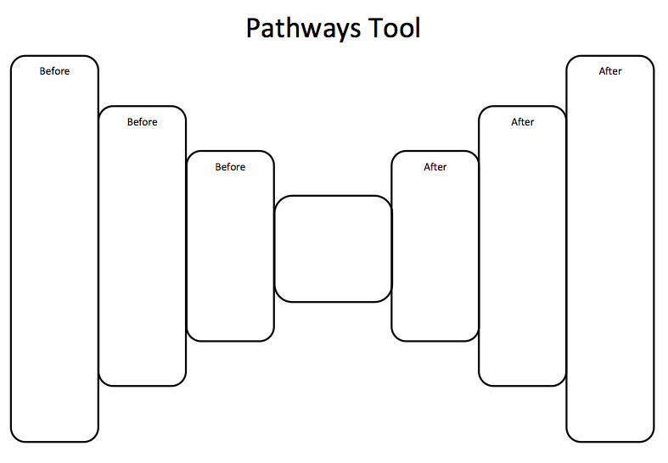

Drivers and Constraints Tool
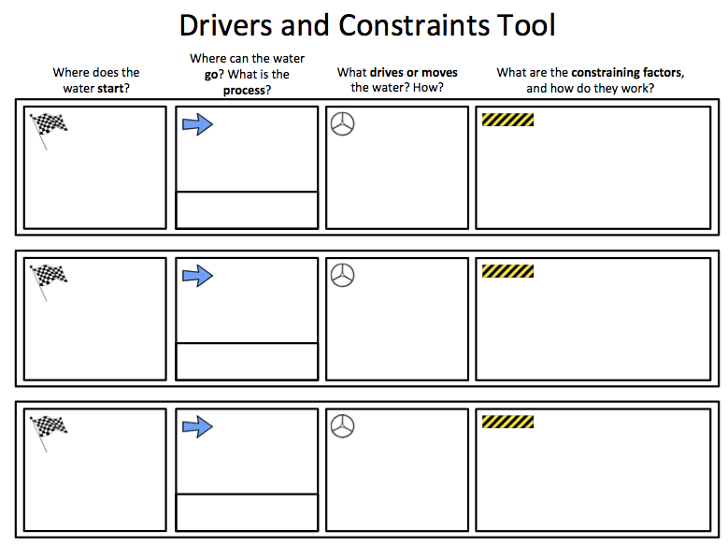

Activity 5

TE Exploration #1.1 (Mapping Proportions of Surface Areas) and Exploration #1.2 (Runoff)

Explorations 1.1 and 1.2 both involve mapping the school grounds and can be completed simultaneously, however if students are in need of extra scaffolding, these activities could be completed separately.

Exploration #1.1: Determining Proportions of Different Surface Types
Precipitation that falls on your school’s property goes somewhere. The type of surface a raindrop falls on makes a big difference as to where that drop will go. The drop could infiltrate, runoff, evaporate, or transpire. To help us answer our research question, we need to estimate the proportions of the major types of surfaces on our schoolyard including vegetation and built environmental features.

Targeted Understanding 1:
Gravity and topography drive and constrain water pathways.

Steps
- Administer Map Formative Assessment.
- Have students work in groups to complete pathways tool and discuss. You will be revisiting student responses after the explorations.
- Brainstorm all of the different types of surfaces present on your school grounds.
- Lump similar surfaces together if they come up with more than ~6 different types.
- Measure the area of each surface type.

Quantitative Teaching Strategies: Students struggle with finding the areas of irregularly shaped figures and your schoolyard is bound to have an irregular shape. For example, below is a Google Earth picture of the Laramie High School schoolyard.

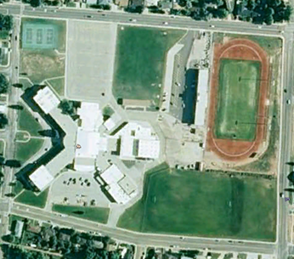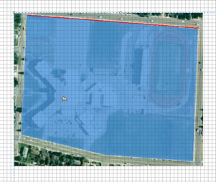

- Option 1: Have students place a clear grid overlay (page 25) on the picture of the school and count the number of grid squares inside the schoolyard boudaries to estimate the area. Note that it does not matter if the unit is in scale with the picture since we are finding a ratio, which is unit-less.

- Option 2: Measure the sides of the school using the Google Earth ruler or have students physically measure the sides with a tape measure. In the image above, Google Earth ruler gives an approximate measurement as north side 381.5 meters, east side 298.2 meters, west side 271.1 meters, southwest side 192.6 meters, and southeast side 195.5 meters. Have multiple students or groups take measurements to illustrate user variability. Here is an opportunity to discuss precision and accuracy: Accuracy (how close the measure is to the actual measure) and precision (how refined the measure is – would it differ if we used centimeters?) can be used to discuss where error in measurement comes from. Students can calculate an average area using the various measurements from each student or group.

Quantitative Teaching Strategies; Proportions and proportional reasoning: Proportions and proportional reasoning are difficult for many students.

- Using the grid overlay, now ask students to estimate the amount of each surface type in terms of a ratio of part- to-whole (proportional reasoning). A ratio is a comparison of two quantities with like units. Ratios can compare part-to-part (area of roof to area of concrete) or part-to-whole (area of roof to whole area). Have students use the clear grid to estimate the area of roof on the picture of the school yard. Note that it does not matter if the unit is in scale with the picture since we are finding a ratio, which is unitless.
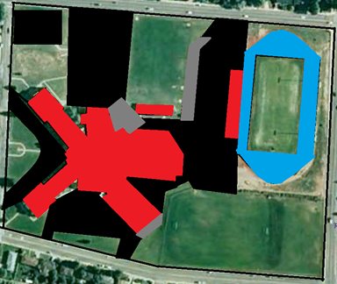

- For our picture of the schoolyard we had approximately 207 cm² for the entire schoolyard. The results for each surface type are as follows: 56 cm² black-asphalt, 29 cm² red-roof, 5 cm² gray-cement, 14 cm² blue-track. The grass is the oddest shape and the hardest to estimate so don’t count it directly, subtract your other estimates from the total to get an estimate for grass: 207-56-29-5-14 = 103 cm² of grass.
- Now calculate the ratios of each surface type as surface type area/total area:

Surface area in square cm ratio of surface area/total area % of total area
--------------------------------------------------------------------------------------------------------------------
asphalt 56 56/207 27.1%
concrete 5 5/207 2.4%
grass 103 103/207 49.8%
roof 29 29/207 14.0%
track surface 14 14/207 6.8%
---------------------------------------------------------------------------------------------------------------------
Sum 207 207/207 101.1%

Note that this gives us 101.1% total, have the students discuss the role of rounding and estimation in the above calculations and explain why they should not be surprised if the amount is a bit more or less than 100%.

Note: While you can determine the proportions of surface types in the school yard with a map and grid, always take your students outside and have them ground truth their maps.

- Have each team make a pie chart showing the proportions of the different surface types and then combine onto a single pie chart for the class.

Examples of student work
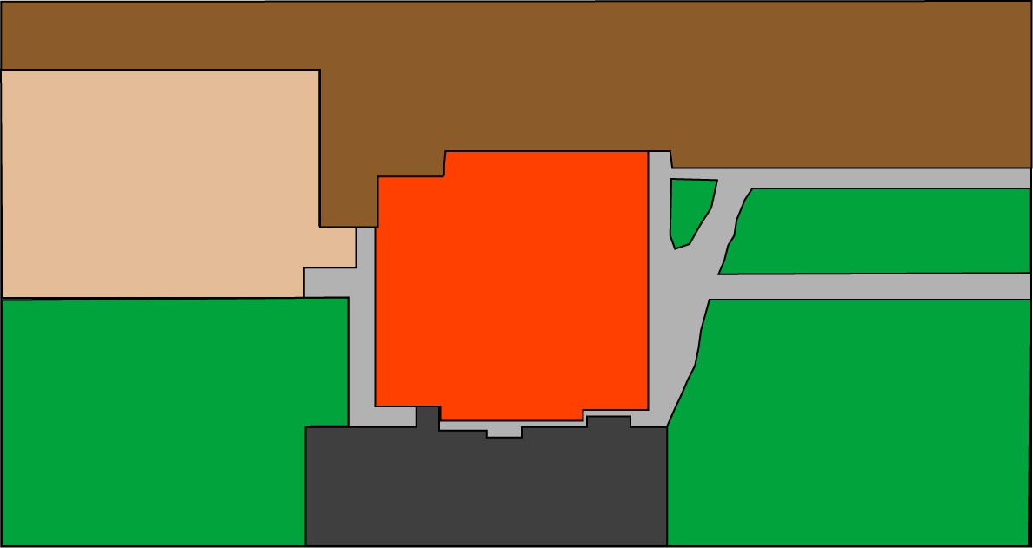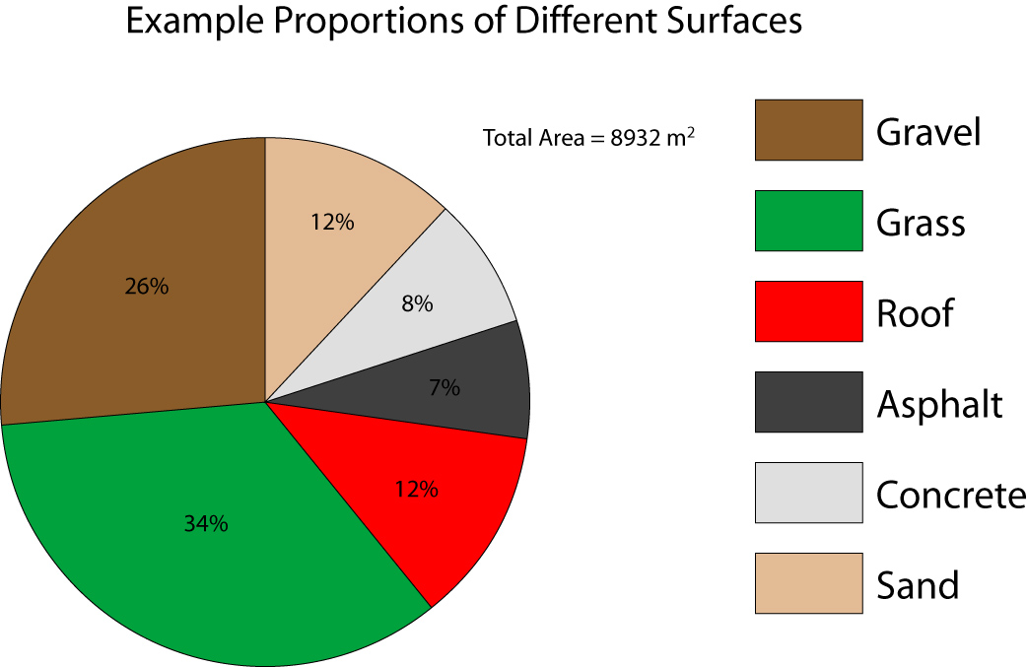

Discussion Prompts
- How does the present land cover compare to what was here before civilization?
- If you could change your school grounds, what would you do?
How does your school’s land cover compare to the land cover of other schools in your community?

Grid Overlay for Schoolyard Mapping Activity - Photocopy this grid onto a transparency

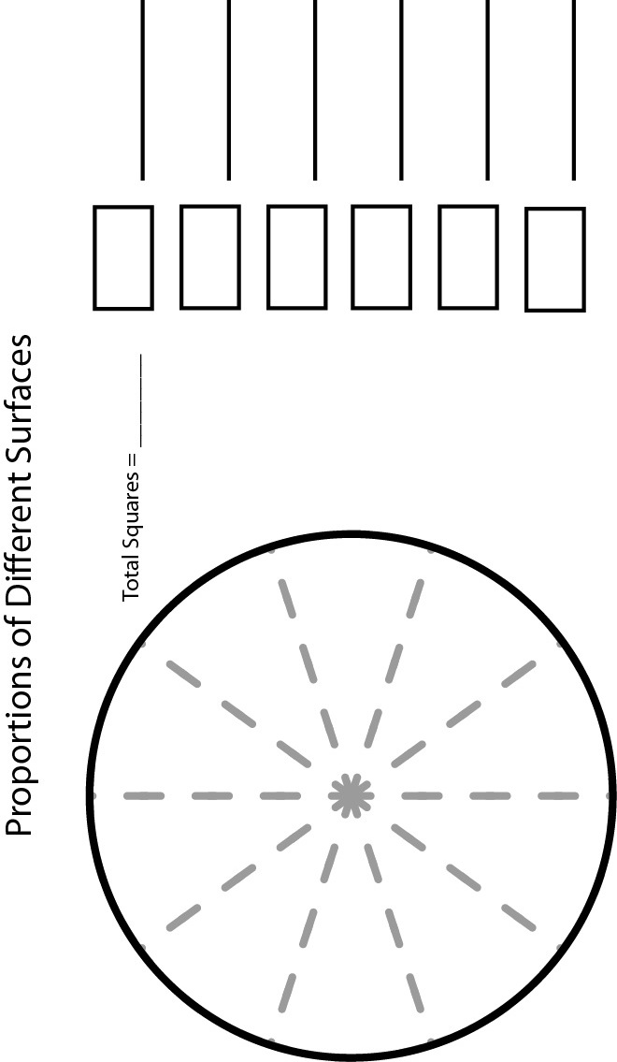

Exploration #1.2: Testing Fundamental Processes: Runoff

Topography and surface type are the key factors that control runoff. Many urban areas have been engineered to some degree to help control runoff of water from storms. For example the ground surrounding most buildings slopes very gradually toward the street to prevent basement flooding. Have students make predictions of runoff directions based on slope of the schoolyard.

Targeted Understanding 2:
Gravity drives water downward and topography constrains its direction.

Steps
1. Administer Runoff Formative Assessment.
2. Have students work in groups to complete the drivers and constraints tool and discuss.
3. Construct inclinometers by gluing the inclinometer page to a stiff piece of cardboard and placing it in a sheet protector. Tie a string to a ¾” washer and poke the other end through the cardboard at the arrow. The washer should hang down far enough to reach the protractor scale.
4. Teams of students will use the inclinometer to measure the slope of the surfaces they mapped in exploration 1.1. They can record angles on their map using the inclinometer. They will then use colored pencils to annotate their map showing where water should go based on topography. Have them locate gutter downspouts, stairways, mounds, drain grates, depressions, etc.
5. You could use buckets of water to verify predictions.

Examples of student work
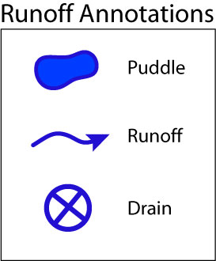
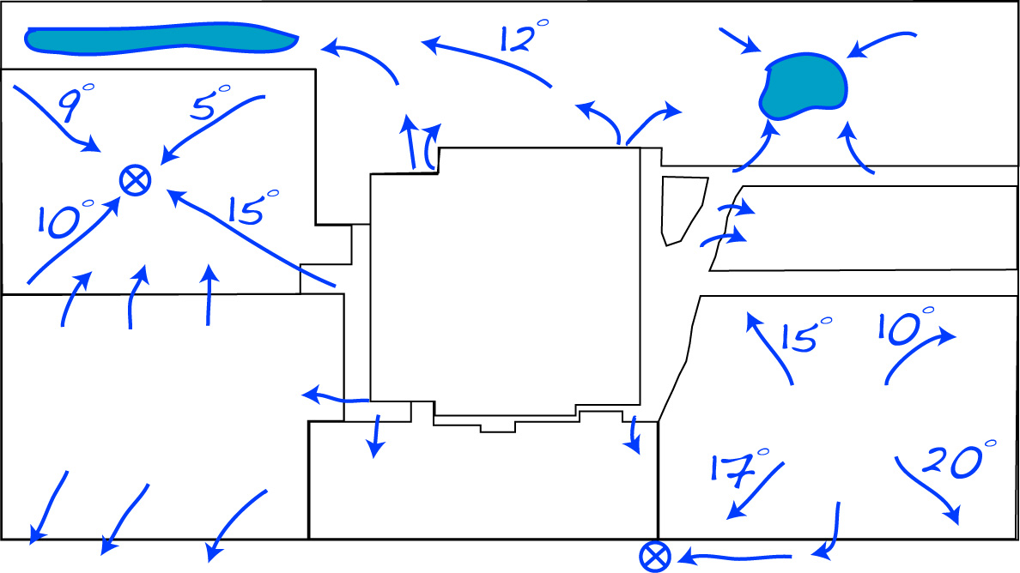

Discussion Prompts
- Where is the rate of runoff the fastest and why?
- Where does the water that runs off go?
- Why do puddles form in some areas and not in other areas?

Runoff Formative Assessment

River Cleanup

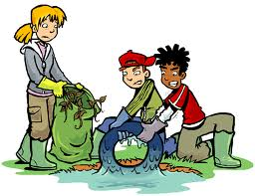

Alberto, Brenda, Cheng, Deja, and Elan were volunteering for the annual river clean-up in their town. They were finding lots of plastic water bottles, tires, shoes, and other garbage in the river. As Elan put yet another plastic water bottle in their trash bag, he asked, “If we didn’t pick this bottle out of the river, where do you think it would go?” Everyone had an idea.

Alberto: Maybe the bottles follow the water from this river to a smaller river.
Brenda: I think the bottles float downstream.
Cheng: I think the bottles float away.
Elan: Well, the bottles could go to the town of Pueblo Rio. The river in Pueblo Rio is connected to this creek.
Deja: I disagree because Pueblo Rio is up in the hills. This river goes to the town of Sweetwater, which is in the lowlands.

Who do you agree with most? _____________________

Explain your reasons. If you agree with no one, please write your own answer to the question.

Purpose
When your students are mapping your school grounds, one of the features of the school grounds that they will be exploring is determining the pathways for surface water runoff. In doing so, students must reason about where surface water flows and why. Our research show that through their direct experiences with water, students realize that water flows downhill. However, students do not often use this embodied understanding to reason about where flowing on the surface goes or why. This formative assessment probe is designed to efficiently provide you with some insight into your students’ reasoning about where water flows before you begin mapping the school grounds. By understanding how your students are thinking about surface water, you can provide more focused guidance in helping them reason about pathways for runoff on the campus and more broadly, what forces drive surface water flow and variables that constrain surface pathways.

Target Understanding (upper anchor)
In reasoning about where surface water flows and why, students must consider driving forces and constraining variables. The driving force for surface water is gravity. Water on Earth’s surface flows downhill because the force of gravity pulls water downhill. The actual pathway that the water takes depends on the topography that shapes the land surface and the permeability of the surface that the water is moving across.

Suggestions for Administration
This assessment is designed so that you can give the prompt to students the day before you plan to go outside to map the school grounds. You may provide a copy of the prompt for each student to write on and turn in to you at the end of the class period or project the prompt and have students write their answers in their science notebooks.
Connecting Student Responses to the Learning Progression Framework
Each person in the scenario offers an answer and a reason that aligns with a level of achievement in the learning progression framework. The descriptions below links each response with a level of achievement and explains the characteristics of student thinking at that level.

Connecting Student Responses to the Learning Progression Framework
The following table shows example responses you might expect to see from students responding at different levels on the learning progression. Note that students’ explanations tend to be more important than the response options they pick for assigning a level of reasoning.
Level | Which student do you agree with the most? | Level Response Descriptions | Implications for Runoff/School Mapping Activity
1 | Cheng: I think the bottles float away | Students do not yet make the connection between water in two different locations. These students see that water in rivers flows and that it flows away from them but they do not yet explain where the water goes when they no longer see the water. They also do not explain where the water flowing in the river comes from. To them, rivers by definition just have water in them. | Students will find it difficult to trace where water on the school grounds will go if there is no visible water flowing. They will have more difficulty tracing overland flow on surfaces covered by vegetation or bare soil.
2 | Alberto: Maybe the bottles follow the water from this river to a smaller river.  Elan: Well, the bottles could go to the town of Pueblo Rio. The river in Pueblo Rio is connected to this creek. | Alberto: Students trace water from somewhere to somewhere else and give reasons for the pathways that water takes. Often students say that water flows from “big water to smaller water.” That is, students explain that since water is always flowing in a river, there must be a large source upstream, such as a large lake or bigger river, that supplies all of the water in the river.  Elan: Students often trace water flowing to other connected water. That is, water in a river flows into other rivers. For students with Level 2 responses, the connection is the main focus. Their answers do not account for the role of topography in constraining the direction that water flows. | Students may also have difficulty tracing where surface water on the school grounds flows if there is no visible water flowing, especially on surfaces covered by vegetation or bare soil. These students may note connections between possible pathways, such as places that are connected to gutters or drainages or creeks. They may also notice the relative size of pathways (such as bigger gutters, bigger drainages, or large puddles).
3 | Brenda: I think the bottles float downstream | Students explain the direction of water flow. They often describe many pathways, including runoff, infiltration, and evaporation. These students also explain that water flows downhill or downstream. However, students who use the term “downstream” are not necessarily referring to a lower elevation, but just describing the direction that water flows. Students with Level 3 responses correctly describe where water goes, but are not yet practiced at providing reasons why the water will flow that way. To Level 3 students, all pathways are equally possible. | Students will be good at identifying possible pathways for water to flow on impervious surfaces such as parking lots and sidewalks, even if there is no water visibly flowing. They may also identify possible surface pathways on vegetated or bare soil surfaces. They may not yet articulate why water will flow in some places and not others.
4 | Deja: I disagree because Pueblo Rio is up in the hills. This river goes to the town of Sweetwater, which is in the lowlands. | Deja indicates she is thinking about topography and elevation in controlling where the water flows. She notes not just the direction but also explains why the water goes one direction and not another. | Students can explain the influence of gravity and topography on surface water.

Level 1: Force Dynamic Accounts
When you are outside, have students look for evidence that water was flowing on the surface. Look for places where leaves or sediment have been moved by water flowing in the past. Follow gutters and other obvious water pathways to see where they lead. You could also pour some water on the ground and have students draw pictures or write about where they see the water going.

Level 2: Force-Dynamic Accounts with Mechanisms
As with Level 1 students, you may begin by pointing out evidence that water has flowed across surfaces in the past, including places where it may have flowed across surfaces that are not impermeable. Then, have students map out possible connections among pathways. Note relative sizes of pathways and guide students in recognizing that as two smaller pathways converge, the volume of water in the merged pathway becomes larger. Pour water across various surfaces from two different locations to observe what happens when the water in two pathways comes together. Also, note higher and lower elevations and make explicit that the water doesn’t just flow to connected water, if flows to places that are downhill.

Level 3: School Science Accounts
The school yard mapping activity and infiltration activities are designed to support students at Level 3 to consider variables that will influence whether water on a surface will infiltrate or runoff. Push students to consider why water will flow on the surface on some school yard surfaces and not others. Help them think about where the water goes on permeable surfaces and what some reasons are for why water might sometimes flow across surfaces that seem relatively permeable. For example, after a long rain event, the soil-covered surfaces may be saturated and water will collect and flow off some soil-covered surfaces. Also, provide students with tools for determining relative elevations of various points on the school yard. Such tools could be topographic maps, levels and surveyor sticks, or even just rolling balls or pouring water across surfaces to see where they go.

Level 4: Model-Based Accounts
Students who agree with Deja will also likely benefit from support considering the role of permeability in controlling surface runoff. Support students at Level 4 using the same suggestions listed above for Level 3 students.
Using the Drivers and Constraints Tool

Use the drivers and constraints tool to consider possible runoff pathways. As students are measuring inclination of surfaces, engage them in considering the implications of topography for runoff pathways. You may ask students to enter a starting location and a possible ending location and then use the tool to consider if water would runoff to that location and why. For example:


Gravity pulls water
downhill
Water
would not runoff the soccer
field because the slope of the soccer
field is 0 degrees.
Parking Lot
Soccer Field
Runoff

Gravity pulls water downhill.
T Water will runoff into the drain because the parking lot slopes 2 degrees towards the drain.
Drain
Parking Lot
Runoff

Supporting student reasoning

Level 1 to Level 2: Students starting at level 1 often focus on humans as the source of all actions. They may not consider that the natural world provides driving forces that do not require human intervention. Use the drivers and constraints tool, perhaps with just one row, to help students at level 1 focus on the central idea that liquid water runs down across a surface because of gravity, and that the shape of the land influences what path the water will take, as gravity pulls water down slopes to lower places.

Level 2 to Level 3: At level 2, students recognize that water flows downhill, but they may encounter difficulty applying that idea to locations that are not immediately adjacent to each other. Use the Drivers and Constraints Tool to help student reason about water moving, for example, from a rain gutter across a parking lot to a street. Support students in thinking about the topography of the school yard and how that affects pathways. Support students in noticing higher and lower elevations.

Level 3 to Level 4: Students operating at level 3 should be able to complete the Drivers and Constraints Tool with moderate amounts of support. Push students to consider the likelihood of various possible pathways for water runoff and the reasons why water might flow along one pathway rather than another. Students at level 3 should also be able to think about how surface permeability affects runoff as well.

Inclinometer

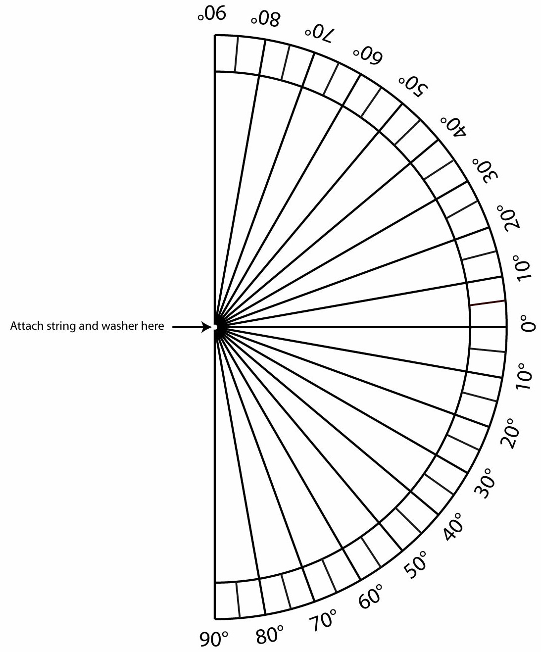

Student Thinking Table
How will students at each level respond to this activity?
 | What ideas and challenges in reasoning will students have? | What should instruction focus on?
Level 3 – School Science Accounts

Level 2 – Force-Dynamic Accounts with Mechanisms

Level 1 – Force Dynamic Accounts

Activity Description Table

Use this table to describe how this activity would look after you modified to support students who are initially at your identified level of achievement (2 or 3).

 | Procedure Description | How will Level (2/3) students respond to this phase of the activity and how will it support their learning toward a higher level?
1
2
3
4
5
6
7
8
9
10

