The purpose of this assessment is to determine your understanding of quantitative reasoning in the context of the water cycle. For open response items provide a brief written answer. For the rating scale questions select 1 for strongly disagree, 3 for no opinion, and 5 for strongly agree.

- The following is a reading from the U.S. Geological Survey water cycle website. Read the passage to identify the processes that makeup the water cycle.
The water cycle has no starting point, but we'll begin in the oceans, since that is where most of Earth's water exists. The sun, which drives the water cycle, heats water in the oceans. Some of it evaporates as vapor into the air; a relatively smaller amount of moisture is added as ice and snow sublimate (change) directly from the solid state into vapor. Rising air currents take the vapor up into the atmosphere, along with water from evapotranspiration, which is water transpired from plants and evaporated from the soil. The vapor rises into the air where cooler temperatures cause it to condense into clouds.
Air currents move clouds around the globe, and cloud particles collide, grow, and fall out of the sky as precipitation. Some precipitation falls as snow and can accumulate as ice caps and glaciers, which can store frozen water for thousands of years. Snow packs in warmer climates often thaw and melt when spring arrives, and the melted water flows overland as snowmelt. Most precipitation falls back into the oceans or onto land, where, due to gravity, the precipitation flows over the ground as surface runoff.
A portion of runoff enters rivers in valleys in the landscape, with stream flow moving water towards the oceans. Runoff, and groundwater seepage, accumulate and are stored as freshwater in lakes. Not all runoff flows into rivers, though. Much of it soaks into the ground as infiltration. Some of the water infiltrates into the ground and replenishes aquifers (saturated subsurface rock), which store huge amounts of freshwater for long periods of time. Some infiltration stays close to the land surface and can seep back into surface-water bodies (and the ocean) as groundwater discharge, and some groundwater finds openings in the land surface and emerges as freshwater springs. Yet more groundwater is absorbed by plant roots to end up as evapotranspiration from the leaves. Over time, though, all of this water keeps moving, some to reenter the ocean.
  - Select all of the following which determine where rain water goes that falls on your school yard by placing an X in the box following the term.

1. Ice caps |  | 6. Precipitation – amount that falls
2. Runoff |  | 7. Surface differences
3. Aquifers |  | 8. Groundwater discharge
4. Evaporation |  | 9. Infiltration
5. Transpiration |  | 10. Fresh water springs

  - Provide a sentence or two that explains the characteristics of evaporation and how it impacts water movement. (QA variable attributes)

  - How is evaporation measured? (QA variable measure)

- The table and bar graph below show the amount of rainfall in Laramie, Wyoming throughout the year. Averages for each month are reported and have been calculated from 1867 to 1987.

 | Jan | Feb | Mar | Apr | May | Jun | Jul | Aug | Sep | Oct | Nov | Dec | Year
mm | 10.9 | 10.8 | 18.5 | 29.6 | 36.5 | 30.0 | 42.2 | 30.7 | 23.3 | 21.0 | 13.1 | 11.2 | 278.8
inches | 0.4 | 0.4 | 0.7 | 1.2 | 1.4 | 1.2 | 1.7 | 1.2 | 0.9 | 0.8 | 0.5 | 0.4 | 11.0

- Rate the statements below from very strongly disagree (1) to very strongly agree (5) on how well they match your interpretation of the trend depicted in the graph and table.

1. | The change in rain amount between months in the table implies that increase in rain is linear. | Very strongly disagree | 1 2 3 4 5 | Very strongly agree
2. | The amount of rain increases at first. | Very strongly disagree | 1 2 3 4 5 | Very strongly agree
3. | The water amount trend is best represented by a quadratic function, not a linear or exponential function. | Very strongly disagree | 1 2 3 4 5 | Very strongly agree
4. | One can identify an entry in the table, such as in June there is 30.0 mm of rain, but cannot use the table to explain trend | Very strongly disagree | 1 2 3 4 5 | Very strongly agree
5. | Trends cannot be determined from this table. | Very strongly disagree | 1 2 3 4 5 | Very strongly agree
6. | The amount of rain across months is not changing at a constant or linear rate. | Very strongly disagree | 1 2 3 4 5 | Very strongly agree
7. | The function y = -x² + 12x – 4 is a possible model for this data, indicating that for a given year the average rain fall peaks in June at around 32 inches. | Very strongly disagree | 1 2 3 4 5 | Very strongly agree
8. | Trends can be determined from this graph. | Very strongly disagree | 1 2 3 4 5 | Very strongly agree

- Below are eight different possible representations of the data table on the rainfall for Laramie, Wyoming. Use these representations and the table and bar graph above to answer questions B, C, and D.

- Scatter Plot | - Histogram
- Pie Chart | - Line Plot
- Linear equation representing data:  y = .02x + 23  where January is numbered as month 0, x is month, y is water height | - Quadratic equation representing data:  y = -0.9x² + 11.5x - 3.6  where January is numbered as month 0, x is month, y is water height
- Exponential equation representing data:  y = 20 x 2.5^{x}  where January is numbered as month 0, x is month, y is water height | - Power equation representing data:  y = 15 x^{0.2}  where January is numbered as month 0, x is month, y is water height
- Rate the statements below from very strongly disagree (1) to very strongly agree (5) on how well they match your understanding of the representations.

1. | The power model gives amount of rain fall for June of 21.46, this does not match the table value of 30 so likely they collected rain amounts in different areas. | Very strongly disagree | 1 2 3 4 5 | Very strongly agree
2. | One can compare the table with the scatter plot since both represent month and water height. | Very strongly disagree | 1 2 3 4 5 | Very strongly agree
3. | The quadratic model gives a water height of 14 for November. While this varies from the table value for rain amount it does not mean one should not use this model. | Very strongly disagree | 1 2 3 4 5 | Very strongly agree
4. | The other representations are of rain fall in different states. | Very strongly disagree | 1 2 3 4 5 | Very strongly agree
5. | The quadratic model is a better fit then the linear model since the data trend is not linear. | Very strongly disagree | 1 2 3 4 5 | Very strongly agree
6. | One would select the representation they prefer and use only it, since there may be differences in the values between the models. | Very strongly disagree | 1 2 3 4 5 | Very strongly agree
7. | There can only be one representation of the amount of rainfall throughout the year, so the other representations are all wrong. | Very strongly disagree | 1 2 3 4 5 | Very strongly agree
8. | One cannot compare the different representations of the data. | Very strongly disagree | 1 2 3 4 5 | Very strongly agree

- Rate the statements below from very strongly disagree (1) to very strongly agree (5) on how well they match your understanding of predicting future events.
1. | It has been raining more in recent years so the water height will increase next year. | Very strongly disagree | 1 2 3 4 5 | Very strongly agree
2. | Determine an estimate of the rainfall water height given a specific month for next year by locating the given month in the graph for this year and determining the average water height during that month. | Very strongly disagree | 1 2 3 4 5 | Very strongly agree
3. | The table represents average rainfall water height for each month over several years, so the amount may not be exactly the same next year. | Very strongly disagree | 1 2 3 4 5 | Very strongly agree
4. | As one moves through the fall months into winter rainfall decreases, so next year there will likely be less rain in January then in December. | Very strongly disagree | 1 2 3 4 5 | Very strongly agree
5. | To estimate the rainfall for next March, substitute 2 for March in the linear equation modeling the data, then solve for the water height. | Very strongly disagree | 1 2 3 4 5 | Very strongly agree
6. | The rainfall in June of next year will be greater than the rainfall for June in the table. | Very strongly disagree | 1 2 3 4 5 | Very strongly agree
7. | Since the graph only provides information for one year of rain, one cannot make predictions of future rain amounts beyond the given data. | Very strongly disagree | 1 2 3 4 5 | Very strongly agree
8. | I am not sure how one can make predictions for future events from any of the representations. | Very strongly disagree | 1 2 3 4 5 | Very strongly agree

- Rate the statements below from very strongly disagree (1) to very strongly agree (5) on how well they match your understanding of how we can revise models. To revise a model means to change a model to better reflect the real world data.

1. | A model for amount of rainfall is fixed and cannot be revised given new information. | Very strongly disagree | 1 2 3 4 5 | Very strongly agree
2. | If the quadratic function does not fit the data, then there is error in the data we collected. | Very strongly disagree | 1 2 3 4 5 | Very strongly agree
3. | One should evaluate the graph and the equation model of the data in the table to see how they inform each other. | Very strongly disagree | 1 2 3 4 5 | Very strongly agree
4. | One should consider revising the model by relating the previous year rainfall trend in Wyoming to the year they are predicting. | Very strongly disagree | 1 2 3 4 5 | Very strongly agree
5. | If the quadratic function does not fit the data, then we need to recollect the data to satisfy the known rainfall law. | Very strongly disagree | 1 2 3 4 5 | Very strongly agree
6. | One should revise the model to better fit the evidence in the table not to make it fit a scientist’s expected model. | Very strongly disagree | 1 2 3 4 5 | Very strongly agree
7. | We can test the graph or equation model for the water height to see if it is a good or bad fit. That is all the revision we can do. | Very strongly disagree | 1 2 3 4 5 | Very strongly agree
8. | One should revise the model so that it improves the ability to predict events, perhaps the rainfall does not obey previous yearly trends. | Very strongly disagree | 1 2 3 4 5 | Very strongly agree

- Below is a chart and table of student collected data using an infiltrometer (instrument for measuring how fast water drains through a surface such as sand or grass). Time is in seconds and the height of water that has infiltrated is in milliliters.

Time | Sand | Grass | Concrete | Roof Shingle
0 | 0 | 0 | 0 | 0
0:30 | 320 | 60 | 3 | 1
1:00 | Unknown | 110 | 5 | 2
1:30 | Unknown | 140 | 10 | 2
2:00 | Unknown | 165 | 15 | 2
2:30 | Unknown | 190 | 18 | 2
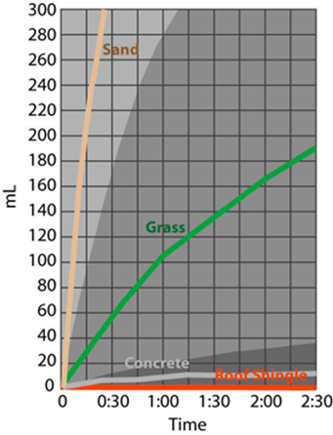

- Rate the statements below from very strongly disagree (1) to very strongly agree (5) on how well they match your interpretation of the trend depicted in the graph and table.

1. | Infiltration is decreasing over time. | Very strongly disagree | 1 2 3 4 5 | Very strongly agree
2. | Trends can be determined from a table. | Very strongly disagree | 1 2 3 4 5 | Very strongly agree
3. | Trends cannot be determined from a graph. | Very strongly disagree | 1 2 3 4 5 | Very strongly agree
4. | One can identify a point on the graph, such as (1:00, 110) as representing seconds and infiltration level for grass, but cannot use the graph to explain trend. | Very strongly disagree | 1 2 3 4 5 | Very strongly agree
5. | The function y = 102.57 x ^{.71} is a possible model for the grass data, indicating that the infiltration rate slows down over time. | Very strongly disagree | 1 2 3 4 5 | Very strongly agree
6. | The rate of infiltration for grass is best represented by a power function, not a linear or quadratic function. | Very strongly disagree | 1 2 3 4 5 | Very strongly agree
7. | The rate of infiltration for grass between 1:00 to 2:30 is less than the rate of infiltration between time 0 to 1:00. | Very strongly disagree | 1 2 3 4 5 | Very strongly agree
8. | Infiltration rate of grass from time 0 to 2:30 is nonlinear. | Very strongly disagree | 1 2 3 4 5 | Very strongly agree

Below are different possible representations of the data table on infiltration. Use these representations and the table and graph above to answer questions B, C, and D.

1. Pie Chart | 2. Bar Graph
- Connected Scatter Plot | - Best Fit Curve
- Linear equation representing grass:  y = 74x -19  where x=0 is time 0 and y is height in ml. | - Quadratic equation representing grass:  y = -5x² + 715x – 64.5  where x=0 is time 0 and y is height in ml.
- Exponential equation representing grass:  y = 54.85 (1.72^{x})  where x=0 is time 0 and y is height in ml. | - Power equation representing grass:  y = 102.57 x ^{.71}  where x=0 is time 0 and y is height in ml.

- Rate the statements below from very strongly disagree (1) to very strongly agree (5) on how well they match your understanding of the representations.

1. | There can only be one representation of the infiltration, so the other representations are all wrong. | Very strongly disagree | 1 2 3 4 5 | Very strongly agree
2. | One cannot compare the different representations of the data. | Very strongly disagree | 1 2 3 4 5 | Very strongly agree
3. | One would select the representation they prefer and use only it, because there may be differences in the values between the models. | Very strongly disagree | 1 2 3 4 5 | Very strongly agree
4. | The power model is a better fit than the linear model because of the rate of increase of infiltration decreasing over time. | Very strongly disagree | 1 2 3 4 5 | Very strongly agree
5. | The other representations are of infiltration rate taken at a different site. | Very strongly disagree | 1 2 3 4 5 | Very strongly agree
6. | One should not compare the pie chart to the graph since the pie chart provides percentage values and not water depth. | Very strongly disagree | 1 2 3 4 5 | Very strongly agree
7. | The linear model for grass gives a water depth of 55 at time 1:00 minute. This varies from the table value for 1:00. | Very strongly disagree | 1 2 3 4 5 | Very strongly agree
8. | One can compare the table with the connected scatter plot because both represent time and water depth. | Very strongly disagree | 1 2 3 4 5 | Very strongly agree

- Rate the statements below from very strongly disagree (1) to very strongly agree (5) on how well they match your understanding of predicting future events.

1. | Since the graph only provides water level from time 0 to 2 minutes 30 seconds; one cannot make predictions of infiltration beyond the given data. | Very strongly disagree | 1 2 3 4 5 | Very strongly agree
2. | As time passes more rain falls so there will be more infiltration for the grassy surface. | Very strongly disagree | 1 2 3 4 5 | Very strongly agree
3. | At a time of 3 minutes the water level for concrete will remain constant. | Very strongly disagree | 1 2 3 4 5 | Very strongly agree
4. | To predict the infiltration amount at 3:30 minutes, substitute 3.5 into the equation model and solve for infiltration amount. | Very strongly disagree | 1 2 3 4 5 | Very strongly agree
5. | The amount of water infiltrated is 20 ml per 30 seconds, so at 3 minutes, 210 ml of water would have been infiltrated. | Very strongly disagree | 1 2 3 4 5 | Very strongly agree
6. | I am not sure how one can make predictions for future events from any of the representations. | Very strongly disagree | 1 2 3 4 5 | Very strongly agree
7. | As time passes the infiltration rate is decreasing for the grassy surface. | Very strongly disagree | 1 2 3 4 5 | Very strongly agree
8. | The concrete surface will stop infiltration at time 1:15. | Very strongly disagree | 1 2 3 4 5 | Very strongly agree

- Rate the statements below from very strongly disagree (1) to very strongly agree (5) on how well they match your understanding of how we can revise models. To revise a model means to change a model to better reflect the real world data.

1. | One should revise the model so that it improves the ability to predict events, not revise the data to fit a model. | Very strongly disagree | 1 2 3 4 5 | Very strongly agree
2. | A model for infiltration is fixed and cannot be revised given new information. | Very strongly disagree | 1 2 3 4 5 | Very strongly agree
3. | One should revise the model to better fit the evidence in the table not to make it fit a scientist’s expectations. | Very strongly disagree | 1 2 3 4 5 | Very strongly agree
4. | If a modeling function does not exactly fit the data, then the data was not collected correctly. | Very strongly disagree | 1 2 3 4 5 | Very strongly agree
5. | One should evaluate the graph and the equation model of the data in the table to see how they inform each other. | Very strongly disagree | 1 2 3 4 5 | Very strongly agree
6. | One can test the graph or equation model for the infiltration data to see if it is a good or bad fit. That is all the revision one can do. | Very strongly disagree | 1 2 3 4 5 | Very strongly agree
7. | If a scientist says that infiltration rate should not be impacted by time, then one needs to recollect the data to satisfy the infiltration law. | Very strongly disagree | 1 2 3 4 5 | Very strongly agree
8. | One should consider revising the model by relating the theory of infiltration to other surfaces. | Very strongly disagree | 1 2 3 4 5 | Very strongly agree

- Below is a model of the global water cycle illustrating how water circulates on a global scale and a graph of change in sea level.
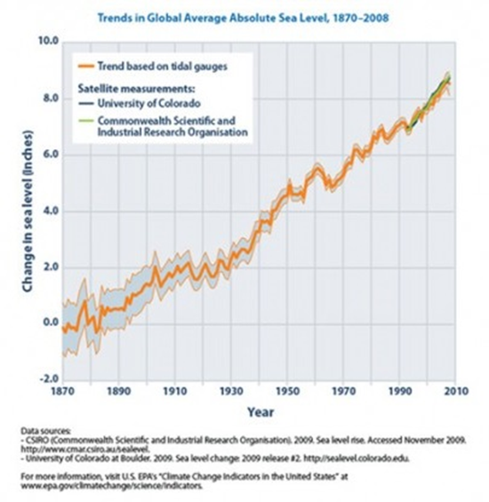
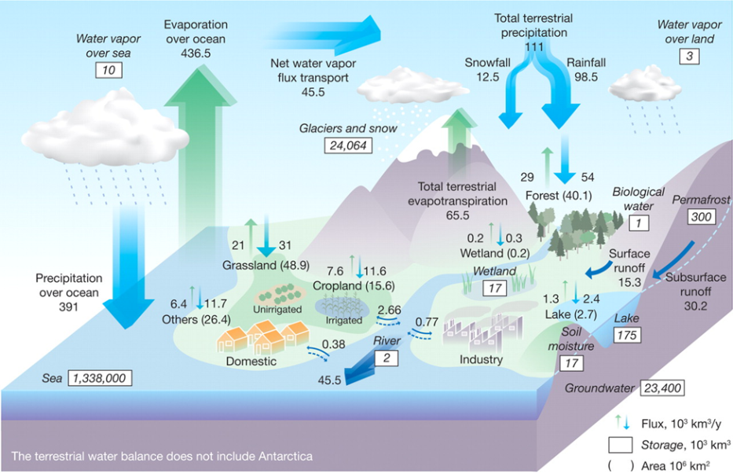

- Rate the statements below from very strongly disagree (1) to very strongly agree (5) on how well they match your interpretation of the trend depicted in the model and table.
1. | The total flux can be found through addition, but one cannot determine the rate of flux. | Very strongly disagree | 1 2 3 4 5 | Very strongly agree
2. | Trends cannot be determined from this box model. | Very strongly disagree | 1 2 3 4 5 | Very strongly agree
3. | Trends cannot be determined from a graph. | Very strongly disagree | 1 2 3 4 5 | Very strongly agree
4. | The precipitation and evapotranspiration for grassland can be used to determine amount of flux for grassland, but the box model cannot be used to explain trends in overall flux. | Very strongly disagree | 1 2 3 4 5 | Very strongly agree
5. | The function y = 0.0615x - 115.6 is a possible model for this data indicating that the change in sea level is increasing by a factor of .0615 each year. | Very strongly disagree | 1 2 3 4 5 | Very strongly agree
6. | The sea level change is best represented by a power function not a linear or quadratic function. | Very strongly disagree | 1 2 3 4 5 | Very strongly agree
7. | As years pass the sea level fluctuates, but overall is increasing. | Very strongly disagree | 1 2 3 4 5 | Very strongly agree
8. | The sea level is increasing and the rate is not constant or linear. | Very strongly disagree | 1 2 3 4 5 | Very strongly agree

Below are different possible representations of the graph of sea level change. Use these representations and the box model and graph above to answer questions B, C, and D.

1. Pie Chart | 2. Bar Graph
3. Connected Scatter Plot | 4. Best fit curve
5. Linear equation representing data  y = 0.0615x - 115.6  with x = 0 representing year 1870 and y sea level change | 6. Quadratic equation representing data  y = 0.0002x² - 0.6833x + 606.47  with x = 0 representing year 1870 and y sea level change
7. Exponential equation representing data  y = 0.6051 1.51^{x}  with x = 0 representing year 1870 and y sea level change | 8. Power equation representing data  y = 0.611x^{1.3456}  with x = 0 representing year 1870 and y sea level change

- Rate the statements below from very strongly disagree (1) to very strongly agree (5) on how well they match your understanding of the representations.

1. | There can only be one representation of the sea level change, so the other representations are all wrong. | Very strongly disagree | 1 2 3 4 5 | Very strongly agree
2. | One cannot compare the different representations of the data. | Very strongly disagree | 1 2 3 4 5 | Very strongly agree
3. | One would select the representation they prefer and use only it, because there may be differences in the values between the models. | Very strongly disagree | 1 2 3 4 5 | Very strongly agree
4. | A linear model is a close fit to the data, indicating a constant rate of increase of the sea level. | Very strongly disagree | 1 2 3 4 5 | Very strongly agree
5. | The other representations are of sea level change in other areas of the world. | Very strongly disagree | 1 2 3 4 5 | Very strongly agree
6. | One should not compare the best fit curve to the box model since the best fit curve is representing sea level change and the box model is representing the water cycle movement. | Very strongly disagree | 1 2 3 4 5 | Very strongly agree
7. | The line graph represents the sea level change during a period of time, between 1870 and 2010 while the box model representing water flow movement is an average over a period of time. So the two models cannot be compared. | Very strongly disagree | 1 2 3 4 5 | Very strongly agree
8. | One can compare the bar graph with the line graph because both represent sea level change over time. | Very strongly disagree | 1 2 3 4 5 | Very strongly agree

- Rate the statements below from very strongly disagree (1) to very strongly agree (5) on how well they match your understanding of predicting future events.

1. | One cannot predict future events from a box model. | Very strongly disagree | 1 2 3 4 5 | Very strongly agree
2. | According to the box model, water is flowing at the same rate throughout the system. | Very strongly disagree | 1 2 3 4 5 | Very strongly agree
3. | According to the box model, flux varies between different surface areas. | Very strongly disagree | 1 2 3 4 5 | Very strongly agree
4. | To predict the sea level change in 2030, use one of the equation models and plug in 160 for x. | Very strongly disagree | 1 2 3 4 5 | Very strongly agree
5. | As time passes sea level change increases which indicates more water is being stored in the sea over the years. | Very strongly disagree | 1 2 3 4 5 | Very strongly agree
6. | I am not sure how one can make predictions for future events from any of the representations. | Very strongly disagree | 1 2 3 4 5 | Very strongly agree
7. | As time goes beyond 2010 the sea level will continue to increase. | Very strongly disagree | 1 2 3 4 5 | Very strongly agree
8. | The landmass areas with larger surface areas have a higher total flux compared to those that have a smaller area. | Very strongly disagree | 1 2 3 4 5 | Very strongly agree

- Rate the statements below from very strongly disagree (1) to very strongly agree (5) on how well they match your understanding of how we can revise models. To revise a model means to change a model to better reflect the real world data.

1. | One should revise the box model to make it fit a scientist’s expectations. | Very strongly disagree | 1 2 3 4 5 | Very strongly agree
2. | One should evaluate the box model and the equation model of the data in the table to see how they inform each other. | Very strongly disagree | 1 2 3 4 5 | Very strongly agree
3. | One can test the box model for flux of a particular surface area data to see if it is a good or bad fit. That is all the revision one can do. | Very strongly disagree | 1 2 3 4 5 | Very strongly agree
4. | One should revise the box model so that it improves the ability to predict events, not revise the data to fit a model. | Very strongly disagree | 1 2 3 4 5 | Very strongly agree
5. | If a scientist says sea levels change at a constant rate of 1 inch per 10 years then one needs to recollect the data. | Very strongly disagree | 1 2 3 4 5 | Very strongly agree
6. | The box model is fixed and cannot be revised given new information. | Very strongly disagree | 1 2 3 4 5 | Very strongly agree
7. | One should consider revising the model if sea rise only in the pacific ocean is considered. | Very strongly disagree | 1 2 3 4 5 | Very strongly agree
8. | If the box model does not exactly fit the data, then there is error in the data we collected. | Very strongly disagree | 1 2 3 4 5 | Very strongly agree

