2013 Carbon Teacher Assessment
Assessment give to Elementary, Middle, and High School science teacher prior to 2013 summer science institutes as a pre-post assessment
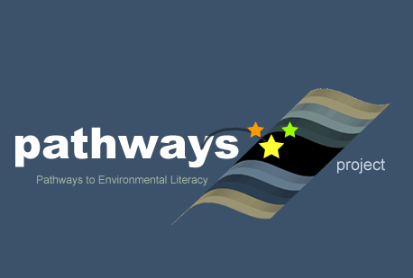
Written by: Carbon Strand
Culturally relevant ecology, learning progressions and environmental literacy
Long Term Ecological Research Math Science Partnership
Spring 2013
Disclaimer: This research is supported by a grant from the National Science Foundation: Targeted Partnership: Culturally relevant ecology, learning progressions and environmental literacy (NSF-0832173). Any opinions, findings, and conclusions or recommendations expressed in this material are those of the author(s) and do not necessarily reflect the views of the National Science Foundation.
Teacher Assessment (May 2012)
Items 7-10 are modified versions of items developed by the Assessing Teacher Learning About Science Teaching (ATLAST) project at Horizon Research, Inc. ATLAST is funded by the National Science Foundation under grant number DUE 0335328.

1. Which of the following is (are) the energy source(s) for plants? Choose either YES or NO for each of the following.

- Water  - Sunlight  - Air  - Nutrients in soil  - Plants make their own energy. | YES NO  YES NO  YES NO  YES NO  YES NO

Explain ALL your answers, including why the things you have chosen NO for are NOT sources of energy for plants.

2. A small plant is put in a large glass chamber with plenty of air and plenty of light. Three days later, what change will have happened to the mass of the air and the mass of the plant? (Note: the plant does not run out of air during this time)
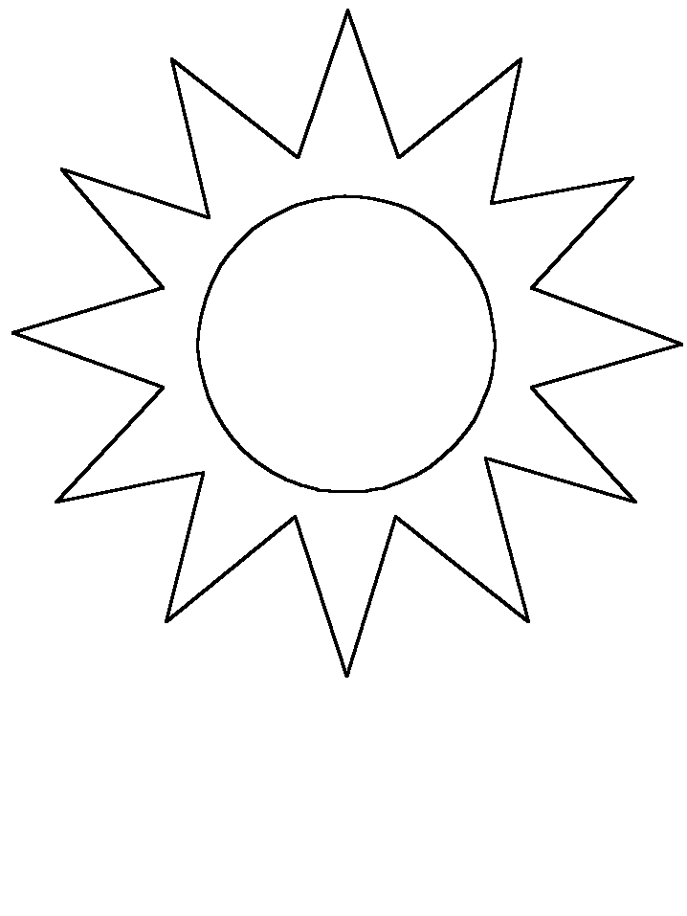
Glass Chamber

1) The mass of the AIR inside the chamber will _____________________________.
a. increase b. decrease c. stay the same
Please explain the reason for your choice.

2) The mass of the plant inside the chamber will ___________________________.
a. increase b. decrease c. stay the same
Please explain the reason for your choice.

3. What happens to energy from the sun after it enters a plant and goes through photosynthesis? Choose either YES or NO for each of the following.
The energy…
 | Please choose YES or NO | Explain why you chose either YES or NO for each option. In your explanation, you could include additional information such as the name of material or the form of energy.
a. will not exist because it is used up in the process. | YES NO
b. will leave the plant’s body as energy | YES NO
c. will change into a material or materials during photosynthesis and be stored in the plant’s body. | YES NO
d. will change into another form of energy during photosynthesis and be stored in the plant’s body. | YES NO
If you think none of the above is true, provide your own answer:
The energy will ____________________________

_________________________________________

4. The graph given below shows changes in concentration of carbon dioxide in the atmosphere over a 50-year span (from 1958 to 2008) at Mauna Loa observatory at Hawaii.

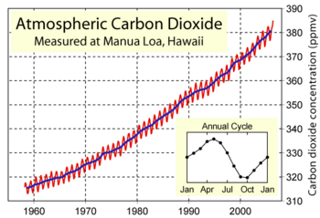

1) This graph shows atmospheric carbon dioxide levels decreasing in the summer and fall every year and increasing in the winter and spring. Why do you think this annual cycle of change occurs?

2) Why do you think this graph shows atmospheric carbon dioxide levels increasing from 1958 to 2008?
5. Our unit focuses on plant growth and metabolism—how plants transform matter and energy—at multiple scales, from atomic molecular to ecosystem. Briefly state up to three learning goals that you hope your students will achieve when they study plant growth and metabolism.
GOAL 1:

GOAL 2:

GOAL 3:

Is there anything commonly included in textbooks or plant units that is NOT important to you in teaching your students about plant growth and metabolism?
NOT IMPORTANT:

6. A teacher gave her students a test. One question on the test is about the growth of an oak tree.
A mature oak tree can have a mass of 500 kg, or more, even after all the water in the tree is removed. Yet it starts from an acorn that weighs only a few grams. Where did this huge increase in mass come from?
Which of the following statements is true? Circle the letter of the correct answer.
a. ALL of the mass came from matter that was originally outside the tree, OR
b. SOME of mass came from matter that the tree made as it grew.

Circle the best choice to complete each of the statements about possible sources of mass from outside the tree. Note that you can choose “all or most” for ONLY ONE SOURCE OF MASS.
All or most… Some… None… …of the dry mass came from the AIR.
All or most… Some… None… …of the dry mass came from SUNLIGHT.
All or most… Some… None… …of the dry mass came from WATER.
All or most… Some… None… …of the dry mass came from SOIL NUTRIENTS.

Explain your choices. How does the oak tree gain mass as it grows?

Here are six student responses to the question. The teacher sorted the responses into 3 groups. Answer the questions below to explain how you think the three groups demonstrate different levels of sophistication in student reasoning.

Students | Mass from outside tree | Air | Sunlight | Water | Soil | Explanation
Group 1. The Best Responses
Student 1 | a. ALL of the mass came from matter that was originally outside the tree | Some | None | Some | Some |  | The oak tree gains mass as it grows by absorbing carbon and other atoms form surrounding areas around the tree.
Student 2 | a. ALL of the mass came from matter that was originally outside the tree | All or most | None | Some | Some |  | The tree absorbs water and nutrients from the soil, but obtains the vast majority of its mass from carbon dioxide in the air via photosynthesis.
Group 2. The Second Best Responses
Student 3 | b. SOME of mass came from matter that the tree made as it grew. | All or most | None | Some | None |  | The tree takes in CO2 from the air and converts it into useable carbon during photosynthesis. Also this happens with the sunlight as well.
Student 4 | b. SOME of the increase in mass came from matter that the tree made as it grew. | Some | Some | All or most | Some |  | Some of the mass comes from the air because the tree uses carbon dioxide to grow (photosynthesis). Some of the mass comes from sunlight because the tree uses sunlight in photosynthesis.
Group 3. The Third Best Responses
Student 5 | a. ALL of the mass came from matter that was originally outside the tree | Some | None | None | All or most |  | It grows over time and the tree grows more outside matter such as bark causing the tree to weigh more
Student 6 | b. SOME of mass came from matter that the tree made as it grew. | None | None | Some | None |  | It gains mass by the branches and things it grows on it and as its size increases the mass increases.

1) Looking at the responses in Group 1 (the best responses), what characteristics do they have in common? Why are they the best responses?

2) Looking at the responses in Group 3 (the third best responses), what characteristics do they have in common? Why are they the least sophisticated responses?

3) Looking at the responses in Group 2 (the second best responses), what characteristics do they have in common? Why are Group 2 responses more sophisticated than Group 3 responses and less sophisticated than Group 1 responses?

4) Which types of responses would you expect to be most common in your class at the beginning of the school year? Why?

7. A teacher asks students where plants get their food. A student responds,
“Along with soil, plants use carbon dioxide, sunlight, and water to help them make food.”

In order to find out more fully how the student’s ideas of how matter is transformed when plants grow, which of the following question(s) would you ask next?
A. How is your explanation related to the process of photosynthesis?
B. Where does carbon dioxide go during this process?
C. Is sunlight used for energy? How do you know?
D. Is the plant food made of only carbon dioxide, water, soil and sunlight? Is there anything else that the plants use to make their food?

Why would this question help you better understand the student’s ideas?

8. During a discussion about how plants and animals get energy, one student says,
“I know animals break down food to get energy, but I don’t think plants break down food for energy because they get light energy from the Sun.”
What, if anything, is wrong with this student’s statement?
A. Similar to animals, plants break down food, releasing energy.
B. In addition to plants getting light energy from the Sun, they also get energy from carbon dioxide and water.
C. Neither animals nor plants break down food; the food is transformed into energy.
D. Nothing is wrong. The student’s statement is correct.

Why is the response you chose better than the others?

9. In a lesson on food, students debate whether or not water is food for plants. Which one of the following would be the best next instructional step to resolve this issue for these students?
A. Place stalks of celery in colored water and have students observe them over a few days.
B. Cut open a cactus to show students that water is stored inside.
C. Have students observe two plants, only one of which is watered, over a period of a week.
D. Explain to students that water does not provide energy to plants, and therefore is not food.

Explain why you think the next step you chose would be better than the others:

10. In a class discussion about the role of sunlight in photosynthesis, one student says,
“Sunlight is turned into sugars that are food for the plant.”
If the majority of students agree with this statement, what should the teacher do next?
A. Remind students of the role of minerals in the soil during photosynthesis.
B. Explain that it is the energy in the sugars, not the sugars themselves, that comes from the sunlight.
C. Suggest an experiment where students compare sugar levels in similar plants grown with different amounts of sunlight.
D. Because these students seem to have a good understanding of the role of sunlight, the teacher should now fill in more detail about photosynthesis.

Explain why you think the response you chose would be better than the others:

