Citizenship Teaching Experiment Teacher Feedback Form
Form where teachers give feedback on the teaching experiment and document their implementation.
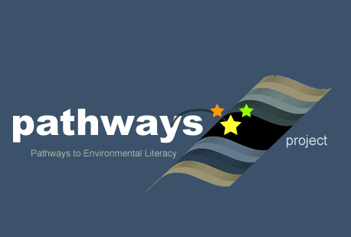
Written by Beth Covitt (University of Montana) and Cornelia Harris (Cary Institute of Ecosystem Studies)
Culturally relevant ecology, learning progressions and environmental literacy Long Term Ecological Research Math Science Partnership
2012
Disclaimer: This research is supported by a grant from the National Science Foundation: Targeted Partnership: Culturally relevant ecology, learning progressions and environmental literacy (NSF-0832173). Any opinions, findings, and conclusions or recommendations expressed in this material are those of the author(s) and do not necessarily reflect the views of the National Science Foundation.


Teacher Feedback Form Teacher Name: ______________________________________
Scientific Argument / Citizenship Activity
NSF – MSP Culturally Relevant Ecology School / Grade Level: _______________________________

Course Name: _______________________________________

Dates of Unit Instruction: __________________________

Please complete the following form either during or after your completion of the Scientific Arguments Mini-Unit. All information will be kept confidential and will be utilized to assist our research to improve the scientific literacy of all students.

Learning Objectives
As a result of engaging in this lesson (and additional activities similar to this), students will:
- Understand that in science, we use scientific arguments to answer scientific questions.
- Be able to distinguish between questions that can be addressed by science, and those that cannot.
- Understand that a scientific argument includes
  - A claim (a statement that answers a scientific question),
  - Evidence (scientific data that supports a claim),
  - Reasoning (an explanation that supports a claim by providing a logical connection between the evidence and the claim).
- Understand that in science, we use specific criteria such as replication, peer review, experimental control, multiple measures, etc. to evaluate scientific arguments.
- Be able to read multiple sources’ stances on a socioscientific issue and identify claims, evidence, and reasoning presented by each source.
- Be able to evaluate the credibility of different sources’ arguments through relying on at least one scientific criterion for judging an argument.
- Understand that science is just one lens for considering socioscientific issues, and that other lenses including personal values, economic values, social justice, etc. can also contribute to understanding and evaluating these issues.

Record of Teaching Activities

The table on the following page lists the activities included in the unit. It is important that we know what happened in your classroom during and between lessons. In particular, we need to know:
- When you did each activity
- Any additional content you taught during that time
- Modifications made to the lessons
- How you may have formatively assessed your students.

Activity | Date(s) | What happened in your classroom?  - How did this lesson help your students learn the desired goal(s)?  - Refer to the learning objectives– what parts of this lesson helped your students increase their understanding of the lesson concept.  - Any additional visual aids or diagrams necessary to add in your instruction for greater understanding of lesson? | Did you modify the lesson?  Please describe the following specifically:  • Why and how did you modify the activity?  • What additional activities did you add? Why?
Activity One:
Introduction to Scientific Argumentation

Activity Two:
Examining Alternative Scientific Arguments

Activity Three:
Introduce Argument Evaluation Criteria

Activity Four
Why Should We Care About Scientific Arguments?

Optional Activity

Formative Assessment(s)
Be specific about how you may have formatively assessed your students and how you used the assessments to modify your instruction.

Final Questions:

- How comfortable are your students becoming using CER?

- Do you see yourself practicing these procedures throughout the year? Why or Why not?

- What other socioscientific topics would you use in your classroom?

Additional Information you would like to share – e.g.

- Student engagement in activity?

- Feedback on overall effectiveness?

- Additional ideas you would like us to pursue?

- Other?

Thank-you for your continued support of the NSF-MSP Culturally Relevant Ecology project!
~The CCP team

