Student Worksheets for the Substances Water Teaching Experiment
Full unit for middle and high school students

Written by: * Andrew Warnock¹, Alan Berkowitz², Brad Blank¹, Aubrey Cano³, Bess Caplan², Beth Covitt⁴, Katherine Emery³, Kristin Gunckel⁵, LaTisha Hammond⁶, Bill Hoyt⁷, Nicole LaDue⁸, John Moore¹, Tamara Newcomer², Tom Noel¹, Lisa Pitot¹, Jen Schuttlefield⁹, Sara Syswerda⁸, Dave Swartz¹, Ray Tschillard¹⁰, and Ali Whitmer⁶.
Culturally relevant ecology, learning progressions and environmental literacy
Long Term Ecological Research Math Science Partnership
June 2012
Disclaimer: This research is supported by a grant from the National Science Foundation: Targeted Partnership: Culturally relevant ecology, learning progressions and environmental literacy (NSF-0832173). Any opinions, findings, and conclusions or recommendations expressed in this material are those of the author(s) and do not necessarily reflect the views of the National Science Foundation.


Name:

Schoolyard Substances in Water
Student Worksheets

Version 2.0

Table of Contents
Schoolyard Model – page 2
Schoolyard Substances Chart – page 3-4
Scale Tool – page 5
Tracing Mixtures with Water Tool – page 6
Construction Site Formative Assessment – page 7
Fertilizer Formative Assessment – page 8
Lab Sheet 9-10
Methods 11-12

Name: _______________________________________

Schoolyard model

Please use the space below to draw the different pathways that substances in solutions and suspensions can take in your schoolyard (be sure to consider surface runoff, groundwater flow, living things, and the atmosphere).

Name: _______________________________________
Schoolyard Substances Chart
Substance | Where does it come from? | How does it move with water? | What type of mixture is this? | How might it affect the environment?
1. |  | Over the ground  Through the ground  Into the atmosphere  Into plants | Solution Suspension Emulsion
2. |  | Over the ground  Through the ground  Into the atmosphere  Into plants | Solution Suspension Emulsion
3. |  | Over the ground  Through the ground  Into the atmosphere  Into plants | Solution Suspension Emulsion
4. |  | Over the ground  Through the ground  Into the atmosphere  Into plants | Solution Suspension Emulsion
5. |  | Over the ground  Through the ground  Into the atmosphere  Into plants | Solution Suspension Emulsion

Name: _______________________________________
Schoolyard Substances Chart

Substance | Where does it come from? | How does it move with water? | What type of mixture is this? | How might it affect the environment?
6. |  | Over the ground  Through the ground  Into the atmosphere  Into plants | Solution Suspension Emulsion
7. |  | Over the ground  Through the ground  Into the atmosphere  Into plants | Solution Suspension Emulsion
8. |  | Over the ground  Through the ground  Into the atmosphere  Into plants | Solution Suspension Emulsion
9. |  | Over the ground  Through the ground  Into the atmosphere  Into plants | Solution Suspension Emulsion
10. |  | Over the ground  Through the ground  Into the atmosphere  Into plants | Solution Suspension Emulsion
11. |  | Over the ground  Through the ground  Into the atmosphere  Into plants | Solution Suspension Emulsion

Construction Site Formative Assessment



A school is doing a construction project and had to dig up some of the ground around the school. The project left a lot of dirt exposed on the surface of the ground. One problem is that when it rains, the rain could wash away a lot of the dirt exposed by the construction project. In a rain storm, where might the dirt go?

For each choice below, decide if the dirt would go there, circle YES or NO, and then explain your answer.

Could the dirt get here? | YES or NO (Circle one) | Explain your answer
- Groundwater | YES or NO
- A nearby creek that runs by downhill from the school | YES or NO
- Inside trees and plants in the undisturbed areas around the school | YES or NO

Fertilizer Formative Assessment

On the right is a map of the school.

The person who takes care of the school grounds spread fertilizer on the playing field grass one Friday morning. That Friday afternoon it rained and some of the fertilizer on the grass mixed with water and lay in puddles on the playing field.

Where do you think the fertilizer could end up?

- Do you think the fertilizer mixed with water on the playing field could get into the atmosphere and come back down as rain with fertilizer mixed into it? YES NO
If you think yes, explain how. If you think no, explain why not.

- Do you think the fertilizer mixed with water on the field could get into School Creek? YES NO
If you think yes, explain how. If you think no, explain why not.

- Do you think the fertilizer mixed with water on the field could get into the groundwater? YES NO
If you think yes, explain how. If you think no, explain why not.

- Do you think the fertilizer mixed with water could get inside of grass on the playing field? YES NO
If you think yes, explain how. If you think no, explain why not.

Name: _______________________________________ Lab Sheet page 1 of 2

 | Evaporation Experiment | Sediment | Vegetable Oil | Fertilizer | Salt | Control
Hypothesis | How do you think this substance can evaporate with water? | yes no | yes no | yes no | yes no | yes no
Observation | What do you observe?
Observation | Did this substance evaporate with water? | yes no | yes no | yes no | yes no | yes no
 | Plant Uptake with Celery | Sediment | Vegetable Oil | Fertilizer | Salt | Control
Hypothesis | How do you think this substance can move up into celery? | yes no | yes no | yes no | yes no | yes no
Observation | Observation
Observation | Did this substances move up through the celery? | yes no | yes no | yes no | yes no | yes no
 | Surface Water Runoff with Watershed Model | Sediment | Vegetable Oil | Fertilizer | Salt | Control
Hypothesis | Do you think each substance will move with surface water runoff? | yes no | yes no | yes no | yes no | yes no
Observation | Observation
Observation | Did this substances move with surface water runoff? | yes no | yes no | yes no | yes no | yes no

Name: _______________________________________ Lab Sheet Day – page 2 of 2

 | Groundwater Infiltration with  Soil Column | Soil | Vegetable Oil | Fertilizer | Salt | Control
Hypothesis | Do you think each substance will move with water into the soil? | yes no | yes no | yes no | yes no | yes no
Observation | Final conductivity
Observation | Observation
Observation | Could this substance move through soil into groundwater? | yes no | yes no | yes no | yes no | yes no
 | Tyndall Effect with a Laser beam | Soil | Vegetable Oil | Fertilizer | Salt | Control
Hypothesis | Will you see the laser beam through this mixture? | yes no | yes no | yes no | yes no | yes no
Observation | Can you see the laser beam reflecting off the substance? | yes no | yes no | yes no | yes no | yes no

 |  | Soil | Vegetable Oil | Fertilizer | Salt
After the presentation on molecular properties of substances mixed with water | Based on your laboratory observations, determine what type of mixture is made from each substance mixed with water? | Solution  super-saturated solution  suspension  emulsion | Solution  super-  saturated  solution  suspension  emulsion | Solution  super-  saturated solution  suspension  emulsion | Solution  super-  saturated  solution  suspension  emulsion

Plant Uptake Using Celery - Which substances will move up into plants?
Materials for each group: labeled beaker with you group name and substance you will be testing, 2-3 celery stalks with leaves, spoon.

Step 1: Add 50 ml of water to your beaker and stir in 1 teaspoon of substance.
Add celery stalks to the beakers & place the beakers in a sunny location.

Step 2: Record your hypothesis about which substances will move up into the celery on your ‘Schoolyard Substances Lab Sheet.’

Step 3: Over the course of a the week, record your observations in your
‘Schoolyard Substances Lab Sheet.’
-----------------------------------------------------------------------------------------------------------------------------

Surface Water Runoff with a Watershed Model - Which substances will runoff?
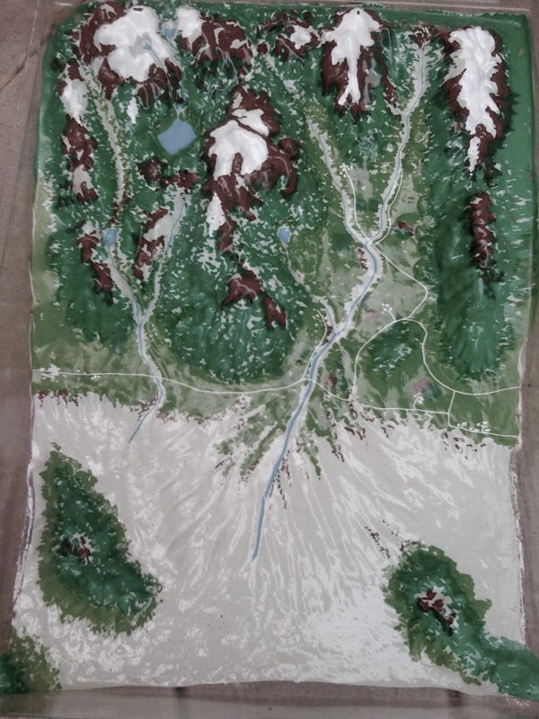
Materials: Watershed model, spoon, Spray bottle with water

Step 1: Carefully place a teaspoon of substance on the watershed model.

Step 2: Record your hypothesis about which substances will move with surface runoff on your ‘Schoolyard Substances Lab Sheet.’

Step 3: Mist it with water using the spray bottle and record you observations in the ‘Schoolyard Substances Lab Sheet.’ Pour water from a watering can over your substance and record you observations in the lab sheet. Continue to record your observations regarding how different velocity affects runoff.
-----------------------------------------------------------------------------------------------------------------------------

Evaporation with a Bunsen Burner - Which substances will evaporate?
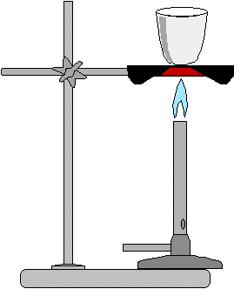
Materials: Bunsen burner, beaker, 3 g of substance, 30 ml of water

Step 1: Record the mass of the beaker to the nearest 0.1 grams. Add 3 g of substance and 30 ml of water and stir thoroughly.

Step 2: Record your hypothesis about which substances will move with evaporation on your ‘Schoolyard Substances Lab Sheet.’

Step 3: Gently heat mixture water. Steam should escape from the beaker but the mixture should not spit or spatter. As the water evaporates and the substance dries out, it is especially important to heat gently. Let the beaker cool completely. Weigh the beaker with the dried substance and compare to their original masses. You may not have 100% recover if there was moisture if your substance (especially the soil) or if there was spillage.

Step 4: Record you observations in the ‘Schoolyard Substances Lab Sheet.’

Infiltration with a Soil Column – Which substances move through groundwater?
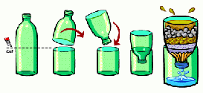
Materials for each soil column experiment: soil column, media (ex. sand, rocks, and/or soil), beaker, spoon, Tape & Sharpie Marker, 50 ml of water

Step 1: Stir a spoonful of substance into 50 ml of water in beaker.

Step 2: Record your hypothesis about which substances will move with groundwater infiltration on your ‘Schoolyard Substances Lab Sheet.’

Step 3: Slowly pour mixture into column making sure not to overfill or spill. Record your observations. This will take a couple minutes.

Step 4: Record the conductivity of the solution in the bottom of your groundwater column.

Record any additional observations here:

