Green Eyes On: Atrazine Higher in June – Watch Out Midwesterners!
Reading to accompany Atrazine Citizenship Mini-Unit

Written by: Sara Snow
Culturally relevant ecology, learning progressions and environmental literacy
Long Term Ecological Research Math Science Partnership
2012
Disclaimer: This research is supported by a grant from the National Science Foundation: Targeted Partnership: Culturally relevant ecology, learning progressions and environmental literacy (NSF-0832173). Any opinions, findings, and conclusions or recommendations expressed in this material are those of the author(s) and do not necessarily reflect the views of the National Science Foundation.


Green Eyes On: Atrazine Higher in June – Watch Out Midwesterners!
By Sara Snow, published June 7, 2010 on www.treehugger.com .

I saw on my local news station's website and recently in The Organic Center's newsletter, The Scoop, warnings about The "June Effect." The definition: Relatively high levels of the corn herbicide atrazine are present in Midwestern water supplies in June, following the spring spray season, triggering an increase in birth defects among children born nine months later.
There are two reasons why this concerns me. First, I'm pregnant and I know that atrazine and other chemicals like it are especially dangerous for pregnant women and the developing fetus. Second, I live in the Midwest and I drink the water that comes through my tap. Yes, I filter it, but that doesn't solve the problem, does it?
According to a recent news report that got a lot of play around here, federal investigators are once again looking into concerns that atrazine, a common herbicide used on crops in the Midwest and found in what could be potentially hazardous amounts in midwest drinking water, could be linked to birth defects. According to a local neonatologist, studies have shown that women who conceive between April and July in the state of Indiana are most likely to deliver babies with birth defects. These rates of birth defects directly correlate with spikes of atrazine in the state's drinking water during the summer growing season. This has since been dubbed "the June Effect." And as seen on the map and chart here, atrazine levels are highest in the Midwest states with spikes during the summer months.
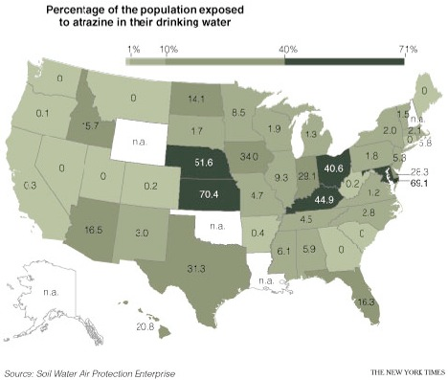

Atrazine is used on many crops but used prevalently on corn during the months of April, May, June and July. The EPA currently requires that levels of atrazine stay below a 12-month average of three parts per billion. And while water utility companies treat water to keep levels within that limit, some are still concerned.
A couple of months ago I wrote for TreeHugger about a recent study that showed that some male frogs exposed to atrazine turned into fully functioning females. The study showed that frogs born male can become so completely female that they can actually mate and lay viable eggs. Now doctors, scientists and citizens are questions whether the EPA's acceptable levels of atrazine in drinking water are truly safe. Especially for pregnant women.
Here's what you can do.
I still wouldn't advocate drinking bottled water that has been shipped in but it's imperative that you filter your tap water. Choose a filter that is certified by the National Science Foundation International to meet ANSI's (American National Standards Institute) Standard 53. Standard 53 addresses point-of-use (POU) and point-of-entry (POE) systems designed to reduce specific health-related contaminants such as VOCs, lead and other health-related contaminants like atrazine and other pesticides that may be present in public or private drinking water.
And then be vigilant about drinking only from this filtered tap. This goes for water for your coffee maker, water with dinner, and water to take to bed at night.

