School Water Budget Transparency Set
Supplemental figures for the pathways water teaching experiment

Written by: * Andrew Warnock¹, Alan Berkowitz², Brad Blank¹, Aubrey Cano³, Bess Caplan², Beth Covitt⁴, Katherine Emery³, Kristin Gunckel⁵, LaTisha Hammond⁶, Bill Hoyt⁷, Nicole LaDue⁸, John Moore¹, Tamara Newcomer², Tom Noel¹, Lisa Pitot¹, Jen Schuttlefield⁹, Sara Syswerda⁸, Dave Swartz¹, Ray Tschillard¹⁰, and Ali Whitmer⁶.
Culturally relevant ecology, learning progressions and environmental literacy
Long Term Ecological Research Math Science Partnership
2012
Disclaimer: This research is supported by a grant from the National Science Foundation: Targeted Partnership: Culturally relevant ecology, learning progressions and environmental literacy (NSF-0832173). Any opinions, findings, and conclusions or recommendations expressed in this material are those of the author(s) and do not necessarily reflect the views of the National Science Foundation.


School Water Budget
Transparency Set

Version 2.4

Table of Contents
School Map – page 2
Evaporation – page 4
Transpiration – page 5
Infiltration – page 6
Tracing Pathways – 9



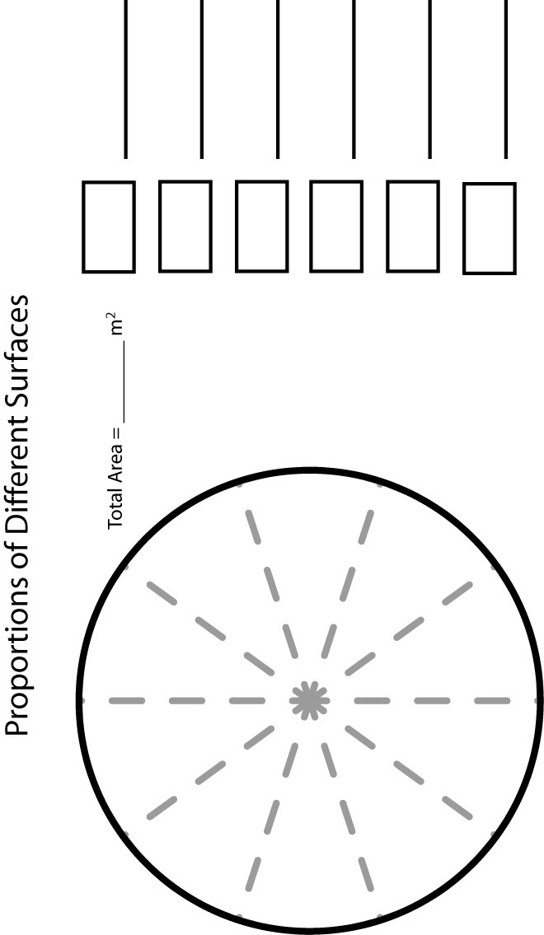

Evaporation Instructions and Data Sheet

1. Your team is responsible for an evaporation pan.
2. Fill your pan half full with water.
3. Use duct tape to attach window screen to cover the pan (to prevent animals from drinking the water). Put the tape on in such a way that you can open the top to take a measurement each day.
4. Place outside in a carefully chosen location. (Shade, full sun, calm wind, full wind. Avoid sprinklers.)
5. Use the ruler to measure the height of the water at the edge of the pan in the same place each time (in case the pan in not exactly level). Measure to the nearest 1/8”.
6. Revisit your pan the next day to measure and record water height.

Month:
Site Description:

Pan Location | Day 1  (inches) | Day 2  (inches) | Evaporation Rate  (Day 2 – Day 1)  (inches/day)

Extrapolate your evaporation rate to a year by multiplying by 365.

Annual Evaporation
(inches/year)
Transpiration Instructions and Data Sheet

1. Label the bag with a sharpie marker with your team’s name.
2. Go outside and find a suitable tree with limbs you can reach.
3. Place a baggie over a batch of leaves or needles of similar size and use duct tape to tightly seal it around the stem. You might have to remove some leaves or needles where you attaché the duct tape to make a tight seal. Also, make sure the top of your baggie is higher than the bottom to prevent leaks.
4. Count or estimate the number of leaves or needles in your baggie.
5. Return to the tree the next day, carefully remove the baggie without spilling any water that accumulated.
6. Use a 25 mL graduated cylinder to measure the volume of water collected.
7. Divide your result by the number of leaves or needles in the baggie and then multiply by the estimated number of leaves or needles on the tree.

Month:
Site Description:

Tree Type:

Number of leaves or needles in baggie | Volume of water measured (mL) | Volume of Water from 1 leaf or needle (mL) | Estimated number of leaves on tree | Total amount  transpired per day
Infiltrometer Instructions and Data Sheet

1. We need to place the infiltrometer on the surface you want to test and make a good seal. In sand or loose soil, simply push the tube into the ground. In hard packed soil or gravel, you may need to twist, push harder, or wet the soil a tiny bit. On concrete, asphalt, or roofing shingles you will need to create the seal with a 25 cm long ‘snake’ made out of the modeling clay. The snake should be about 1 cm in diameter.

2. Find a spot on the ground that is smooth and free of plants. Have someone in your group get ready to write down the numbers you read off once the experiment begins.

3. Use the bucket of water to fill the infiltrometer up to the 0mL mark then quickly start the stopwatch. Every 15 seconds, read and record the water level.

4. Plot your results on the graph below.

5. Repeat test on two different types of surfaces.

6. Rank your three surfaces by permeability and be prepared to share with the class.

