Using complexity in food webs to teach biodiversity
NARST Paper 2011
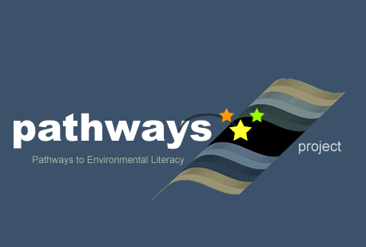
Written by: Cornelia Harris & Alan Berkowitz (Cary Institute of Ecosystem Studies)
Culturally relevant ecology, learning progressions and environmental literacy
Long Term Ecological Research Math Science Partnership
April 2011
Disclaimer: This research is supported by a grant from the National Science Foundation: Targeted Partnership: Culturally relevant ecology, learning progressions and environmental literacy (NSF-0832173). Any opinions, findings, and conclusions or recommendations expressed in this material are those of the author(s) and do not necessarily reflect the views of the National Science Foundation.


Using complexity in food webs to teach biodiversity
Cornelia Harris & Alan Berkowitz, Cary Institute of Ecosystem Studies

Abstract

A broad interview-based survey of Americans found that many think of the environment as a set of complex interconnections, and by removing or altering one group of organisms everything else is affected (Kempton, Boster, and Hartley 1996). While this paints an attractive and perhaps pedagogically useful view with regard to ecological and environmental education, it is not the case that everything on earth is directly connected and teaching ecology in this manner oversimplifies the complexity of biodiversity. In this paper we asked, “How do middle and high school students think through complex connections?” and “How does improving the scientific accuracy of student understandings of complexity assist students with understanding the recognition and maintenance of biodiversity?”
For this paper we used data from over 1000 written assessments administered to middle and high school students, while also interviewing students about the connections between biotic and abiotic components in a food web. Only 21% of high school and 12% of middle school responses were at level 3 or 4 on a scale of 1 to 4, with 1 being the lowest. Our results are consistent with the research literature in that students primarily recognize direct, unidirectional connections between organisms (e.g. predatory-prey interactions), but do not recognize indirect, resource-mediated interactions (e.g. competition). However, we also found that students struggle with reasoning through how a change in biotic components of an ecosystem can impact the resources and conditions within an ecosystem, and they fail to recognize biodiversity at different scales, generally ignoring population or community diversity. We believe that explicitly teaching the relationship between resources, conditions, and biota can help students recognize biodiversity in any place, and build understanding of how ecosystems change over time in response to disturbances.

Supported by a grant from the National Science Foundation: Targeted Partnership: Culturally relevant ecology, learning progressions and environmental literacy (NSF-0832173). Any opinions, findings, and conclusions or recommendations expressed in this material are those of the author(s) and do not necessarily reflect the views of the National Science Foundation.

Introduction

The upper anchor of our biodiversity learning progression describes a student who recognizes that communities are structured by dispersal, abiotic conditions and resources, interactions with other organisms, and the nature of those interactions. When students are asked to think about how a change in an ecosystem might impact other organisms or the abiotic environment, they should be able to think through interactions among three components of ecosystems: dispersal, abiotic resources and conditions, and biotic interactions. Students should be able to understand not only how abiotic resources and conditions limit survival and reproduction, but also how organisms change the abiotic environment as they live, feed, reproduce, and die, and how these changes may in turn impact the food web. Understanding these interactions, which go beyond feeding (predation), competition or other direct interactions, encourages students to think more deeply about the potential impacts of changes to populations such as the introduction of invasive species, the reduction of populations through overharvesting or habitat loss, or the increase in pollution or changes wrought by global warming. To really understand any of these changes, students need to be aware not just of the feeding relationships but of the direct and indirect interactions between the organisms and their environment. Furthermore, we hope that students will gain a sense of the complexity of these interactions, and how variability and the strength of interactions impact the ecosystems around us.
Much has been written about students’ understandings of food chains, food webs, and the general relationships between organisms and the ecosystem in which they live. Students are proficient at recognizing predator-prey relationships, and they can identify disruptions that are linear in a food web (Hogan 2000; Griffiths and Grant 1985; Munson 1994; Barman and Mayer 1994). However, students simplify the complexity of food webs and begin to make generalizations when asked to extrapolate their reasoning about changes, such as the belief that if one population in a food web is changed, it affects those populations that are connected to it through predator-prey relationships (Griffiths and Grant 1985; Barman and Mayer 1994) and the change will not be passed along different pathways of the food web (Barman and Mayer 1994). Similarly, students believe that a change in the population of a first order consumer will not affect the producer populations (Barman and Mayer 1994) and that all organisms above an eliminated population in a food chain would die out (Reiner 2001).
However, Gotwals and Songer (2009) found that while students were able to reason up a food chain more easily than down, a possible unfamiliarity with a producer may have affected the students’ ability to explain how things changed. Hogan (2000) found that students more easily reasoned down a food web; so it is possible that context and knowledge about the system is important when asking students to explain complex changes. A study in which students were provided with a food web diagram for a Northeastern forest and asked to identify three changes that would result from a year in which there were few acorns, less than a third of the students gave more than one change and no students identified changes beyond two organisms or gave any indication of feedback mechanisms between different populations (Notin et al, in prep). All of these studies point to the fact that students have a simplistic view of causality, and that even after targeted instruction, students still struggle to make multiple connections among organisms (Grotzer and Basca 2003).
Connections between abiotic and biotic components of ecosystems have been studied less frequently, even in the context of food webs. Students have difficulty explaining concepts of energy transfer and the “invisible” processes (i.e. microbes) and organisms that govern ecosystem dynamics (Magntorn and Hellden 2007; Grotzer and Basca 2003). When investigating students’ understanding of energy flow and matter cycling, Lin and Hu (2003) found that students struggled the most with relationships between the living world and the non-living world. Sander et al. (2006) found that students can recognize one-sided relationships where a non-living factor, such as climate, affects species, but students were not able to explain any non-human species that affect climate. They also found that when asked about succession, students assumed that organisms followed the environmental conditions, and that the conditions were not changed by the activity of the organisms (Sander et al. 2006).
When we began our learning progression assessments, we were interested in exploring students’ ability to make both multiple connections between populations in an ecosystem and connections between a change in a population and that of an abiotic factor in the ecosystem. We wanted to learn about students’ understanding of the feedback that exists between a change in a population and abiotic resources in an ecosystem, in order to see whether students can start to recognize the relationship that Lin and Hu (2003) found so difficult for students. Ecologists study these kinds of connections constantly, from the zebra mussel invasion in the Hudson River causing increases in water clarity which in turn increased the littoral fish community (Strayer et al 2008) to the way in which removing floods increased populations of grazing insects, thus leading to changes in predatory fish in the Colorado River system (Wootton et al 1996). If we expect to develop environmentally literate citizens, we need to take the time to teach them about complexity in ecosystems, moving beyond the most simplistic food webs and encouraging students to ask the appropriate questions about connections between the biotic and abiotic components of ecosystems, and how those connections may change over time.

Procedure

This study is part of a multi-year project supported by the National Science Foundation to develop culturally relevant learning progressions for environmental literacy.
In this study, we began by piloting two versions of an interactions question that focused on the changes in phytoplankton population caused by the invasion of the zebra mussel in the Hudson River with middle and high school students in New York (31 middle school and 26 high school) and Michigan (84 middle school and 85 high school). Answers were scored using a rubric developed by a single coder. Revisions to this question led to the development of an interactions question on oysters, given during the 2009-10 school year to 135 high school students and 54 middle school students in Maryland, Michigan, California, Colorado, and New York.
We used a new rubric to score the student answers (Figure 1) which was developed from an initial subset of 25-30 actual student responses. This rubric has four levels, based on the over-arching framework on community and population progress variables developed by the working group. For the oyster question, we scored all parts of the question together except for bullet in part C (see question in Appendix), which we felt more adequately fit with the individual framework. We assigned the lowest score (1) to students who focused only on the target population and used anthropomorphic stories or force-dynamic reasoning to explain their answer. Students who used predator-prey interactions as the primary focus of their answer, and did not consider the impact of abiotic resources or conditions were given a score of 2. Answers that included an explanation of competition as mediated by resources as a secondary connection or explained a resource constraint were given a score of 3. Scores of 4 indicated that students understood how a change in the abiotic resources or conditions could then affect other parts of the food web or other biota in the ecosystem, or how a population could cause a change in an abiotic resource or constraint which then impacted other parts of the food web. Answers were coded by two different coders, who checked every 10th answer of the second coder for discrepancies. The coders then discussed their concerns with any answers on which they did not agree, and revised the rubric as necessary.
Five validation interviews were conducted with students from all sites. Responses were transcribed and discussed with the working group to look at the relationship between students’ written answers and their interviews. Based on this information, we decided to use this concept as a major focus of our teaching experiment, which was developed in the spring of 2010 and used by teachers in the 2010-11 school year (ongoing). We wrote new interactions questions that highlighted the connections between biotic and abiotic factors, as well as questions that asked students to think about the constraints on a new ecosystem based on the interactions that were present. These teaching experiment questions were given before and after the students conducted the two-week lesson sequence (see Appendix A for all questions).
We conducted several exploratory interviews with students who had already completed the teaching experiment, to probe their understanding of this topic further. These exploratory interviews used a scaffolded interview protocol in which the students were asked to create a food web from a set of cards depicting an aquatic ecosystem (see Appendix B). Students first explained the connections they made between the organisms, after which the food web was “disturbed” by the researcher. They were asked to explain how the populations might change in response to the disturbance. A set of abiotic factor cards was then introduced, and students were encouraged to explain how those factors could impact or be impacted by different populations in the food web. Students were allowed to ask clarifying questions of the researcher in order to learn more about both the biotic and abiotic components of the system. Students were provided with an organizing tool to help them scaffold their thinking, and in order to encourage them to use a process of questioning when investigating potential changes in an ecosystem (see Appendix C). As a way to assess the transferability of students’ understanding, the last part of the interview asked students to complete a reading on an ecosystem they haven’t studied in school, and to explain a similar range of connections as in the aquatic ecosystem.

Assessment Findings

In our first iteration of an interaction question, “Oysters”, students were given a graph showing the impact of the zebra mussel invasion on phytoplankton. Students had no difficulty in explaining how a decrease in the phytoplankton population would impact other living things in the river, and since students were asked “What would you need to know in order to explain how the food web of the Hudson River would change?”, they were able to answer the question without needing content knowledge about this specific system. Many students gave very general answers that indicated hidden mechanisms about ecosystem function, such as “This could affect other parts of the river as well because more plants and animals could die causing a whole ecosystem to collapse and a new one to spring up” (Cary A27, 9th grade, 2009) or “Well the animals that might eat phytoplankton will start to fight for food and soon they will die. When this happens whoever eat those animals will die, the food chain will be disturbed and things would have to find a way to adapt” (Cary A30, 9th grade, 2009). This type of oversimplification of ecosystem processes and the students’ inability to describe the mechanisms that govern changes in ecosystem structure was common.
Students were also unable to think about how abiotic factors might change in response to a change in the population of an organism, and when asked how the change in phytoplankton might impact abiotic factors in the river, only 11% of the students were able to think about any possible relationships. We recognized that many students did not understand the word “abiotic”, and thus we removed this in the next iterations of our assessment. We also decided to change the context of the question, remove the graph, and ask students about time lags.
With the revised question using oysters and plankton, students were told that oysters were filter feeders that eat plankton, which are free floating plant-like organisms (see Appendix A for question text). The majority of middle school students were at Level 1, focusing only on the oysters and not explaining any other possible interactions (see Figure 2). Most high school students were at Level 2, focusing on the immediate biotic interactions of predator-prey without explaining any additional interactions. We gave this same question to teachers at all of our sites (n=120) and found that most teachers were at Level 3, explaining additional interactions that were mediated through resources and conditions, including competition and mutualism. While some teachers did answer this question with a Level 4, providing examples of how the change in abiotic conditions or resources could impact other biota in the food web, we became concerned that the question does not adequately cue for this level. Since it does not ask specifically for an explanation of how the change in the resource or condition might impact other biota in the ecosystem, it is possible that students and teachers know more than they are providing during the written assessments.
We conducted five validation interviews for the oysters interaction question. We asked students to first read us their answers and then asked probing questions to understand more about their thinking. Our validation interviews confirmed the trend that most responses focus first on predator-prey relationships, but that is also reasonable to expect since our question was scaffolded to illicit this response at the outset. When asked to describe what else might change in the ecosystem besides the oysters and the plankton population, students responded with abiotic changes that were caused by unknown factors or humans (temperature changes, an oil spill, other types of pollution). As was demonstrated by Lin and Hu (2003) and Magntorn and Heller (2007), students see the link between an abiotic change and an organism’s response. However, none of the interviewed students volunteered information about how an abiotic change might occur as a result of biota living in the system, and none linked any abiotic change back to a response in the food web that included oysters and plankton, as in the answers given by students below:
Researcher: I guess do you think there’s any other physical stuff out in the ocean, like any physical characteristics of the water? Maybe if there’s different stuff in the water, or if the water temperature changes. I guess what do you think would happen [to the oysters or plankton with] that?
EAS, 7th grade: If like the climate instantly changed the water would be like colder or warmer and the plankton would not really be used to that or if like oil or if a ship ran into something, the oil would do something to that or like the air, or water pollution, boats, like their gas or if they throw stuff overboard.
Researcher: What kind of information would you need to figure out how a decline in oyster might affect other parts of the ecosystem besides the plankton?
EAS: There could be pesticides or chemicals that are put in there or spilled or accident or something. So that could kill off the oysters or the plankton or all the animals in there so that everything would be dead. Or there could be things taken out of there that the plankton or the other animals in the water need.
Having identified the difficulty students have between making connections between the ecosystem and the food web, we decided to focus on this understanding as one of the key goals of our teaching experiment curriculum.

Development of the Teaching Experiment

Our teaching experiment was developed by a group of science educators, teachers, and researchers. We identified a number of goals that we wanted to fulfill by developing a series of lessons that teachers could use to move their students along our identified learning progression. In addition to the understanding of how abiotic factors, biotic interactions, and dispersal interact in complex ways to determine the biodiversity of a community, we also wanted students to have facility with the outdoors, using their local place as a way to become more confident with recognizing and identifying a diverse group of organisms. We decided to use an aquatic leaf pack experiment because it is easy to obtain materials and set up the equipment, it can be done inside the classroom if a field trip is impossible, and it allows students to explore a wide range of organisms that are relatively easy to identify with freely available tools.
The purpose of the unit is to increase students’ ability to apply principles of biodiversity to their observations and reasoning about the natural world, using freshwater stream ecosystems as the context for learning. Specifically, the unit was been designed to help students:
- Recognize that macroinvertebrate and microorganism diversity exists.
- Learn to classify organisms based on similarities and differences in morphology, evolutionary relatedness, and biotic (e.g. type of prey or food available) and abiotic (e.g. the concentration of dissolved oxygen, the amount of sunlight) requirements.
- Understand major factors that structure biological communities: organisms have particular abiotic and biotic requirements that must be met if they are to survive and reproduce.
- Recognize that an organisms' activities (e.g. feeding activities) influence the abiotic environment (e.g. water clarity, dissolved oxygen, mineral nutrients) and be able to predict how a change in the population of a given organism would impact the abiotic environment and, in turn, other biota
Students work in small groups and as a whole class to perform a qualitative and quantitative analysis of organisms found in 2-4 leaf pack treatments (i.e. location in stream, type of leaves). Students use keys to identify organisms and supplemental resources (e.g. readings, diagrams and sorting cards) to group and classify organisms and describe organisms’ interactions with the abiotic and biotic environment. In each of their analyses, students start with macroscopic organisms and gradually add microscopic ones (see appendix for a more thorough overview of the teaching experiment).
By examining both macroinvertebrates and the microbial community that lives on the leaves, we hope that students build an appreciation for the diversity of life that exists beyond the common kingdoms (Plantae, Animalia) that students explain when asked to describe organisms living in their backyard. Scraping leaves allows students to see fungi, bacteria, and a variety or protists that use the leaves as habitat and food. Classification is a common part of the biology curriculum, and this part of the teaching experiment allows teachers to reinforce this concept with real organisms.
Pedagogically, it was important to us to have students connect the stream ecosystem they are investigating to an ecosystem that is “familiar” to them, building on their ability to connect their school science narrative to their own experiences. As pointed out by Covitt et al (2009), most students draw on their out-of-school experiences to explain phenomena and make decisions in citizenship situations, instead of relying on understandings developed in school. By making connections between their classroom experiences and what they already know, we hope to help students use the framework they are learning in the classroom to help explain connections in another system.
In addition to developing the teaching experiment curriculum, we developed items for pre and post-assessment of student learning. We created questions that asked students to explain how they recognize the presence of diversity, how they classify organisms, how ecosystems are structured and how interactions affect the diversity of organisms and the structure of the ecosystems. Students were given one of two versions of the assessment, which varied the content of the questions, such as asking questions about a stream ecosystem in one, and a forest ecosystem in another (see Appendix A).

Preliminary Teaching Experiment Data

To date, our teaching experiment pre and post assessments have been taken by 734 students (446 middle school and 286 high school students). We anticipate an additional 500-1000 students will complete the assessments before the end of the 2010-2011 school year. In this paper, we will report data from one question that examines students’ ability to explain how the action of feeding by a population changes the abiotic environment, and how that change in the environment could impact other biota.
Since we wanted to focus on students’ ability to understand the connections between the biotic (food webs) and abiotic factors and conditions (ecosystem), we gave them several questions on the pre and post assessment that encouraged them to explain how these complex connections might play out. One question, which we call “biotic-abiotic-biotic”, asks students to think about how the process of feeding in a stream might cause changes to the abiotic resources and conditions, and how that change may impact other living things in the stream. Students spent time during the teaching experiment explaining exactly this kind of a complex connection, using the leaf pack experiment. Using a revised rubric (see Figure 3), we found that most students in both middle and high school were at Levels 1 and 2, indicating that they were unable to explain complex connections between the food web and the ecosystem (see Figure 4). However, since these data are preliminary and not all questions that focus on interactions have been coded nor have all classrooms completed the assessments, we anticipate changes to our findings demonstrating growth in student understanding as we complete our analyses of these data.
We also conducted three exploratory interviews with students from Baltimore, MD, to investigate their ability to transfer thinking about complex connections to different ecosystems. We began the interview by giving students a number of pictures that were from a familiar local ecosystem (the Chesapeake Bay), and asking students to arrange the pictures into any set of connections that makes sense to them (see Appendix B). Cards that listed abiotic factors (dissolved oxygen, nutrients) were then introduced, and students were asked to explain how changes in the food web might impact the abiotic factors. Below is an excerpt from one of the interviews, demonstrating the student’s ability to explain the connection between biotic and abiotic changes:
Researcher: What kind of information would you need to figure out how a decline in oysters might affect other parts of the ecosystem, besides the plankton?
Jane: Well…I didn’t really explain it…if plankton increase it would eventually take over the whole pond and animals that were living there besides the oysters would die off because the plankton would take over the whole pond.
Researcher: When you say take over, what do you mean?
Jane: Well when you say more plankton, maybe less sunlight would get in the water. So the other organisms like the- I don’t know- the plants that are in the pond wouldn’t get enough sunlight.
Researcher: Well what if the opposite happened, and there was less plankton?
Jane: Well the water would get clearer, so there would be a noticeable change and since there is more sunlight, the water celery would increase because they use photosynthesis to get their food.

All three students who participated in the exploratory interviews were able to explain multiple connections within the constructed system, although the middle school students struggled more to make connections between biotic and abiotic factors than the high school student. We believe that students who have completed the teaching experiment, such as the one above, will be able to reason more completely about complexity in ecosystems, and will be better able to transfer their mechanism of understanding to other ecosystems. We will continue to interview students and revise our materials to probe this topic, and to understand whether students can transfer between ecosystems without having background knowledge about the specific system and how to best encourage high level responses from written assessments.

Implications

Throughout our study, we found that students were much more likely to invoke predator-prey and other direct interactions among two species than to describe indirect, resource-mediated interactions that demonstrate the ways in which the environment changes in response to an organism, and how that change might impact other parts of the ecosystem. Some students, both in interviews and the written assessments, were able to talk about how a change in the ecosystem would impact the biota, but this ‘change’ tended to be from exterior causes, such as pollution or a climate shift. Students did not tend to recognize the possibility that organisms can impact the ecosystem around them, nor were they able to make additional connections between that change and the ecosystem. We will be investigating students’ ability to move along our learning progression with regards to this concept as a result of the teaching experiment intervention, and we will continue to explore the ability of students to transfer their thinking about interactions from the stream context to other ecosystems. We will also be developing ways to scaffold students’ thinking about complexity in ecosystems, using framing questions that they can use to explain the structure of any biological system. We hope this work will help encourage teachers to connect food webs and ecosystems, as well as provide a context for teaching about causality models that helps students to use complex reasoning. Ultimately, we think that understanding the nature of relationships in ecosystems will help students become more environmentally literate.

4 | Student recognizes a change in abiotic resources or conditions as a result of the change in the target organism
3 | Indicates uncertainty about the connections between the organism and the ecosystem; may mention other interactions such as competition
2 | Changes in focus population driven by predator-prey
1 | General bad terms (e.g. bad stuff, trash, pollution) without mechanism; explanation of feeding
Figure 1: Rubric for Oysters question, 2009-2010.

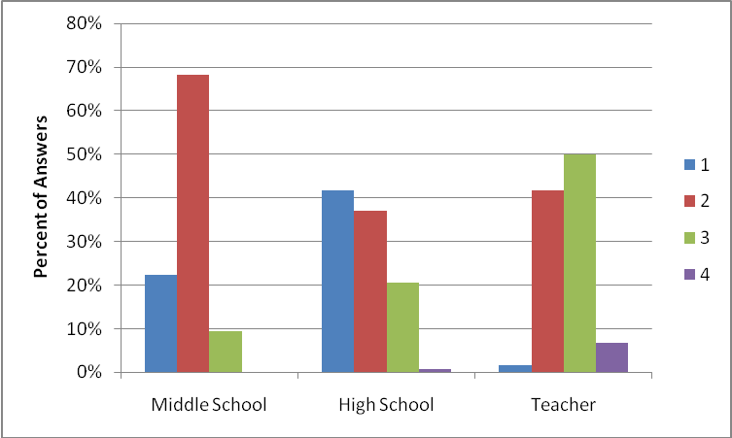
Figure 2: Student and teacher answers for the oyster question, grouped by levels, based on assessments taken during the 2009-2010 school year. N=127 high school students, 161 middle school students, and 120 teachers.

Levels
4 | Student answers at a level 3 and in part D of the question, the student talks about how the change in the abiotic factor by the organism has affected some aspect of matter and energy acquisition by other organisms
3 | Student acknowledges predator-prey and other interactions (e.g. providing shelter or habitat). Student states more than one abiotic factor (e.g. sunlight, oxygen) AND explicitly links the abiotic factor to the trait of the organism that affected it.
2 | Student mentions predator-prey (one organism eating another) interactions only, doesn't recognize how organisms affect abiotic environment or says only one abiotic thing (e.g. soil) and doesn't connect it as an interaction.
1 | Student sees organisms as helping or harming; sees anthropomorphic result of interaction as good or bad; essentially not recognizing interactions with other biota.
Figure 3: Rubric for biotic-abiotic-biotic questions on the teaching experiment assessment.
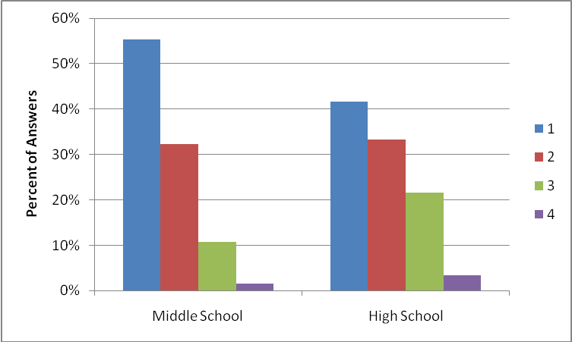

Figure 4: Biotic-abiotic-biotic question from the teaching experiment assessments during the 2010-2011 school year. N= 181 middle school students, 78 high school students.

Literature Cited
Barman, C.R. and D.A. Mayer. 1994. An analysis of high school students’ concepts & textbook presentations of food chains and food webs. The American Biology Teacher. 56(3):160-163.
Covitt, A.B., Tan., E., Tsurusaki, K.B., & W. C. Anderson. 2009. Students’ use of scientific knowledge and practices when making decisions in citizens’ roles. Paper presented at the Annual Converence of the National Association for Research in Science Teaching, Garden Grove, April 17-21, 2009.
Gotwals, A.W. and N.B. Songer. 2009. Reasoning up and down a food chain: using an assessment framework to investigate students’ middle knowledge. Science Education :2-23.
Griffiths, A. K., & Grant, B. A. C. 1985. High school students' understanding of food webs: Identification of learning hierarchy and related misconceptions. Journal of Research in Science Teaching, 22(5), 421-36.
Grotzer, T.A. and B. Bell Basca. 2003. How does grasping the underlying causal structures of ecosystems impact students understanding? Journal of Biological Education. 38: 16-29.
Hogan, K. 2000. Assessing students’ systems reasoning in ecology. Journal of Biological
Education. 35 (1): 22-26.
Kempton, W., Boster, J. S. and J. A. Hartley. 1996. Environmental Values in American Culture. MIT Press, Boston.

Lin, C.Y. and R. Hu. 2003. Students understanding of energy flow and matter cycling in the context of the food chain, photosynthesis, and respiration. International Journal of Science Education, 25(12), 1529-1544.

Magntorn, O. and G. Hellden. 2007. Reading nature from a ‘bottom-up’ perspective. Journal of Biological Education. 41(2):68-75.
Munson, B. H. (1994). Ecological misconceptions. Journal of Environmental Education. 24(4): 30-34.
Notin, K., Berkowitz, A. and M. McLean. In preparation. Lyme disease and interaction webs: middle school students’ understanding of complex interactions.

Reiner, M. 2001. Conceptual classroom environment-A system view of learning. International Journal of Science Education. 23(6):551-568.

Sander, E., Jelemenska, P. and U. Kattman. 2006. Towards a better understanding of ecology. Journal of Biological Education. 40(3): 119-123.

Strayer, D. L., M. L. Pace, N. F. Caraco, J. J. Cole, and S.E.G. Findlay. 2008. Hydrology and grazing jointly control a large-river food web. Ecology 89(1):12-18.

Wootton, J.T., M.S. Parker, and M.E. Power. 1996. Effects of disturbance on river food webs. Science 273(5281):1558-1561.

Appendix A: Interactions Assessment Questions
Interactions 2009 Pilot
The graph above shows the response of phytoplankton (microscopic floating plants) in the Hudson River to the zebra mussel invasion, designated by the line at 1991 (when the invasion was first noticed). Zebra mussels are filter feeders that get food from the water by straining out food particles they take into their bodies.
  - Describe what happened to the phytoplankton population. Explain why you think this change occurred.
  - How could this change affect other parts of the Hudson River food web? Think about the other animals that might eat phytoplankton. If you’re not sure, explain what you would need to know in order to answer the question.
  - Would this change in phytoplankton affect any of the abiotic factors in the river? Why or why not?
  - Imagine you return to the river in 10 years, and you find that the phytoplankton population has returned to pre-invasion levels. Explain why this may have happened. What else would you need to know in order to answer the question?

Interactions: Oysters & Algae 2010

Oysters are filter feeders that live in the ocean. They eat plankton (microscopic marine organisms).
A. What kinds of things do you think could cause a change in the amount of plankton in the water?

B. Explain how oysters and plankton interact with each other. Think about how one organism might help or harm the other.
C. If the number of oysters decreases, how might that impact the plankton population?
How long do you think would that take?
What else would you need to know to feel confident about your answer?
D. What kind of information would you need to figure out how a decline in oysters might affect other parts of the ecosystem, besides the plankton?

Teaching Experiment Question: Biotic-Abiotic-Biotic
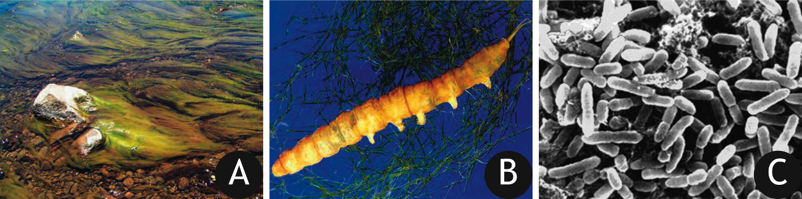
6. Look at the pictures above and decide which one you want to answer questions about. Which one would you pick?
A B C
- What does the living thing you picked eat? How does it get its food?

- What abiotic (non-living) factors does it change as it gets its food?

- What kinds of living things would be affected by the changes you described in Part B?

- In what way would the living things you listed in Part C be affected?

Appendix B: Interview Protocol – Biodiversity January 2011
These interviews will be recorded.
Main ideas: Level four students can trace changes in the population of the focus organism to both biotic components of the ecosystem (changes in population of predator or prey of the focus organism) AND the abiotic resources and/or conditions of the ecosystem.
- Students will read and answer, on paper, the “Oysters” question from the biodiversity test. Then, ask students to read the questions aloud and discuss them.
- Use a set of cards that have pictures of the main organisms in the Chesapeake Bay. Ask students to arrange the connections, while asking them why they are putting the cards where they are and asking them to explain the relationships between the organisms. This is an opportunity to ask or observe which organisms/connections they have a hard time understanding, the order they place the organisms, etc. Ask them to diagram out their connections and label it with their code.
- Students will then be given a list of questions that they will use to ask the interviewer more about the food web scenario, focusing on the oyster. Using these questions, the student can fill in the arrows to represent the flow of energy in the system and clarify any questions he/she may have.
- What does my organism eat?
    - Does eating its food change the resources available for other living things in the ecosystem? Or, what else eats your organisms’ food?
    - Does eating its food change anything about the ecosystem?
    - Or, does decreasing the food source in the ecosystem change abiotic conditions?
- What eats it?
- What does my organism need in order to survive, besides food?
- Ask students to fill in the resources/conditions chart.
- Ask the student to add the relevant resources/conditions cards to the visual & the diagram.

Positive and Negative Relationships
- Ask students to place positive and negative signs on the arrows to show the nature of the connections, starting with the oyster.
  - If students have trouble with this, say: “If you were the oyster, which organisms would have a positive impact on you? A negative impact?
Strength and Time lags
- Tell the students that they oyster population has doubled in size.
  - How did this happen? What might have caused it? Use the cards to show what is going to happen now that there are more oysters.
  - As they make changes, ask how long is it going to take for that change to occur?
- If I asked you to create a big change, or disruption, in the ecosystem by getting rid of only one organism, which one would you get rid of? Why?
Variability
- A long time ago, the Chesapeake Bay was full of oysters. Now, we only have 1% of the original population left. How do you think that decline in oysters would impact the food web you created?
- What would happen if you increased both the fish and the osysters?
- Imagine you are a scientist in the future. You have come back to the Chesapeake Bay in 2111, exactly one hundred years from now. You discover that the oyster population has doubled in size. How might this have happened? What are the consequences of this change? Which organisms would be most impacted?
Transfer
- Ask students to read the article “Wolves Return to Yellowstone” and create a similar diagram to the one from the Chesapeake Bay. Then, ask the student to answer the questions about the wolves:
  - What does my organism eat?
    - Does eating its food change the resources available for other living things in the ecosystem? Or, what else eats your organisms’ food?
    - Does eating its food change anything about the ecosystem?
    - Or, does decreasing the food source in the ecosystem change abiotic conditions?
  - What eats it?
  - What does my organism need in order to survive, besides food?
  - Have the student fill in the resources/conditions chart.

Appendix C: Student Scaffolding Tool

January 2011; Biodiversity Interactions Interview
Student Code:
School:
Grade:

Questions you should ask when deciding what impact a change will have in any ecosystem:
    - What is my organism?
    - What does it eat?
      - Does eating its food change the resources available for other living things in the ecosystem? Or, what else eats your organisms’ food?
      - Does eating its food change anything about the ecosystem? Or, does decreasing the food source in the ecosystem change abiotic conditions?
    - What eats it?
    - What does my organism need in order to survive, besides food?
      - Examples of resources: sunlight, carbon dioxide, oxygen, water, food (glucose, other animals, plants, bacteria), nutrients
      - Examples of conditions: temperature, soil conditions, pH of soil or water, climate, dissolved oxygen, water clarity, wind speed
      - Make a chart of what your organism needs and organize it in the following way:
Resources | Conditions

    - Think about how changes in the food web might affect the resources or conditions of your ecosystem.
    - Think about how changes in the population of your organism might affect the resources or conditions of your ecosystem.

