

A Cross-cultural study: Comparing learning progression for
ENVIRONMENTAL LITERACY
Carbon-Transforming Process of Americna and chinses Student
Handout with 2010 NARST Presentation

Written by: Hui Jin, Li Zhan, Charles W. Anderson (Michigan State University)
Culturally relevant ecology, learning progressions and environmental literacy
Long Term Ecological Research Math Science Partnership
April 2010
Disclaimer: This research is supported by a grant from the National Science Foundation: Targeted Partnership: Culturally relevant ecology, learning progressions and environmental literacy (NSF-0832173). Any opinions, findings, and conclusions or recommendations expressed in this material are those of the author(s) and do not necessarily reflect the views of the National Science Foundation.

A Cross-cultural study: Comparing learning progression for
ENVIRONMENTAL LITERACY
Carbon-Transforming Process of Americna and chinses Student
Hui Jin, Li Zhan, Charles W. Anderson
Michigan State University

RESEARCH QUESTIONS:
- How do K-12 students from the US and China reason about carbon-transforming processes?
- How do American and Chinese students progress with respect to reasoning about carbon-transforming processes from elementary to high school?

FINDINGS
1. revised learning progression framework
Explaining Progress Variable |  | Naming Progress Variable
Level 4. Linking processes with matter and energy as constraints | Linking carbon-transforming processes at atomic-molecular, macroscopic, and global scales with matter and energy as constraints | Level 4. Scientific statements | MATTER: scientifically appropriate names for both reactants and products; both gases and solids/liquids named as material reactants or products  ENERGY: all forms of energy involved in the chemical change; heat as byproduct
Level 3. Changes of Molecules and Energy Forms with Unsuccessful Constraints | Link macro-processes with change of molecules and/or energy forms at atomic-molecular or global scale, but cannot successfully conserve matter/energy. | Level 3. Scientific words of organic molecules, energy forms, and chemical change | MATTER (organic molecules): glucose, C6H12O6, monosaccharide, glycogen, lipid, ATP, ADP, carbohydrate, hydrocarbon, octane;  ENERGY (bonds, energy forms): C-C bond, C-H bond, light energy, kinetic energy (American version), electrical energy, chemical energy, heat energy  PROCESS (chemical reaction): cellular respiration (American version), combustion (American version), oxidation, light reaction, dark reaction
 |  | Level 2.5. Easier scientific words with mixed meanings | MATTER: Fat, sugar, starch, organic matter, carbon, molecule, atom  ENERGY: stored energy, motion energy/动能  PROCESS: photosynthesis, decomposition/decomposer, chemical reaction/change, 燃烧，呼吸作用  OTHERS: chloroplast
Level 2. Force-dynamic accounts with hidden mechanisms | Link macro-processes with unobservable mechanisms or hidden actors (e.g., decomposer), but the focus is on enablers, actors, abilities, and results rather than transformation of matter and energy. | Level 2.5. Easier scientific words with mixed meanings
Level 2. Force-dynamic accounts with hidden mechanisms |  | Level 2. Hidden mechanism words | MATTER: carbon dioxide, oxygen, nutrients, gas (as in gas, liquid, and solid),  ENERGY: calories, electricity  PROCESS: digestion, digest, digestive system, break down  OHTERS: bacteria, fungi, micro organisms), cell, power plants
Level 2. Force-dynamic accounts with hidden mechanisms |  | Level 1.5. Easier hidden mechanism words | ACTOR: organs (e.g., lung, stomach, heart, etc.), machine parts (e.g., engine, cylinder, piston), material  ENABLER: fuels (e.g., gasoline, diesel, oil, coal, petroleum), heat
Level 1. Macroscopic force-dynamic accounts | Describe macro-processes in terms of the action-result chain: the actor use enablers to accomplish its goals; the interactions between the actor and its enablers are like macroscopic physical push-and-pull that does not involve any change of matter/energy. | Level 1.5. Easier hidden mechanism words
Level 1. Macroscopic force-dynamic accounts |  | Level 1. Words about actors, enablers, and results | ACTOR: body parts (e.g., leaves, roots, leg, etc.)  ENABLER: water, air, sunlight, food (e.g., food, milk, bread, etc.), bugs, wind, lighter, etc.  RESULT: strong, healthy, grow, run, warm, etc.
2. Distribution Graphs for Interview

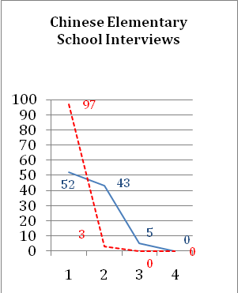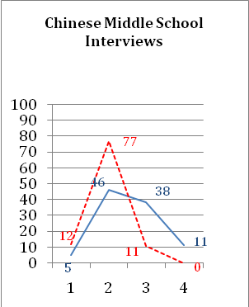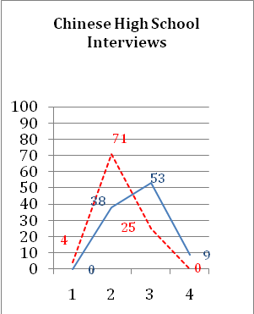
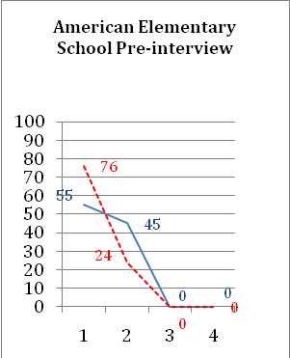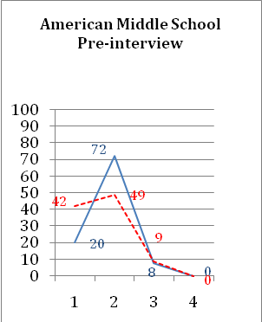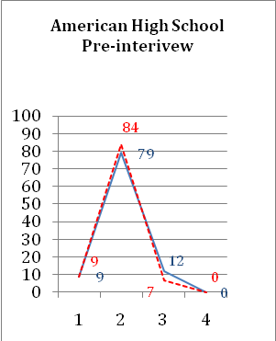

(Red Dash Line: explaining; Blue Line: naming) (Y: Percentage of account units; X: Level)

CONTACT US:
Environmental Literacy Research Project
http://edr1.educ.msu.edu/EnvironmentalLit/index.htm

jinhui@msu.edu, zhanli@msu.edu, andya@msu.edu

