A synthesis of current knowledge on forests and carbon
storage in the United States
Reading to accompany Carbon Sequestration Citizenship Mini-Unit

Written by: McKinley, Duncan C., et.al.
Culturally relevant ecology, learning progressions and environmental literacy
Long Term Ecological Research Math Science Partnership
2012
Disclaimer: This research is supported by a grant from the National Science Foundation: Targeted Partnership: Culturally relevant ecology, learning progressions and environmental literacy (NSF-0832173). Any opinions, findings, and conclusions or recommendations expressed in this material are those of the author(s) and do not necessarily reflect the views of the National Science Foundation.


A synthesis of current knowledge on forests and carbon
storage in the United States
Author:McKinley, Duncan C., et.al.

Source: ECOLOGICAL APPLICATIONS Volume: 21 Issue: 6 Pages: 1902-1924
Published: SEP 2011
Readability Level: 12+

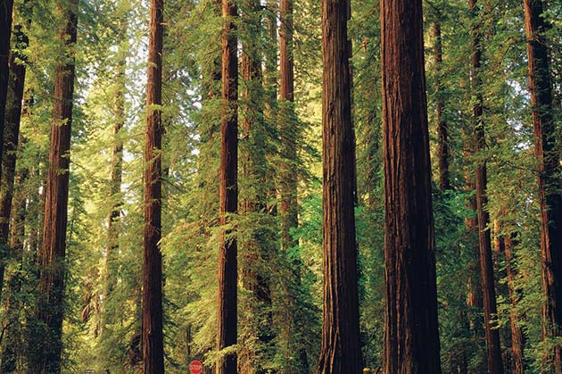
Abstract: Using forests to mitigate climate change has gained much interest in science
and policy discussions. We examine the evidence for carbon benefits, environmental and
monetary costs, risks and trade-offs for a variety of activities in three general strategies:
(1) land use change to increase forest area (afforestation) and avoid deforestation;
(2) carbon management in existing forests; and (3) the use of wood as biomass energy,
in place of other building materials, or in wood products for carbon storage.

We found that many strategies can increase forest sector carbon mitigation above the
current 162-256 Tg C/yr, and that many strategies have co-benefits such as biodiversity,
water, and economic opportunities. Each strategy also has trade-offs, risks, and
uncertainties including possible leakage, permanence, disturbances, and climate
change effects. Because; similar to 60% of the carbon lost through deforestation
and harvesting from 1700 to 1935 has not yet been recovered and because some
strategies store carbon in forest products or use biomass energy, the biological
potential for forest sector carbon mitigation is large. Several studies suggest that
using these strategies could offset as much as 10-20% of current U. S. fossil fuel
emissions. To obtain such large offsets in the United States would require a
combination of afforesting up to one-third of cropland or pastureland, using the
equivalent of about one-half of the gross annual forest growth for biomass energy,
or implementing more intensive management to increase forest growth on one-third
of forestland. Such large offsets would require substantial trade-offs, such as lower
agricultural production and non-carbon ecosystem services from forests. The
effectiveness of activities could be diluted by negative leakage effects and
increasing disturbance regimes.

Because forest carbon loss contributes to increasing climate risk and because
climate change may impede regeneration following disturbance, avoiding
deforestation and promoting regeneration after disturbance should receive
high priority as policy considerations. Policies to encourage programs or projects
that influence forest carbon sequestration and offset fossil fuel emissions should
also consider major items such as leakage, the cyclical nature of forest growth
and regrowth, and the extensive demand for and movement of forest products
globally, and other greenhouse gas effects, such as methane and nitrous oxide
emissions, and recognize other environmental benefits of forests, such as
biodiversity, nutrient management, and watershed protection. Activities that
contribute to helping forests adapt to the effects of climate change, and which
also complement forest carbon storage strategies, would be prudent.

