Effects of management on carbon sequestration in forest biomass in Southeast Alaska.
Reading to accompany Carbon Sequestration Citizenship Mini-Unit

Written by: Leighty, W., Hamburg, S., & Caouette, J.
Culturally relevant ecology, learning progressions and environmental literacy
Long Term Ecological Research Math Science Partnership
2012
Disclaimer: This research is supported by a grant from the National Science Foundation: Targeted Partnership: Culturally relevant ecology, learning progressions and environmental literacy (NSF-0832173). Any opinions, findings, and conclusions or recommendations expressed in this material are those of the author(s) and do not necessarily reflect the views of the National Science Foundation.


Effects of management on carbon sequestration in forest biomass in Southeast Alaska. Ecosystems, 9 (7) 1051-1065.

Tg of Carbon (1 Teragram = 1012 grams)

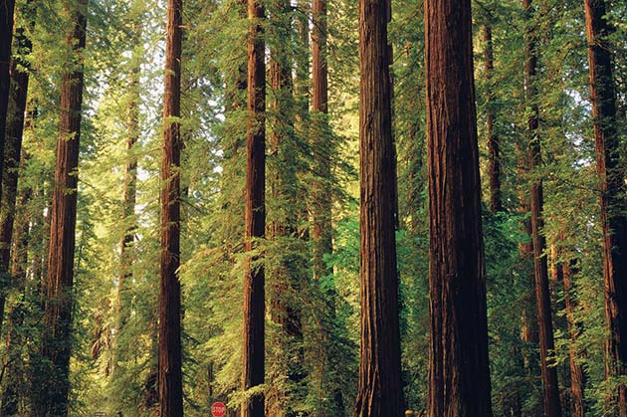
"The Tongass National Forest (Tongass) is the largest national forest and largest area of old-growth forest in the United States. Spatial geographic information system data for the Tongass were combined with forest inventory data to estimate and map total carbon stock in the Tongass; the result was 2.8 +/- 0.5 Pg C, or 8% of the total carbon in the forests of the conterminous USA and 0.25% of the carbon in global forest vegetation and soils. Cumulative net carbon loss from the Tongass due to management of the forest for the period 1900-95 was estimated at 6.4-17.2 Tg C.
Using our spatially explicit data for carbon stock and net flux, we modeled the potential effect of five management regimes on future net carbon flux. Estimates of net carbon flux were sensitive to projections of the rate of carbon accumulation in second-growth forests and to the amount of carbon left in standing biomass after harvest. Projections of net carbon flux in the Tongass range from 0.33 Tg C annual sequestration to 2.3 Tg C annual emission for the period 1995-2095. For the period 1995-2195, net flux estimates range from 0.19 Tg C annual sequestration to 1.6 Tg C annual emission.
If all timber harvesting in the Tongass were halted from 1995 to 2095, the economic value of the net carbon sequestered during the 100-year hiatus, assuming $20/Mg C, would be $4 to $7 million/y (1995 US dollars). If a prohibition on logging were extended to 2195, the annual economic value of the carbon sequestered would be largely unaffected ($3 to $6 million/y). The potential annual economic value of carbon sequestration with management maximizing carbon storage in the Tongass is comparable to revenue from annual timber sales historically authorized for the forest."

Full Citation:

Leighty, W., Hamburg, S., & Caouette, J. (2006).Effects of management on carbon sequestration in forest biomass in southeast Alaska.Ecosystems, 9 (7) 1051-1065.

