Teaching Experiments and the Carbon Cycle Learning Progression
2009 AERA Paper
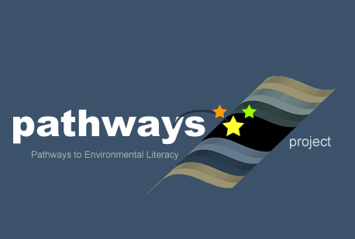
Written by: Lindsey Mohan and Andy Anderson (Michigan State University)
Culturally relevant ecology, learning progressions and environmental literacy
Long Term Ecological Research Math Science Partnership
April 2009
Disclaimer: This research is supported by a grant from the National Science Foundation: Targeted Partnership: Culturally relevant ecology, learning progressions and environmental literacy (NSF-0832173). Any opinions, findings, and conclusions or recommendations expressed in this material are those of the author(s) and do not necessarily reflect the views of the National Science Foundation.


Teaching Experiments and the Carbon Cycle Learning Progression
Lindsey Mohan and Andy Anderson
Michigan State University

Introduction

Our work on the Environmental Science Literacy Project documents the investigating, accounting, and decision-making practices students use to reason about processes that occur in natural and human social systems. The carbon cycle strand of this project focuses on accounting for the movement of carbon through different systems and processes. At the macroscopic scale the processes include growth, weight loss, decay and burning. At the large scale the processes include the movement of carbon between reservoirs and global warming. The goal of our work has been to develop a learning progression that describes how accounts of carbon cycling processes develop from grades 4-12, with a particular focus on students’ reasoning about matter, energy, and scale.
In this paper, we first describe the learning progression framework that has emerged from our work over the past six years. Next, we discuss the aspects of students’ starting knowledge as a source for revising the framework and assessments, and developing teaching materials. We consider the different tools we have developed to support students in making progress on reasoning about matter, energy and scale. We conclude with a discussion of the criteria we use for validation of the learning progression, and an update on our progress meeting those criteria.

The Carbon Cycle Learning Progression Framework

The carbon cycle learning progression has developed using an iterative approach, where assessment data and framework development have informed each other. We first developed an initial framework, used the framework to develop assessments, then used assessment data (as well as other sources of information) to revise the framework. What emerged from several years of work was a carbon cycle learning progression grounded in empirical data from classrooms. The learning progression encompassed a large domain of content transcending the traditional boundaries that define life, earth, and physical sciences, as well as social sciences. It is important to point out, however, that our current learning progression is largely based on student reasoning in status-quo teaching. Although we are currently conducting teaching experiments (which we will discuss later in the paper), our current framework has emerged from classrooms without instructional intervention. We do not see this learning progression as a “base-line” progression, but rather one learning trajectory that is currently more the norm than the exception in American classrooms (based mostly on data from Michigan and Washington state).
Our learning progression framework includes a Lower Anchor (level 1) that describes what students know and can do at upper elementary level. The progression also includes an Upper Anchor (level 4) based mostly on what we (i.e., science educators) would hope students would know and do by the end of high school. There are two transitional levels (levels 2 and 3) that describe intermediate levels of reasoning between the two anchor points. Our research indicates that Upper Anchor reasoning, while obtainable by high school students, is quite rare (Mohan, Chen, & Anderson, in press). We have come to believe that achieving Upper Anchor reasoning requires substantial shifts in students’ discourse, knowledge, and practice.
Changes in Discourse
By “discourse” we mean general ways of thinking and manner of talking about the world. We all participate in multiple discourses, including our primary discourse—the ways of thinking and talking that we acquire in our homes and families—and secondary discourses that we encounter in school, church, work, etc (Gee, 1996). Discourses are associated with communities of practice: groups of people who share common activities, values, and ways of talking and thinking. We are especially interested in one secondary discourse: scientific discourse, which has been developed in scientific communities of practice.
Level 1 (force dynamic) discourse. Students acquire a “theory of the world” as they learn to speak grammatical English and experience everyday events. Although all students do not share the same primary discourse, linguists such as Stephen Pinker (2007) and developmental psychologists such as Leonard Talmy (1988) argue that there is a “theory of the world” built into the basic grammar of our language, so we all must learn that theory in order to speak grammatical English. Level 1 discourse, the way of talking about the world that is built into our everyday language, explains the events of the world in terms of actors and abilities, enablers, and purposes.
- Actors and abilities. The events of the world are largely caused by actors in accord with their abilities. Humans have the most abilities, followed by animals, then plants. Dead things have no abilities, even to preserve themselves, so they decay away or are acted on by other actors. Non-living entities such as flames and machines can also be actors with limited abilities.
- Needs or enablers. In order to use their abilities and fulfill their purposes, actors have needs. For example, a tree needs soil, water, air, and sunlight to grow. A flame needs heat, fuel, and air to burn.
- Purposes and results. Actors have goals or purposes, and the results of events are are generally the fulfillment of the actors’ purposes. Higher level actors can have many purposes, so animals grow, move, think, etc. Lower level actors have fewer purposes, so the main purpose of a tree is to grow; the main purpose of a flame is to burn.
- Events or actions. So the events of the world (such as trees growing, flames burning, people running, etc.) take place when actors have all their needs, so that they are able to achieve their purposes. Sometimes there are conflicts between different actors with different purposes (such as when the wolf wants to eat and the deer wants to live). In those cases, the more powerful actor prevails.
- Settings or scenes for the action. Finally, there are settings or scenes for the action, including air, earth, water, stones, etc. Unless the settings fulfill the needs of particular actors, they normally don’t get a lot of attention in force dynamic accounts.
So the world as constructed by everyday English is dominated by actors (including people, animals, plants, flames, and machines), who fulfill their needs and accomplish their purposes. When actors come into conflict, the more powerful actor can control what happens. Understanding the world means understanding the powers, needs, and purposes of all the different actors.
Level 4 (scientific) discourse. Even though scientists may speak in English, scientific discourse has constructed an entirely different kind of world. Instead of actors in settings scientists see a hierarchy of dynamic systems at different scales. Instead of powers and purposes scientists see laws—fundamental principles that govern the working of the systems. We have organized our learning progression around three key principles: the hierarchy of systems and scales, conservation and cycling of matter, conservation and degradation of energy.
- Hierarchy of systems and scales. The world is organized into dynamic systems that have structures at multiple scales (we are concerned about atomic molecular to global scales). The systems are dynamic in that matter and energy are constantly flowing through them and being changed by them.
- Conservation and cycling of matter. Matter flows through smaller systems and cycles within larger systems, such as ecosystems or earth systems. In chemical and physical changes it always obeys conservation laws at two scales:
  - Conservation of mass. There is a quantitative conservation law that applies at all scales. The mass of the material products of a chemical or physical change is equal to the mass of the inputs or reactants.
  - Conservation of atoms. There is also a version of this law that explains what qualitative changes in substances are possible. At a macroscopic scale, the rules seem completely arbitrary: Why is it possible to change carbon dioxide and water into glucose but impossible to change lead into gold? At an atomic molecular scale, though, those rules make perfect sense: Chemical processes can rearrange atoms into new molecules, but they never create or destroy atoms.
- Conservation and degradation of energy. Energy is an elusive entity. Light, heat, sound, glucose, height, motion, etc., don’t appear on the surface to have much of anything in common. If we can learn to recognize and measure the different forms of energy in a system, we can use two other laws that constrain all processes.
  - Conservation of energy. Energy is like matter in that it is not created or destroyed in physical and chemical changes. The total amount of energy at the end is the same as the amount of energy in the beginning. (This is the First Law of Thermodynamics.)
  - Degradation of energy. Energy is not like matter in that it cannot be recycled. All processes change energy from more useful to less-useful forms, especially low-grade heat. (This is the Second Law of Thermodynamics.)
One important conclusion from our work, and our experiences in classrooms, is the following: When students enter school they use force-dynamic narratives to explain how the world works. In Gee’s (1996) terms, this is the students’ primary discourse. The information they learn in science class teaches them more detailed narratives and new vocabulary, and students try to fit the new information into their existing narratives. Thus, students tell the same stories with more details, instead of learning new, more principled accounts about their world. This is what we have seen in students’ discourse in the learning trajectory we documented over the past few years.

Changes in Practice
The Environmental Science Literacy project is ultimately interested in three practices that are essential for environmentally responsible citizenship, represented in Figure 1 below. Our work in the carbon strand thus far has focused on the practice of accounting—accounts that explain and predict what is happening in a situation.

Figure 1: Framework for analyzing students’ decision-making discourses and practices
Discourses: Communities of practice, identities, values, funds of knowledge

Explaining and Predicting (Accounts)
What is happening in this situation? What are the likely consequences of different courses of action?

Investigating
What is the problem?
Who do I trust? What’s the evidence?
Deciding

What will I do?

Level 1 explaining and predicting practices. Level 1 students explain and predict using the language and theories of force dynamic discourse. A good explanation identifies the three key elements that determine the course of an event: the actors and their abilities, the needs or enablers, and purposes or results. Aspects of settings (air, water, earth, etc.) are not important unless they satisfy needs of actors. A good prediction concerns whether actors achieve their purposes. They can achieve their purposes if they have all the necessary enablers and if there are no antagonists or opposing actors. If there are antagonists, then the outcome depends on which actor has greater powers (i.e., the interplay of forces).
Level 4 explaining and predicting practices. Level 4 students explain and predict using the language and theories of scientific discourse. A good explanation connects observations to patterns and models. We are particularly interested in explanations that trace matter and energy through processes that transform carbon from organic to inorganic forms and back, using the key principles of matter, energy, and scale. A good prediction uses data about the particular situation with the laws of nature—models that follow principles—to determine the movement and transformations of matter and energy.

Changes in Knowledge
Knowledge is embedded within discourses and practices, so students at different levels have very different ideas about what they need to know. Figure 2 shows how we have organized the domain of knowledge at the Upper Anchor with respect to carbon cycling processes.

Figure 2: Loop diagram for carbon cycling in socio-ecological systems
Human Impact: Waste from human energy use (CO₂)

Environmental Systems

Human Social and Economic Systems

Human Actions in
Roles such as:

Consumers
Voters
Workers
Learners

CO₂ emissions

Atmosphere (Physical Systems)
(composition of air; atmospheric CO₂)

Oxidation of organic carbon & Energy dissipation (respiration, combustion)
Generation of organic carbon & Harnessing of energy (photosynthesis)

Biosphere (Biological Systems)

Transformation of organic carbon & Passing on of energy
(biosynthesis/growth, digestion, food chains, sequestration)

Combustion

Food & Fuels

Environmental system services: Foods and fuels as the sources for energy use

Level 4 knowledge. The Loop Diagram specifies that scientifically literate citizens need to be able to interpret the boxes and arrows of Figure 2 in terms of chemical models. The right-hand Environmental Systems box includes the familiar ecological carbon cycle, which students need to understand at multiple scales—as atomic-molecular, cellular, organismal, and ecological processes. It highlights carbon-transforming processes in environmental systems, as well as the process of combustion that connects environmental systems to the needs and impact of human systems. We grouped the processes into those that generate organic carbon through photosynthesis, those that transform organic carbon through biosynthesis, digestion, and food chains, and those that oxidize organic carbon through cellular respiration and combustion. We have chosen to organize the Upper Anchor around these processes because they are the means by which living and human systems acquire energy and the means by which environmental systems regulate levels of atmospheric CO₂.
The goal of science is to build up coherent systems that help us explain and predict the world around us. Figure 2 is one representation of a coherent system that traces matter and energy through systems at multiple scales. Table 1 shows the contrast between knowledge (and organization of knowledge) at the Upper Anchor with that of the Lower Anchor.

Table 1: Contrasting ways of grouping carbon-transforming processes
Upper  Anchor | Carbon-transforming process | Generating organic carbon | Transforming organic carbon |  |  | Oxidizing organic carbon
Upper  Anchor | Scientific accounts | Photosynthesis | Biosyn-thesis | Digest-ion | Biosyn-thesis | Cellular respiration |  | Combus-tion
Macroscopic events |  | Plant growth |  | Animal growth |  | BreathingExercise  Weight loss | Decay | Burning
Lower Anchor:  Informal accounts |  | Natural processes in plants and animals, enabled by food, water, sunlight, air, and/or other things |  |  |  |  | Natural process in dead things | Flame consuming fuel

Level 1 knowledge. Students at level 1 feel a need to know facts about the world, organizing their world based on actors (as opposed to processes). Actors are organized into living things, machines, and flames. The students pay particular attention to the different needs and abilities of these actors, and to the outcomes of events that involve actors struggling to fulfill their natural tendencies. Dead things have lost their capacity to be actors (students often say that they “have no energy”), so they are prone to decay. In this way, understanding enablers and potential antagonists are important for building coherent stories about actors.

Units of Analysis
The learning progression framework we developed has the general structure represented in Table 2. This framework identifies a unit of analysis: Learning performances. It organizes students’ learning performances according to (a) practices, principles and processes and (b) Levels of Achievement.

Table 2: Learning Progression Framework for Carbon

Levels of Achievement | Practices, principles, and processes
Levels of Achievement | Practices: Inquiry, accounts, decisions | Principles: Matter, energy, scale | Linking processes
4: Qualitative model-based accounts | Learning performances for specific processes  and Levels of Achievement:  Inquiry, accounts, citizenship decisions about processes in socio-ecological systems
3: “School science” narratives
2: Force-dynamic with hidden mechanisms
1: Force-dynamic narratives
Practices, principles, and processes are our versions of what is sometimes referred to in the literature on learning progressions as “big ideas” (Catley, Lehrer, and Reiser, 2005; NRC, 2007, Chapter 8; Smith, et al., 2006). These are aspects of knowledge and practice that are present in some form at all Levels of Achievement, so their development can be traced across Levels. Our practices, principles and processes are derived partly from theories about how knowledge and practice are organized and partly from empirical research on assessment and student reasoning (Briggs, Alonzo, Schwab, & Wilson, 2004; Wilson, 2005, Draney & Wilson, 2007).
Practices. Our work on carbon has focused on the practice of “accounts” that explain and predict. Therefore, learning performances are in the form of accounts of processes in socio-ecological systems (e.g., accounts of tree growth or photosynthesis; accounts of combustion of gasoline, etc).
Linking Processes. Since learners who rely on different discourses see the world in fundamentally incompatible ways, one of the challenges in developing a learning progression framework is identifying phenomena that both Lower Anchor and Upper Anchor learners can describe and explain in their own terms. We wanted to look at how students accounted for different macroscopic and large-scale processes, but initially based our assessment items on the macroscopic events in Table 1 because the events are shared by most people, allowing students of different ages (and levels of reasoning) to account for the same or similar events.
Principles. Our assessment items asked students to explain and predict how materials and energy change during events (e.g., where the mass of a tree comes from, what happens to the mass of fat when a person loses weight, etc). These accounts can be furthered examined according to three important features:
- Inputs
  - Enablers that do not distinguish matter and energy at Lower Anchor
  - Material reactants and chemical energy at Upper Anchor
- Agents/Systems/Processes
  - Powers and abilities of agents at Lower Anchor
  - Transformation of matter and energy during chemical processes at Upper Anchor
- Outputs
  - Results of the interplay of forces at Lower Anchor
  - Material and energy products at Upper Anchor
Levels of Achievement are patterns in learners’ knowledge and practice that extend across practices, principles, and processes (see Mohan et al., in press). The four Levels of Achievement in our learning progressions describe performances we have seen in students from middle school through adult professionals (teachers).
Learning Performances are the contents of the individual cells of Table 1: the specific practices characteristic of students who are at a particular Level of Achievement and reasoning about a particular practice, process, and principle. The Learning Performances should be consistent with their position in Table 1, but they also provide specific predictions about student reasoning and student learning that can be used to develop assessment items and tested empirically.

Current Learning Progression
Levels 1 and 4 have been described in some detail above, but we have also documented intermediate levels—levels 2 and 3—in which students show increasing sophistication in their accounts. Figure 3 shows the current carbon cycle learning progression (green arrows), and a desirable alternative we are testing in our teaching experiments (blue arrows).

Figure 3: Conventional and Desirable Learning Trajectories (from Jin, 2009)

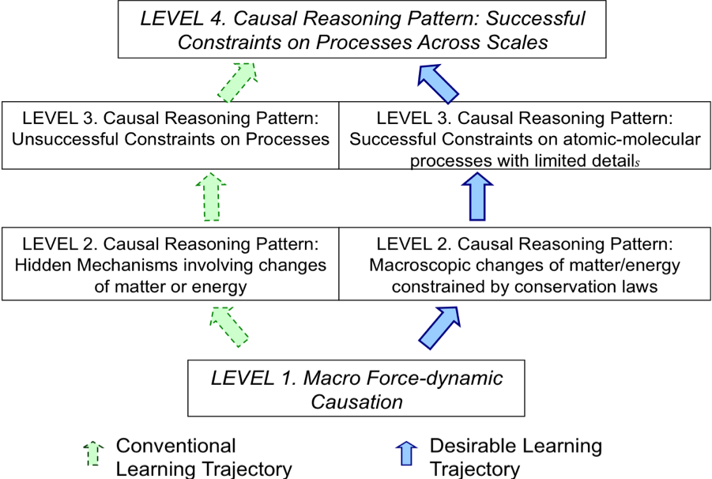

The learning trajectory illustrated by the green arrows show the Levels of Achievement we observed in classrooms with very little to no instructional intervention. We will briefly describe the intermediate levels in this learning progression, and then spend the latter half of the paper discussing how our current learning progression has helped us propose a desirable trajectory based on aspects of students’ starting knowledge, and using tools we believe will be supportive for students in reasoning about matter, energy and scale.
Intermediate Levels
Level 2 was prevalent among all age groups (39% of elementary students, 44% of middle school students, 40% of high school students, from Mohan et al., in press). An important characteristic of level 2 reasoning was the emergence of “hidden mechanisms” to explain macroscopic events (i.e., changes resulted from internal or invisible parts and mechanisms, such as organs (e.g., lungs, stomach), decomposers, and gases (CO₂, O₂)). Even though level 2 accounts continued to focus mostly on observable enablers supporting the actors, they also accounted for observable products (e.g., dead tree becoming soil). For this reason, level 2 students were mostly committed to conservation of solids and liquids. Thus, they recognized that gases as materials, and sometimes used chemical names for the most familiar ones: oxygen and carbon dioxide. They recognized oxygen and carbon dioxide as enablers or products of processes in plants, animals, and burning materials. For example, they recognized oxygen must be present for breathing and burning, but treated it as a condition, or enabler, as opposed to a material that is combined with other materials.
Level 2 students appeared to rely on two key cycles involving changes in materials as shown in Figure 4—the solid-solid and gas-gas (CO₂-O₂) cycles. The solid-solid cycle followed food through food chains, which later became soil and nutrients through decay that were reabsorbed by plants. The gas-gas cycle followed carbon dioxide and oxygen between plants and animals (i.e., people take in oxygen and exhale carbon dioxide, while the opposite is true for plants). The cycles were an important achievement of level 2 reasoning because the students paid attention to the flow of materials through systems at the macroscopic and “hidden” scales. The cycles were also indicative of how level 2 students still treated gases as ontologically different from solids and liquids—that is, while gases were recognized as materials, level 2 students did not see gases as having mass like other solid and liquid materials.
Figure 4: Gas-gas and solid-solid cycles at level 2
Animals
Plants
Carbon dioxide
Oxygen
The oxygen-carbon dioxide cycle
Decay
Plants
Nutrients, soil
Food chain
The solid-solid cycle

Level 3 is an understanding of matter transformation observed mostly among high school students (35% of high school students, from Mohan et al., in press). In contrast with level 2 students who showed little awareness of chemical processes, level 3 students tried to explain both life processes and combustion in chemical terms (i.e., the hidden mechanisms observed at level 2 were replaced by mechanisms for chemical change). Level 3 accounts recognized the transformation of matter as essential to carbon-transforming processes, but their accounts were limited by their lack of understanding of chemical substances and their continued use of energy as a “fudge factor”—to account for materials that seemed to mysteriously appear or disappear. They had a general commitment to tracing matter, recognizing that the materials in objects and organisms have to come from somewhere and go somewhere, but still resorted to matter-energy conversions rather than solid-gas conversions. Like level 2 students, level 3 students were reluctant to attribute mass gain and loss to gases. Thus, they were unsuccessful at using conservation of matter or conservation of energy as constraints on processes.
About 10% of high school students demonstrated level 4 reasoning, indicating to us that level 4 is obtainable by this age of students. This also indicates that the current trajectory is not the most efficient or successful means for progress toward level 4. We recognize that level 4 reasoning represents a major intellectual achievement, requiring substantial shifts in students’ discourse, practice and knowledge, and one that will need to be supported by sustained teaching of core scientific principles.

Work on Teaching Experiments: Matter, Energy and Scale

Aspects of students starting knowledge
The goal of our teaching experiments is to develop materials that will support students in making progress toward Upper Anchor reasoning, so that most students achieve level 4 reasoning before they leave high school. When working with a large age span of students, this means carefully thinking about reasonable expectations to have at each age level. Given that our current learning progression documented an unsuccessful trajectory to Upper Anchor reasoning, we had to determine the aspects of students’ starting knowledge at each level that we should capitalize upon in teaching experiments (i.e., the most important aspects of knowledge we should consider and build upon).
General Characteristics. The type of accounts given by students, no matter what age level, generally follow a structure that describes 1) inputs/enablers, 3) agents or systems and processes, and 3) products of purposes. Consider Figures 5 and 6. Students reasoning at level 1 describe needs or enablers (which may include materials, forms of energy, or conditions) that actors must have to accomplish their purpose. The results are usually not in material forms; matter is simply allowed to appear or disappear without accounting for it. At level 4, the inputs are distinguished in terms of matter and energy inputs, for particular processes, and the results are matter and energy outputs.

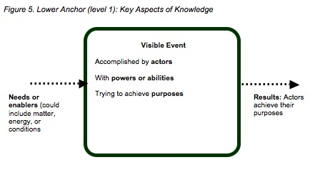

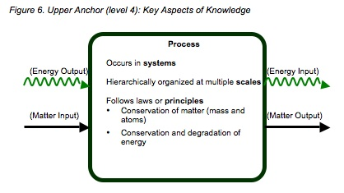

Unique Characteristics at each Level. In addition to following the general pattern described above, each level also has unique characteristics that describe the types of inputs, systems/processes, and outputs that students use at a particular level:
- Level 1 Enablers: Students at level 1 are aware of macroscopic enablers that actors need in order to fulfill their goals. These enablers may include materials and/or energy forms or conditions, but enablers are limited to the macroscopic scale (i.e., visible, tangible).
- Level 2 Gas-gas and solid-solid cycles: Students at level 2 have developed the idea of hidden mechanisms, indicating they have moved beyond the macroscopic scale, and moved beyond the idea of natural tendencies. They trace material and energy inputs and outputs (although not necessarily separating the two). The gas-gas and solid-solid cycles are an example of their attempts to trace materials.
- Level 3 Atoms, molecules, and chemical change: Students at level 3 know about materials at the atomic-molecular level. They know about atoms and molecules, and that molecules undergo chemical changes. They attempt to use chemical change (and the names of some chemical substances and processes) to account for matter and energy, but their commitment to conservation of gases is weak, and they often use energy as a “fudge factor” to account for mass change that should be attributed to gases.
Both the general patterns of students’ knowledge, and the unique characteristics of each level can be used to develop goals for a desirable learning trajectory. Table 3 summarizes our goals for how we would like students at each level to learn to explain matter and energy transforming processes. In elementary school we do not think that it is reasonable to expect students to switch to fully scientific discourse and practice, but students can learn to elaborate on their force dynamic accounts in ways make them aware of the hierarchy of systems and scale and help them start to trace matter and energy through systems (focusing particularly on distinguishing between different types of enablers, and helping them becomes more aware of gases as a form of matter). We believe that middle school students can learn how to use atomic molecular models to explain transformations of matter and energy, though without much chemical detail. High school students can master additional chemical details.

Table 3: Goals in our hypothetical (desired) learning progression

Level | Enablers or Inputs | Actors and Settings or Systems | Results: Purposes or Products
Level 1. Current elementary starting point | Needs or enablers | Abilities or powers of actors  Settings for events | Achieving purposes or goals of actors
New Level 2. Elementary goal | Different kinds of enablers:  --materials (solid, liquid, gas)  --energy sources  --conditions | Abilities of actors plus internal structure (organs, cells) and movement of materials and energy through settings and actors | Material products  --gas-gas cycles  --growth as matter moving into bodies  Energy products
New Level 3. Middle school goal | Material inputs, distinguishing organic from inorganic materials  Forms of energy, including chemical energy (C-C and C-H bonds) | Movement of materials through systems at multiple scales  Living systems made of organic materials | Changes in matter obeying conservation laws  Transformation and degradation of energy
New Level 4. High school goal | Material inputs with specific chemical identities  Energy inputs | Movement of atoms in molecules through systems at atomic-molecular to large scale socio-ecological systems | Material products tracing atoms between inorganic and organic forms  Transformation and degradation of energy

Tools For Principled Reasoning

Using the goals from Table 3 as a guide, and the key principles in our framework, we have developed teaching materials that contain tools we believe will help students make progress toward more sophisticated, and principled reasoning about matter, energy, and scale. These tools are built into all the teaching experiment materials, so students and teachers use the tools repeatedly across multiple topics and domains. Our tool are designed to support reasoning about the following principles:
- Conservation of Matter-Atoms
- Conservations of Matter-Mass
- Conservation of Energy
- Energy degradation
- Scale
Conservation of Matter and Energy. A key tool we use in our teaching experiments is called the Process Tool. This tool can be used to describe both macroscopic events (e.g., match burning) and chemical processes (e.g., combustion of wood) depending on the level of students, and the goals from Table 3. The process tool requires that students trace both matter and energy inputs and outputs (keeping the two separate). This tool was designed to support students in using conservation of matter and conservation of energy to reason about events or processes. Students are given a limited numbers of forms of matter—solids, liquids, and gases—that they can name using either macroscopic descriptors/language (e.g., food) or chemical identities (e.g., glucose: C₆H₁₂O₆). The tool also uses a limited number of energy forms—light energy, motion energy, chemical energy, electrical energy, and heat (they are also given a blank energy label for instances they need to talk about other energy forms, such as nuclear energy, gravitational potential energy, etc). Students much decide the matter inputs and the form of matter required for the event or processes. They do the same for energy inputs. Then students determine matter and energy outputs. See Figure 7 for an example of our process tool and Appendix A for additional examples. The process tool is used in the classroom in three forms: a 3x4 poster with Velcro or magnetic tabs for matter and energy labels, in student activity pages, and in powerpoints for the teacher to use during whole group instruction).

Figure 7. Snapshot of Process Tool
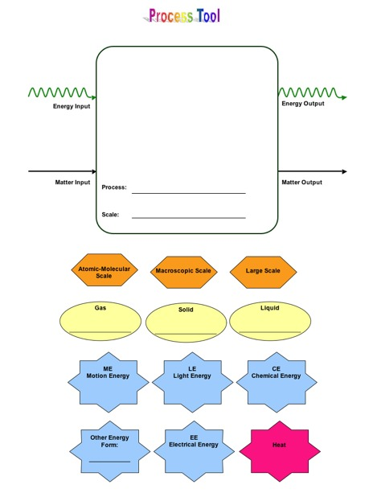

Note that “heat” is treated differently than other forms of energy. Heat has a different color in the process tool label in Figure 7 and is also noted with a different color in the process tool diagrams in Appendix A. We wanted to provide teachers with a way of helping students work on the principle of energy degradation. Where most energy transformations use a “green arrow”, transformations to heat energy use a “red arrow” indicating that this form of energy is no longer usable to organisms or objects. For example, the food chain diagram in Appendix A shows that chemical energy continues to move from organism to organism, but heat leaves the food chain.
In addition to the process tool, molecular models kits are used to help students conserve atoms and identify substances with chemical energy. When students build molecular models, they are taught a general rule of thumb for indentifying materials with chemical energy. They look for C-C and C-H bonds. In this way materials, such as foods and fuels, can be compared in terms of similarities in chemical structure. The students use the molecular models to simulate a chemical process, with a focus on the idea that chemical processes involve the rearrangement of atoms that result in both matter and energy transformations.

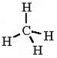
Figure 8. Example of Molecular Model Kit Activity

Methane burns by combining with oxygen in the air to make carbon dioxide and water vapor. One methane molecule reacts with 2 oxygen molecules:

CH₄ + 2 O₂ → CO₂ + 2 H₂O

 | Reactants and Products of the Chemical Change |  |  | Does the substance contain Energy
 | How many carbon atoms does it have? | How many oxygen atoms does it have? | How many hydrogen atoms does it have? | What type of bonds does the substance contain? (C-C, C-H, O-H, C-O, O=O) | Is the substance a source of chemical energy?  (yes or no)
Begin with…
Methane

Oxygen

End with…
Carbon Dioxide

Water

To help students work on conservation of mass, they use both the process tool and digital balances. Digital balances are used at all grade levels to measure mass change over time. For example, consider the following activity: students measure the mass change in a cup of crickets over a period of 1-2 days (without feeding crickets). They find that mass decreases and use the process tool to help identify where the mass has gone.

Figure 9: Example of Digital Balance Activity
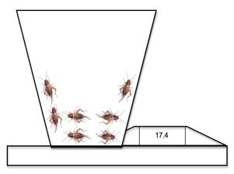
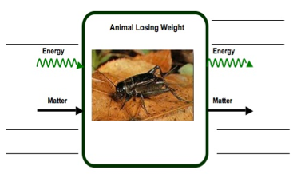
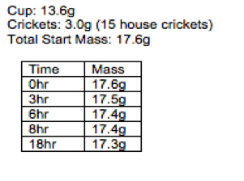

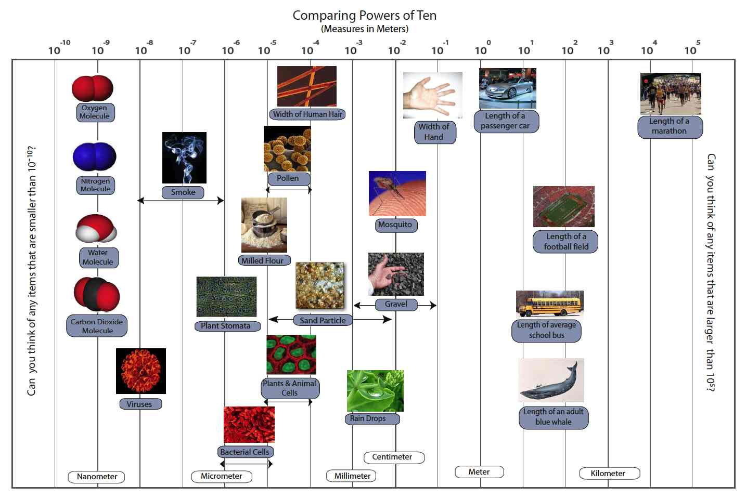
Hierarchy of Scales. Students use powers of ten to reason about processes at different scales. Several representations of powers of ten are built into classroom activities. Students view the Eames brothers Powers of Ten DVD. Teachers use a 3x4 wall chart to locate systems using powers of ten (see Figure 10).

We have also developed powerpoints that use powers of ten to zoom into different systems (e.g., zoom into a cloud, zoom into a flame, zoom into a hand, zoom into a plant, etc). Figures 11 and 12 shows screenshots of powerpoints that zooms into a flame and a plant.
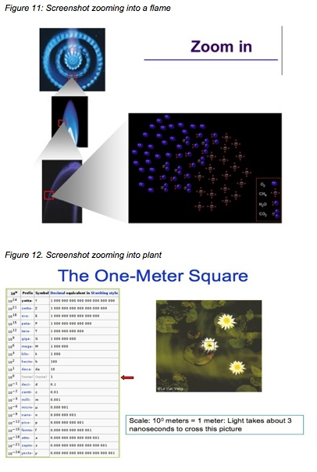

Powerpoints also may include animations of chemical change. For example, the powerpoint that zooms into a flame includes an animation of combustion of methane so students see why a flame is a mixture of gases at the atomic-molecular level.

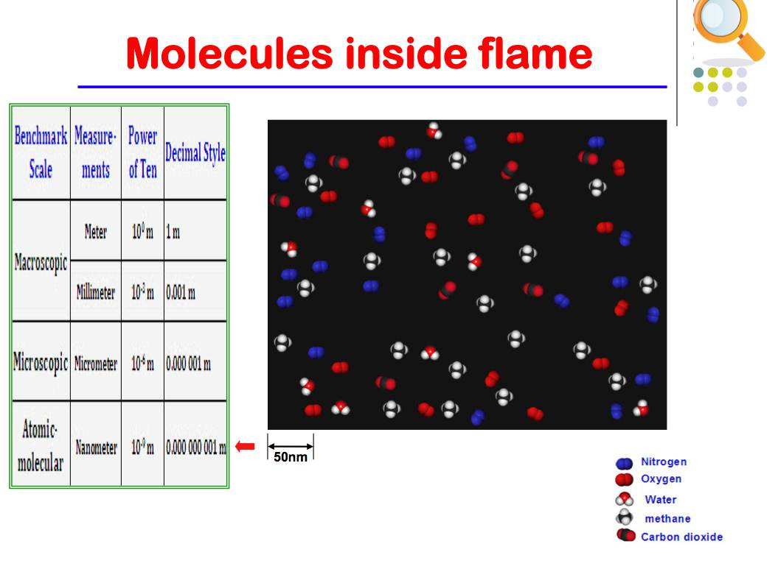
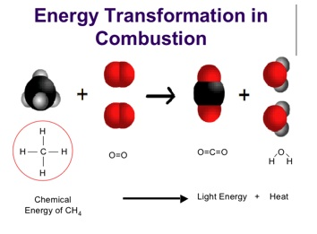
Figure 13. Powerpoints with animations: scale, matter, and energy
Criteria for Design and Validation

We seek to develop learning progressions that have three qualities:
- Conceptual coherence: a learning progression should “make sense,” in that it tells a comprehensible and reasonable story of how initially naïve students can develop mastery in a domain.
- Compatibility with current research: a learning progression should build on findings or frameworks of the best current research about student learning. This research rarely provides precise guidance about what Learning Performances are appropriate for students at a particular grade level, but it does provide both domain-specific (i.e., focusing on specific subject matter) and domain-general (i.e., focusing on more general aspects of learning and reasoning) constraints on learning progressions.
- Empirical validation: The assertions we make about student learning should be grounded in empirical data about real students.

These criteria are applied to the key elements of the structure of learning progressions—Learning Performances, Levels of Achievement, and Practices, Processes, and Principles—in Table 2.

Table 4: Criteria for Validity of Learning Progressions
Characteristic of Learning Progressions | Conceptual Coherence | Compatibility with Current Research | Empirical Validation
Individual cells: Learning performances | - Learning performances are described in consistent ways, including (a) knowledge, (b) practice, and (c) context—real-world systems and phenomena. | - Learning performances are compatible with those described in the research literature. | - Learning performances describe actual observed performances by real students.  - Students are consistent across different questions or modes of assessment (e.g., written assessments and clinical interviews) that assess the same learning performance
Rows: Levels of Achievement | - Levels are conceptually coherent: Different Learning Performances reflect some underlying consistency in reasoning or outlook | - Levels reflect consideration (explicit or implicit) of strands of scientific literacy (see above). | - Levels have predictive power: Students should show similar Levels of Achievement for Learning Performances associated with different Progress Variables.
Columns: Practices, principles, and processes | - Definition of Progress Variable captures important aspects of Learning Performances at all Levels of Achievement | - Progress from one Level to the next is consistent with research on students’ learning. | - Progress from one Level to the next can be achieved through teaching strategies that directly address the differences between Learning Performances

Progress on Validation

We have made a great deal of progress in validating learning performances, as reported in Mohan et al. (in press) and Jin and Anderson (2008). While we are continuing to revise assessments and the framework, a majority of our work over the past few years has focused on validating learning performances using assessments, and in developing a conceptually coherent framework with corresponding assessments. Our work during the current year (2008-2009) has focused on further validation of Levels of Achievement (see Mohan et al., 2009 as an example). In this paper we examine patterns in student reasoning about processes and principles that further inform the levels of achievement in our framework. We are also currently conducting teaching experiments in elementary, middle, and high school classrooms to further validate learning performances, levels of achievement, and our progress variables.

References

Briggs, D., Alonzo, A., Schwab, C., & Wilson, M. (2004). Diagnostic Assessment with Ordered Multiple-Choice Items. Educational Assessment, 11(1), 33-63
Catley, K., Lehrer, R, and Reiser, B. (2005). Tracing a Prospective Learning Progression for Developing Understanding of Evolution. Paper Commissioned by the National Academies Committee on Test Design for K-12 Science Achievement.
Draney, K., and Wilson, M. (2007, July). Developing progress variables and learning progressions for the Carbon Cycle. Paper presented at the Knowledge Sharing Institute of the Center for Curriculum Studies in Science. Washington, D. C.
Gee, J. P. (1996). Social linguistics and literacies: Ideology in discourses (2nd ed.). Bristol, PA: Taylor & Francis.
Jin, H. (2009). Dissertation proposal
Mohan, L., Chen, J., & Anderson, C.W. (in press). Developing a multi-year K-12 learning progression for carbon cycling in socio-ecological systems. Journal of Research in Science Teaching.
Mohan, L., Chen, J., Choy, J., Lee, Y., Baek, H., & Anderson, C.W. (2009, April). Validation of a multi-Year carbon cycle learning progression: A closer look at progress variables and processes. To be presented at the annual meeting of National Association of Research in Science Teaching, Garden Grove, CA.
National Research Council (2007). Taking science to school: Learning and teaching science in grades K-8. Committee on Science Learning, Kindergarten through Eighth Grade. Richard A. Duschl, Heidi A. Schweingruber, and Andrew W. Shouse, editors. Board on Science Education, Center for Education, Division of Behavioral and Social Sciences and Education. Washington, DC: The National Academies Press.
Pinker, S. (2007). The stuff of thought: Language as a window into human nature. New York:
Penguin Group.
Smith, C., Wiser, M., Anderson, C. W., and Krajcik, J. (2006). Implications of research on children’s learning for assessment: Matter and atomic molecular theory. Measurement: Interdisciplinary Research and Perspectives, 14 (1 & 2), 1-98.
Talmy, L. (1988). Force dynamics in language and cognition. Cognitive Science, 12(1), 49-100.
Wilson, M. (2005). Constructing Measures: An Item Response Modeling Approach. Mahwah, NJ: Erlbaum.
Appendix A: Additional Process Tool Examples

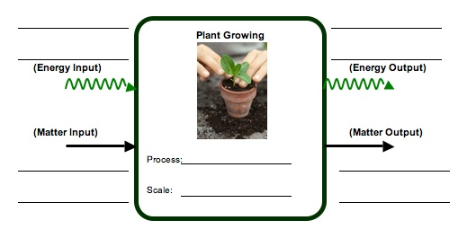
Single Process

Multiple Pathways
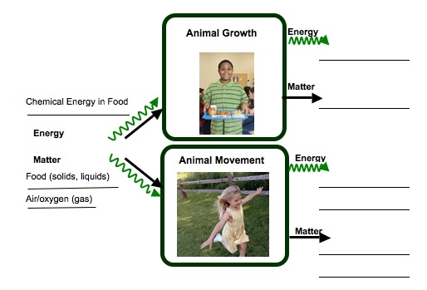

Note: Processes in human beings are categorized with other animal processes, thus we use “animal growth” and “animal movement” to describe processes in humans.
Connected Chain of Processes

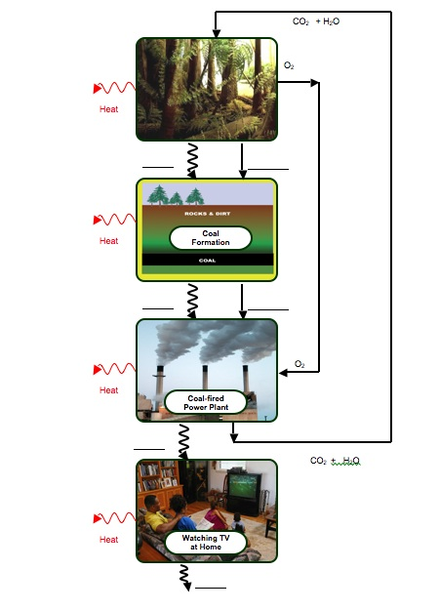

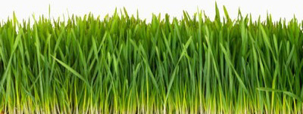


Process Tool for Food Chain with Answers in blue and red fonts
CO₂ (gas)
H₂O (gas/liquid)
H₂O (gas/liquid)
H₂O (gas/liquid)
CO₂ (gas)
CO₂ (gas)
Motion Energy
Motion Energy
HEAT
HEAT
HEAT
Cellular
Respiration

Rabbit Body Structure (solid)
Chemical Energy
Grass Structure (solid)
Sugar & Starch in Grass Structure (solid)
Sunlight
Carbon Dioxide (gas)
Water (liquid)
Chemical Energy
Chemical Energy
Photosynthesis

Grass Growth Biosynthesis

Rabbit Growth
Biosynthesis

Cellular
Respiration

Wolf Growth
Biosynthesis

Cellular Respiration

Matter Cycles
Energy Flows

