**Interview Protocol – Water Transport**

**Version B: Environmental Quantitative Reasoning Assessment – Water 1-18-12**

Based on Water Interview River Map Cluster Fall 2010. ALLOW and encourage use of calculator for all calculations, this is not an arithmetic test the focus is on reasoning.

The topological map below provides information on shape of the land around the Mill River and two of its tributaries. The contour intervals are in 20 meter increments.

1. **(Macro Scale):** Can pollution in the river water at point B get to point C? Explain why or why not [WT#1]. (Scientific qualitative account)

***WT#1***

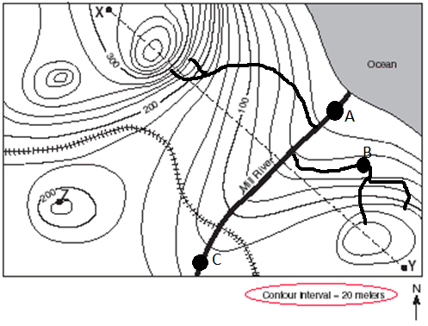

* 1. ***What direction is the water flowing in the Mill River?***

SOLUTION: Water flows from higher elevation to lower due to gravity, so flows from C towards A or northeast (QI graph/map, elevation and direction). If experienced with topographical map may state rule of V, that water flows in direction of V or U which indicates a valley. (QI graph/map)

* 1. ***What can you say about elevation change along the Mill River from C to A.***

SOLUTION: C is on 120-130 contour and A is on 0 to 20 contour, so approximately a 100 meter change in elevation. (QI graph/map, QL numeracy-calculation)

* 1. ***On the Mill River and its tributaries, where is water flowing fastest? Where is it flowing slowest?***

SOLUTION: Contour lines that are closer together mean a quicker 20 meter drop, so when lines are close together the slope of the land is steeper and water flows faster, in converse if the contour lines are farther apart than water flows more slowly. (QI graph/map, QL proportional reasoning-rates).

* 1. ***Can you calculate the stream (river) gradient from point C to A given that these two points are 5 kilometers apart?***

SOLUTION: Stream gradient is slope of the river, so this is the change in vertical distance which is 100 meters by the change in horizontal distance which is 5 kilometers, giving 100m/5km or 20m/km. This is a standard measure for stream gradient. (QL numeracy-calculation, proportional reasoning-rates, measurement-dimensional analysis)

* 1. ***If there was a dump at point X, would water from this pollution source reach the Mill River? Why or why not? What can you say about the watershed for the Mill River from this map?***

SOLUTION: No since X lies on the opposite side of the hill, unless it reaches the river through groundwater flow (Science qualitative account, QI graph/map) Water flows roughly perpendicular to the contours, with water flowing down from all sides of the knobs or hills, so if you follow the troughs of the Us on the graph you get a sense of the water shed which includes all water flowing off of knob Y and Z, but not knob X since it is at highest elevation water on northwest side will run away from Mill River. (QI graph/map)

1. **Hidden Mechanism (Microscopic-Atomic):** Below is a map of the Potomac River Watershed [WT#2]. What can you tell me about a watershed for a river? (Science qualitative account)

***WT#2***

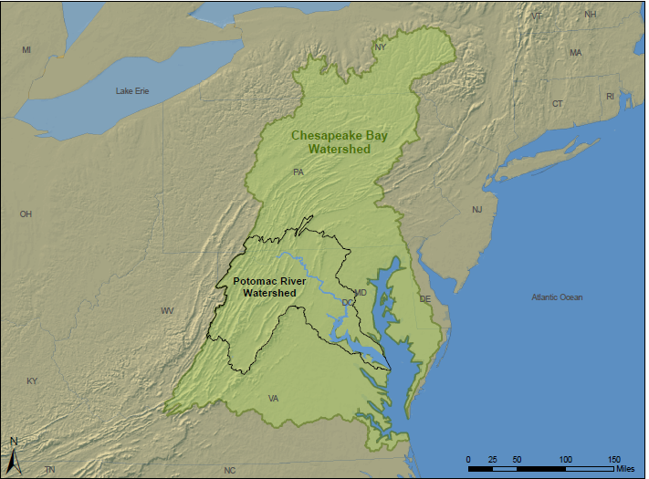

* 1. ***What are potential pollution sources for the Potomac river?*** (QI variable)

SOLUTION: Possible pollution sources include mining, sewage from cities, and agricultural runoff. Let them identify as many as they can before asking the next question.

* 1. **Agricultural Pollutant: *The farmlands near the Potomac River are treated with fertilizer in the spring, do you think that fertilizer could get into the Chesapeake Bay? What chemicals are in the fertilizer? Does it form a solution or a suspension? Will there be enough to do harm to the bay?*** (Science qualitative account)

SOLUTION: The watershed indicates the geographic area for which water flows into the river, so fertilizer could get into the river and be transported to the ocean. Fertilizer has nitrates and phosphates which are potential pollutants. Solution or suspension considers if the pollution can be seen or not. A suspension would settle upon standing – heterogeneous mixture with particles with diameters greater than one micrometer so visible to naked eye, while a solution has pollutant completely dissolved – homogeneous mixture with particle sizes on molecule or ion level, .01 to 2 nanometers so not visible leaving mixture to appear transparent. Fertilizer solubility changes with temperature and amount of fertilizer in the mix, so it may be either a solution or a suspension. (QL measure)

* 1. **Transport:** The river transports (moves) the nitrates and phosphates in the fertilizer down the river. ***If they enter the river 100 kilometers from the bay will they reach the bay? If so then how fast will they reach the bay?***

SOLUTION: Discuss if the nutrients will float with the current or sink. (Science qualitative account) Estimate that the river flows at certain rate, say 4 km/hour (this is an average fast river speed), then determine that the water with nutrients will reach the bay in 100km/(4km/hour) = 25 hours. (QL number sense-calculation, estimation, proportional reasoning-rates, proportions)

* 1. **Hidden Mechanism**: ***What are the variables that impact the rate of flow of water in the river? How much can the river carry?***

SOLUTION: Rate of flow is impacted by gravity, cross sectional area of river (width or size of river), roughness of the river channel bed and banks, perimeter of bed and banks in contact with water (hydraulic radius), and the slope of the river bed. Gravity and slope speed up the water flow, the remaining variables slow the water flow. (QI varible) How much the river can carry is impacted by river flow rate and buoyancy of the object. (QL variable)

* 1. **Flow Models:** Brahm’s Law says that the mass of objects that may be carried away by a river is proportional to the sixth power of the river flow speed: $m=ks^{6}$. In addition the volumetric flow rate (volume of fluid which passes through a given cross section of a river per unit time which is a measure of river flow speed) is given by $Q=\frac{1}{n}×A×R^{2/3}×S^{1/2}$ with dimension of meter3/second where
     + n is the channel roughness coefficient which for a river is 0.1
     + A is the cross-sectional flow area in meters squared
     + R is the hydraulic radius of the channel in meters, which is the ratio of the cross-sectional area A to the perimeter of the river bed and banks P for A
     + S is the slope of the channel bottom

***Using these models how would you determine when the nutrients would reach the bay?*** (QI equation)

SOLUTION: First use the volumetric flow rate formula to determine flow speed. So estimate a cross section of the Potomac River to be 100 meters by 10 meters, with a slope of 20m/km or 0.02. These are only estimates, the student would base these either on having seen the river or based on what they believe about rivers. If the student does not provide estimates then provide the values above and see if they can interpret them in the analytic model. They should also note that the area and slope will vary across the 100 kilometers to the bay. Using the known and estimated values we get

$Q=\frac{1}{0.1}×{1,000m}^{2}×{\left(\frac{1000}{120}\right)}^{2/3}m×0.02$ so Q = 822 m3/s

and so the river can move m = 8226 = 3.08x1017 cubic meters of mass per second.

So the river can move a large volume of nutrients to the bay. In addition it can move them there quickly if it is moving at 4km/hr. (QI analytic model, QL proportional reasoning, numeracy, measurement)

1. **(Landscape-Global Scale):** The Potomac River is transporting nitrogen to the Chesapeake Bay, but what is the trend and what are the implications. Use the table and graph below to discuss trends in nitrogen transportation to the bay. Nitrogen is measured in millions of pounds, water flow in billions of gallons per day. What is the table telling you about nitrogen transport [WT#4 & WT#5]? (QI table, graph)

***WT#4***

|  |  |  |  |  |  |  |  |  |  |  |  |  |
| --- | --- | --- | --- | --- | --- | --- | --- | --- | --- | --- | --- | --- |
| YEAR | **1990** | **1991** | **1992** | **1993** | **1994** | **1995** | **1996** | **1997** | **1998** | **1999** | **2000** | **2001** |
| Monitored Nitrogen Loads from (RIM) Sites | 197.50 | 229.85 | 140.98 | 287.92 | 289.73 | 144.22 | 312.88 | 229.61 | 283.49 | 95.11 | 147.45 | 109.91 |
| Monitored Loads from Wastewater Treatment | 65.48 | 60.86 | 59.92 | 59.67 | 58.19 | 55.87 | 55.23 | 49.04 | 45.99 | 45.19 | 45.17 | 40.66 |
| Simulated Loads from Nonpoint Sources | 78.65 | 93.11 | 55.14 | 121.59 | 122.95 | 55.14 | 126.56 | 92.66 | 117.07 | 36.61 | 58.31 | 40.36 |
| Simulated Loads from Atmospheric Deposition | 24.05 | 22.38 | 22.42 | 23.76 | 23.59 | 21.93 | 24.33 | 21.67 | 21.66 | 22.00 | 21.96 | 21.00 |
| **Total Nitrogen Load to Bay** | **366** | **406** | **278** | **493** | **494** | **277** | **519** | **393** | **468** | **199** | **273** | **212** |
| **Annual Average River Flow** | **48.86** | **54.29** | **39.04** | **65.28** | **69.16** | **38.72** | **74.33** | **58.04** | **68.51** | **29.47** | **45.63** | **34.00** |
|  |  |  |  |  |  |  |  |  |  |  |  |  |
| YEAR | **2002** | **2003** | **2004** | **2005** | **2006** | **2007** | **2008** | **2009** | **2010** |  |  |  |
| Monitored Nitrogen Loads from River Input | 98.10 | 306.13 | 319.36 | 240.48 | 200.40 | 198.02 | 182.79 | 133.83 | 178.50 |  |  |  |
| Monitored Loads from Wastewater Treatment | 39.33 | 40.97 | 39.63 | 36.55 | 34.97 | 34.83 | 36.30 | 33.23 | 33.23 |  |  |  |
| Simulated Loads from Nonpoint Sources | 36.07 | 123.85 | 136.96 | 97.63 | 84.98 | 77.03 | 71.33 | 48.77 | 48.77 |  |  |  |
| Simulated Loads from Atmospheric Deposition | 21.25 | 23.60 | 21.21 | 22.41 | 21.54 | 21.43 | 21.32 | 19.37 | 17.42 |  |  |  |
| **Total Nitrogen Load to Bay** | **195** | **495** | **517** | **397** | **342** | **331** | **312** | **235** | **278** |  |  |  |
| **Annual Average River Flow** | **29.34** | **76.92** | **76.27** | **56.62** | **50.09** | **51.39** | **48.02** | **40.98** | **51.64** |  |  |  |

***WT#5***

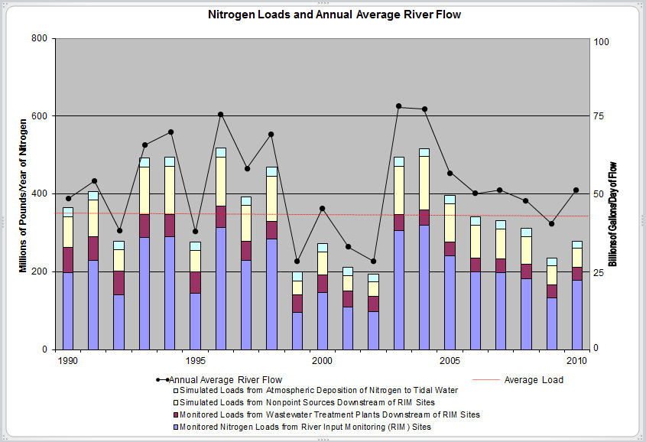

1. ***How much nitrogen reached Chesapeake Bay in 2010? What is the trend in nitrogen concentrations in Chesapeake Bay?***

SOLUTION: 278 million pounds of nitrogen reached the bay in 2010. The trend fluctuates but has been on a downward trend since 2004 except for an increase in the last year. Currently below the average load. Appears the water quality in the bay is improving. (QI graphic, tabular, translation, case, trends, translation)

1. ***Is there a relationship between annual river flow and nitrogen concentrations?***

SOLUTION: There does appear to be a relationship with flow driving amount of nitrogen concentration? (QI graphic, tabular, translation, trends) More flow due to increased precipitation causes more runoff which brings more nitrogen.

1. Water quality is still rated as poor, meeting just 24% of health goals and only 59% of health goals for fish and shellfish abundance. ***Given the pie chart for sources of nitrogen reaching the bay, what would you recommend for agriculture to do about transport by the river to address concerns about the bay in the future [WT#6]?***

SOLUTION: Discuss reduction of agriculture aspects including manure (17%) and chemical fertilizer (10% + 15%), recommend more optimal reduced application of fertilizer and protective berm areas for river for example. (QI graphic, QL numeracy, proportional reasoning)

***WT#6***

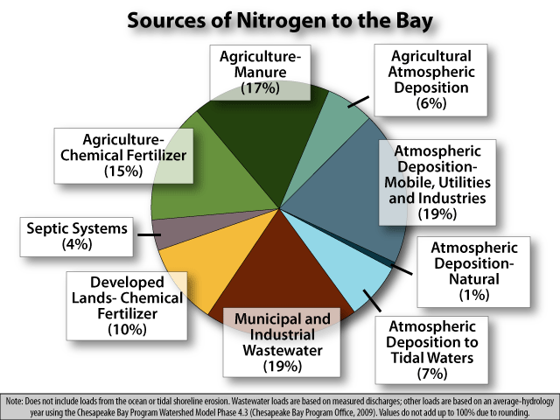

1. **(Grand Challenge-Citizenship):** Dead zones are areas in the ocean where a rapid increase in the density of phytoplankton depletes the available oxygen in the water. This phenomena is known as an algal bloom and is devastating to marine life in the dead zone area. The model below provides information on dead zones around the world [WT#7]. What does the model tell you? (Science qualitative)

***WT#7***

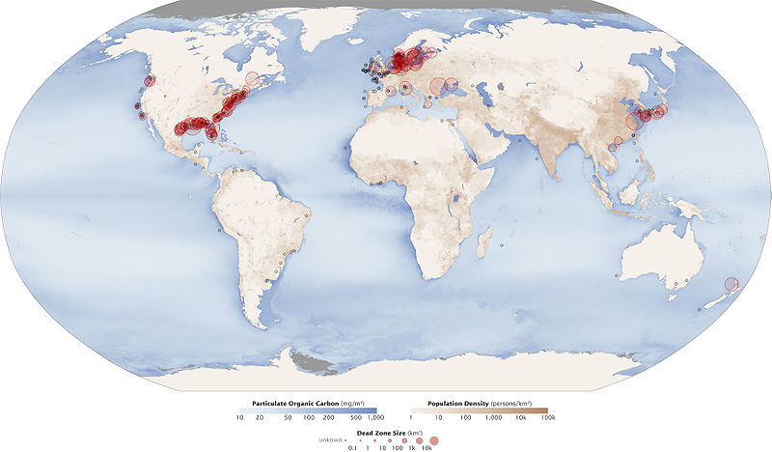

1. ***What conclusions can you draw about the location of dead zones and their possible cause from the model?***

SOLUTION: Dead zones are located near highly populated coast lines and major river outlets. (OI science model, QL numeracy - density concept) The largest dead zones are around the U.S. east and Gulf coasts and Europe.

1. One of the worst dead zones is the 22,126 square kilometer Gulf of Mexico dead zone shown on the map below [WT#8]. ***What is the cause of this dead zone?*** (Science qualitative)

SOLUTION: The Mississippi river dumps fertilizers into the Gulf which increase chemical nutrients in the water, which is called eutrophication. The primary chemicals are nitrogen and phosphorus which leads to the rapid increase in density of phytoplankton observable as the algal bloom. The bloom decreases oxygen in the water, called hypoxic (less than 2% ppm dissolved oxygen) which harms marine life. (Science qualitative account; QI science model)

WT#8

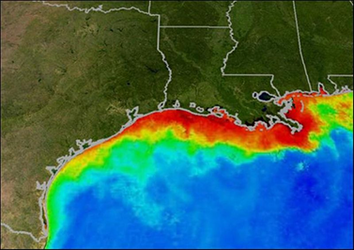

1. The bar graph below provides data on the size of Gulf of Mexico dead zone including a prediction for 2011 [***WT#9***]. ***What can you say about the general trend for the dead zone? What do you think might be causing some of the fluctuation in the size of the dead zone from year to year?***

SOLUTON: There is a lot of flux in the size of the dead zone, but since 2000 the long term average has been exceeded 6 out of 10 years and except for the decline in 2009, there has been a study increase in size since 2005. In addition the prediction for 2011 is for the largest dead zone since 1985. (OI graphic, QL proportional reasoning-rate, basic prob/states-mean). Two potential causes of the flux are change in use of fertilizer, which is doubtful, and amount of fertilizer carried to the Gulf by the Mississippi River. (Science qualitative account) So in years where the Mississippi floods I would suspect an increase in the dead zone. (QI variable)

***WT#9***

