Interview Protocol - Water Cycle QR

Version A: Environmental Quantitative Reasoning Assessment – Water 1-10-12
Based on Water Interview Pie Chart Cluster Fall 2010. ALLOW and encourage use of calculator for all calculations, this is not an arithmetic test the focus is on reasoning.

- (Macro Scale): The pie chart below describes where water goes on a school grounds when it rains [WC#1]. If 15 centimeters of rain falls on the school yard in one day, how could you determine how much would runoff? (QI – interpret pie graph)

  - What are reasonable dimensions for a school yard? (QL Measure-estimation)
SOLUTION: Student gives estimate, have them do it in meters if they give it in other dimensions first.

  - Say reasonable dimensions are 300 meters x 200 meters. How can you determine how much rain falls on your school yard? (QL measure–area, numeracy-calculation)
SOLUTION: 300m x 200m =60,000 square meters. Then amount of rain is a volume (QL measure) 15cm x 60,000m² = 900,000cm-m².

  - Can you express the amount of rain in m³? (QL measure, numeracy-calculation) SOLUTION: 15cm is 0.15 meters so 0.15m x 900,000m² =135,000m³.

  - So how much water runs off the schoolyard? Can you provide a common sense estimate of how much water this is? (QL measurement–estimation, numeracy-calculation, proportional reasoning-percents; QI graph)
SOLUTION: 135,000m³ x 0.48 = 64,800m³ or 64,800m³ x 1,000lt/1m³ = 64,800,000 liters. Imagine 64,800,000l/2l – 32,400,000 2 liter bottles of water as runoff.
WC#1
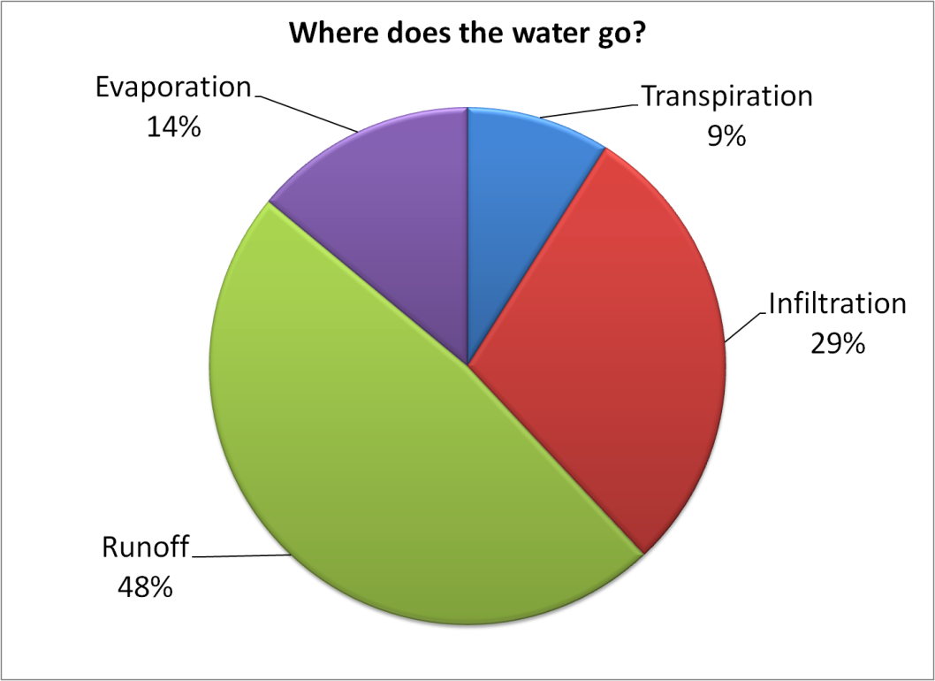
  - If they miss calculate or don’t finish calculation give them the amount of runoff as 135,000m³. Say then that 135,000m³ of water is runoff from the playground from the 15cm rain. Where does this runoff go? How can you tell if there is too much? What if the amount of runoff increased, how might this impact your schoolyard? Is this good or bad for the schoolyard? How might you impact the amount of runoff for the schoolyard? Would you want to increase it or decrease it? (Science qualitative accounts within context).
SOLUTION: Runoff goes into drainage system or floods street if too much. You could reduce runoff by improving drainage system, increasing grass areas for greater infiltration, or reducing runoff from roofs through capturing water. Some runoff is a natural part of the water cycle, only need to be concerned if there is too much runoff at once which creates flooding.

  - Create a new pie graph model representing your proposed change to reduce runoff from the schoolyard and discuss the impact on all the water processes. (QM–extend pie chart model, QI-interpret model dynamically, QL proportional reasoning-percents, fraction part-of-whole)
SOLUTION: Suppose they reduce runoff by converting 25% of parking lot to grass, have to relate this percent to total percent of runoff area, say 10% is converted to grass, then reduce runoff by 10%, so 48%-10%=38%. Then have to dynamically change model to account for whole being 100%, so increase infiltration by 10%+29%=39%. Use this to construct new pie graph model. So runoff is reduced by 64,800,000l x .10 = 6,480,000 liters. This of course supposes that the grass would allow infiltration at a high enough rate to absorb the 15 cm of rain.

- (Microscopic-Atomic Scale): What happens to the water that falls on the parking lot versus the grassy surface? Can you explain this in terms of infiltration, evaporation, transpiration, and runoff. (Scientific qualitative account – unless we quantify with models the hidden mechanisms). We will focus on discussing infiltration.

  - Infiltration is the process by which water enters underground reservoirs. The infiltration rate is the rate at which a surface is able to absorb rainfall and is measured in millimeters per hour. What do you think impacts infiltration rates? (Science qualitative account, QI variable).
SOLUTION: Gravity, permeability of surface, and capillary action (advanced response), saturation, evaporation, evapotranspiration, storage, runoff.

  - Infiltration models: Create a model of infiltration for the grassy service. What variables do you need to consider? (QM-conceptual science model or analytic model) SOLUTION: student may provide visual model (QM science model) by drawing porous grassy service and discussing rate of flow (QL proportional reasoning-rates), or could provide an analytic model with variables indicating what increases or decreases infiltration (QM modeling-analytic model).

  - Interpreting science process model: After students have attempted to identify variables for the infiltration process on their own, then provide the infiltration process model below [WC#2]. Are there variables in the model for infiltration that you have not considered? Can you determine how the variables impact infiltration, which increase it and which decrease it. (QI science model, variables)
SOLUTION: Students analyze the visual model and identify possible variables influencing infiltration: precipitation, rate of infiltration, surface runoff, storage areas such as lake, evapotranspiration, evaporation (which strangely is not given in this model), type of soil (percolation rate), and amount of runoff from adjacent areas.
WC#2
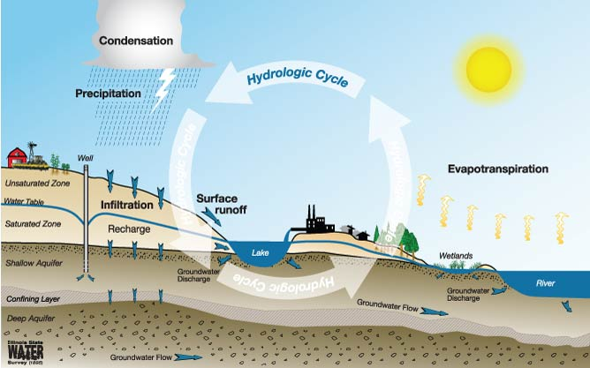

  - Infiltration algebraic model: Given the following variables [WC#3], write an algebraic equation for volume of infiltration F that indicates which variables increase infiltration and which decrease infiltration:
    - B_{I} is boundary input which is amount of runoff R from adjacent areas
    - B_{O} is the boundary output which is the amount of runoff from the area
    - P is precipitation
    - E is evaporation
    - ET is evapotranspiration
    - S is storage such as a pond that holds water
    - I_{A} is the initial abstraction which is short term storage such as puddles
    - R is surface runoff
SOLUTION: F = B_{I} + P − E − T − ET − S − R − I_{A} − B_{O} (QM modeling-algebraic model), student may simply indicate what adds to or subtracts from infiltration, likely to provide a verbal description of the model, encourage them to write out an equation.

  - Infiltration rate model: Scientists have proposed two models for infiltration rates, Horton’s equation which is an exponential model and Kostiakov’s equation which is a power function model [WC#4]. Compare the models for the parking lot versus the grassy surface. What can you say about the comparative values of the parameters k, a, and m for the two surfaces? Make a sketch of the two models and discuss what the long term trend for infiltration is based on the models (QI translation-equation models).
WC#4
Horton’s equation assumes that f_{t} (infiltration rate at time t) depends on a constant initial rate f₀ and is decreasing exponentially with time leveling off at a constant rate of f_{c}, where k is the decay constant specific to the soil:  f_{t} = f_{c} + (f₀ − f_{c})e ^{− kt} | Kostiakov’s equation assumes the infiltration rate declines over time according to a power function with parameter a representing the infiltration rate at time t = 1 and m representing the rate of decline of infiltration:  f_{t} = at^{m} + f_{c}

SOLUTION: Assuming that pavement has an initial rate and constant rate of 0 infiltration, Horton’s equation simple says that infiltration rate at time t is f_{t} = 0+(0)e^{-kt} = 0 (QI analytic), similarly for Kostiakov’s equation the infiltration rate at time t=1 and the constant rate = 0 so f_{t} = 0t^{m} +0 = 0. Depending on quality of the pavement there may be some infiltration, pavement may be porous, in which case there would be a small initial rate and constant rate of infiltration. For the grassy surface we would expect a greater initial rate and constant rate of infiltration, varying with the level of compactness (how porous) of the soil. This can be measured with an infiltrometer as is done in the teaching experiment. The decay constant k tells us how fast the rate of infiltration drops depending on the soil composition, for larger k values the amount of infiltration drops faster. Similarly in Kostiakov’s equation larger values of a mean the amount of infiltration drops faster than for smaller values. Sketches of the two models for values f_{c} =1, f₀=3, k=0.1 and m=-0.1 are given below [WC#5]. (QM extend, QI analytic power-exponential models).
WC#5
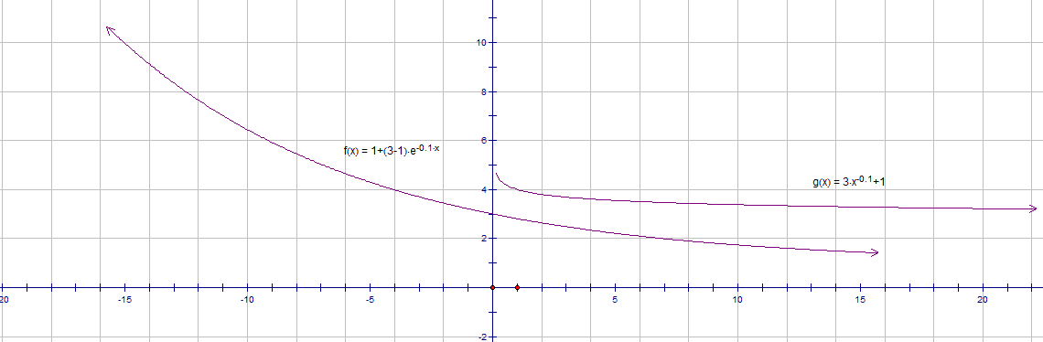

NOTE: Similar hidden mechanism models could be found for evaporation, transpiration, and runoff. The water teaching experiment has a graph on infiltration that could be used in our QR assessment (page 20). The original QR Water assessment used a hidden mechanism for evaporation and presented models. The values for the flow rates, k and m are made up.

- (Landscape-Global Scale): Below is a model of the global water cycle illustrating how nearly 577,000 km³ of water circulates through the cycle each year and a model of a infiltration on a more regional level [WC#6]. Each numeric value indicates the amount of water moving between the components of the system within one year measured in km³. What do the models tell you about infiltration [WC#7]? (QI science model)

  - What is the amount of infiltration globally? (QI science model interpretation) SOLUTION: 2,200 km³ ground water flow, so that is the amount of water that infiltrates. Students may interpret the flow of water from the models, water infiltrates the soil, replenishes ground water, and a portion of it flows back into streams or the ocean. With the focus on infiltration and ground water students may notice the areas of runoff provided in square kilometers. They should be able to interpret these as areas and not volumes due to the unit (QL measure).
WC#6 WC#7
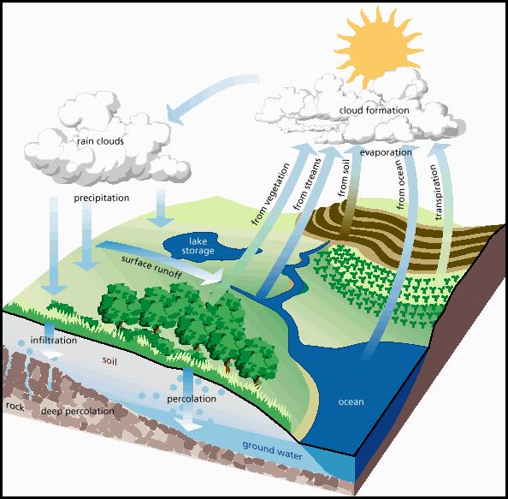
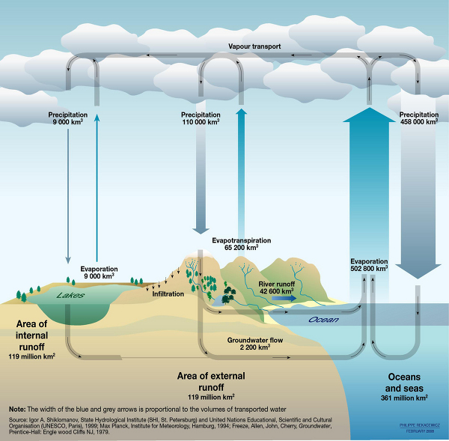

  - Below are two tables [WC#8]. Table 1 presents data on water flow between storage areas called reservoirs, such as lakes, the ocean, and even precipitation. Table 2 presents data on volumes of water in those reservoirs. What do the tables tell you about infiltration? (QI tables) Compare the tables to the water cycle model above, do they tell the same story? Why or why not? (QI translation between models)
SOLUTION: Table 1 provides data on percolation which states it is movement from surface to underground, given as 100 km³ per year (QI table, QL proportional reasoning-proportion). The only information related to infiltration in the second table is amount of ground water 23,400,000 km³. (QI table) However this is the amount in
WC#8
Table 1: Water flow between Earth’s reservoirs
Process | From/to Reservoir | Flow Rate
Precipitation | Atmosphere to Ocean/Land | 505,000 km³/year
Ocean precipitation | Atmosphere to Ocean | 398,000 km³/year
Land precipitation (except snow) | Atmosphere to Land/surface | 96,000 to 107,000 km³/year
Evapotranspiration | Ocean and Land/surface and Plants to Atmosphere | 505,000 km³/year
Ocean evaporation | Ocean to Atmosphere | 434,000 km³/year
Land evaporation | Land/surface to Atmosphere | 50,000 km³/year
Transpiration | Plants to Atmosphere | 21,000 km³/year
Uptake by plants | Land/surface to Biota | 21,000 km³/year
Runoff | Land/surface to Ocean | 36,000 km³/year
Melting | Ice/snow to Land/surface | 11,000 km³/year
Snowfall (on land only) | Atmosphere to Ice/Snow | 11,000 km³/year
Percolation | Underground to and from (??) Land/surface | 100 km³/year
Table 2: Reservoir Volumes
Reservoir | Volume | Fraction or % of a larger reservoir
All of Earth's water | 1,386,000,000 to 1,460,000,000 km³ | NA
Oceans | 1,338,000,000 to 1,400,000,000 km³ | 97% of total water
Fresh water | 35,030,000 km³ | 2.5 to 3% of total water
Ice & snow | 43,400,000 km³ | -
Ice caps, glaciers, and permanent snow | 24,064,000 to 29,000,000 km³ | 68.7% of fresh water  ~2% of total water
Antarctic ice & snow | 29,000,000 km³ | ~90% of all ice
Ground water (saline and fresh) | 23,400,000 km³ | -
Ground water (saline) | - | 54% of ground water
Ground water (fresh) | 10,530,000 km³ | 30.1% of fresh water  46% of ground water
Surface water (fresh) | - | 0.3% of fresh water
Lakes | - | 87% of surface fresh water
Swamps | - | 11% of surface fresh water
Rivers | - | 2% of surface fresh water
Atmosphere | 12,000 to 15,000 km³ | -

ground and does not indicate the flow, so not of much help. (QL measure -distinguish volume from rate, proportional reasoning-rate) So comparing the information on infiltration between the box model and the table, we have 2,200 km³ ground water flow in the box model compared to 100 km³ of percolation. (QI translate) Are these comparing the same things? Do other things then infiltration add to ground water flow? We are looking for students to discuss estimation in models or error or interpretation and move away from temporal (different time of year) or place (different part of planet) arguments which are misinterpretations of the models. (QI table, graph, translation between models)
  - Do they relate what they find about infiltration to the water cycle? What does it mean in terms of the cycle? What is the impact on the reservoirs in the system of infiltration? (Science qualitative account)
SOLUTION: Have students relate their discussion of infiltration back to the water cycle as a whole. Provide a qualitative account of the importance of infiltration in the water cycle.

- (Grand Challenge-Citizenship): The models below indicate how ground water is replenished by infiltration and the human-engineered system that interacts with the natural system [WC#9].
WC#9
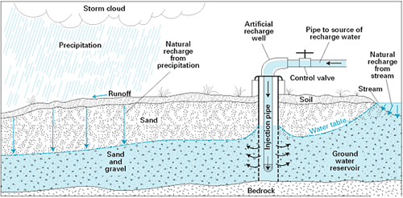
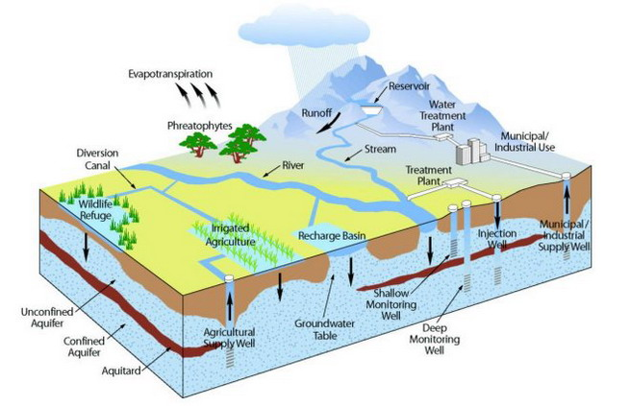
  - What can you tell me about ground water and the water table? Why is ground water important? How does the human-engineered system interact with the natural system of ground water? (Science qualitative account)

  - Below is a table with graphics giving data on Earth’s groundwater [WC#10]. What percent of Earth’s total water is groundwater? What percent of groundwater is freshwater (not saline)? What percent of Earth’s freshwater is groundwater?

WC#10
Water Source | Water Volume (cubic miles) | Water Volume (cubic kilometers) | Percent Earth’s water | Percent Earth’s freshwater | 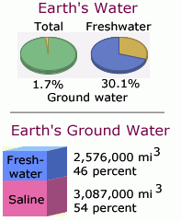
Fresh groundwater | 2,526,000 | 10,530,000 | 0.8% | 30.1%
Total groundwater | 5,614,000 | 23,400,000 | 1.7%
Total global water | 332,500,000 | 1,386,000,000

SOLUTION: Could leave percent columns blank and have students calculate, otherwise they read values from table or graph. (QI table, graph, translation between models)

  - The table below provides data on groundwater withdraw in the United States [WC#11]. For example in 2005 Colorado, Utah, Arizona, and New Mexico withdrew 8,700,000 acre-feet of water from underground sources (one acre-foot is volume of water needed to cover 1 acre of land to depth of 1 foot or 43,560 cubic feet of water). The model below indicates water table decline in that general region. What can you determine about groundwater use related to infiltration? (QI table, graph, translation) What is the impact of the trends you see? (Science qualitative account)
WC#11
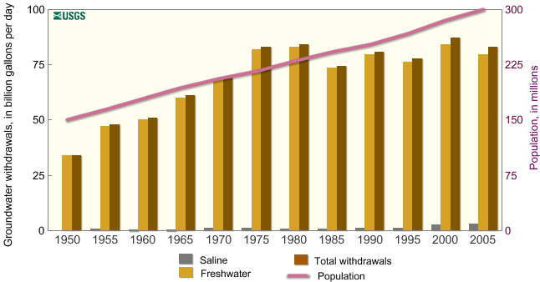

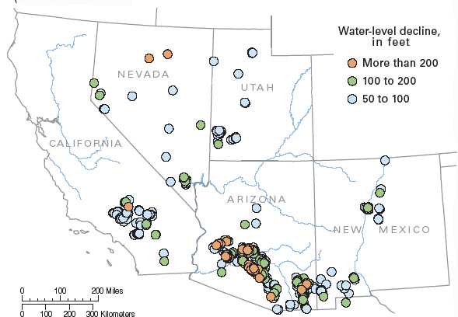

SOLUTION: Withdrawal from groundwater is increasing and water table is declining in some areas, so the rate of infiltration is less than the rate of water use. (QL proportional reasoning – rates) Impacts include declining water production from a well, more energy to bring water up from deeper level, reduced surface water and flow since groundwater is connected to surface water which impacts ecosystem, subsidence of land (sinking), and deterioration of water quality.

  - What can be done to address concerns about groundwater loss? Where is groundwater loss occurring and why? (Science qualitative – citizenship)
SOLUTION: Students should identify patterns in the map where water levels are declining and interpret reasons for the decline – human population growth in desert regions where infiltration is not sufficient to replenish supply. Solutions include reduced consumption due to irrigation (watering lawns), recycle water and return it to the groundwater system. Discussion of snow pack in mountainous areas as a key source of water for the region.

