Interview Protocol – Carbon Storage 1-10-12

Version B: Environmental Quantitative Reasoning Assessment – Carbon Storage 1-10-12
Based on Carbon Interview Fall 2010. ALLOW and encourage use of calculator for all calculations, this is not an arithmetic test the focus is on reasoning.

- (Macro scale): Where does the mass from the tree in your school yard or home yard come from? What is the tree made of? (Science qualitative account)

  - Name the substances that make up the mass of a tree. (QI variables).
SOLUTION: Let students provide input without prompting, then follow up with this question: What percentage of the log is made up of each of these materials – sunlight, water, soil, other chemical elements? Students will likely say substances like soil, water, minerals, sunlight, but will not mention carbon as a primary component of the mass of the tree. Correct if they say carbon makes up about 50% of the log (QL proportional reasoning)

  - You are handed a log from a tree growing in your region which is one cubic foot in volume. What does the log have to do with the carbon cycle? (Science qualitative)
SOLUTION: Photosynthesis fixes carbon supplying the bulk of the mass of a tree, it does not consist of soil. Does the log store carbon? If so what percent of the log is carbon? Depending on the type of wood, the log will be around 50% carbon. (QL measure, proportional reasoning-percentage)

  - Using the table [CS#1] below, determine the amount of carbon stored in a two cubic foot log from your region. (Source: www.sampsongroup.com/Papers/Monitoring and Measuring Wood Carbon, Birdsey 1996)?
CS#1
Region | Forest Type | Lbs. per cu. Ft | Percent Carbon as a Decimal
Southeast | Loblolly Pine | 29.33 | 0.531
 | Longleaf Pine | 33.70 | 0.531
 | Oak-Hickory | 38.06 | 0.479
Northeast | Pines | 25.58 | 0.521
 | Spruce-Fir | 23.09 | 0.521
 | Oak-Hickory | 38.06 | 0.498
 | Maple-Beech-Birch | 38.06 | 0.498
North Central | Pines | 25.58 | 0.521
 | Spruce-Fir | 23.09 | 0.521
 | Oak-Hickory | 38.06 | 0.498
 | Maple-Beech | 36.19 | 0.498
 | Aspen-Birch | 28.70 | 0.498
West | Douglas-Fir | 28.08 | 0.512
 | Ponderosa Pine | 23.71 | 0.512
 | Fir-Spruce | 21.84 | 0.512
 | Hemlock-Sitka | 26.83 | 0.512
 | Lodgepole Pine | 26. 21 | 0.512
 | Redwoods | 26.21 | 0.512
 | Hardwoods | 23.71 | 0.496

SOLUTION: For example in Georgia the native forests were Longleaf Pine, though they are now reduced to less than 2% of the trees. So a cubic foot log weighs 33.7 lbs/ft³ and contains 0.531 percent carbon. What does the 0.531 represent? Percent represented as a decimal, so this means the log is 53.1% carbon. (QI table, QL proportional reasoning-percent) So what is the weight of the log? The log we are given is two cubic feet, so using the ratio of weight to cubic feet we have a total weight of 2 x 33.7 lbs = 67.4 lbs. (QL numeracy-computation, QI table) And how much carbon is in the log? Multiply weight by the percent carbon to get total carbon, 67.4 lbs x 0.531 = 35.8 lbs of carbon. (QL proportional reasoning)

- (Microscopic-Atomic Scale): Carbon cycles from the atmosphere to the Earth are stored in reservoirs (areas where carbon accumulates).

  - Carbon Storage: What carbon reservoirs can you name? (Science qualitative account)
SOLUTION: Carbon is stored in plants, the ocean, the atmosphere, the soil, in fossil fuels, and even in animals like us. Human engineering is now working on ways to sequester carbon dioxide underground or in the ocean. (QI variable identification)

  - Science Process Model: After student has attempted to identify variables on their own, then provide the carbon storage model below [CS#2]. Does the model have additional variables you should consider for carbon storage?
CS#2
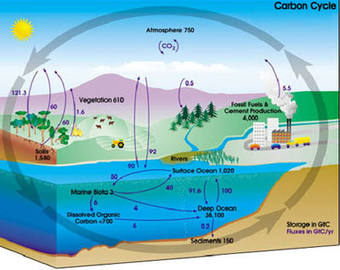
SOLUTION: Student reviews model to determine potential variables for carbon storage. At this time we are not interested in the numeric values, we want to focus on the hidden mechanisms, but note if the students use or refer to the numeric values. (QI interpret science model, variables)

  - Carbon Storage Processes: How does the tree accumulate its carbon mass? (Science qualitative account) What is the process that allows a tree to take in carbon? Where does the tree get the carbon from?
SOLUTION: The process that fixes carbon from the atmosphere is photosynthesis (carbon fixing). (QI variable recognition) The tree takes carbon dioxide from the atmosphere and in the photosynthesis process fixes carbon which builds up the plant mass. (Science qualitative account)

Photosynthesis: Photosynthesis is a process that removes carbon dioxide from the atmosphere and fixes it to make up the mass of a tree. What can you tell me about it? (Science qualitative account)

SOLUTION: Student explains what they know about the process of photosynthesis. Photosynthesis is a chemical process that converts carbon dioxide into organic compounds using the energy of the sun. Photosynthesis is the primary source of energy for life on Earth. Photosynthesis is also the source of carbon in all organic compounds. Carbon dioxide and water plus energy from the sun are the inputs; the output is glucose and oxygen. (QI variables) Plant cells contain chloroplasts which use the compound chlorophyll to take energy from sunlight for the process.

  - Photosynthesis Model: What are the inputs and outputs of photosynthesis? Where does the energy for the process come from? Can you balance the chemical equation for this process? (QM chemical model, QL numeracy-balancing equation)
SOLUTION: Carbon dioxide (CO₂) and water (H₂O) are the inputs, energy comes from the sun, and glucose (C₆H₁₂O₆) and oxygen (O₂) are the outputs. The chemical equation is:
6CO₂ + 6H₂O + energy $→$ 6O₂ + C₆H₁₂O₆
  - Photosynthesis Fixing Carbon: You conduct an experiment in your classroom using probes to study how plants affect levels of CO₂ in the air around them [CS#3]. The first 200 seconds or so of this trial were recorded with radish plants in the dark, after which the cover was removed to expose them to light.
CS#3
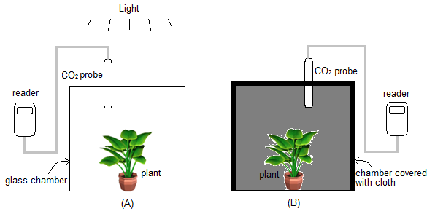

A portion of the data table from the experiment is provided below which shows CO₂ in the chamber after the plants are in the dark for the first 200 seconds [CS#4]. What does it tell you about carbon uptake and photosynthesis? (QI table)
CS#4
Time (sec) | 0 | 50 | 100 | 150 | 200 | 250 | 300 | 350 | 400 | 450 | 500 | 550 | 600
CO₂ (ppm) | 380 | 461 | 562 | 616 | 588 | 611 | 636 | 623 | 560 | 582 | 581 | 535 | 558

SOLUTION: The CO₂ in the container is fluxing, but mostly increases from 0 to 300 seconds. (QI trends) This indicates that for 200 seconds in the dark the plant is not photosynthesizing and so CO₂ in the container is not being fixed, in fact it is increasing so the plant is respiring (releasing CO₂). CO₂ actually increases for the next 100 seconds even after the light is allowed in, so photosynthesis lags indicating it takes a bit for the process to startup. For the last 300 seconds CO₂ decreases due to plant photosynthesis. (QI table). What is the amount of increase for the first 300 seconds? Estimate it by taking difference in CO₂ from 0 to 300 seconds: 636 ppm -380 ppm = 256 ppm CO₂ or a percentage increase of 256 ppm/380 ppm = 0.674 or 67.4%. (QL numeracy-calculation, proportional reasoning)

  - Below is both a graph and a partial table of the data [CS#5]. Does the graph provide any additional insights? If you were asked to predict the CO₂ in 1000 seconds if the plants remained in the light, would you use the table or graph? Make a prediction and explain how you did it. (QI graph, table, translation)
CS#5
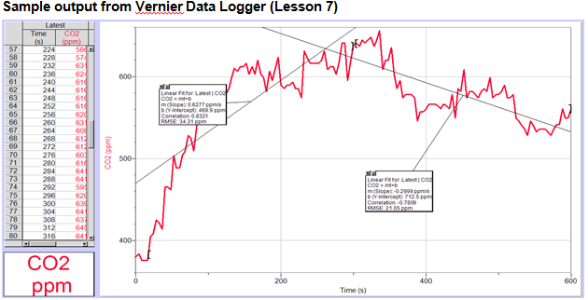
SOLUTION: The graph provides better evidence of the amount of flux since you can see continuous data. (QI graphic) Students often choose the table, ask them why they prefer one representation over the other? (QI translation between models) To use the table to make a prediction they will need to estimate a rate of change, for example they may consider that since the light is on for the next 400 seconds that the amount will decrease and use some average of rates from 300 to 600 to find a rate, so calculate the slope between points for example: (623-636)/(350-300) =-0.26 slope. Find the average of these slopes to get an estimate of the overall trend, estimate overall change (sum of slopes)/(number of slopes) = -1.56/6 ppm/sec = -0.26 ppm/sec decrease on average between 300 sec and 600 sec. So for an additional 1000 sec – 600 sec = 400 sec we have -0.26 ppm/sec x 400 sec = -104 ppm additional reduction. (QL numeracy-calculation, proportional reasoning-slope)

Time (sec) | 300 | 350 | 400 | 450 | 500 | 550 | 600
CO₂ (ppm) | 636 | 623 | 560 | 582 | 581 | 535 | 558
Change rate | -0.26 | -1.26 | 0.44 | -0.02 | -0.92 | 0.46

Using the graph they will need to visual a line much like the one shown in the model, which indicates the rate of decrease visually. Extend that line and the graphic model out to 1,000 and estimate the value. For example select two points that seem to be on the trend line, which could be visualized by the students using a ruler or piece of paper to match the trend. Using the trend line on the model as an example, we estimate two points on the line to be (300, 636) and (450,582) so the change is (636-582)/(300-450) = -0.36 (QI cases, numeracy). Using this to predict the change in CO₂ yields -0.36 ppm/sec x 400 sec = -144 ppm decrease. Note a similar method can be used with the table but it is more difficult to see the rate to use. (QI graph-trend, prediction)

- (Landscape-Global Scale): Below are models of the carbon storage on Earth [CS#6 & CS#7]. The one on the right is a box model of global carbon dioxide movement between 2000 and 2005. The numbers represent billions of tons (gigatons) of carbon dioxide per year. What do these models tell you about carbon storage? (Science qualitative, QI science model)

  - Explain what you see in the box model. What do the boxes (pictures) and arrows mean to you (QI science model)? What does the arrow labeled 8 represent (QL measure)?
SOLUTION: The boxes represent reservoirs of carbon, the arrows represent flux or movement between the reservoirs represented in gigatons. The number 8 represents 8 gigatons of carbon being transported from human energy use to the atmosphere, a hugh human impact on the carbon cycle. (QI science model)
CS#6 CS#7
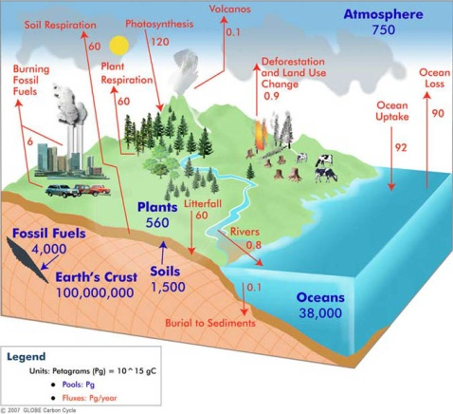

  - Compare the pools (reservoirs) of carbon in the models. What are the impacts that humans are having on the reservoirs? (QI translation)
SOLUTION: For example, compare plant and soil respiration in each model. What can you say about them? Humans reduce the fossil fuels pool by burning coal and natural gas, we reduce soil pool through agricultural processes like tilling soil and fertilizing, we reduce plants through processes such as deforestation, but we increase carbon in the atmosphere. (QI science model)

  - What is the total carbon stored on Earth in reservoirs humans impact? Is the total amount of carbon on Earth reduced or increased by humans?
SOLUTION: The total carbon stored, excluding the Earth’s crust which humans do not impact much, is 4,000 Pg + 1,500 Pg + 38,000 Pg + 560 Pg + 750 Pg = 44,810 Pg. (QI science model; QL numeracy) The amount of stored carbon moves around the system, such as through burning coal, but it is not reduced. So how much carbon is 44,810 Pg? Relate it to something you are familiar with. A Petagram is defined as 10¹⁵ grams, so we can convert it to more familiar units (QL measurement, proportional reasoning):
$${44,810 Pg ×\frac{{10}^{15}g}{1 Pg}=4.481×10}^{19}g×\frac{1kg}{1000g}=4.481×{10}^{16}kg×\frac{2.2lb}{1kg}=9.8582×{10}^{16}lb$$
But how many pounds is that or what does 10¹⁶ represent in size? Well 9.8 is close to 10 so think about 10¹⁷ lbs to get an estimate. 1 ton is 2000 lbs, so we have 10¹⁴ ½ ton pickups of carbon. How many million ½ ton pickups is that? 10⁸ million ½ ton trucks or 100 million ½ ton trucks. Student may use other measures, but relate to something they know. (QL measure, dimensional analysis, proportional reasoning, numeracy-estimation)

  - What percent of this 44,810 Pg of carbon is stored in plants? Make a pie chart model of the percent of the 44,810 Pg of carbon stored in each area. (QM create model)
SOLUTION: 560 Pg/44,810 Pg which is about 1.2%. (QL proportional reasoning, numeracy-calculation). To make the pie chart we calculate the percent of carbon in each of the storage areas: fossil fuels 8.9%, soils 3.3%, 84.8% ocean, 1.7% atmosphere. Check to see if the sum is 100 for total percent: 99.9%. Explain why it is not 100% due to rounding. Draw pie chart.

- (Grand Challenge-Citizenship): Below is a model of deforestation [CS#8]. What does the model tell you? (QI graph)

  - Explain the variables in the model? (QI variable)
SOLUTION: Distance from center of a city by proportion of deforestation. Independent variable is distance, dependent variable is proportion. (QI axes) Proportion is given as a percent. (QI graphic, proportional reasoning) Interpret the graph at the point (600, 10)? At 600 meters from the center of the city deforestation is 10%. (QI graph case).

CS#8
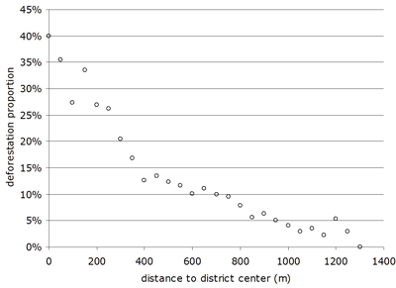

  - What is the general trend of the data? Predict deforestation beyond 1,400 m. (QI trend, prediction)
SOLUTION: Decreasing at a curvilinear rate not a linear rate, so as distance decreases there is less deforestation at faster than a linear rate (QI graphic, trend). It appears that the impact of the city on deforestation is near 0% beyond 1,300 meters. (QI prediction)

  - Can you find an equation modeling the data in the graph?
SOLUTION: Is the model linear or nonlinear? The model is not linear. By the shape and concavity of the graph which of these is the best model: quadratic, cubic, square root, exponential, logarithmic? The graph appears to have asymptotes at the x-axis, so it is likely exponential and not power. Though a power function (power between 0 and 1) with negative coefficient does give the upper concavity and will decrease through the interval. If exponential then would be decay model with negative power. How would you find the model for the data? Use regression curve of best fit to find equation. (QM model analytic)

  - The regression curve of best fit for the data and the equation for the curve is given below [CS#9]. Relate the equation to the graph. (QI graph, analytic, translation) Which model would you use to find the percent of deforestation at 350 meters from the city center? (QI predict, QL proportional reasoning)
SOLUTION: The equation is exponential with a negative exponent that reflects the graph about the x-axis to give us a decreasing or decay situation. The independent variable is the distance x and the dependent variable is the percent of deforestation y. (QI translate) Which model below would you use to find deforestation at 350 meters? (QI prediction). See which they choose. If they use the formula simply substitute 350 for x and simplify to get approximately 20% deforestation. (QI analytic) If they use the graph they have to interpolate – estimate from the graph by estimating location of 350 on x-axis, tracing vertically up from 350 to graph, horizontally over to y-axis. (QI graphic, translate)

CS#9
$$y=57.3e^{-0.003x}$$

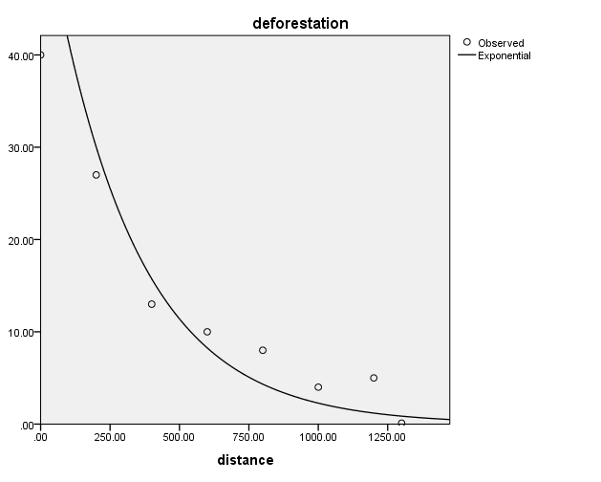

  - How does this deforestation impact carbon cycle? (Science qualitative)
SOLUTION: The trees are storing carbon, when they are cut down and likely burned then the carbon is released in the process back into the atmosphere. This carbon sink becomes a carbon source.

