Interview Protocol
Version A: Environmental Quantitative Reasoning Assessment – Carbon 1-10-12
Based on Carbon Interview Fall 2010. ALLOW and encourage use of calculator for all calculations, this is not an arithmetic test the focus is on reasoning.

Carbon Cycle QR
- (Macro scale): How much carbon dioxide (CO₂) you release into the atmosphere is called your carbon footprint. What adds to your family or your personal carbon foot print? (Science qualitative account)

  - Name five things you do that emit carbon dioxide into the air (QI variables).
SOLUTION: heating/cooling house, driving a car, using appliances, food we purchase, watching TV, using computer, not recycling, recreation (trips), electronics purchased

  - Use the table [CC#1] below to estimate a portion of your carbon foot print. Discuss how you would calculate the footprint for your family (QI table interpretation).
SOLUTION: What is the mpg for the primary car your family drives? Suppose one car at 30 mpg. What is the number of miles your family drives the car in a year? Say 15,000 miles.

CC#1
Driving | Use | Per Use | kg CO₂ / year
Gasoline | 1 gallon | 8.7 kg
Diesel | 1 gallon | 9.95 kg
Appliance | Usage | Per Use | kg CO² /year
Microwave Oven | 96 times per year | 0.945 kWh per use | 39
Washing Machine | 187 washers per yr | 0.63 kWh per use | 51
Electric Dryer | 148 uses per year | 2.50 kWh per cycle | 159
Gas Oven | 135.1 uses per year | 1.52 kWh per use | 38
Electric Oven | 135.1 uses per year | 1.56 kWh per use | 91
Dishwasher | 135 uses per year | 1.44 kWh per use | 84
Fridge-Freezer | 24 hours a day | 270 kWh per year | 116
TV CRT (Cathode Ray Tube) 34-37 in. | On 6.5 hours a day | 198.5 W | 203
TV LCD (Liquid Crystal) 34-37 inch | On 6.5 hours a day | 211.1 W | 215

Then we have (QL numeracy-calculation, measurement-dimensional analysis, proportional reasoning):
$$15000m÷\frac{30m}{1gal}=\frac{15000}{30}g=500g$$
$$500g×\frac{8.7kg}{1g}=4,350kg$$

Select the household appliances they use and add up the kg CO₂ per year column, including the amount from driving. The per use data for appliances is not needed for this calculation, but the usage column could be used to adjust the overall carbon released, say they stated that their families LCD TV was on only 3 hours a day on average, then the emissions can are reduced by the fraction 3hrs/6.5hrs x 215 kg CO₂/yr or 99 kg CO₂/yr. The following calculation is an example:
4,350 kg/yr (driving) + 39 kg/yr (microwave) + 51 kg/yr (washing machine) + 159 kg/yr (dryer) + 91 kg/yr (electric oven) + 116 kg/yr (fridge) + 99 kg/yr (LCD TV) = 4,905 kg CO₂/yr.

  - Given the table [CC#2] below, how could you assess if your footprint was low, average, or high? How could you reduce your footprint (QI table)?
SOLUTION: Have to convert kg to lbs (QL measure, proportional reasoning) so
$$4,905 \frac{kg}{yr}×\frac{2.2lb}{kg}=10,791\frac{lb}{yr}$$
which is less than average, of course we have not calculated all sources of carbon for this family. You could reduce your footprint by reducing driving or driving in a higher mileage car, using high efficiency appliances, unplugging appliances when not used.

CC#2
Pounds of CO2 emissions per year | Result
Below 6000 lbs/yr | Much less than average
Between 6000 and 11,010 lbs/yr | Less than average
Between 11,010 and 21,010 lbs/yr | Average
Between 21,010 and 26,005 lbs/yr | More than average
Above 26,005 lbs/yr | Much more than average

- (Microscopic-Atomic Scale): Carbon cycles throughout the planet moving from the atmosphere to the earth and back again. But what are the processes that move carbon through the cycle? (Science qualitative account)

  - Carbon Processes: Name some processes that return carbon to the atmosphere. Processes that remove carbon from the atmosphere?
SOLUTION: Processes that return carbon to the atmosphere include respiration – plant and animal, combustion, decay, cement factories, volcanoes. Process that removes carbon of the atmosphere is photosynthesis (carbon fixing). Carbon is also sequestered in plants and through human-manufactured processes. (QI variable recognition)

  - Science Process Model: After student has attempted to identify variables on their own, then provide the carbon cycle model below [CC#3]. Does the model have additional variables you should consider for removing and returning carbon from the atmosphere?
SOLUTION: Student reviews model to determine potential variables represented in the carbon cycle. At this time we are not interested in the numeric values, we want to focus on the hidden mechanisms, but note if the students use or refer to the numeric values. (QI interpret science model)

CC#3

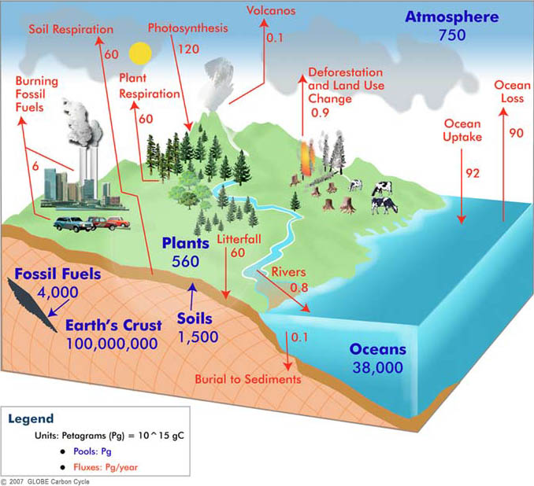

Respiration: Respiration is one process that returns carbon dioxide to the atmosphere. What can you tell me about it? (Science qualitative account)

SOLUTION: Student explains what they know about the process of respiration at the organism level or cellular respiration. Respiration at the organism level is the transport of oxygen from the atmosphere to the cells within tissues, and the transport of carbon dioxide out of the cell to the atmosphere. Cellular respiration is the metabolic process by which an organism obtains energy.

Respiration Model: What are the inputs and outputs of cellular respiration? Can you setup and balance a chemical equation for the process? (QM chemical model, balancing equation-numeracy)

SOLUTION: Cellular respiration occurs when biomass is consumed by an animal and converted to energy. The input for respiration is glucose, oxygen and water, the output is water, carbon dioxide, and released energy which is captured in the form of adenosine triphosphate (ATP) (QI variable). If the student does not know the inputs and outputs then provide them and ask them to balance the chemical equation:

C₆H₁₂O₆ + 6O₂ + 6H₂O → 12H₂O + 6 CO₂

Carbon dioxide is released through respiration back to the atmosphere.

Photosynthesis: Photosynthesis is a process that removes carbon dioxide from the atmosphere. What can you tell me about it? (Science qualitative account)

SOLUTION: Student explains what they know about the process of photosynthesis. Photosynthesis is a chemical process that converts carbon dioxide into organic compounds using the energy of the sun. Photosynthesis is the primary source of energy for life on Earth. Photosynthesis is also the source of carbon in all organic compounds. Carbon dioxide and water plus energy from the sun are the inputs, the output is glucose and oxygen. Plant cells contain chloroplasts which use the compound chlorophyll to take energy from sunlight for the process.
  - Photosynthesis Model: What are the inputs and outputs of photosynthesis? (QI variable) Where does the energy for the process come from? Can you balance the chemical equation for this process? (QM chemical model, balancing equation-numeracy)
SOLUTION: Carbon dioxide (CO₂) and water (H₂O) are the inputs and glucose (C₆H₁₂O₆) and oxygen (O₂) are the outputs. The chemical equation is:
6CO₂ + 6H₂O + energy --> 6O₂ + C₆H₁₂O₆

  - Photosynthesis Rate: What impacts the rate of photosynthesis? (Science Qualitative) Below is a graph [CC#4] of rate of photosynthesis to amount of carbon dioxide in the atmosphere for two types of plants (C3 wheat, rice cotton) and C4 plants (corn, sugar cane, sorghum). C3 plants have a net lower level of photosynthesis then do C4 plants. What impact does doubling CO₂ in the atmosphere have on the plants?

CC#4
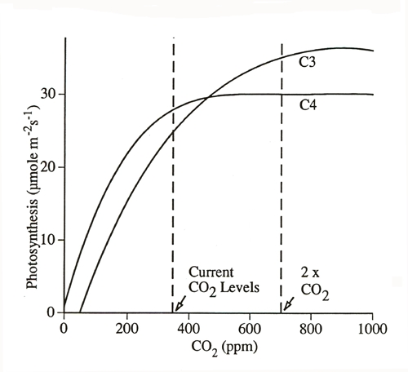
SOLUTION: Variables impacting rate of photosynthesis include light intensity, amount of CO₂ in atmosphere, temperature, wave length of light. (QM variables) The overall trend in the graph is an increase in CO₂ increases photosynthesis, but long term the rate of photosynthesis levels off. (QI graph, trend) Ask what is percentage increase in C3 plants between current levels and levels doubling? For the current CO₂ level of about 380 ppm concentration the photosynthetic rate is about 25 moles per meter per second, at double the concentration, about 760 ppm concentration the rate is about 35 moles per meter per second. (QI case) So the percentage increase is (35-25)/25 = 40%. (QL proportional reasoning-rates).
NOTE: We could have models of light intensity, temperature, wave length all impacting rate of photosynthesis. We could also take the data directly from the teaching experiment for carbon (page 78 Data Set for Gas Exchange) which explores impact of light intensity.

- (Landscape-Global Scale): The following is a box model [CC#5] of global carbon dioxide movement between 2000 and 2005. The numbers represent billions of tons (gigatons) of carbon dioxide per year. Explain what you see in this diagram. (Science qualitative account)
CC#5
- What do the boxes (pictures) and arrows mean to you? (QI interpret model) What does the arrow labeled 8 represent? (QL measure)
SOLUTION: The boxes represent reservoirs of carbon, the arrows represent flux or movement between the reservoirs represented in gigatons. The number 8 represents 8 gigatons of carbon being transported from human energy use to the atmosphere, a hugh human impact on the carbon cycle.

- Can you explain what the box with plants, animals, and soils has to do with carbon movement? (Science qualitative account)
SOLUTION: Relates back to the microscopic-atomic discussion, animals and plants respire releasing carbon dioxide. But plants use photosynthesis to fix carbon, taking it out of the atmosphere.

- What is the net flux (change) in CO₂ with respect to the atmosphere? Is it increasing or decreasing? By how much? (QL numeracy, QI interpret model)
SOLUTION: Plants and animals and soils remove 120 Gt – 122 Gt = - 2 Gt reduction in atmospheric carbon. Human energy adds 8 Gt to atmosphere, and Oceans remove 90 Gt – 92 Gt = -2 Gt. So the overall is an increase of -2 Gt + 8 Gt – 2 Gt = 4 Gt of CO₂ over the 5 year period.

- Is it a concern that CO₂ is increasing in the atmosphere? (Science Qualitative) Why? What would we have to do to balance the exchange of carbon dioxide with the atmosphere? (QL numeracy, QI interpret box model, QM extend model)
SOLUTION: Vary the amounts of CO₂ exchanged so that the atmosphere CO₂ remains the same (QM-logic in system). Explain from a science perspective what we would need to do to make your model a reality (Science qualitative). Need to reduce human production of CO₂ by burning less fossil fuels or find ways for humans to sequester the carbon. So a new model could have humans omitting 6 Gt and sequestering 2 Gt to balance with the 4 Gt gain through plants, animals, soils and the ocean.

- The graph [CC#6] below shows the concentration of carbon dioxide in the atmosphere in parts per million (ppm) for every year since 1958. Explain what you see in this graph. (QI graph)
CC#6
SOLUTION: Can you explain what is measured along the y-axis (QI graph axis)? The y-axis represents CO₂ concentration in parts per million in the atmosphere. What is meant by “concentration”? A concentration is a proportion of part to whole (QL proportional reasoning, measure) What is “ppm” (QL measure)? Parts per million means out of a million and is used for very dilute concentrations of substances, so 310 ppm means 310/1,000,000 parts in the atmosphere are CO₂ What is the trend in the graph (QI graph trend)? The trend is increasing though it does flux each year. Why is the graph going up (Science qualitative)? Relate this on their own to the previous box model, more CO₂ is being released to the atmosphere then can be captured by photosynthesis or stored in reservoirs. (QI translation)

- Find the change in CO₂ in the atmosphere from 2000 to 2005? (QI graph, QL proportional reasoning-rates) How does this compare to what you found about carbon in the atmosphere from the box model above? (QI translation)
SOLUTION: Consider the slope between the two points on the graph, estimate the points: (2000, 370) and (2005, 380). (QI case, numeracy) So the change is about 10 ppm in 5 years. How does the change in concentration relate to the change in gigatons (QL measure, proportional reasoning, QI translation)? The change in concentration in the box model for the same time period is 4 gigatons, so need to compare gigaton to ppm. The conversion is 1 ppm = 2.08 gigatons of carbon in the atmosphere. So
$$10 ppm× \frac{2.08 Gt}{1 ppm}=20.08Gt$$
which is different from the estimate in the box model of a 4 Gt increase. Why so different? We have ppm which is a volume mixing ratio, so we multiple by the mass of the atmosphere weight by the relative mass of carbon atoms compared to air molecules.

- Is the rate of change in CO₂ in the atmosphere constant? (QL-QI)
SOLUTION: Compare the change in CO₂ for another 5 year interval, say 1970-1975, to that from 2000-2005. Is the rate of change for this new interval less, the same, or more than the change from 2000-2005 (QL proportional reasoning-slope, rate)? The rate of change is increasing, this is seen in the slope of the tangent line to points on the graph getting steeper. What are the implications of the rate of change of CO₂ in the atmosphere increasing (Science qualitative)? This implies that not only is CO₂ increasing, but it is increasing at a faster rate with time. What does such an increase mean for us (Science Qualtitative)? The increase in CO₂ is documented, the question is whether this increase is a short term trend that is not of concern, or a long term trend that could result in global warming.

- Predict the concentration of CO₂ in the atmosphere in 2050? Explain how you made your prediction. (QI prediction)
SOLUTION: The prediction can be made by extrapolating the current trend from the Mauna Loa graph. This may be done by extending the Keeling curve and the two axis and estimating a value (QI graphic) or by estimating a rate of change based on the latest trend, say 10 ppm per 5 yrs, and reasoning proportionally (QI proportional reasoning) 2050-2010 = 40 year period. 40 yr x 10ppm/5 yr = 80 ppm increase by 2050 or total of 385 ppm (2010) + 80 ppm = 465 ppm in 2050 (QL numeracy)
- (Grand Challenge-Citizenship): Examine the following models of CO₂ emissions and global warming. Explain what these models are telling you. (Science qualitative account)

  - What do the models indicate about CO₂ emissions and global temperatures? (QI graphic, science model, translation)
SOLUTION: Both are increasing over the past 100 years and are predicted by these models to continue to increase through 2100. (QI trend)

CC#7 CC#8
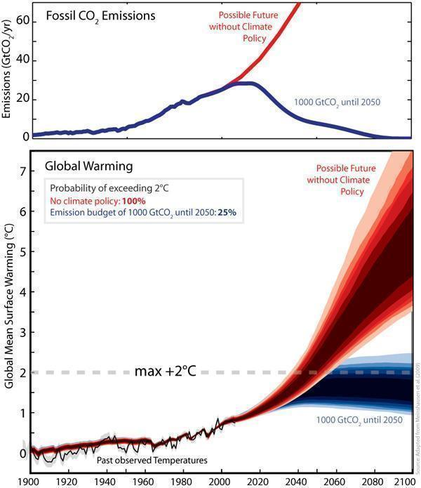

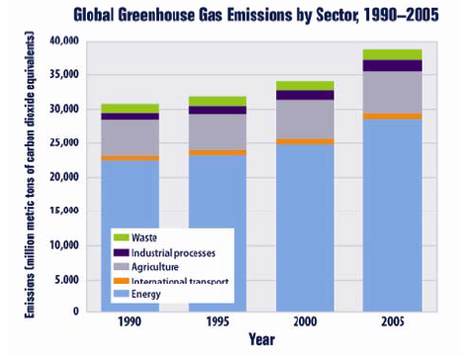

  - Is there a connection between CO₂ increase and increased temperatures? Is so what is it? (Science qualitative)
SOLUTION: Carbon dioxide is a greenhouse gas which absorbs energy from the sun and traps it in the atmosphere, which warms the Earth.

- Does a joint increase in CO₂ and global temperature imply that one causes the other?
SOLUTION: While it implies that they may be related, it does not prove that one causes the other (QM logic-reasoning).

- What are some consequences of global warming? (Science qualitative)
SOLUTION: Provide examples of the long term impact of global warming. Determine if they can base them in current trends like the following. Heat waves have been on the rise since 1970, increase in precipitation in the U.S. of 6% more intense rains that result in flooding, more intense tropical storms with 6 of 10 most active hurricane seasons in the past 20 years, sea level rise increased from 0.6 of an inch to more than 1 inch per decade, increased ocean acidity due to more carbon dioxide dissolved in water, reduction of artic sea ice with 24% decrease from 1979 to 2000, melting glaciers worldwide have lost more than 2,000 cubic miles of water since 1960, longer growing season with increase of 2 weeks in U.S. over the last 100 years.

