Version B: Biodiversity Quantitative Reasoning Assessment – Biodiversity 1-20-12
Based on identification of second theme within Biodiversity PD. ALLOW and encourage use of calculator for all calculations, this is not an arithmetic test the focus is on reasoning.

Biodiversity Extinction QR

- (Macro Scale): Southwestern gray wolves are on the Endangered Species List, which means that they are in danger of extinction [BE#1]. The governments of both the United States and Mexico are breeding Southwestern gray wolves in the hopes that they can someday be returned to the wild. Can you name an animal in your region that is in danger of extinction? (Science qualitative)

BE#1
Southwestern gray wolves (Canis lupus baileyi)
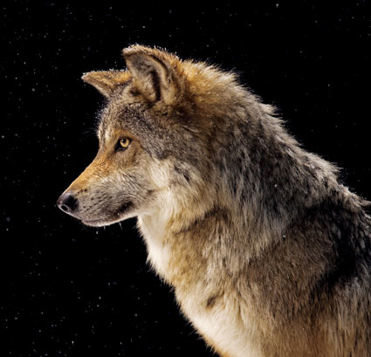
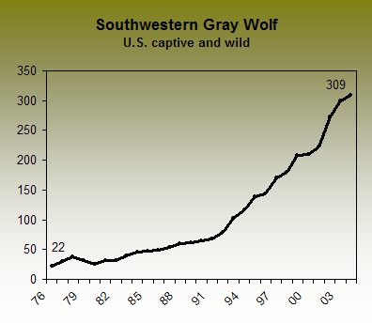
- What are the variables that may cause a species to go extinct? (QI variables)
SOLUTION: Habitat destruction and conversion, overexploitation by humans of the species, human development through urbanization, agriculture, mining, invasive species, pollution, disease, and competition with new species. Past extinctions may have been caused by natural catastrophes such as asteroids or volcanic eruption.

- What does this graph of the Southwestern Gray Wolf tell you about the population? (QI graphic)
SOLUTION: What do the axes represent? The x-axis represents years from 1976 to 2003; the y-axis represents number of wolves. (QI axes) Select a point on the graph and tell me what it represents? For example, the point (88, 50) represents the year 1988 having a wolf population of 50.
- What is the trend in the population? (QI graphic trend)
SOLUTION: The population was as low as 22 individuals and has increased to 309 individuals. There is an increasing trend. (QI trend) Is the trend linear or nonlinear? The trend is not linear, it appears to be a power function or perhaps even exponential. What can you tell me about the rate of increase? The rate of increase is changing, small at first and then increasing. (QL proportional reasoning, numeracy – calculation). Find a rate of increase for some interval of the graph. Select two points and find the slope between the points to estimate the rate of increase. For example, between (82,40) and (91,65) the rate of increase is fairly constant, with a slope or rate of r = (65-40)/(91-82) = 15/9 or 1.67 wolves per year. However, from (1994, 95) to (2000, 210) the rate increases to r = (210-95)/(2000-1994) = 15/6 = 19.17 wolves per year. (QL proportional reasoning, numeracy – calculation).

- Predict the number of gray wolves in the population in 2020. (QI graphic, prediction)
SOLUTION: The prediction can be determined by extrapolating the graph or estimating numerically with slope. Graphically, extend the x-axis to 2020, estimate a line that represents the rate of change late in the existing graph, find the point of intersection of a vertical line from 2010 up to the extended graph, and determine the intersection of a horizontal line through the point of intersection to the y-axis. A reasonable linear estimate is that in 2010 there will be around 500 wolves. Student can provide a drawing to support their argument. (QI graphic prediction, quantitative reasoning) Numerically, the student can use a slope estimating change late in the graph, for example our slope above of around 19 wolves per year increase, in 2005 the number of wolves was 309, from 2005 to 2020 there will be an additional 19 x 15 = 285 wolves, so the total is 309 + 285 = 594. (QL proportional reasoning, numeric – calculation).

- Does it matter if the grey wolf goes extinct? (Science qualitative account)
SOLUTION: Extinction of a species impacts the entire food chain and therefore the ecosystem. Students may also argue that the loss of any species, especially due to the actions of human kind, is abhorrent and morally wrong.

- (Microscopic-Atomic Scale): A major environmental challenge that scientists face is to explain why some species of animals are more susceptible to extinction than others. Scientists already know that one trait associated with high extinction rates is large body size. However, it is still unclear what factors connect high extinction rates and large body size. The graphs below depict 6 variables (weaning age, gestation length, population density, geographic range size, external threat index, and human population density) that scientists believe may predict high extinction rates for mammals with large body size [BE#2]. The y-axis for each graph is the slope of the predictor variable against extinction risk. The x-axis for each graph is values for the lower bound of body mass interval in kilograms. What are these graphs telling you? (Science qualitative account)

  - What do the x-axis and y-axis represent in graph E? (QI graph, axes, case)
SOLUTION: The x-axis is the body mass in kilograms of different adult animals. The y-axis actually has a hidden variable since it involves plotting slopes of external threat index over extinction rate. (QL proportional reasoning – slope). For a specific point, say (1, 1.6) what does the point represent? The x-coordinate indicates an animal with a mass of 1 kilogram or about 2.2 pounds (QL measure). The y-coordinate indicates that (external threat index)/(extinction rate) is 1.6, so for a 1 kilogram body mass, the graph of external threat index (y-axis) by extinction rate (x-axis) has a positive slope greater than one. So the graph comparing external threat index and extinction rate at this point is increasing at more than a 1 to 1 rate. (QI graph; QL proportional reasoning – slope)

  - What is the trend in Graph E and what does it tell you? (QI graph, trend)
SOLUTION: The trend is increasing and appears to be non-linear (QI trend). This indicates that as the slope of external threat index and extinction rates increase, so does the body mass index of the organism. Therefore, external threats are covaring with larger body size (higher body mass index) and larger mammals have comparatively more external threats compared to extinction risk then smaller mammals. (Science qualitative)

  - Graph C: population density and graph D: geographic range both have an inverted y-axis, that is as you go up the values get smaller rather than larger. What does this mean? (QI graphic)
SOLUTION: Population density and geographic range size have an inverse relationship to body mass. So larger body mass is correlated with a decrease in population density and geographic range size when compared to extinction rates. (QI graphic, QL proportional reasoning)

BE#2
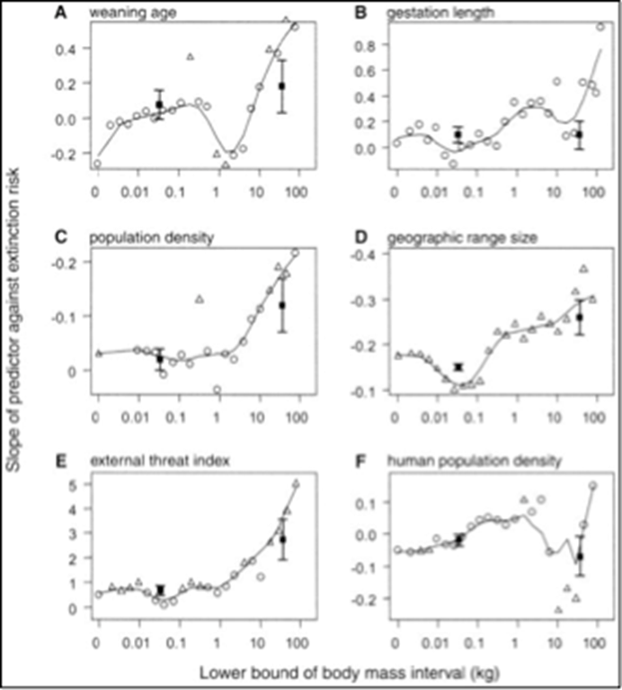

- (Landscape-Global Scale): There are hundreds of stories in the news that say many species on the planet are going extinct. These extinctions are happening everywhere, possibly even near your home [BE#3].

  - What do the graph and table tell you about extinctions? (QI graph, table, translation)
SOLUTION: The number of extinctions was stable up until 1890 and then started to increase more rapidly. (QI graph, trend) The table indicates that the number of species threatened with extinction in 2008 is on average near 38%, with birds the least threatened and plants the most threatened. (QI table; QL proportional reasoning)
BE#3

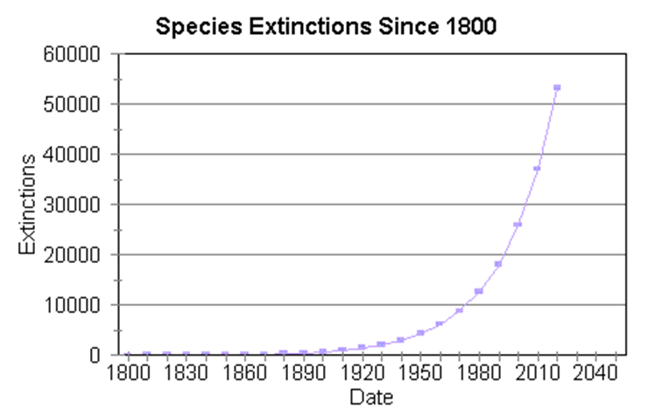
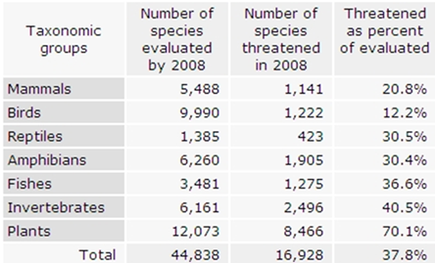

- What do you think could be causing the patterns in the graph and table? (Science qualitative)
SOLUTION: The advent of the industrial age and modern society coincide with the increase in extinctions. Causes include the human created variables of habitat destruction and conversion, overexploitation by humans of the species, human development through urbanization, agriculture, mining, invasive species, and pollution.

- What is the estimated number of extinctions between 1980 and 2010? How does this rate compare with 1920 to 1950? (QI graph)
SOLUTION: Read the graph to determine the related number of extinctions for a given year: (1980, 13000), (2010, 37000), (1920, 2000), and (1950, 5,000). So the number of extinctions from 1980 to 2010 is 24,000, while from 1920 to 1950 is only 3,000. How much of an increase is this in extinctions? This is a 24000/3000 = 8 fold increase in extinctions. (QI graph; QL proportional reasoning)

- Compare the graph and table for 2008. What can you say about 2008 based on the models? (QI graph, table; case)
SOLUTION: Estimating the point on the graph for 2008, we have about 26,000 extinctions in 2000 and 37,000 in 2010, an increase of 11,000 over that interval. Dividing the interval into equal years means there is about 11,000/10 = 1,100 extinctions per year. (QI case; QL proportional reasoning, numeracy – calculation) The table indicates there were 44,838 identified species in 2008, so 1,100/44,838 = 2.4% went extinct in 2008 alone, and of those considered threatened 1,100/16,928 = 6.5% were lost. (QI table; QL proportional reasoning, numeracy – calculation)

- (Grand Challenge-Citizenship): What impact are humans having on extinction rates? What are some variables which humans control that impact extinction rates? (Science qualitative account)

  - What kinds of things do you think will happen to natural areas as human populations grow? Why? (Science qualitative)
SOLUTION: Answers may vary. Possible answers are: (1) Habitats will decrease, (2) pollution will increase, (3) species populations may decrease. Why? Because as the number of people increases, habitats and species population will decrease. Humans will be taking over areas to populate. This is an inverse proportional relationship. (Science qualitative; QL proportional reasoning; QI variables)

  - What does the graph below indicate about the relationship between human population growth and species extinction [BE#4]s? Explain the pattern and why it occurs? (QI graph, trend)
SOLUTION: As human populations increase, so does species extinction. This may be happening because humans are destroying species natural habitats; there is competition between humans and other species for natural resources; and humans may be driving many of these species to extinction.
BE#4
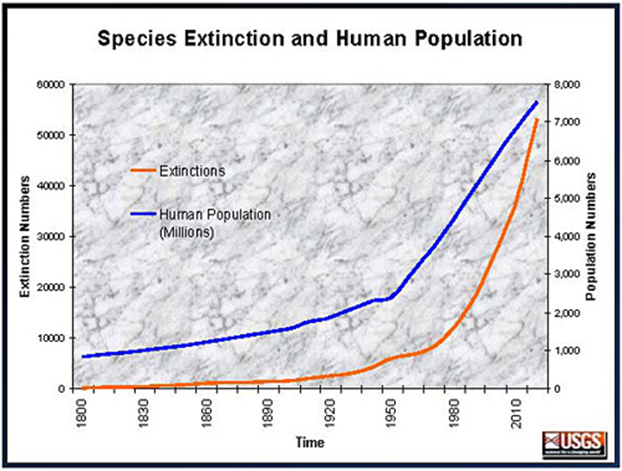

  - In 2000, scientists estimate that 19,500 new species were discovered. What is the ratio of new species discovered in 2000 to extinction numbers in 2000? Using the number you calculated, would it be OK for the earth’s biodiversity if some species went extinct as long as others were being discovered? Explain? (QI graph; QL proportional reasoning)
SOLUTION: 19,500/40,000 OR 48.7%. No it is not ok for the earth’s biodiversity if some species went extinct as long as others are being discovered. The number calculated is not the only significant information needed to solve this problem. Because each species satisfies a certain ecological niche, if that niche is not filled, then the impact is substantial and across ecological systems. However, if the new species being discovered occupy the same niches that the extinct species does, then the impact on biodiversity and ecological systems may not be as significant. (Science qualitative; QI graph; QL proportional reasoning)

  - Statistics on rates of extinction have been inferred from a species-area relationship and projections of habitat destruction: S = CA^{z} where S is number of species, C is a constant, A is area of habitat, and z is a decay value which is commonly between a low of 0.15 and a high of 0.35. If we are interested only in the proportion of species remaining after some portion of habitat has been destroyed, then we have:

$$\frac{S1(after habitat destruction)}{S2(before habitat destruction)}=\frac{C×A1(habitat area after destruction)}{C ×A2(habitate area before destruction)}$$
If current rates of tropical deforestation continue for another 30 years half of the remaining forest will be gone. What percent of the species will go extinct? (QM model extension; QI analytic; QL proportional reasoning, numeracy)
  - SOLUTION: The proportion or percent of species surviving is given by the ratio of S1/S2. The constant C cancels so we do not need to know that value. The ratio of areas A1/A2 = 0.5 since ½ the area of the forest habitat is destroyed. The value for z can be any between the lower value of 0.15 and the upper of 0.35. The best solution is to find values for both the lower and upper so that you have an interval solution. Substituting we get the percent of species that survive is a low of 0.5^{0.35} = 0.78 and a high of 0.5^{0.15} = 0.90. So how many go extinct? Subtract those that survive from 100% to get 10% to 22% will go extinct. (QI analytic)

BE#5

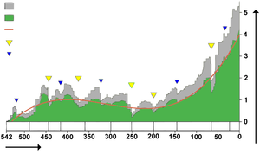

BE#6

