Interview Protocol Biodiversity Communities QR
Version A: Environmental Quantitative Reasoning Assessment DRAFT – Biodiversity 11-29-11. ALLOW and encourage use of calculator for all calculations, this is not an arithmetic test the focus is on reasoning.

- (Macro scale): A biological community is the set of all populations that inhabit a certain area. An ecosystem includes both the community (biotic) and its physical environment (abiotic). Name a stream or river or close to where you live. Let’s talk about the ecosystem of that local stream.

  - Local Biological Community - Biotic: Identify at least five organisms that live in or near the river. Create a food web which indicates who eats whom [BC#1] (QM variable recognition, QM graphic model). Suggest using boxes and arrows to create the food web.
SOLUTION: Students are to construct a box model representation of a food web. Want a hierarchical structure including produces, decomposers and at least two levels of consumers. Below is an example, though it omits decomposers.
BC#1
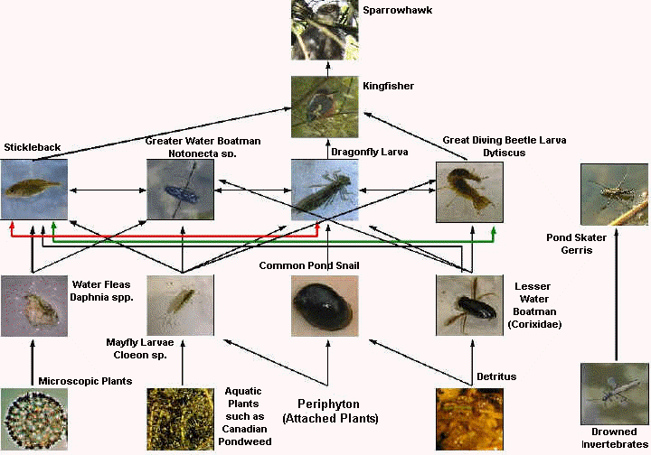

- Food web: What does the food web below tell you about the stream biological community [BC#2] (QI science model)?

BC#2
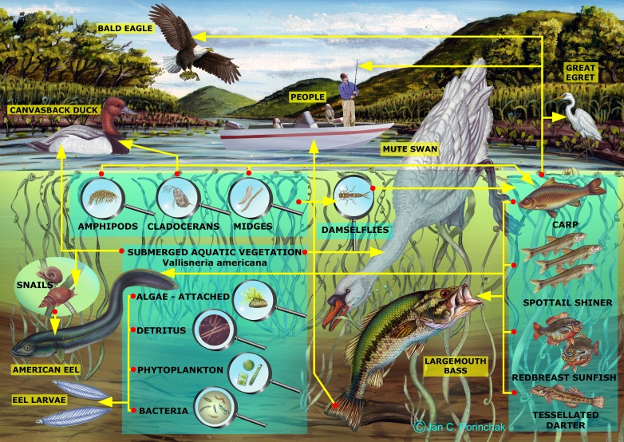
SOLUTION: Students should identify the organisms and their predator-prey relationships. Have them trace one line of the food web to ensure the can do this, for example: midges eaten by damselflies eaten by carp eaten by egret.

- Community Abiotic: Abiotic components of an ecosystem are non-living chemical and physical factors in the environment which affect the system, such as light, temperature, oxygen, nitrogen, phosphorus, and sulfur. For example a water beetle needs between 8-12 mg/L of dissolved oxygen in water to survive, but a leeches only require that dissolved oxygen is 4 mg/L or greater. The graph and table below provide models for oxygen saturation in water due to temperature, where saturation is the maximum amount of oxygen that can dissolve in the water [BC#3]. What do the models below tell you (QI graph-table, translation between models, trends)? What can you say about the temperature at which water beetles and leeches can live in the water (QL number sense, proportional reasoning)?
BC#3
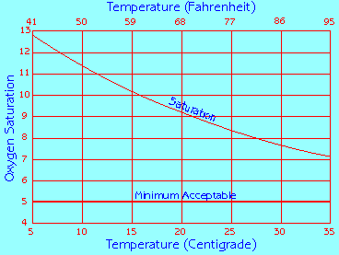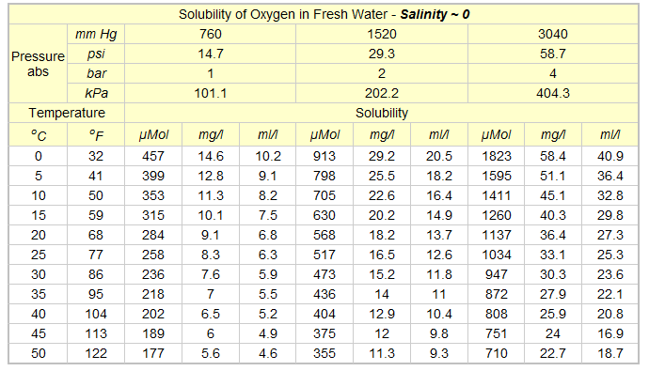

SOLUTION: Students can identify a decreasing trend in oxygen saturation as temperature increases. Ask them if they are using the graph or table? Ask them to relate the graph to the table? See if they can select the mg/L column that fits the graph, it is the 4th column. Students can estimate the upper bound of temperature for the water beetle to have enough dissolved oxygen: at the lower level of 8 mg/L the beetle can survive in water that is not warmer than approximately 27.5 $℃$ or 80$℉$. If they give only one of the temperature scales ask them if they can find the other from the table or graph. Students should also be able to say that the leech is safe at temperatures up to at least 50$℃$ or 122$℉$ according to the table, since 5.6 mg/L > 4 mg/L.

- Prediction: Below are two best fit models for dissolved oxygen (d) as a function of temperature (t) in Celsius, one is a linear (line) approximation and the other is an exponential approximation.
$$d=-0.17t+13.28 d=13.77e^{-0.019t}$$

We want to predict how hot the water would have to be to endanger the leech (QI analytic, prediction)? Given the graph and table above and the equations below, which would you use to predict this (QM preference, translation)? Use the model you selected to find a predicted temperature at which the leech is endangered.
SOLUTION: Students should be clear on what model they prefer: graph, table, or equation. They should describe what they are doing in estimating the value. The quickest means to finding the approximation is to use the equation. If the student has not studied exponential models yet, they will probably choose the linear model. Substituting into the equations with dissolved oxygen of 4 mg/L will give the desired temperature at which leeches are threatened: $$4=-0.17t+13.28 or 4=13.77e^{-0.019t}$$
$$0.17t=8.22 e^{-0.019t}=0.29$$
So the linear model estimates the temperature to be 48.4$℃$ and the exponential model 65.2$℃$. Students may avoid the equations and use the graph, in which case they extend the graph until it intersects the horizontal line representing 4 mg/L then interpret the value on the x-axis that corresponds to that point. This gives an estimate around 75 $℃$. Finally they could interpolate from the table: using the last value of 50$℃$ at 5.6 mg/L and a rate of decrease of (50-45)/(5.6-6) = -5/0.4 we want an additional decrease of 5.6-4 = 1.6 so 1.6/0.4 = 4 more steps of 5 degrees giving 50 + 4*5 = 70$℃$ as an approximation. If students mention more than one approximation, have them discuss why they are different. They are of course approximations and the linear approximation is not very good since the actual trend is curvilinear.

- (Microscopic-Atomic Scale): What happens to biomass and energy in a community? As you move up the food web are there more or less organisms? (Science qualitative) [BC#4]
  - Below are pyramids of energy and biomass for a system. What do the pyramids tell you about biomass and energy in the community (QI science model)?
SOLUTION: Student should see trend of reduction in energy and reduction in biomass as you move up the food web from producer to highest level of consumers. Ask them for some specific examples, such as: plants have the most biomass at the base of the pyramid and are storing energy from the sun through photosynthesis, while predators at the top have the smallest numbers, biomass, and energy stored (QI science model interpretation).
BC#4

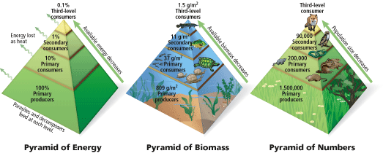

  - What percent of energy and biomass is lost at each step in the pyramid?
SOLUTION: Students should calculate percent energy lost at each level, which is 1/10 or 10% (QL proportional reasoning, number sense). For biomass students calculate percents which vary but are always decreasing: 37/809 is 5%, 11/37 is 30%, and 1.5/11 is 14%. In each case there is a significant loss of biomass at each step (QL proportional reasoning)

- What happens to the biomass that a consumer does not eat, such as beaks or bones? (Science qualitative account)
SOLUTION: Students need to account for the hidden mechanism of decomposers, such as bacteria and fungi. They may account for some of the uneaten biomass as fodder for scavengers, but should also account for the essential role played by decomposers.

- Bacteria are living single-celled organisms shaped like spheres, rods, or spiral twists. A bacteria is about 10⁻⁶ of a meter in length. Just how small is that? How many would fit end-to-end in an inch (QL scale)?
SOLUTION: The student should convert from meters to centimeters so they have a comparison to an inch, since there are 100 cm in a meter there are 10⁻⁶/100 = 10,000 bacteria per centimeter. There are approximately 2.5 cm per inch so 2.5 x 10,000 = 25,000 bacteria per inch (QL proportional reasoning, measure)

- (Landscape-Global Scale): A global model of the world’s biodiversity is given below. The index currently incorporates data on the abundance of 555 terrestrial species, 323 freshwater species, and 267 marine species around the world.
  - What does the model tell you about biodiversity on the planet? What does a population of index of 100 in 1970 mean? (QI graph) [BC#5]
SOLUTION: The student should discuss the decreasing trend in marine, terrestrial, and freshwater species. Think of population index as a percent, the graph is comparing current levels to 1970 as a 100% level (QI graph, QL proportional reasoning)
BC#5
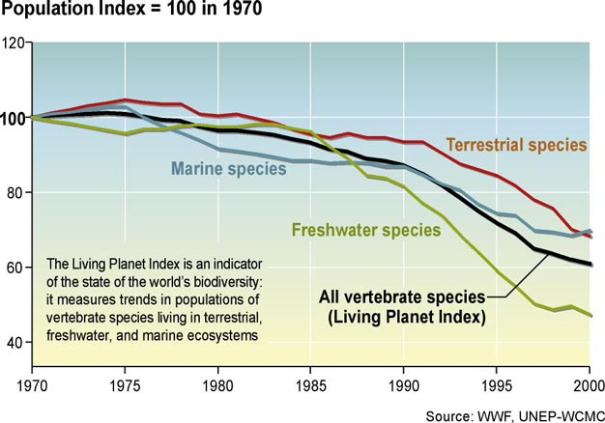

  - How much as the population index changed from 1970 to 2000? (QI graph)
SOLUTION: While the index fell by some 40% between 1970 and 2000, the terrestrial index fell by about 30%, the freshwater index by about 50%, and the marine index by around 30% over the same period. The most alarming change is in the amount of marine loss.

- (Grand Challenge-Citizenship): On Feb 16, 2006 at Howe Cave near Albany, NY a photograph was taken of a bat with white fungus on its noes, ears, and wings. By the following year, 97% of bats in Howe Cave were gone, and White Nose Syndrome (WNS) was found at 33 sites in Connecticut, Massachusetts, New York, and Vermont. WNS is only currently found in cave hibernating bats, but 70-100% of bats in caves showing symptoms will die. The white color comes from a new fungus called Geomyces destructans (see photos below). It is a cold tolerant fungus and species in this genus are found worldwide. Scientists believe that the fungus is transferred from cave to cave through human activity and natural bat movements. The graph below is a representation of colony growth of Geomyces destructans (millimeters per day) and temperature. [BC#6]
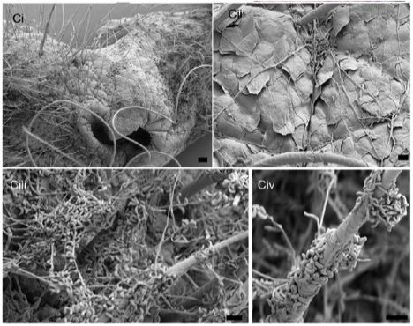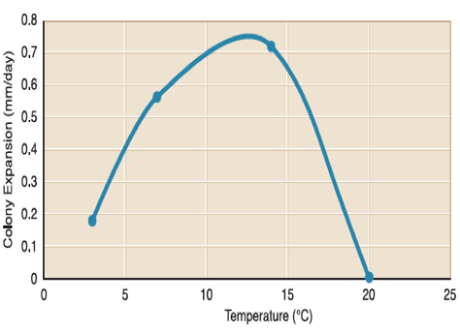
- Should we be concerned about the loss of bat colonies? Why? (Science qualitative)
SOLUTION: We might hope that students would be concerned about the loss of any species due to decreased biodiversity and the impact on a biological community. Bats control insect populations and are therefore useful to humans as well.

- What does the y-axis represent? What is the point (5, 0.4) represent? What is the relationship between colony expansion and temperature (QI graph, trend)?
SOLUTION: The y-axis represents the rate of growth of the fungus in mm/day. So the point (5, 0.4) means that when the temperature is 5$℃$ the rate of growth is 0.4 mm/day. The fungus expansion rate is increasing between around 3$℃$ and 12$℃$, but decreases after that until it ceases to expand at 20$℃$ or more. Students should note that the rate of increase is not constant. May ask for what temperatures the rate of growth is increasing most rapidly? This would be between 3$℃$ and 7$℃$. The rate of increase tapers off after that.

- Cave temperatures are proportional to the outside air temperature. What does this indicate about the spread of the WNS for bats across the northeast United States?
SOLUTION: If we know the temperature ranges in a cave are outside of the range of (3, 20) then the bats in the cave are not at risk. However, this range is so broad and cave temperatures are so moderate that there is not much chance this will occur often enough to stop the spread of the epidemic.

- Below is a map showing the spread of WNS in the Southeastern U.S. [BC#7]. What is it telling us about the spread of WNS (QI science model)? What are the impacts of this spread in terms of decreased bat population for the region (QL proportional reasoning)?
SOLUTION: The student should perceive a spread in the WNS and the treat to the bat population of 70-100% death rates (QI science model). Ask them to discuss the rate of spread using the scale in miles? Drawing a circle around the gray areas of infection gives a spread of about 100 miles radius in 2007-2008 or a diameter spread of about 200 miles, for 2008-2009 the spread is more in an oval following the Appalachian Mountains with an axis of close to 800 miles. In 2009-2010 the expansion was primarily northwest leaving the Appalachian chain, so may have to consider increased area, but the maximal linear expanse does increase to about 850 miles. In 2010-2011 the maximal linear expanse jumps to 1,400 miles. So it increases by to 200, 800, 850, and 1,400. The spread was 4 times from the first to second year and about 1.75 times from year 2 to year 4 (QL measure, proportional reasoning, geometry). Ask will it reach Kansas in the next year? It has already spread to western Kentucky is about 350 miles, so it can certainly reach Kansas in 2011-2012 (QL number sense, estimation). Ask for bat population, say the population is 1 million bats (need to get an actual estimate) for the region shown in the map. Then between 70% and 100% would die if infected, meaning there would be only 300,000 to no bats left in the region (QL proportional reasoning).
BC#7
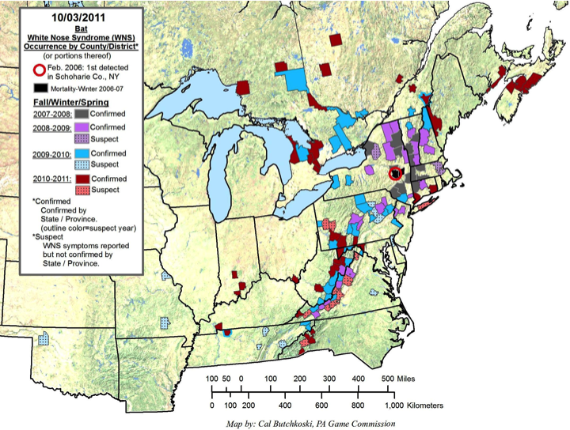

- Chiropteran bats like the ones who are susceptible to WNS are found all over Earth [BC#8]. The representation below depicts the number of Chiropteran bats found around the world. It demonstrates the richness per grid-cell area for the variety of Chiropteran species (need more on what the number quantities represent). What is the concentration of species for the area of the WNS outbreak in the northeast U.S.? Where are concentrations of species highest? What does this have to do with the WNS outbreak? (QI science model)
SOLUTION: Students can interpret the table to determine that the concentration of species in the northwest U.S. is 7 (QI science model). They can also see that the highest concentration of bat species are near the equator (QI science model). Ask them to provide some reasons for this, such as more abundant food supply in tropical climates. Students should discuss the potential spread of WNS that is already spreading across the northeast U.S. to go global. As it nears the equator it will have more dense populations which could result in increased rate of spread due to more contact between bats. The impact of increase in temperature could be discussed as well, for example will the temperature be warm enough to exceed 20$℃$ in tropical caves and stop the spread of the fungus? (QI science model, table, graph; translation between models, trends; qualitative science account)
BC#8
