Atrazine Ban Would Spell Disaster for Illinois Economy
Reading to accompany citizenship mini-unit on atrazine
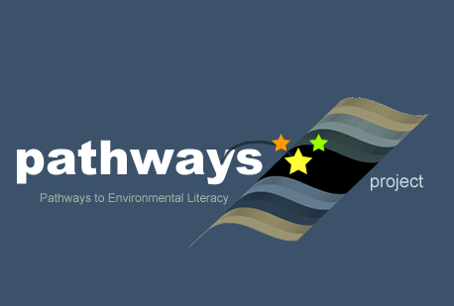
Written by: Bonner Cohen
Culturally relevant ecology, learning progressions and environmental literacy
Long Term Ecological Research Math Science Partnership
2012
Disclaimer: This research is supported by a grant from the National Science Foundation: Targeted Partnership: Culturally relevant ecology, learning progressions and environmental literacy (NSF-0832173). Any opinions, findings, and conclusions or recommendations expressed in this material are those of the author(s) and do not necessarily reflect the views of the National Science Foundation.


Atrazine Ban Would Spell Disaster for Illinois Economy
May 1, 2007 by Bonner Cohen, published online on www.heartlander.org .

A ban on atrazine, a widely used weed-killing herbicide, would inflict enormous financial damage on the Illinois economy and degrade the state's environment, according to a study released February 27. Activists are pushing for such a ban in Illinois and other states.
"Without atrazine, Illinois growers would absorb a loss in the first year between $161 million and $577 million," said Don Coursey, a University of Chicago professor and author of the study. "It is the equivalent of a huge tax hike on Illinois corn farmers." As the nation's second-largest corn-producing state, Illinois would suffer enormously by the removal of the popular pesticide from the marketplace. "Illinois may become less competitive with respect to other states in the production of ethanol," Coursey pointed out.
In 2005, sales of corn produced in Illinois amounted to $3.5 billion, or nearly 40 percent of the state's total farm receipts, according to the U.S. Department of Agriculture.
Decades of Safe Use
Atrazine, produced by the Swiss agribusiness giant Syngenta, has been used in the United States for nearly half a century and is the most popular corn herbicide in the country. Some 70 million pounds of atrazine are used in the United States each year. Over the years, environmental activists and some researchers have advocated banning atrazine, claiming the herbicide poses a threat to public health and the environment.
In 2002, for example, University of California-Berkeley researcher Tyrone Hayes said exposure to very low levels of atrazine could disrupt hormones and cause aberrant sexual development in male African clawed frogs. Hayes later produced a study finding atrazine appears to make leopard frogs--the most common native American frog--hermaphrodites in the wild. Hayes' claims, however, have not been substantiated by the U.S. Environmental Protection Agency (EPA).
In the aftermath of Hayes' findings, EPA released a "White Paper on Potential Developmental Effects of Atrazine on Amphibians," in which the agency stated, "the available data do not establish a concordance of information to indicate that atrazine will or will not cause adverse developmental effects in amphibians." EPA was critical of Hayes' research, saying his "data did not show a clear dose-response relationship."
In June 2006 EPA concluded the cumulative risks associated with triazine herbicides, a group to which atrazine belongs, pose "no harm that would result to the general U.S. population, infants, children or other ... consumers."
Environmental Benefits
In his study, Coursey finds the use of atrazine benefits the environment. Because the available alternatives to atrazine, in addition to being more expensive, also must be used in much greater quantities to combat the growth of weeds, banning the herbicide would lead to more sedimentary runoff, more chemical runoff, higher water treatment costs, increased use of fossil fuels, more carbon dioxide releases, reduced soil quality, and less habitat for wildlife.
"The availability of relatively inexpensive corn in Illinois is essential in reducing the nation's dependence on foreign oil, further developing renewable and environmentally friendly fuel alternatives," said Coursey in a news release accompanying the study. "Without atrazine, each of these efforts would be thwarted, making the solution harder and more expensive to attain."
Critics Persist
Atrazine critics continue to push for a ban on the chemical in Illinois and other states, regardless of the findings of Coursey and EPA. In early 2005, the Minnesota House Agriculture Committee rejected three bills that would have banned or restricted use of the herbicide.
The case for atrazine was significantly strengthened by the state's agriculture department, which in a 2004 survey found trace amounts of the weed-killer in only four of 71 drinking water wells in the state's agricultural region. The highest was 1.52 parts per billion (ppb), well below the federal limit of 3 ppb in municipal water systems.

Bonner R. Cohen (bonnercohen@comcast.net) is a senior fellow at the National Center for Public Policy Research in Washington, DC and author of The Green Wave: Environmentalism and its Consequences, published by the Capital Research Center.

