Validation of a Multi-Year Carbon Cycle Learning Progression: A Closer Look at Progress Variables and Processes
2009 NARST Paper
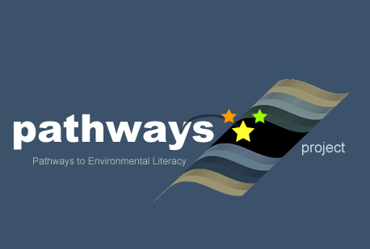
Written by: Lindsey Mohan, Jing Chen, Hamin Baek, and Charles W. Anderson (Michigan State University), Jinnie Choy and Yong-Sang Lee (University of California-Berkeley)
Culturally relevant ecology, learning progressions and environmental literacy
Long Term Ecological Research Math Science Partnership
April 2009
Disclaimer: This research is supported by a grant from the National Science Foundation: Targeted Partnership: Culturally relevant ecology, learning progressions and environmental literacy (NSF-0832173). Any opinions, findings, and conclusions or recommendations expressed in this material are those of the author(s) and do not necessarily reflect the views of the National Science Foundation.


Validation of a Multi-Year Carbon Cycle Learning Progression: A Closer Look at Progress Variables and Processes
Lindsey Mohan, Jing Chen, Hamin Baek, and Charles W. Anderson
Michigan State University

Jinnie Choy and Yong-Sang Lee
University of California-Berkeley

This paper reports on the empirical validation of a multi-year carbon cycle learning progression that add to our existing reports (Mohan, Chen, & Anderson, in press). While our prior reports have focused on describing our framework and sharing Levels of Achievement, this paper further explores the nuanced patterns within the learning progression, and statistical analyses of our assessments. The goal of this paper is to share results from both statistical and conceptual analyses aimed at understanding and improving the assessment instruments used in our learning progression work.
Carbon Cycle Learning Progression Framework
Our learning progression framework contains two important dimensions: Progress variables and Processes. The Upper Anchor of our learning progression is organized around three key Processes that tie systems together: the generation of organic carbon (photosynthesis), the transformation of organic carbon (digestion, biosynthesis, food chains, sequestration), and the oxidation of organic carbon (cell respiration, combustion). Within this organization, we have identified two key Progress Variables that are the focus of our work: tracing matter and tracing energy. In the learning progressions language, progress variables are treated like “big ideas” that are central within the learning progression domain.
We have identified four levels of achievement that describe students’ progress toward more sophisticated reasoning about matter and energy within the key processes. Level 1 represents the Lower Anchor of our learning progression, or what is observed of students at the beginning of the learning progression (i.e., upper elementary). At this level students use force-dynamic reasoning to explain how enablers help actors fulfill their natural tendencies. They pay attention to the interplay of forces—the enablers that support natural tendencies and the antagonists that prevent actors from fulfilling their goals. For example, plants are seen to have a natural tendency to grow, enabled by water, soil, space, “plant food”, etc. Plants grow because that’s what living things do. This growth may be prevented if there is no sunlight, no water, or if the air is too cold (i.e., antagonists).
By level 2, students move beyond natural tendencies, and attempt to explain processes using “hidden mechanisms” and begin to trace materials and energy forms that are visible or tangible (e.g., solids, liquids, heat, sunlight, motion, etc). Students believe that hidden mechanisms, which cannot be observe with the human eye, cause observable changes in organisms and objects. For example, level 2 students use gas-gas and solid-solid cycles to describe processes in plants and animals, and decomposition.
At level 3 students are aware of cellular processes and chemical reactions, and they are aware that materials are composed of different types of substances. While the progress in understanding the chemical nature of processes is apparent in level 3 responses, these students do not have a robust commitment to conservation of matter and energy, and often default to matter-energy conversions to account for mass change that should be attributed to gases.
Level 4 represents the Upper Anchor of our learning progression. At level 4 students have a strong commitment to using scientific principles as constraints in their reasoning, therefore they attempt to conserve both matter and energy are multiple scales.
In these prior reports we reported on characteristics of student reasoning at different levels of achievement. We primarily looked at patterns in the way students of different age groups were distributed across the levels of achievement. This report builds on our understanding of the current levels of achievement, by exploring patterns in the way students come to understand the progress variables (i.e., matter and energy) and process dimensions. The following questions were used to guide our work:
- Are there patterns in the way students account for matter and energy? Do they tend to score the same, higher, or lower on one or the other dimension?
- How consistent are students in terms of their accounts of processes? Are there patterns that indicate students understand some processes more or less than others?

Design & Analyses
Our work uses an iterative process typical of design-based research, in which there is continual negotiation between framework development and design of assessments. We developed an initial framework, used the framework to construct assessments, and then used the data from assessments to revise the framework. We have now completed four cycles of framework design and assessment, and report findings from assessment analyses on the fourth cycle. The design products of this work are a set of validated assessments and a learning progression framework.
The assessments were administered to students in grades 4-12. For our purposes we groups students in grade bands, with grades 4-5 classified as upper elementary, grades 6-8 as middle school, and grades 9-12 as high school. Our total sample was 771 assessments, from 18 classrooms in rural and suburban Michigan, and a suburban school district in Washington state. More specifically, we included 190 assessments from elementary students in 6 classrooms in Michigan, 288 assessments from middle school students in 2 Michigan and 1 Washington classrooms, and 294 assessments from high school students in 5 Michigan and 4 Washington classrooms.
The assessments were mostly comprised of open-response items that focused on five macroscopic processes that we believe all students within our grade range recognize: Plant growth, animal growth, animal weight loss and movement, decay, and burning. Within the context of these five macroscopic processes, our questions focused on accounting for matter and mass, as well energy. We included a total of 29 assessment items in our analyses. Many of the items were scored for both matter and energy, giving each participant a total of 45 scores. Table 1 summarizes the distribution and coverage of items included on our assessments.

Table 1. Coverage of Items
 | Number of item scores (Total items= 29; Total Scores= 45)
 |  | Elementary Forms |  |  | Middle Forms |  |  | High Forms
Category | Total | EA | EB | EC | MA | MB | MC | HA | HB | HC
[ Principles ]
Matter | 25 | 9 | 9 | 7 | 7 | 7 | 9 | 5 | 7 | 9
Energy | 20 | 6 | 6 | 3 | 7 | 6 | 6 | 5 | 6 | 7
Total | 45 | 15 | 15 | 10 | 14 | 13 | 15 | 10 | 13 | 16
[ Processes ]
Photosynthesis | 8 | 3 | 2 | 1 | 4 | 3 | 1 | 3 | 3 | 2
Digestion/Growth | 6 | 2 | 1 | 1 | 2 | 2 | 2 | . | 2 | 2
Cellular Respiration | 10 | 3 | 2 | 2 | 3 | 1 | 1 | 3 | 1 | 1
Decomposition | 4 | 2 | 2 | 2 | 2 | 2 | 2 | 2 | 2 | 2
Combustion | 7 | 2 | 4 | 1 | 2 | 2 | 4 | 2 | 2 | 4
Cross Process | 10 | 3 | 4 | 3 | 1 | 3 | 5 | 0 | 3 | 5
Total | 45 | 15 | 15 | 10 | 14 | 13 | 15 | 10 | 13 | 16

The responses from students on our assessments were transcribed in excel workbooks and then scored by at least 2 raters using our descriptions and exemplars of our existing Levels of Achievement. The items included in this analysis reached 90% agreement among raters in the reliability check.
Once the data was transcribed and coded, we conducted a qualitative analysis where raters judged the appropriateness of items in terms of the four levels of achievement. Eight raters made judgments to identify “invalid levels” (i.e., item was not appropriate for assessing a particular level). The invalid levels were accounted for during the subsequent analyses. We then conducted between-item multidimensional Partial Credit Model (PCM) analysis to explore patterns in the two progress variables and the six processes.

Results

The results section is divided into three sections. In the first section we address the results to our research questions—whether there were patterns in students’ accounts of progress variables or processes. We follow up this first section with additional analyses that look at the quality of items and a look at how the items aligned according to levels.

Progress Variables and Processes

Table 2. Principles dimensions: variance-covariance matrix and EAP reliabilities

Dimension | Dimension
Dimension | Matter | Energy
Matter  Energy | 1.231  0.959 | 1.335
EAP Reliability | 0.623 | 0.614
Note: The values on the diagonal are variances and values below are correlation.

Although we were aware that most students confuse matter and energy, we wanted to examine these progress variables closer to see if there were patterns in students’ accounts. One hypothesis was that students might understand matter before they understand energy, or vice versus.
A correlation between the matter and energy progress variables was produced based on person ability estimates. The correlation between matter and energy dimensions was fairly high (0.959), indicating that students have a similar level of understanding of both progress variables—if they have a certain level of understanding of one, it is likely they will have the same level of understanding of the other. This makes sense given the characteristics of student accounts at each level. At level 1, enablers represent a mix of materials and/or energy forms and conditions; these students are not committed to tracing enablers through an event (whether matter or energy), and therefore share a similar understanding of the two that does not recognize conservation. At level 2 students start to show matter-energy conversions to account for mass change that should be attributed to gases. They begin to trace solids and liquids, and may know “tangible” forms of energy forms (e.g., sunlight, heat, motion), but their confusion around gases and chemical energy prevent conservation. At level 3, the matter-energy conversions are more prevalent, even down to atomic-molecular scale. Again, these students struggle with chemical energy and tracing atoms through processes. Students achieving level 4 understanding are likely to have strong commitment to conservation of both matter and energy.
The scatterplot shows general overall item difficulty and step difficulty of items when scored based on Matter and Energy (see Figure 1). For example, item R1 (i.e., how food helps you move your finger) and item D1 (what happens to an apple as it rots) showed notable differences in student performance for matter and energy. In general, it was more difficult to the same level of energy score as matter score for these items. Interesting patterns also occurred for item B1 (what happens to a candle as it burns) and item D2 (what happens to a tree as it decays). For both items it was easier to score level 3 for matter than for energy, however, the opposite was true in order to score level 4.
.

Figure1. Comparison of item and step difficulty for the items with both Matter and Energy scores
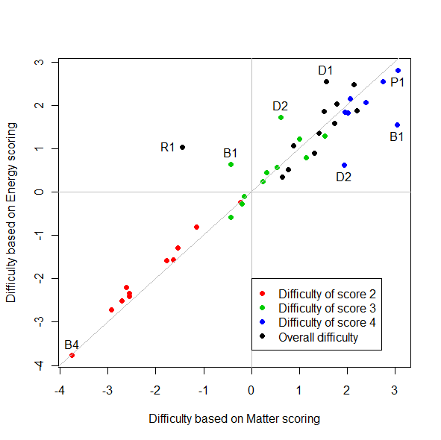

Notes. The item and step difficulties are estimates from the between-item multidimensional partial credit model for Matter and Energy dimensions.

While our Upper Anchor is organized around the three key processes, we have used linking processes as a way of designing assessments for students at all grade levels. These linking processes are the five macroscopic processes of plant growth, animal growth, weight loss and movement, decay, and combustion. Our previous work has identified trends in student progress in explaining these processes, but without rigorous statistical analyses to explore whether there is differential progress depending on the processes. Using Multidimensional IRT analyses using ConQuest software, we were able to obtain person ability estimates, which then gave us correlations between performance on clusters of process items (e.g., photosynthesis items, combustion items, etc). We examined whether performance on items about one type of process correlated with performance on items about another type of process (see Table 3).
The correlations between the process dimensions were generally high. For example, if students had a certain level of understanding for photosynthesis they likely had a similar level of understanding for other processes. In general cellular respiration had the lowest correlations with other processes indicating that students may have different levels of understanding for this process compared to other processes.

Table 3. Process dimensions: variance-covariance matrix and EAP reliabilities
Dimension | Dimension
Dimension | Photo-synthesis | Digestion/ Growth | Cellular Respiration | Decompo-sition | Combustion | Cross Process
Photosynthesis  Digestion/Growth  Cellular Respiration  Decomposition  Combustion  Cross Process | 2.666  0.764  0.706  0.818  0.802  0.774 | 1.590  0.576  0.711  0.798  0.724 | 1.012  0.551  0.659  0.542 | 0.871  0.771  0.804 | 2.639  0.830 | 1.983
EAP Reliability | 0.543 | 0.501 | 0.375 | 0.494 | 0.562 | 0.553
Note: The values on the diagonal (blue) are variances and values below are correlations.

Figure 2 shows a scatterplot for item difficulty color-coded by process. No patterns appear in the scatterplot, indicating that no process appeared to be particularly easy or difficult, although the plot shows there were no easy items for cell respiration.
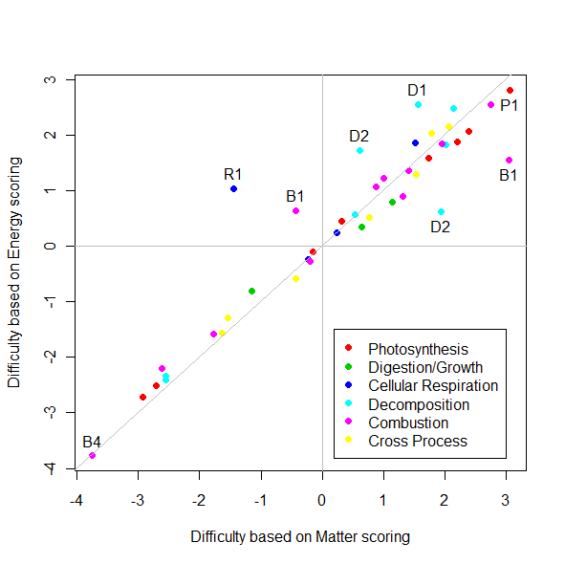
Figure 2. Comparison of item and step difficulty for the items with both Matter and Energy scores: Grouped by Processes

Quality of Items

The following analysis was conducted to see if students scored particularly high or low on specific items in comparison to their average score on all items on the assessment. A classical item discrimination index provided a correlation between students’ scores on specific items and their total score (see Figure 3). The results show that students general performed the same across all items, with the exception of two items: item 19, which asked students to explain what happened to the mass of fat when Jared the Subway guy lost weight, and item 22, which asked students to explain why a person’s body can stay warm on a cold day. For both items, the correlation between scores on the item and total score was lower than other items, indicating that student performance on these items was not always similar to their overall performance.

Figure 3. Classical item score discrimination index

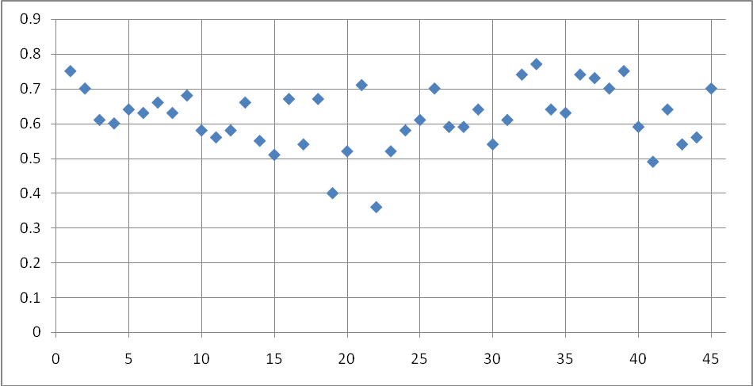

Patterns in Levels
In order to look at overall patterns in performance on items, person ability estimates and item threshold estimates were produced by unidimensional partial credit model using all the item scores and persons. The product of this is a Wright map (see Figure 4).
Figure 4. Wright Map of latent distribution and item score thresholds
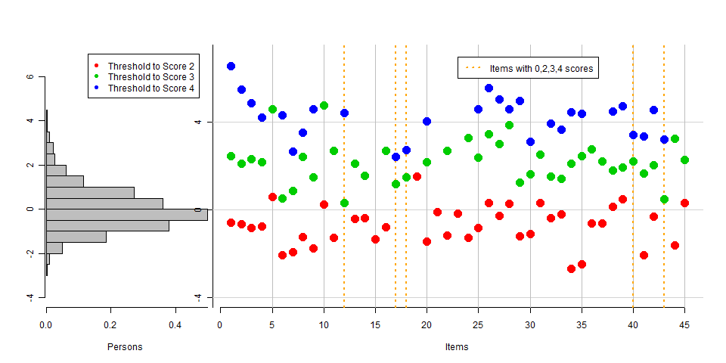

The Wright map shows both 1) the latent distribution of persons and 2) the location of item threshold estimates on the same logit scale. Generally, it was fairly easy for students to get score 2 (red dots) for most of the items. This seems logical given that a majority of our sample was from middle and high school. We would expect most students from these age groups to have at least a level 2 understanding. Also, comparing the person latent ability distribution and the item threshold map shows us that it was generally difficult for most of the students to get score of 3’s and 4’s for the most of the items.

Specific Item Score Trends

Photosynthesis. The Wright map shows that some items, and some levels were particularly easy or more difficult for students. Items 1-8 were about photosynthesis. Items 1-4 shows us that a majority of students scored level 2 for these items, however, some students did receive 3’s and 4’s. For these items, it was more difficult to get a score of level 4 for matter than it was to score level 4 for energy. Items 5-7 were about energy and plants and the Wright map shows that this item was particularly difficult for elementary (item #5) but was easier for middle and high school. Item 8 was only asked to high school students. This item was about photosynthesis and cellular respiration in plants. The Wright map shows little different between the threshold to score 3 compared to the threshold to score 4.
Digestion/Growth. Items 9-14 were about transformation processes within organisms. Item 10 (elementary item) and item 11 (middle and high school) asked for students to account for mass change in an infant as the infant grows. The Wright map shows that no student answered this item with a level 4 response and it was more difficult for elementary to score level 2 and 3 compared to middle and high school. Items 13 and 14 were about energy sources for people and no students scored level 4.
Cellular Respiration. Items 15-22 asked about cellular respiration. Item 15 was asked only to elementary students. This item asked how food can help a person move their finger. The Wright map shows that no one scored above level 2 for this item. Also item 19 (asked only to elementary students) received no scores above level 2. This item asked students to accounts for mass decrease during weight loss. The middle and high school counterparts to these items (items 17-18 about how glucose in a grape helps to move a finger; item 20 about weight loss) showed that some students answered using level 4. We observed an interesting pattern in the weight loss items at the elementary level—when asked about weight loss in people, no elementary student gave a response above level 2 and it was difficult to score level 2 for this item, however, when asked about weight loss in animals during hibernation, it appeared easier for students to score level 2.
Decomposition. Items 25-28 were focused on decomposition. Students scored all levels for the decomposition items, although it appeared that level 2 was particularly common and level 4 had a much higher threshold.
Combustion. Items 29-35 asked about combustion. Items 29, 34, and 35 seemed particularly easy to get level 2 and more difficult to get level 4. Again, it appeared that level 2 was the most common response. There were no scores of level 4 on item 31, but this item was only asked to elementary students.
Cross Process. Students were asked to make comparisons and connections across multiple processes. We found that all students struggled with these questions. For example, item 36 and 37 received no scores of level 4. Some of these items were only asked to elementary (44, 45) or only asked to high school (40, 42) making these results of these items difficult to interpret.

Conclusions
The results of this study provide additional empirical validation of our learning progression framework and assessments. We can use these results to improve our assessments and to think about why patterns in levels may have emerged. From the present data we can conclude that students have a similar level of reasoning on matter as they do energy, and that level of reasoning about different processes is also similar. While there are unique patterns for each item, the overall trend does not suggest major differences in reasoning based on progress variable or process dimensions. We need to continually monitor patterns in the dimensions as we revise our assessments and framework.

