The purpose of this assessment is to determine your understanding of quantitative reasoning in the context of biodiversity - extinction. For open response items provide a brief written answer. For the rating scale questions select 1 for strongly disagree, 3 for no opinion, and 5 for strongly agree.

- The following is a reading from the University of Michigan global change website. Read the passage to identify ways humans contribute to extinction of species.

Extinction is a natural event and, from a geological perspective (over thousands of years), routine. We now know that most species that have ever lived have gone extinct. The average rate over the past 200 million years is 1-2 species per year, and 3-4 families per million years. There have also been occasional episodes of mass extinction, when many taxa representing a wide array of life forms have gone extinct in the same blink of geological time. In the modern era, due to human actions, species and ecosystems are threatened with destruction to an extent rarely seen in earth history.

We can attribute the loss of species and ecosystems to the accelerating transformation of the earth by a growing human population. As the human population passes the six billion mark, we have transformed, degraded or destroyed roughly half of the world's forests. We use roughly half of the world's net primary productivity for human use. We use most available fresh water, and we harvest virtually all of the available productivity of the oceans. It is little wonder that species are disappearing and ecosystems are being destroyed.

Over-hunting has been a significant cause of the extinction of hundreds of species and the endangerment of many more, such as whales and many African large mammals. Most extinctions over the past several hundred years are mainly due to over-harvesting for food, fashion, and profit. Habitat loss/degradation/fragmentation is an important cause of known extinctions. As deforestation proceeds in tropical forests, this promises to become the cause of mass extinctions caused by human activity. Invasion of non-native species is an important and often-overlooked cause of extinctions. Pollution from chemical contaminants certainly poses a further threat to species and ecosystems.

A changing global climate threatens species and ecosystems. The distribution of species (biogeography) is largely determined by climate, as is the distribution of ecosystems and plant vegetation zones (biomes). Climate change may simply shift these distributions but, for a number of reasons, plants and animals may not be able to adjust.

- Select all of the following which are human causes that contribute to the extinction of species by placing an X in the box following the term.

1. Mass extinction |  | 6. Diversity of species
2. Human population growth |  | 7. Over use of resources
3. Over hunting |  | 8. Pollution
4. Habitat loss |  | 9. Climate change
5. Non-native species |  | 10. Distribution of species

B. Provide a sentence or two that explains the characteristics of how habitat loss affects extinction.

C. How is the variable of habitat loss measured?

- The following is a table and graph of the Southwestern Gray Wolf population, which is an endangered species.

Year Number of Wolves  1976 22  1979 46  1982 30  1985 50  1988 54  1991 65  1994 103  1997 138  2000 212  2003 291 | 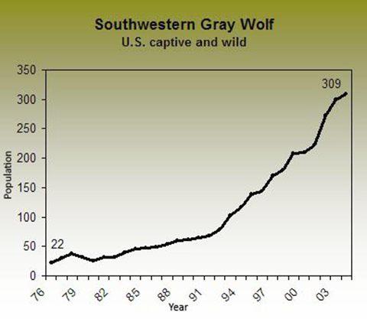

- Rate the statements below from very strongly disagree (1) to very strongly agree (5) on how well they match your interpretation of the trend depicted in the graph and table.

1. | Trends can be determined from this graph. | Very strongly disagree | 1 2 3 4 5 | Very strongly agree
2. | The population trend is best represented by a power or exponential function, not a linear function. | Very strongly disagree | 1 2 3 4 5 | Very strongly agree
3. | The change in population by year in the table implies that increase in population is linear. | Very strongly disagree | 1 2 3 4 5 | Very strongly agree
4. | The population is increasing at a rate that is not constant or linear. | Very strongly disagree | 1 2 3 4 5 | Very strongly agree
5. | The population is increasing. | Very strongly disagree | 1 2 3 4 5 | Very strongly agree
6. | Trends cannot be determined from this table. | Very strongly disagree | 1 2 3 4 5 | Very strongly agree
7. | One can identify a point on the graph, such as (1991, 65) as representing year and wolf population, but cannot use the graph to explain trend. | Very strongly disagree | 1 2 3 4 5 | Very strongly agree
8. | The function y = 22 ˖ 1.1^{x} is a possible model for this data, indicating that for each year the wolf population will increase by a ratio of 1.1 over the previous year. | Very strongly disagree | 1 2 3 4 5 | Very strongly agree

Below are eight different possible representations of the data table on the Southwestern Gray Wolf population. Use these representations and the table and graph above to answer questions B, C, and D.

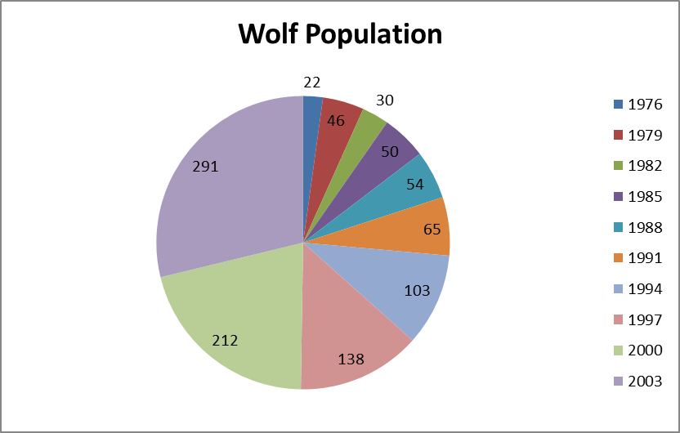  1. Pie Chart | 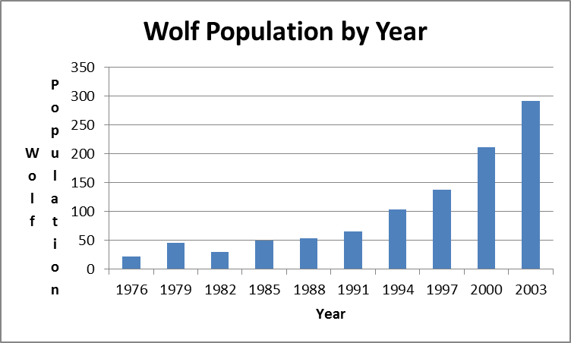  2. Bar Graph
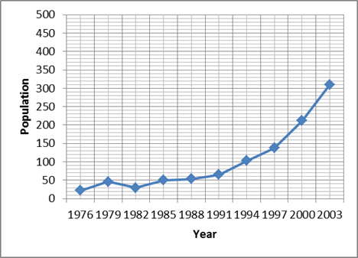  3. Connected Scatter Plot | 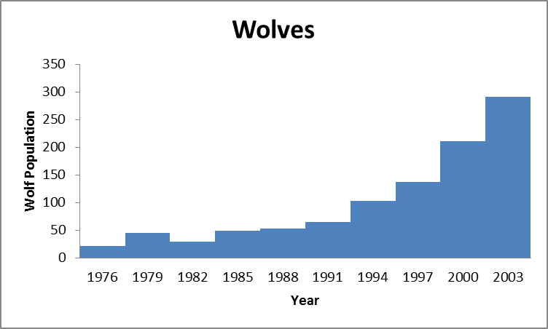  4. Histogram
5. Linear equation representing data  y = 9x -18.6  where 1976 is numbered as year 0, x is year, y is population | 6. Quadratic equation representing data  y= 0.6x²-6.9x+45  where 1976 is numbered as year 0, x is year, y is population
7. Exponential equation representing data  y = 22 ˖ 1.1^{x}  where 1976 is numbered as year 0, x is year, y is population | 8. Power equation representing data  y = 8.9 x^{0.9}  where 1976 is numbered as year 0, x is year, y is population

- Rate the statements below from very strongly disagree (1) to very strongly agree (5) on how well they match your understanding of the representations.

1. | There can only be one representation of the wolf population, so the other representations are all wrong. | Very strongly disagree | 1 2 3 4 5 | Very strongly agree
2. | The exponential model gives a population of 39 for year 1982. While this varies from the table value for wolf population, it does not mean one should not use this model. | Very strongly disagree | 1 2 3 4 5 | Very strongly agree
3. | One would select the representation they prefer and use only it, because there may be differences in the values between the models. | Very strongly disagree | 1 2 3 4 5 | Very strongly agree
4. | The other representations are of wolves in a different area, not in the Southeast U.S. | Very strongly disagree | 1 2 3 4 5 | Very strongly agree
5. | The exponential model is a better fit than the linear model because the data trend is not linear. | Very strongly disagree | 1 2 3 4 5 | Very strongly agree
6. | One cannot compare the different representations of the data. | Very strongly disagree | 1 2 3 4 5 | Very strongly agree
7. | The power model gives a wolf population of 155 for year 2000, this does not match the table value of 212 so likely they collected data on different wolf populations. | Very strongly disagree | 1 2 3 4 5 | Very strongly agree
8. | One can compare the table with the connected scatter plot because both represent year and population. | Very strongly disagree | 1 2 3 4 5 | Very strongly agree

- Rate the statements below from very strongly disagree (1) to very strongly agree (5) on how well they match your understanding of predicting future events.

1. | Time and number of wolves are both increasing together, so before 1976 there were more than 20 wolves. | Very strongly disagree | 1 2 3 4 5 | Very strongly agree
2. | As time passes the number of wolves is increasing, so there will be more wolves in 2013. | Very strongly disagree | 1 2 3 4 5 | Very strongly agree
3. | To predict the number of wolves in 2013 substitute 37 for year in the equation modeling the data, then solve for number of wolves. | Very strongly disagree | 1 2 3 4 5 | Very strongly agree
4. | One could extend the nonlinear trend of the data off the end of the graph, then estimate the year and number of wolves on the curve. | Very strongly disagree | 1 2 3 4 5 | Very strongly agree
5. | I am not sure how one can make predictions for future events from any of the representations. | Very strongly disagree | 1 2 3 4 5 | Very strongly agree
6. | The population is at 309 and increasing so there will be more wolves. | Very strongly disagree | 1 2 3 4 5 | Very strongly agree
7. | Since the graph only provides information for up to 2005, one cannot make predictions of wolf population beyond the given data. | Very strongly disagree | 1 2 3 4 5 | Very strongly agree
8. | Based on the wolf population trend one would predict the population remains at 309. | Very strongly disagree | 1 2 3 4 5 | Very strongly agree

- Rate the statements below from very strongly disagree (1) to very strongly agree (5) on how well they match your understanding of how we can revise models. To revise a model means to change a model to better reflect the real world data. Use the following information in addressing these statements: A general law of population growth is that populations will grow exponentially at first.

1. | If the exponential function does not fit the data, then one needs to recollect the data to satisfy the population growth law. | Very strongly disagree | 1 2 3 4 5 | Very strongly agree
2. | One should consider revising the model by relating the theory of population growth to endangered species populations. | Very strongly disagree | 1 2 3 4 5 | Very strongly agree
3. | One should evaluate the graph and the equation model of the data in the table to see how they inform each other. | Very strongly disagree | 1 2 3 4 5 | Very strongly agree
4. | We can test the graph or equation model for the wolf population data to see if it is a good or bad fit. That is all the revision one can do. | Very strongly disagree | 1 2 3 4 5 | Very strongly agree
5. | If the exponential function does not fit the data, then the data was not collected correctly. | Very strongly disagree | 1 2 3 4 5 | Very strongly agree
6. | One should revise the model to better fit the evidence in the table not to make it fit the population growth law. | Very strongly disagree | 1 2 3 4 5 | Very strongly agree
7. | One should revise the model so that it improves the ability to predict events. Perhaps this population does not obey the law. | Very strongly disagree | 1 2 3 4 5 | Very strongly agree
8. | A model for wolf population is fixed and cannot be revised given new information. | Very strongly disagree | 1 2 3 4 5 | Very strongly agree

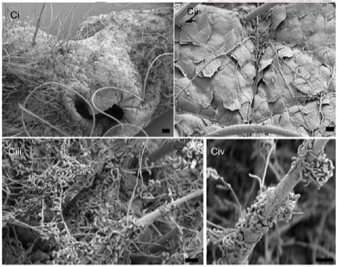
- White Nose Syndrome (WNS) is currently found in cave hibernating bats, where 70-100% of bats in caves showing symptoms will die. A new fungus causing WNS is called Geomyces destructans (see picture of fungus to the left). It is a cold tolerant fungus and species in this genus are found worldwide. Scientists believe that the fungus is transferred from cave to cave through human activity and natural bat movements. The table and graph below are representations of colony expansion of Geomyces destructans (millimeters per day) and temperature (Celsius).

Temperature (Celsius) Expansion (mm/day) Temperature (Celsius) Expansion (mm/day)  3 0.175 12 0.75  4 0.3 13 0.74  5 0.41 14 0.71  6 0.5 15 0.65  7 0.55 16 0.55  8 0.61 17 0.42  9 0.66 18 0.28  10 0.7 19 0.15  11 0.71 20 0 | 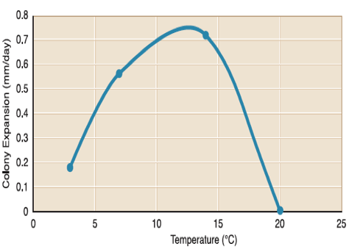

- Rate the statements below from very strongly disagree (1) to very strongly agree (5) on how well they match your interpretation of the trend depicted in the graph and table.

1. | The population trend is best represented by a power function, not a linear or exponential function. | Very strongly disagree | 1 2 3 4 5 | Very strongly agree
2. | The population is still increasing above a temperature of 11 and the rate of colony expansion is linear. | Very strongly disagree | 1 2 3 4 5 | Very strongly agree
3. | The function y = -0.009x²+0.201x-0.379 is a possible model for this data, indicating that if a bat carrying WNS moves to a cave with a temperature of 25C it will infect others in the new colony. | Very strongly disagree | 1 2 3 4 5 | Very strongly agree
4. | One can identify a point on the graph, such as (10, 0.7) as representing temperature and colony expansion, but cannot use the graph to explain trend. | Very strongly disagree | 1 2 3 4 5 | Very strongly agree
5. | Trends can be determined from this table. | Very strongly disagree | 1 2 3 4 5 | Very strongly agree
6. | Trends cannot be determined from this graph. | Very strongly disagree | 1 2 3 4 5 | Very strongly agree
7. | The colony is expanding more slowly above a temperature of 11. | Very strongly disagree | 1 2 3 4 5 | Very strongly agree
8. | The population is increasing up to a temperature of 11. | Very strongly disagree | 1 2 3 4 5 | Very strongly agree

Below are different possible representations of the data table on colony expansion. Use these representations and the table and graph above to answer questions B, C, and D.

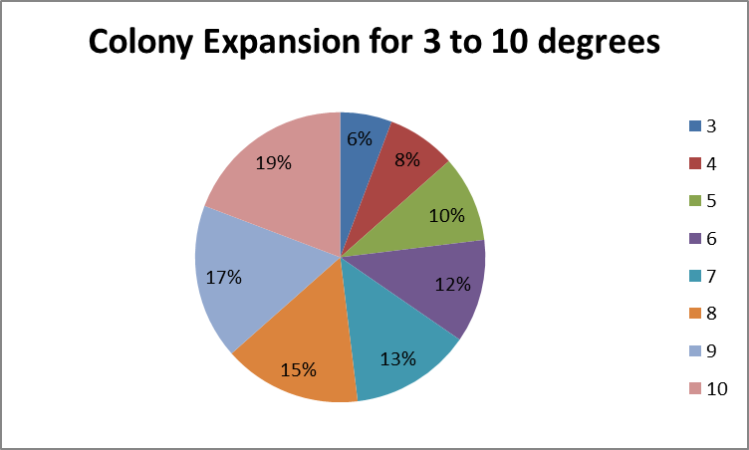  1. Pie Chart | 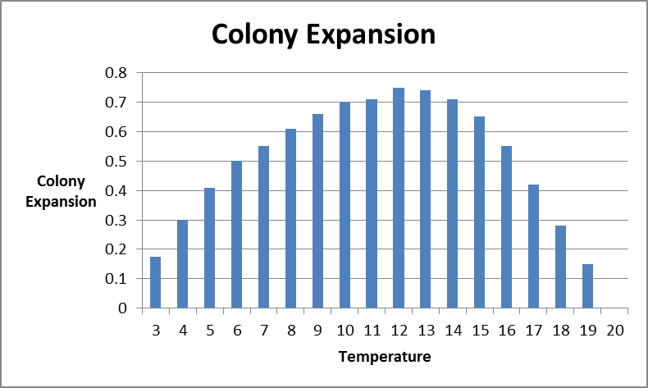  2. Bar Graph
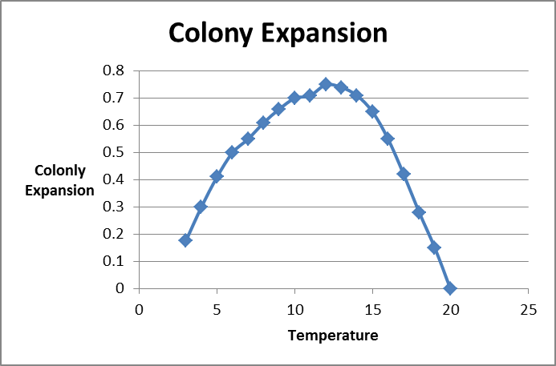  3. Connected Scatter Plot | 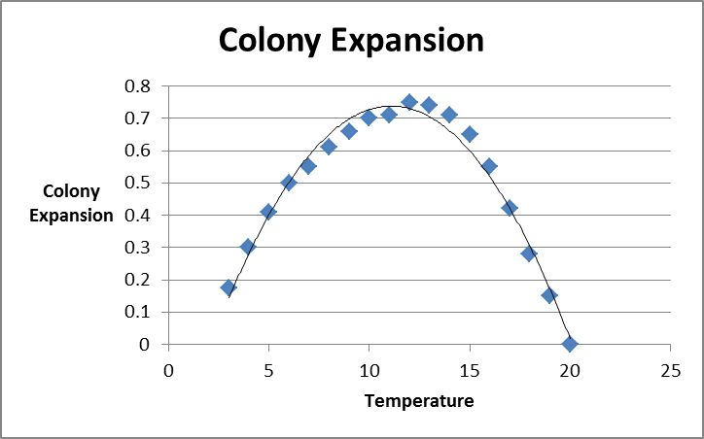  4. Best fit curve
5. Linear equation representing data  y = -0.0073x + 0.5768  where x is temperature and y is colony expansion. | 6. Quadratic equation representing data  y = -0.009x²+0.201x-0.379  where x is temperature and y is colony expansion.
7. Exponential equation representing data  y = 0.18 ˖ 1.15^{x}  where x is temperature and y is colony expansion. | 8. Power equation representing data  y = 0.07 x^{0.98}  where x is temperature and y is colony expansion.

- Rate the statements below from very strongly disagree (1) to very strongly agree (5) on how well they match your understanding of the representations.

1. | The other representations are of colony expansion in different caves. | Very strongly disagree | 1 2 3 4 5 | Very strongly agree
2. | One should not compare the pie chart to the graph since the pie chart provides percentage values and not colony growth. | Very strongly disagree | 1 2 3 4 5 | Very strongly agree
3. | One cannot compare the different representations of the data. | Very strongly disagree | 1 2 3 4 5 | Very strongly agree
4. | The quadratic model is a better fit than the exponential model because of the increasing and decreasing nature of the data trend. | Very strongly disagree | 1 2 3 4 5 | Very strongly agree
5. | There can only be one representation of the colony expansion, so the other representations are all wrong. | Very strongly disagree | 1 2 3 4 5 | Very strongly agree
6. | The quadratic model gives a rate of colony expansion of 0.731 for a temperature of 10 degrees. This varies from the table value for this temperature due to estimates in model. | Very strongly disagree | 1 2 3 4 5 | Very strongly agree
7. | One would select the representation they prefer and use only it, because there may be differences in the values between the models. | Very strongly disagree | 1 2 3 4 5 | Very strongly agree
8. | One can compare the table with the bar graph because both represent temperature and colony expansion. | Very strongly disagree | 1 2 3 4 5 | Very strongly agree

- Rate the statements below from very strongly disagree (1) to very strongly agree (5) on how well they match your understanding of predicting future events.

1. | For a temperature of 25 degrees the colony expansion will continue to slow. | Very strongly disagree | 1 2 3 4 5 | Very strongly agree
2. | If the colony begins to expand at 2 degrees, then one could extend the graph and predict the colony expansion using the graph. | Very strongly disagree | 1 2 3 4 5 | Very strongly agree
3. | As temperature increases beyond 12 degrees the rate of colony expansion decreases. | Very strongly disagree | 1 2 3 4 5 | Very strongly agree
4. | The colony expansion will stop at 20 degrees. | Very strongly disagree | 1 2 3 4 5 | Very strongly agree
5. | Colony expansion is decreasing so it will become a negative expansion. | Very strongly disagree | 1 2 3 4 5 | Very strongly agree
6. | To predict the colony growth at a temperature of 5.5 degrees, substitute the 5.5 into the equation model and solve for colony expansion rate. | Very strongly disagree | 1 2 3 4 5 | Very strongly agree
7. | I am not sure how one can make predictions for future events from any of the representations. | Very strongly disagree | 1 2 3 4 5 | Very strongly agree
8. | Since the table only provides temperatures between 3 and 20 degrees, one cannot make predictions of colony expansion beyond the given data. | Very strongly disagree | 1 2 3 4 5 | Very strongly agree

- Rate the statements below from very strongly disagree (1) to very strongly agree (5) on how well they match your understanding of how we can revise models. To revise a model means to change a model to better reflect the real world data.

1. | One should revise the model to better fit the evidence in the table not to make it fit a scientist’s expectations. | Very strongly disagree | 1 2 3 4 5 | Very strongly agree
2. | If a scientist says that the colony expansion should not be impacted by temperature, then one needs to recollect the data. | Very strongly disagree | 1 2 3 4 5 | Very strongly agree
3. | One should evaluate the graph and the equation model of the data in the table to see how they inform each other. | Very strongly disagree | 1 2 3 4 5 | Very strongly agree
4. | If the modeling function does not exactly fit the data, then the data was not collected correctly. | Very strongly disagree | 1 2 3 4 5 | Very strongly agree
5. | One should revise the model so that it improves the ability to predict events, not revise the data to fit a model. | Very strongly disagree | 1 2 3 4 5 | Very strongly agree
6. | A model for colony expansion is fixed and cannot be revised given new information. | Very strongly disagree | 1 2 3 4 5 | Very strongly agree
7. | One should consider revising the model by relating the colony expansion to bat deaths. | Very strongly disagree | 1 2 3 4 5 | Very strongly agree
8. | One can test the graph or equation model for the colony expansion data to see if it is a good or bad fit. That is all the revision one can do. | Very strongly disagree | 1 2 3 4 5 | Very strongly agree

- Plants and animals depend on each other for the survival of their species. Use the box model of energy flow within the food chain to answer the following questions.

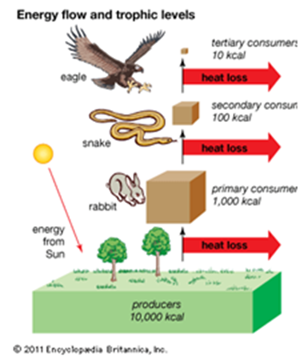  Box Model of Energy Flow | Trophic Level Energy  Tertiary Consumer Level 3 10 kcal  Secondary Consumer Level 2 100 kcal  Primary Consumer Level 1 1,000 kcal  Producers Level 0 10,000 kcal

- Rate the statements below from very strongly disagree (1) to very strongly agree (5) on how well they match your interpretation of the trend depicted in the model and table.

1. | The amount of energy is decreasing at a rate which is not constant or linear. | Very strongly disagree | 1 2 3 4 5 | Very strongly agree
2. | The amount of energy is decreasing. | Very strongly disagree | 1 2 3 4 5 | Very strongly agree
3. | The energy trend is best represented by an exponential function, not a linear or power function. | Very strongly disagree | 1 2 3 4 5 | Very strongly agree
4. | Trends cannot be determined from this table. | Very strongly disagree | 1 2 3 4 5 | Very strongly agree
5. | Trends can be determined from this box model. | Very strongly disagree | 1 2 3 4 5 | Very strongly agree
6. | The change in energy loss is decreasing at the same multiplicative rate across levels so it is not linear. | Very strongly disagree | 1 2 3 4 5 | Very strongly agree
7. | The function y = 10000 ˖ 0.1^{x} is a possible model for this data, indicating that at each stage the amount of energy lost is 90%. | Very strongly disagree | 1 2 3 4 5 | Very strongly agree
8. | One can identify the amount of energy for primary consumers from the table, but cannot use the table to explain trends in heat loss. | Very strongly disagree | 1 2 3 4 5 | Very strongly agree

Below are different possible representations of the data table on model of energy flow. Use these representations and the table and box model above to answer questions B, C, and D.

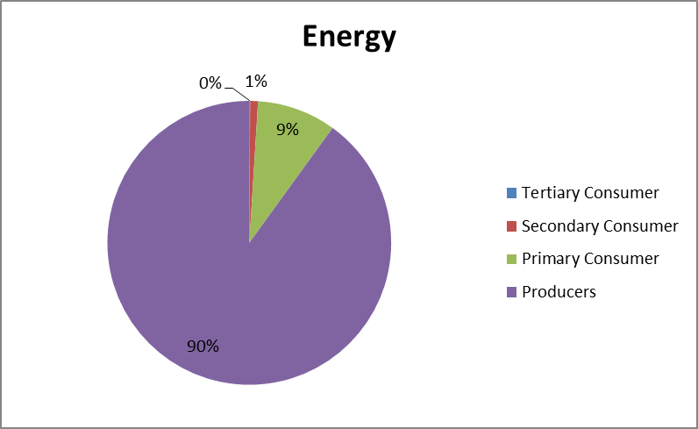  1. Pie Chart | 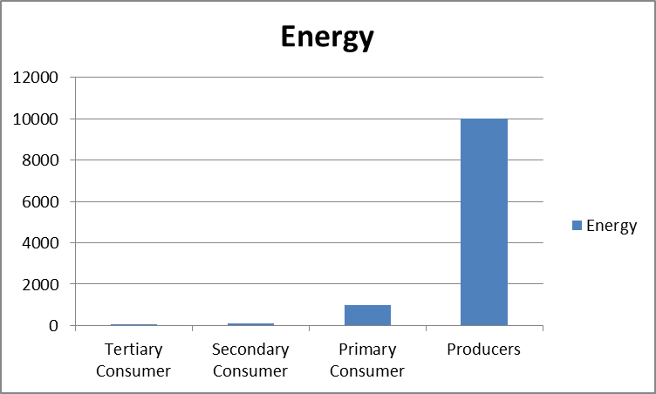  2. Bar Graph
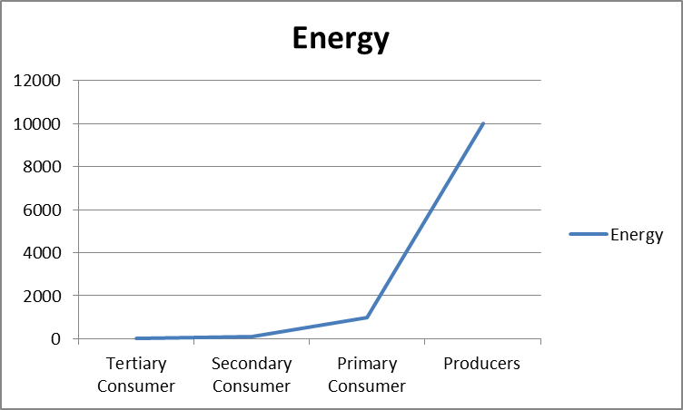  3. Line Graph | 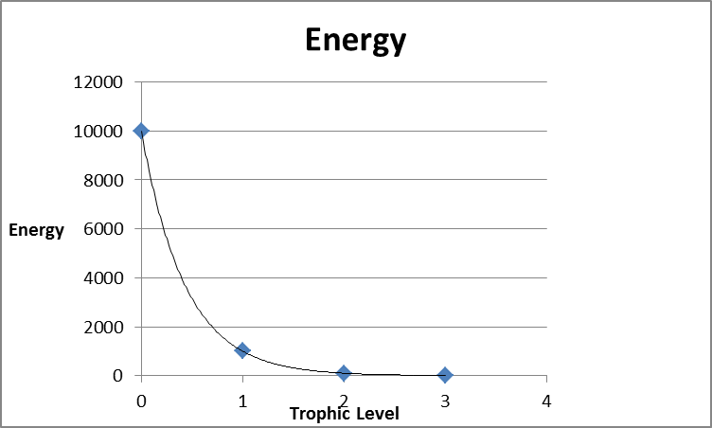  4. Best fit curve
5. Linear equation representing data  y = -3087x + 7408  where x represents the trophic levels and y represents the energy at a trophic level. | 6. Quadratic equation representing data  y = 2227x²-9770x+9636  where x represents the trophic levels and y represents the energy at a trophic level.
7. Exponential equation representing data  y = 10000 ˖ 0.1^{x}  where x represents the trophic levels and y represents the energy at a trophic level. | 8. Power equation representing data  y = 1156 x^{-4.1}  where x represents the trophic levels and y represents the energy at a trophic level.

- Rate the statements below from very strongly disagree (1) to very strongly agree (5) on how well they match your understanding of the representations.

1. | One would select the representation they prefer and use only it, because there may be differences in the values between the models. | Very strongly disagree | 1 2 3 4 5 | Very strongly agree
2. | The pie chart provides a visual representation of the percentage of energy at each level within the box model. There is no difference between values in the box model and the pie chart. | Very strongly disagree | 1 2 3 4 5 | Very strongly agree
3. | One cannot compare the different representations of the data. | Very strongly disagree | 1 2 3 4 5 | Very strongly agree
4. | One can compare the pie chart with the box model because both represent energy flow in a system. | Very strongly disagree | 1 2 3 4 5 | Very strongly agree
5. | The other representations are of energy flow in different systems, such as a mountain ecosystem. | Very strongly disagree | 1 2 3 4 5 | Very strongly agree
6. | One should not compare the best fit curve to the box model due to the small number of values used to determine the curve. | Very strongly disagree | 1 2 3 4 5 | Very strongly agree
7. | There can only be one representation of the energy flow in a system, so the other representations are all wrong. | Very strongly disagree | 1 2 3 4 5 | Very strongly agree
8. | An exponential model fits the data exactly, indicating a common multiplier of 1/10 between each trophic level. | Very strongly disagree | 1 2 3 4 5 | Very strongly agree

- Rate the statements below from very strongly disagree (1) to very strongly agree (5) on how well they match your understanding of predicting future events.

1. | Energy at a fourth trophic level would be more than at the third level. | Very strongly disagree | 1 2 3 4 5 | Very strongly agree
2. | To predict the energy at a given level divide the previous level by 10. | Very strongly disagree | 1 2 3 4 5 | Very strongly agree
3. | I am not sure how one can make predictions for future events from any of the representations. | Very strongly disagree | 1 2 3 4 5 | Very strongly agree
4. | As one goes up trophic levels the energy reduces. | Very strongly disagree | 1 2 3 4 5 | Very strongly agree
5. | One cannot predict future events from a box model. | Very strongly disagree | 1 2 3 4 5 | Very strongly agree
6. | Energy appears to decrease between trophic levels two and three. | Very strongly disagree | 1 2 3 4 5 | Very strongly agree
7. | Energy is lost in the system. | Very strongly disagree | 1 2 3 4 5 | Very strongly agree
8. | If the system has a fourth trophic level, then the energy remaining would be one kcal. | Very strongly disagree | 1 2 3 4 5 | Very strongly agree

- Rate the statements below from very strongly disagree (1) to very strongly agree (5) on how well they match your understanding of how we can revise models. To revise a model means to change a model to better reflect the real world data.

1. | One should evaluate the box model and the equation model of the data in the table to see how they inform each other. | Very strongly disagree | 1 2 3 4 5 | Very strongly agree
2. | One should revise the box model so that it improves the ability to predict events, not revise the data to fit a model. | Very strongly disagree | 1 2 3 4 5 | Very strongly agree
3. | The box model is fixed and cannot be revised given new information. | Very strongly disagree | 1 2 3 4 5 | Very strongly agree
4. | If a scientist says energy flow should reduce only by a half at each stage, then one needs to recollect the data. | Very strongly disagree | 1 2 3 4 5 | Very strongly agree
5. | One should revise the box model to better fit the evidence in the table not to make it fit a scientist’s expectations. | Very strongly disagree | 1 2 3 4 5 | Very strongly agree
6. | One can test the box model for energy flow data to see if it is a good or bad fit. That is all the revision one can do. | Very strongly disagree | 1 2 3 4 5 | Very strongly agree
7. | One should consider revising the model if the eagle is removed from the system or if a producer’s energy level is decreased. | Very strongly disagree | 1 2 3 4 5 | Very strongly agree
8. | If the box model does not exactly fit the data, then the data was not collected correctly. | Very strongly disagree | 1 2 3 4 5 | Very strongly agree

