Carbon Learning Progression Summary Table
Learning Progression Summary Table for use with Teachers in professional development
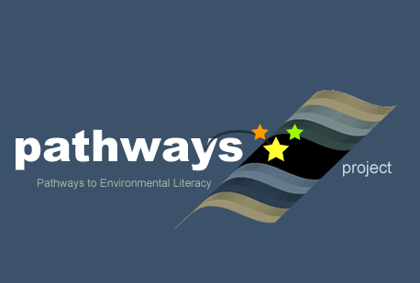
Written by Jonathon Schramm^{A}, Eric Keeling^{B}, Dijanna Figueroa^{C}, Lindsay Mohan^{A}, Michele Johnson^{C}, and Charles W. Anderson^{A} With help from Cheryl Hach^{G}, Becky Drayton^{H}, Dante Cisterna^{A}, Lisa Pitot^{D}, Mike Switzer^{E}, Nissa Yestness^{F}
^{A}Michigan State University, ^{B}Cary Institute of Ecosystem Studies, ^{C}University of California, Santa Barbara, ^{D}Poudre School District (CO), ^{E}Poudre Learning Center, ^{F}Colorado State University, ^{G}Kalamazoo Area Math & Science Center (MI), ^{H}Gobles Public Schools (MI)
Culturally relevant ecology, learning progressions and environmental literacy Long Term Ecological Research Math Science Partnership
2012
Disclaimer: This research is supported by a grant from the National Science Foundation: Targeted Partnership: Culturally relevant ecology, learning progressions and environmental literacy (NSF-0832173). Any opinions, findings, and conclusions or recommendations expressed in this material are those of the author(s) and do not necessarily reflect the views of the National Science Foundation.


Summary Table of Carbon Levels
Level | Micro or Atomic Molecular Scale | Macroscopic Scale | Large Scale
Level 4: Principle-based scientific reasoning | Tracing: Atoms rearrange to form new molecules. Energy transferred through high-energy bonds.  Association: Organic molecules have high-energy C-C and C-H bonds. | Tracing: Plants, animals, decomposers, machines are all systems that transform matter and energy.  Association: Organisms, food, detritus, fossil fuels all made of high-energy organic materials. Only plants generate organic carbon; all organisms oxidize organic carbon. | Tracing: Carbon cycling between atmosphere and biomass. Energy flow from sunlight to chemical potential energy to heat. Oxidation of fossil fuels as part of global carbon cycling.  Association: Processes classified in chemical terms, generating, transforming, oxidizing organic carbon.
Level 3: Partial scientific reasoning | Tracing: Matter/energy moving into and out of cells.  Association: Living things made of cells that carry out life functions. Molecules are inside cells. | Tracing: Matter and energy have to come from somewhere and go somewhere, but can be converted into one another.  Association: Solids, liquids, gases are all matter. Foods and fuels are energy sources. | Tracing: Food chains as passing matter/energy among organisms. Separate nutrient and O₂-CO₂ cycles.  Association: Producers distinct from consumers and decomposers; fossil fuels recognized as organic.
Level 2: Elaborated force-dynamic reasoning | Tracing: Causal internal mechanisms, but minimal tracing matter and energy inside bodies.  Association: Internal organs and organ systems. | Tracing: Structure and function of actors work together so that they can accomplish their purposes.  Association: Foods and fuels are special kinds of enablers that living things and machines depend on. | Tracing: Food chains as cause-and-effect sequences. Separate nutrient and O₂-CO₂ cycles, focused on people.  Association: Purposeful actions by living things different from natural tendencies of dead things.
Level 1: Force-dynamic reasoning | Focus on macroscopic scale | Tracing: Explanations focusing on why events happen in terms of purposes of actors (people, animals, plants, flames, machines) and results of their actions. Materials controlled by actors  Association: Living things different from dead materials; gases not connected with other forms of matter; energy is for purposeful action | Tracing: Food chains as events in a story  Association: Purposeful actions by living things different from natural tendencies of dead things

Contrasting ways of grouping carbon-transforming processes
Upper Anchor: Scientific accounts | Carbon-transforming process | Generating organic carbon | Transforming organic carbon |  |  | Oxidizing organic carbon
Upper Anchor: Scientific accounts | Scientific accounts | Photosynthesis | Biosyn-thesis | Digest-ion | Biosyn-thesis | Cellular respiration |  | Combustion
Macroscopic Events |  | Plant growth |  | Animal growth |  | Breathing, exercise, weight loss | Decay | Burning
Lower Anchor:  Informal accounts |  | Plants and animals accomplishing their purposes, enabled by food, water, sunlight, air, and/or other resources |  |  |  |  | Natural process in dead things | Flame consuming fuel
Comparison of Level 1 and Level 4 Association and Tracing for “Stuff”
Level 4 general categories | Matter |  |  |  | Energy: Heat, chemical, etc. | Conditions: Temperature, care, etc.
Level 4 general categories | Organic matter (including organic gases) |  | Inorganic matter (including inorganic gases) |  | Energy: Heat, chemical, etc. | Conditions: Temperature, care, etc.
Linking states | Solids and liquids |  |  | Gases | Not matter
Linking material kinds | Plants, animals | Dead plants and animals | Water, soil | Air | Light, heat | Temperature, care
Level 1 general categories | Living stuff | Non-living (Dead and inanimate) stuff |  | Insubstantial kinds: gases, conditions, energy

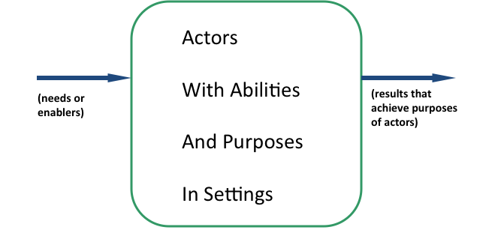  Level 1 reasoning about carbon cycling | 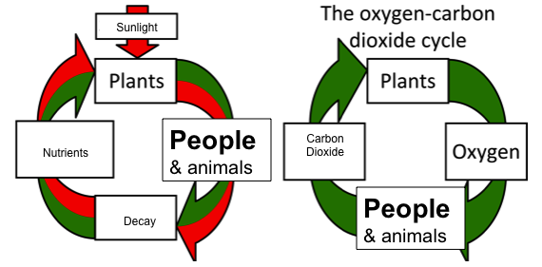  Level 2 Reasoning about matter cycling
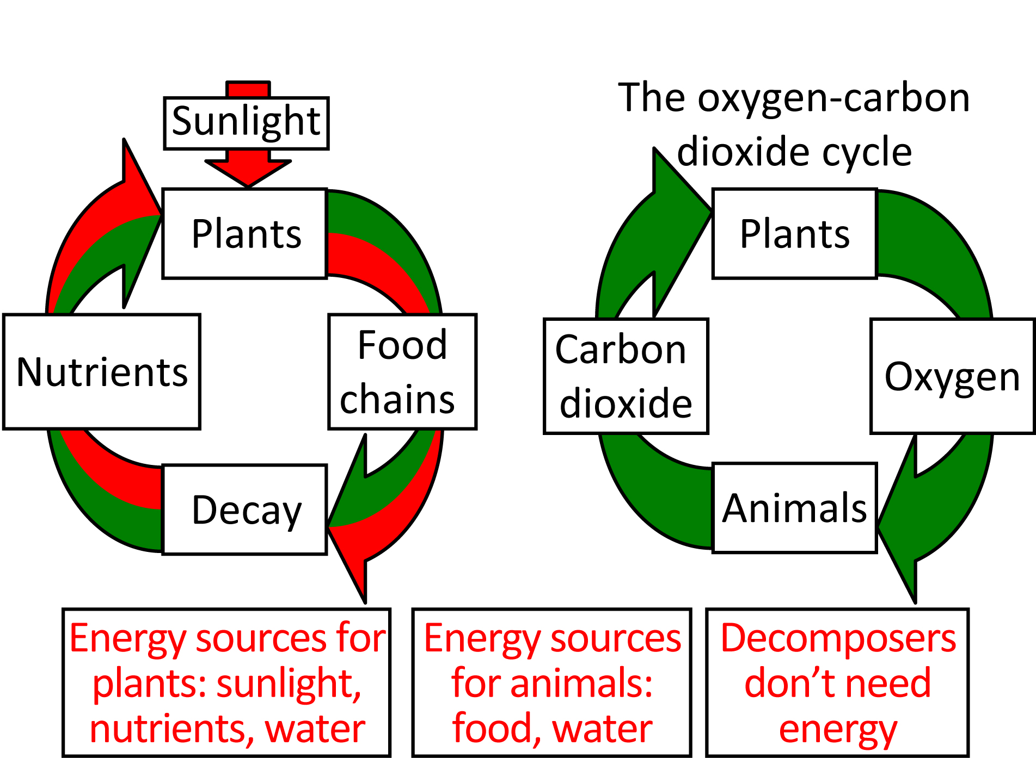  Level 3 Reasoning about carbon cycling | 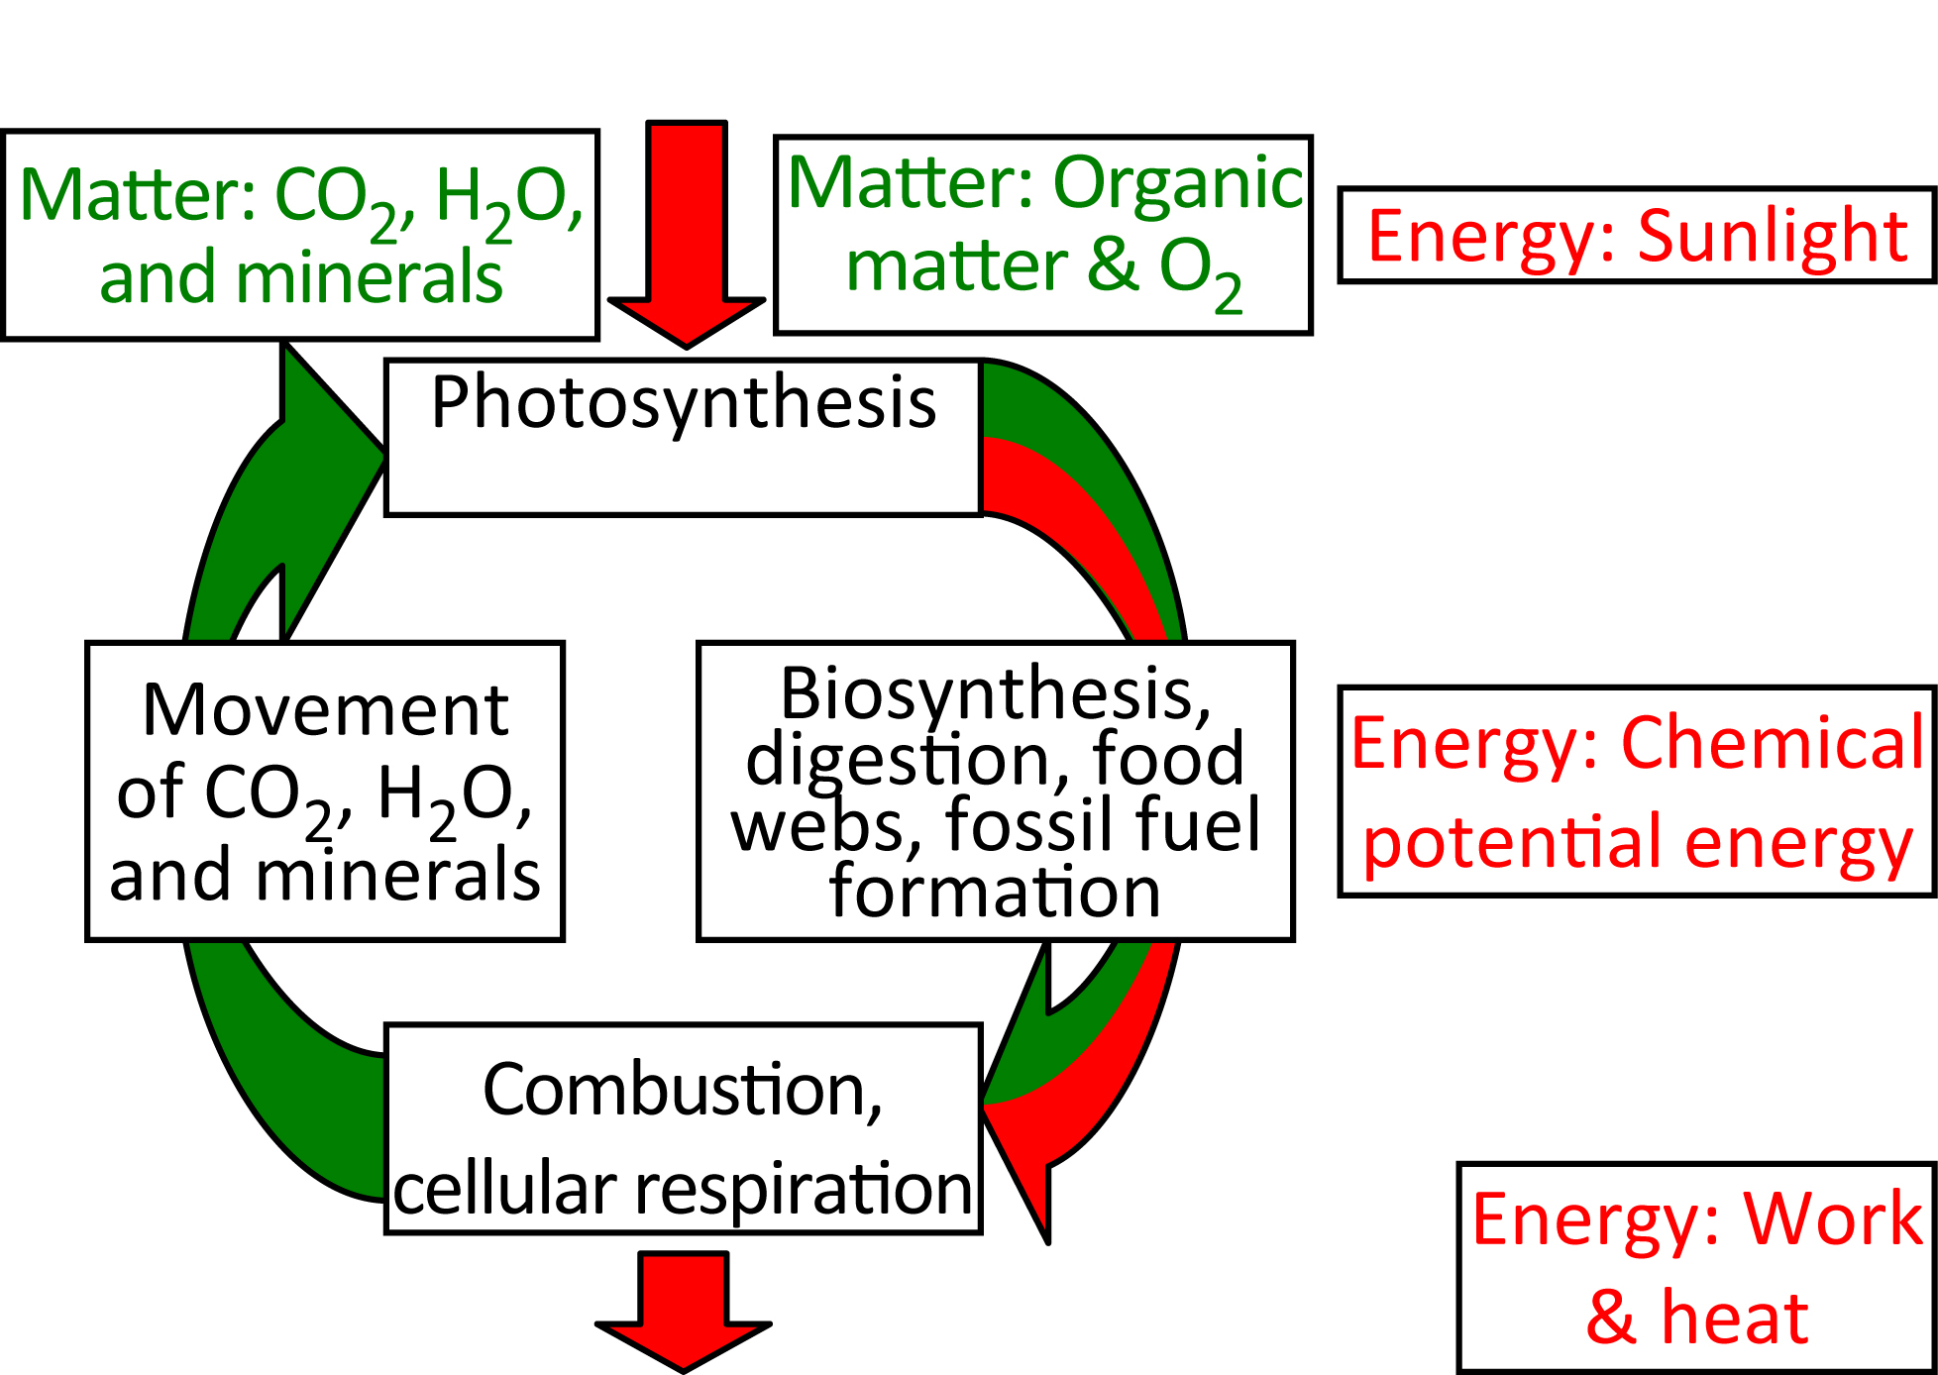  Level 4 reasoning about carbon cycling

